Lesson 2
Objective: Use the place value chart to record and name tens and ones within a two-digit number.

Suggested Lesson Structure
 Fluency Practice (14 minutes)
 Application Problem (5 minutes)
 Concept Development (31 minutes)
 Student Debrief (10 minutes)
Total Time (60 minutes)

Fluency Practice (14 minutes)
- Core Addition Fluency Review 1.OA.6 (5 minutes)
- 3, 4, and 5 More 1.OA.6 (4 minutes)
- Change 10 Pennies for 1 Dime 1.NBT.2 (5 minutes)

Core Addition Fluency Review (5 minutes)

Materials: (S) Core Addition Fluency Review
Note: This addition review sheet contains the majority of addition facts within 10 (excluding some +0 and +1 facts), which are part of the required core fluency for Grade 1. Students are likely to do well with this activity at this point in the year. If not, repeat some addition fluency activities from Module 1 and use this activity as an assessment tool to monitor progress.

NOTES ON
MULTIPLE MEANS
OF ACTION AND EXPRESSION:
Adjust written fluency games for students with motor delays. Give written fluency activities orally to students who may be slowed due to challenges with motor skills, allowing them to experience success with the math skills being addressed.

Students complete as many problems as they can in three minutes. Choose a counting sequence for early finishers to practice on the back of their papers, such as counting by ones from 46 or counting by tens from 3. When time runs out, read the answers aloud so students can correct their work. Encourage students to remember how many they completed so they can try to improve their scores on future Core Addition Fluency Reviews.

3, 4, and 5 More (4 minutes)
Note: This fluency activity provides practice with the grade-level standard of addition within 20, while reinforcing the relationship between single-digit sums and their analogous teen sums.
T: On my signal, say the number that is 3 more.
T: 3. (Signal.)
S: 6.
T: 13. (Signal.)
S: 16.
Continue reviewing 3 more. Then, review 4 and 5 more.

Change 10 Pennies for 1 Dime (5 minutes)

Materials: (S) 10 pennies and 2 dimes for each pair of students
Note: This fluency activity is necessary to prepare students for utilizing coins as abstract representations of tens and ones in Lesson 6.
Students work in pairs. Partner A begins with 10 pennies. Partner B begins with 2 dimes. Both partners whisper-count as Partner A counts 10 pennies into 5-groups (1 cent, 2 cents, etc.). Partner B changes 10 cents for 1 dime and says, “10 cents equals 1 dime.” Students count on, “11 cents, 12 cents, 13 cents, etc.,” replacing the second set of 10 pennies with a dime and saying, “20 cents equals 2 dimes.” Then, Partners A and B switch roles.

Application Problem (5 minutes)

Ted has 4 boxes with 10 pencils in each box. How many pencils does he have altogether?
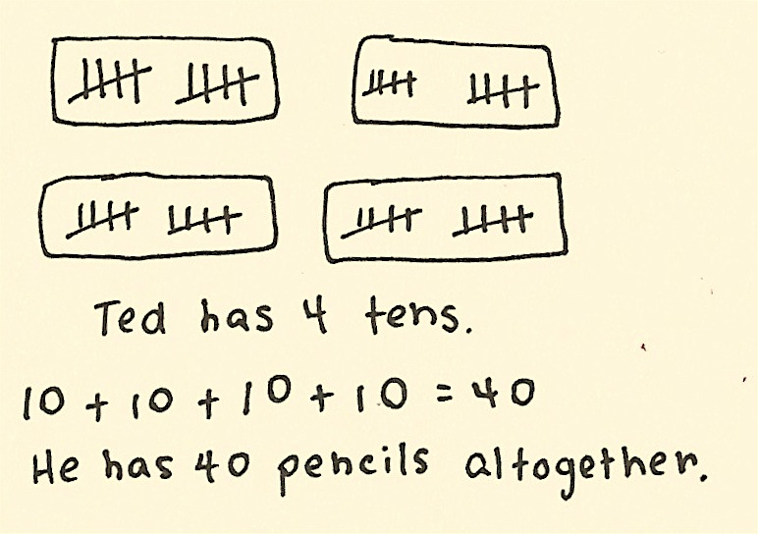
Note: This problem applies the Concept Development from Lesson 1 of counting by tens. As students depict this problem with a drawing, circulate and notice students who are counting all, counting on, or counting by tens. During the Debrief, students will represent the number 40 using a place value chart.

Concept Development (31 minutes)

NOTES ON
MULTIPLE MEANS
OF REPRESENTATION:
Because the Hide Zero cards are familiar from Module 3, students have an easy transition into the use of the place value chart. Just as some students have needed to use various tools for more support, allow the Hide Zero cards and place value chart to be used throughout the module as needed.

Materials: (T) Hide Zero cards (Template 1), chart paper
(S) 4 ten-sticks from personal math toolkit (Lesson 1), personal white board, place value chart (Template 2)
Students sit at their desks with their materials.
T: (Show 17 using Hide Zero cards.) When I pull apart these Hide Zero cards, 17 will be in two parts. What will they be?
S: 10 and 7.
T: (Pull apart 17 into 10 and 7.) You are right! Show me 17 using your linking cubes.
S: (Show 1 ten-stick and 7 extra cubes. If students count out 17 cubes and break them apart separately, ask them to try to make as many tens as possible.)
T: How many tens, or ten-sticks, do you have?
S: 1 ten.
T: How many extra ones do you have?
S: 7 extra ones.
Repeat the process following the suggested sequence: 27, 37, 23, and 32.
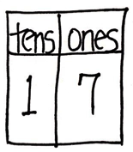
T: (Show 17 with Hide Zero cards and linking cubes again. Make a blank t-chart on the chart paper.)
I can write 1 ten here in this chart. (Write 1 on the left side of the t-chart, which will become the tens place.) How many extra ones do you have?
S: 7 ones.
T: Point to where you think I should write 7.
S: (Point to the second column.)
T: (Write 7 in the ones place.)
T: (Point to the 1 in the tens place.) What does this 1 stand for? Show me with your cubes.
S: (Hold up a ten-stick.) 1 ten.
T: I can write tens here because this 1 stands for 1 ten. (Label the place value chart with tens.)
T: Point to the set of cubes that tells us what this 7 stands for.
S: (Point to 7 loose cubes.) 7 ones!
T: I can write ones here because this 7 stands for…?
S: 7 ones.
T: (Point to the place value chart.) Look at our new chart, which is called a place value chart. What is 1 ten and 7 ones?
S: 17.
T: The Say Ten Way?
S: 1 ten 7.
T: Looking at the cubes in front of you, how many tens and ones are in 17?
S: 1 ten 7 ones.
T: Before we go on to other numbers, let’s make a drawing to show 17.
Repeat the process using the following sequence: 27, 37, 14, 24, 34, 13, 31, 30, 12, 21, and 20.
MP.7
For the first two numbers (27 and 37), have students represent the number with their linking cubes, 5-group column drawings, and place value charts. For the remaining numbers, have students use only their linking cubes and place value charts. Making pictorial representations will be inefficient as the numbers increase.

Problem Set (10 minutes)
Students should do their personal best to complete the Problem Set within the allotted 10 minutes. For some classes, it may be appropriate to modify the assignment by specifying which problems they work on first.

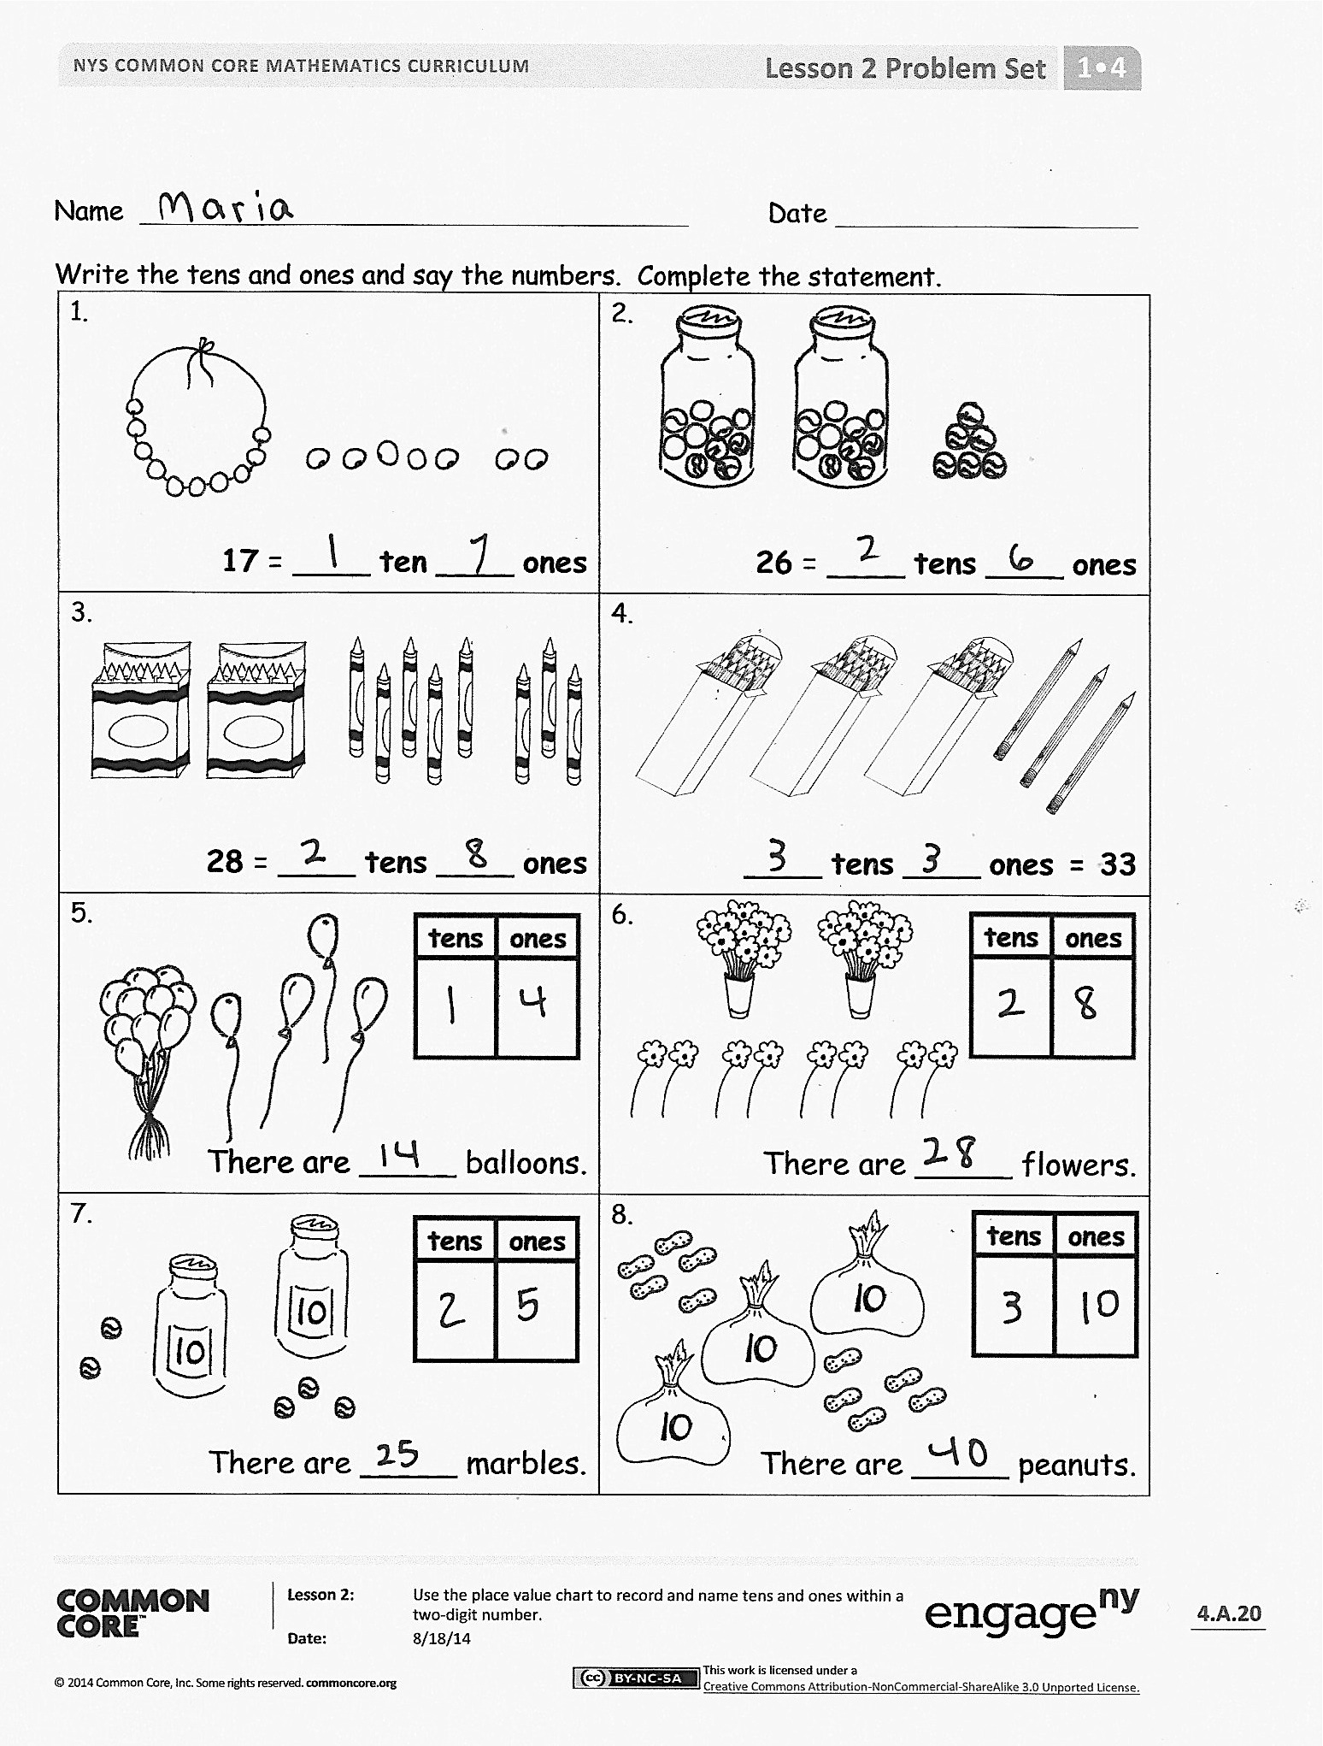
Student Debrief (10 minutes)
Lesson Objective: Use the place value chart to record and name tens and ones within a two-digit number.
The Student Debrief is intended to invite reflection and active processing of the total lesson experience.
Invite students to review their solutions for the Problem Set. They should check work by comparing answers with a partner before going over answers as a class. Look for misconceptions or misunderstandings that can be addressed in the Debrief. Guide students in a conversation to debrief the Problem Set and process the lesson.
Any combination of the questions below may be used to lead the discussion.
- How many tens and how many ones are in the number 29? What amount is greater—2 tens or 9 ones? Explain your thinking. Use your cubes and your place value chart.
- Look at Problem 18. How did you complete your place value chart? Explain your thinking.
- What new math tool did we use to show how many tens and ones are in a number? (Place value chart.) How does the place value chart help us? (It helps us see numbers taken apart into tens and ones.)
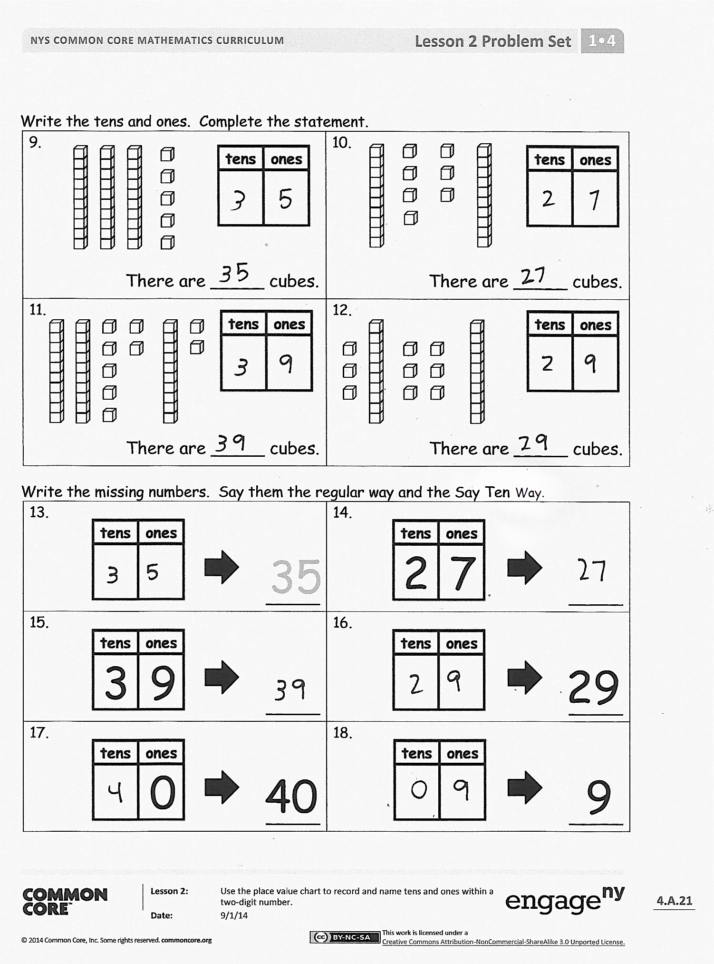
- How did the Application Problem connect to today’s lesson? How would you write the answer in a place value chart?

Exit Ticket (3 minutes)
After the Student Debrief, instruct students to complete the Exit Ticket. A review of their work will help with assessing students’ understanding of the concepts that were presented in today’s lesson and planning more effectively for future lessons. The questions may be read aloud to the students.
Name Date

Core Addition Fluency Review
1. | 2 + 0 = ___ | 16. | 1 + 6 = ___ | 31. | 5 + 3 = ___
2. | 2 + 1 = ___ | 17. | 6 + 1 = ___ | 32. | 3 + 5 = ___
3. | 2 + 2 = ___ | 18. | 6 + 2 = ___ | 33. | 3 + 4 = ___
4. | 4 + 0 = ___ | 19. | 5 + 2 = ___ | 34. | 3 + 3 = ___
5. | 0 + 4 = ___ | 20. | 4 + 3 = ___ | 35. | 4 + 4 = ___
6. | 0 + 3 = ___ | 21. | 2 + 3 = ___ | 36. | 5 + 4 = ___
7. | 0 + 0 = ___ | 22. | 2 + 4 = ___ | 37. | 4 + 6 = ___
8. | 3 + 1 = ___ | 23. | 4 + 2 = ___ | 38. | 2 + 7 = ___
9. | 1 + 3 = ___ | 24. | 3 + 2 = ___ | 39. | 2 + 8 = ___
10. | 1 + 4 = ___ | 25. | 9 + 1 = ___ | 40. | 2 + 5 = ___
11. | 1 + 5 = ___ | 26. | 8 + 2 = ___ | 41. | 5 + 5 = ___
12. | 5 + 1 = ___ | 27. | 7 + 2 = ___ | 42. | 4 + 5 = ___
13. | 1 + 7 = ___ | 28. | 7 + 3 = ___ | 43. | 2 + 6 = ___
14. | 7 + 1 = ___ | 29. | 6 + 3 = ___ | 44. | 3 + 6 = ___
15. | 1 + 8 = ___ | 30. | 6 + 4 = ___ | 45. | 3 + 7 = ___

Name Date
Write the tens and ones and say the numbers. Complete the statement.
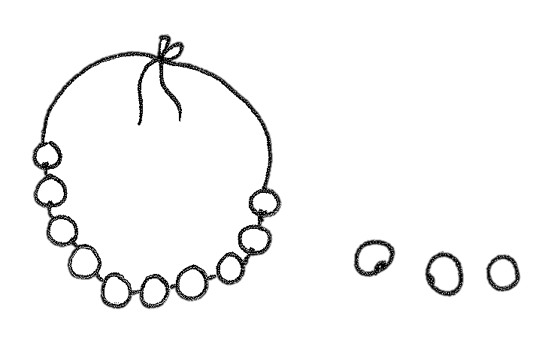  1.  17 = ____ ten ____ ones | 2.  26 = ____ tens ____ ones
3.  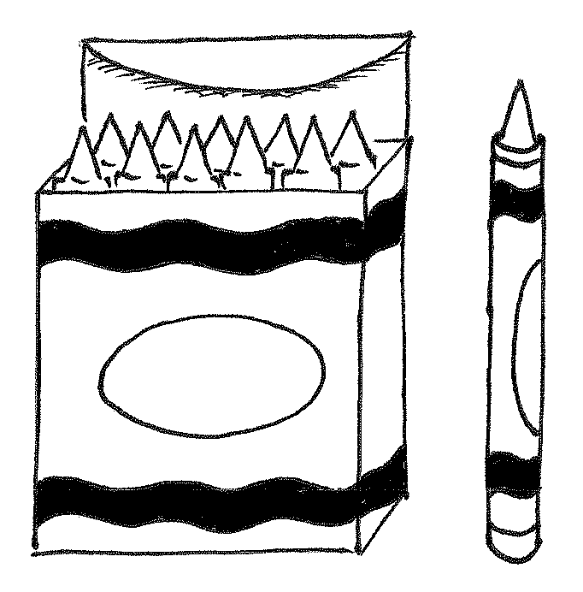  28 = ____ tens ____ ones | 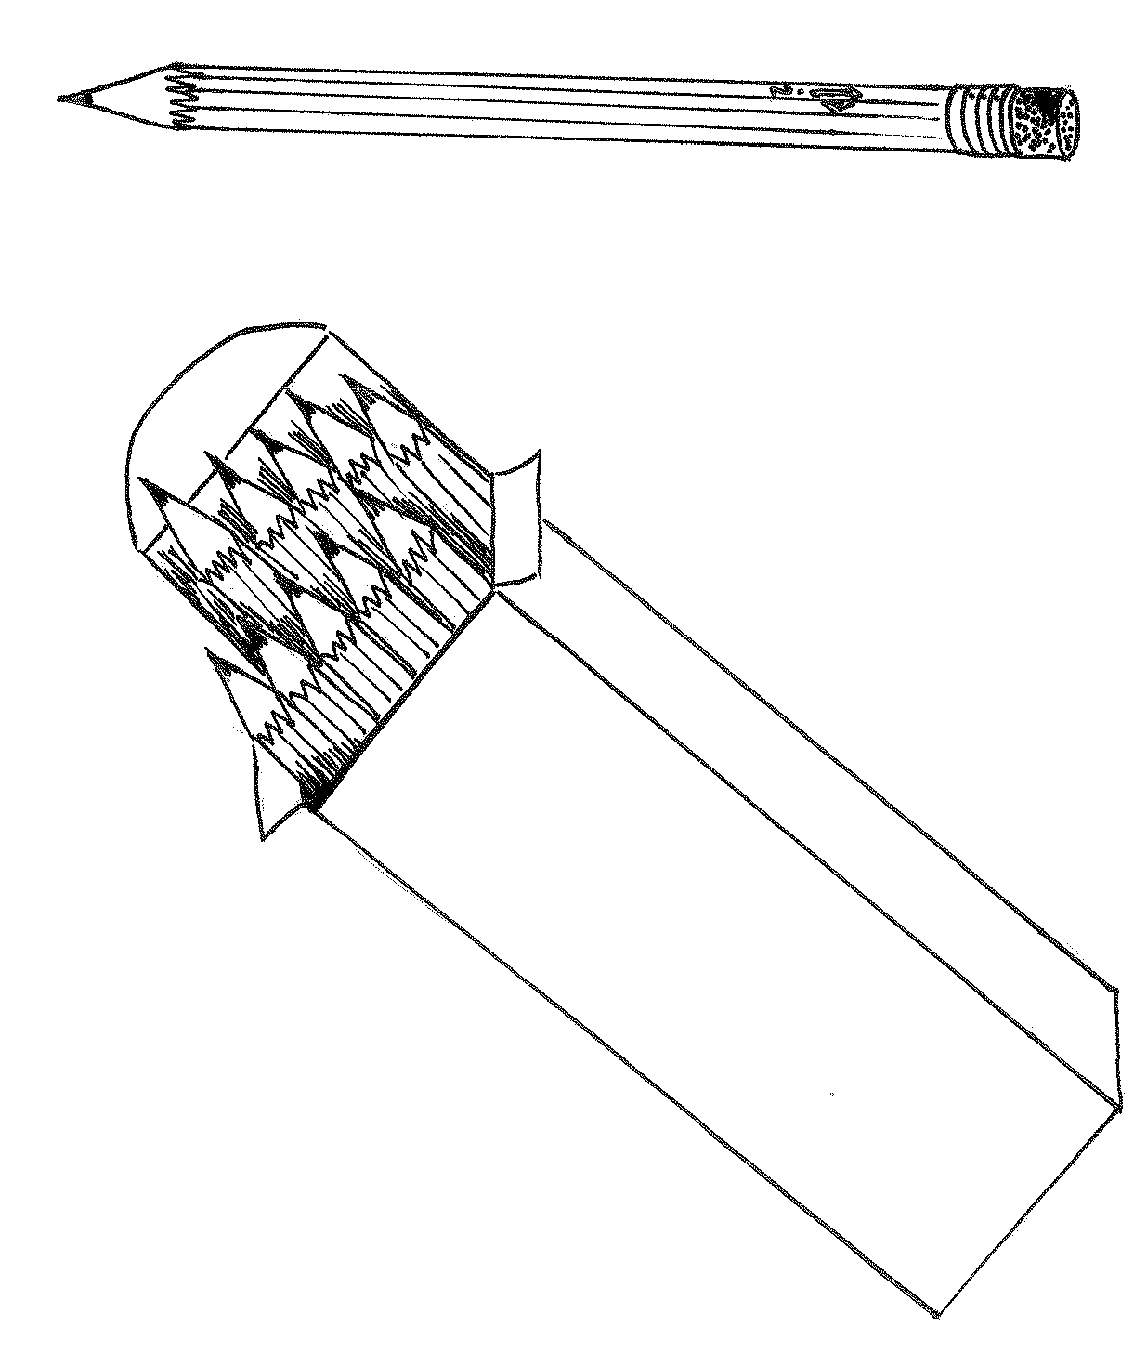  4.  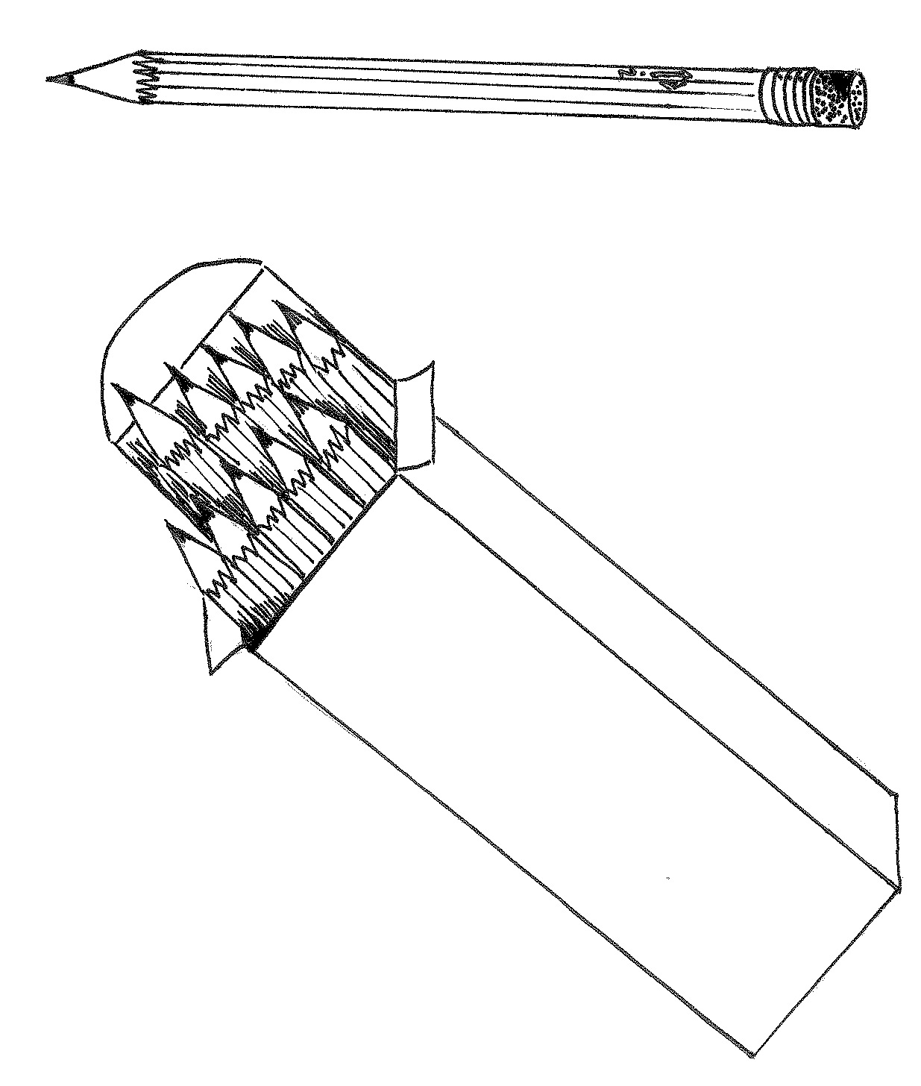  ____ tens ____ ones = 33
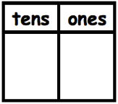  5.  There are _____ balloons. | 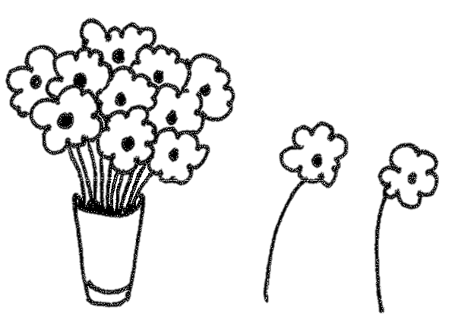  6.  There are _____ flowers.
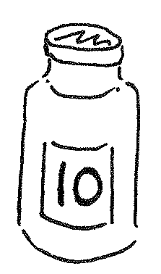  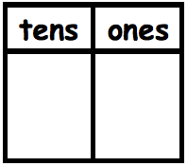  7.  There are _____ marbles. | 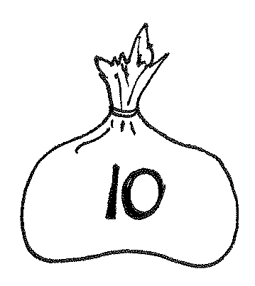  8.  There are _____ peanuts.
Write the tens and ones. Complete the statement.
9.  There are _____ cubes. | 10.  There are _____ cubes.
11.  There are _____ cubes. | 12.  There are _____ cubes.
Write the missing numbers. Say them the regular way and the Say Ten Way.
13.  35  _____ | 14.  2  7  _____
15.  3  9  _____ | 16.  29  _____
17.  40  0  _____ | 18.  9  _____

Name Date

Match the picture to the place value chart that shows the correct tens and ones.
4
0
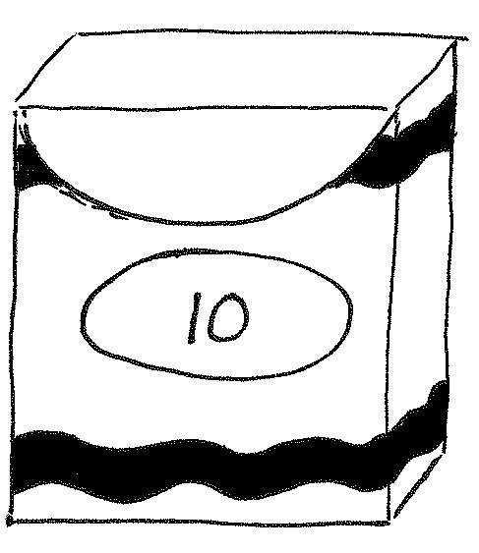
1
7
3
3
Name Date
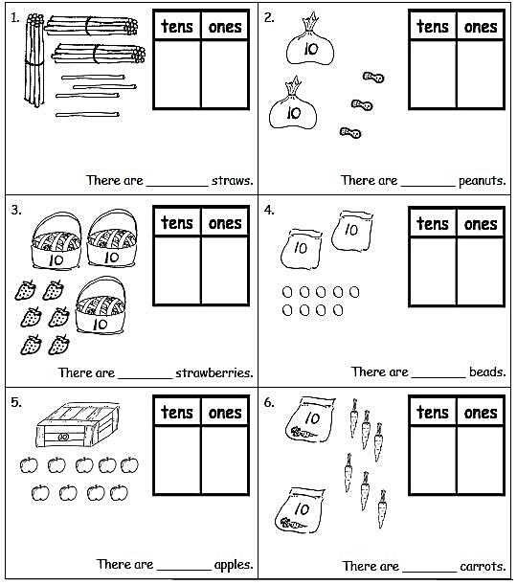
Write the tens and ones and complete the statement.
Write the tens and ones. Complete the statement.
7.  There are _____ cubes. | 8.  There are _____ cubes.
9.  There are _____ cubes. | 10.  There are _____ cubes.
Write the missing numbers. Say them the regular way and the Say Ten Way.
11.  23  _____ | 12.  3  2  _____
13.  0  9  _____ | 14.  29  4  0  _____
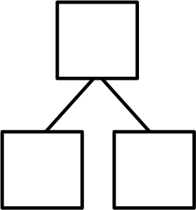
- Choose a number less than 40. Make a math drawing to represent it and fill in the number bond and place value chart.
0 | 1 | 2 | 3
4 | 5 | 6 | 7
8 | 9

 |  | 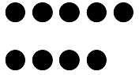 | 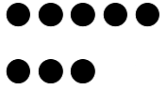

1 | 0 | 2 | 0
3 | 0 | 4 | 0

tens | ones

hide zero cards, numeral side of ones digits (copy double-sided with next page.)
hide zero cards, dot side of ones digits (copy double-sided with previous page.)
hide zero cards, numeral side of tens digits, 10–40 (copy double-sided with next page.)
hide zero cards, dot side of tens digits, 10–40 (copy double-sided with previous page.)
place value chart

