Lesson 1
Objective: Compare the efficiency of counting by ones and counting by tens.

Suggested Lesson Structure
 Fluency Practice (10 minutes)
 Application Problem (5 minutes)
 Concept Development (35 minutes)
 Student Debrief (10 minutes)
Total Time (60 minutes)

Fluency Practice (10 minutes)
- Break Apart Numbers 1.OA.6 (4 minutes)
- Change 10 Pennies for 1 Dime 1.NBT.2 (4 minutes)
- Happy Counting by Tens 1.NBT.5 (2 minutes)

Break Apart Numbers (4 minutes)
Materials: (S) Personal white board, break apart numbers (Fluency Template)
Note: This fluency activity reviews decomposing numbers 5–9 and supports Grade 1’s required fluency of adding and subtracting within 10. It is an essential skill to apply the Level 3 addition strategy of making ten.
If students struggle with this activity, consider repeating it in lieu of some of the fluency activities that provide practice with numbers to 20 and beyond.
Students complete as many different number bonds as they can in one minute. Take a poll of how many students completed all decompositions for 5, 6, etc., and celebrate accomplishments.

Change 10 Pennies for 1 Dime (4 minutes)

Materials: (T) 10 pennies, 1 dime (S) 10 pennies and 1 dime per pair
Note: This activity helps students understand that 10 cents is equal to 1 dime, just as 10 ones are equal to
1 ten. This fluency activity is necessary to prepare students for utilizing coins as abstract units that represent tens and ones in G1–M1–Lesson 6.
Lay out 10 pennies into 5-groups as students count (1 cent, 2 cents, etc.). Make sure students include the unit as they count.
Change the 10 pennies for 1 dime and say, “10 pennies is equal to 10 cents.” Repeat the exact same process, but this time, say, “10 pennies is equal to 1 dime.” Students repeat the activity with a partner.

Happy Counting by Tens (2 minutes)
Note: Reviewing Happy Counting by Tens prepares students to recognize the efficiency of counting groups of 10 in today’s lesson.
Happy Count by Tens the regular way and Say Ten Way from 0 to 120. To really reinforce place value, try alternating between counting the regular way and the Say Ten Way.
T:
T/S: 0 10 20 (pause) 10 0 (pause) 10 20 30 (etc.)

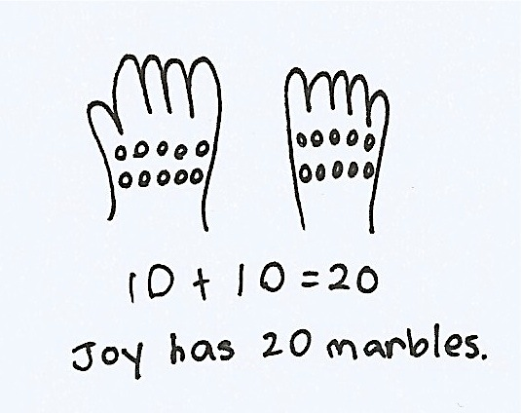
Application Problem (5 minutes)
Joy is holding 10 marbles in 1 hand and 10 marbles in the other hand. How many marbles does she have in all?
Note: This problem applies a doubles fact that is familiar to most students. Circulate and notice students who may need to count on to add the 2 tens. During the Debrief, students will relate the Application Problem to the efficiency of counting by tens instead of counting by ones.

Concept Development (35 minutes)

NOTES ON
MULTIPLE MEANS
OF REPRESENTATION:
As students count, circulate and observe their counting levels. Not all students may be able to switch between counting ones and tens. Take some extra time with the students who need to practice counting these patterns. Play some counting games with the linking cubes. If preferred, send home some counting activities for these students.

Materials: (T) 40 linking cubes (2 colors, 20 of each), projector (S) Resealable plastic bag with 40 separated linking cubes (2 colors, 20 of each), personal white board
Note: When preparing these bags, be sure to use the same two colors for every partner pair. In the later lessons, partners combine their cubes to represent numbers greater than 20 with a single color. In this lesson, students may choose to count by twos and fives, although this is not a Grade 1 standard.
Students sit at their tables with their bags of linking cubes.
T: You will make your own math toolkit today! Look in your bag. How many cubes do you think are in your bag?
S: (Look in bag and make a prediction.)
T: Wow, there are a lot of cubes in our bags. What do you think is the best way to count them?
S: Count by ones. Don’t count by ones. There are too many cubes. Count them by twos. We can put them in 5-groups and count by fives. Put them in 5-groups and count them by tens!
T: Arranging these cubes in 5-groups is a great idea! Arrange your cubes, and then count to see how many cubes there are.
As students arrange their linking cubes and count, circulate, taking note of students’ methods.
T: How many linking cubes did you count?
S: 40 linking cubes.
T: Many of you did a great job putting your cubes in 5-groups and counting by fives or tens. Let’s count by ones to make sure we have 40 cubes.
T/S: (Count by ones.)
T: Now, let’s count them by tens by making them into sticks of 10 cubes. Use the same color cubes for each ten-stick.
S: (Make 4 ten-sticks.)
T: Now that we have these ten-sticks, we can count by…?
S: Tens!
T: Great! Point or move each ten to the side as you count.
S: 10, 20, 30, 40.
T: Did we still count 40 cubes?
S: Yes!
T: No matter how we count, by ones or by tens, we get to the same number. But which way was more efficient to count?
S: Organizing our cubes so we could count by tens was more efficient.
T: Sometimes, when I count by ones and get distracted, I lose count. Then, it takes even longer to count by ones because I have to start over. But if I make tens, I don’t have to start all over again.
T: (Show 12 scattered individual cubes on the projector. Have another scattered set of 12 individual cubes set aside for later.) How can I make these quicker to count?
S: Organize them into 5-groups. Organize them into ten-sticks.
T: Let’s use ten-sticks. (Invite a student volunteer to demonstrate.)
T: Show me this same number of cubes using your own set. Organize them efficiently, like the ones on the board.
S: (Show one stick of 10 and 2 individual cubes.)
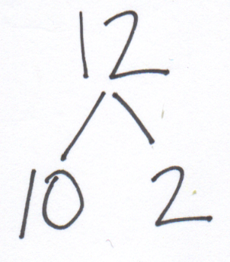
T: (Take out second set of scattered cubes.) Look at the 12 scattered cubes that I have and the 12 cubes you have in front of you. Which makes it easier for you to see 12 quickly?
S: The ones on my desk. The ten-stick and 2 cubes are easier to see 12 quickly.
I don’t even need to count it. I can just see that it’s 12.
T: Let’s make a number bond to show the cubes we grouped and the extra cubes that we added to the grouped cubes. 12 is made of 10 and 2 extra ones.
Repeat the process with 22 scattered cubes. Next, simply call out numbers from 11 to 40 and invite students to show the number using their ten-sticks and extra ones in the suggested sequence: 3 tens 2 ones, 15, 25, 35, 3 tens 7 ones, 1 ten 7 ones, 1 ten 8 ones, 29, and 36.
Each time, have students create a number bond, representing the cubes that were grouped together as tens and the extra ones. Ask student volunteers to show how they counted their cubes to check their work. For example, for 35, one student may count, “10, 20, 30, 31, 32, 33, 34, 35.” Another student may count, “10, 20, 30, and 5 is 35.” Accept different ways of counting the ones, but always guide the students to count the tens first.

NOTES ON
MULTIPLE MEANS
OF REPRESENTATION:
While calling out numbers from 11 to 40 for students to show the number using their ten-sticks, be sure to write the numbers so students can also see them. This helps students who are hearing impaired or visual learners, as well as those who may fall behind while assembling their ten-sticks.
At the end of any lesson using the 40 linking cubes, students should regroup the cubes into 4 ten-sticks and store them in the resealable bag for use during future lessons. These become a part of their math toolkit for Module 4.

Problem Set (10 minutes)
Students should do their personal best to complete the Problem Set within the allotted 10 minutes.
For some classes, it may be appropriate to modify the assignment by specifying which problems students should work on first. With this option, let the purposeful sequencing of the Problem Set guide the selections so that problems continue to be scaffolded. Balance word problems with other problem types to ensure a range of practice. Consider assigning incomplete problems for homework or at another time during the day.

Student Debrief (8 minutes)
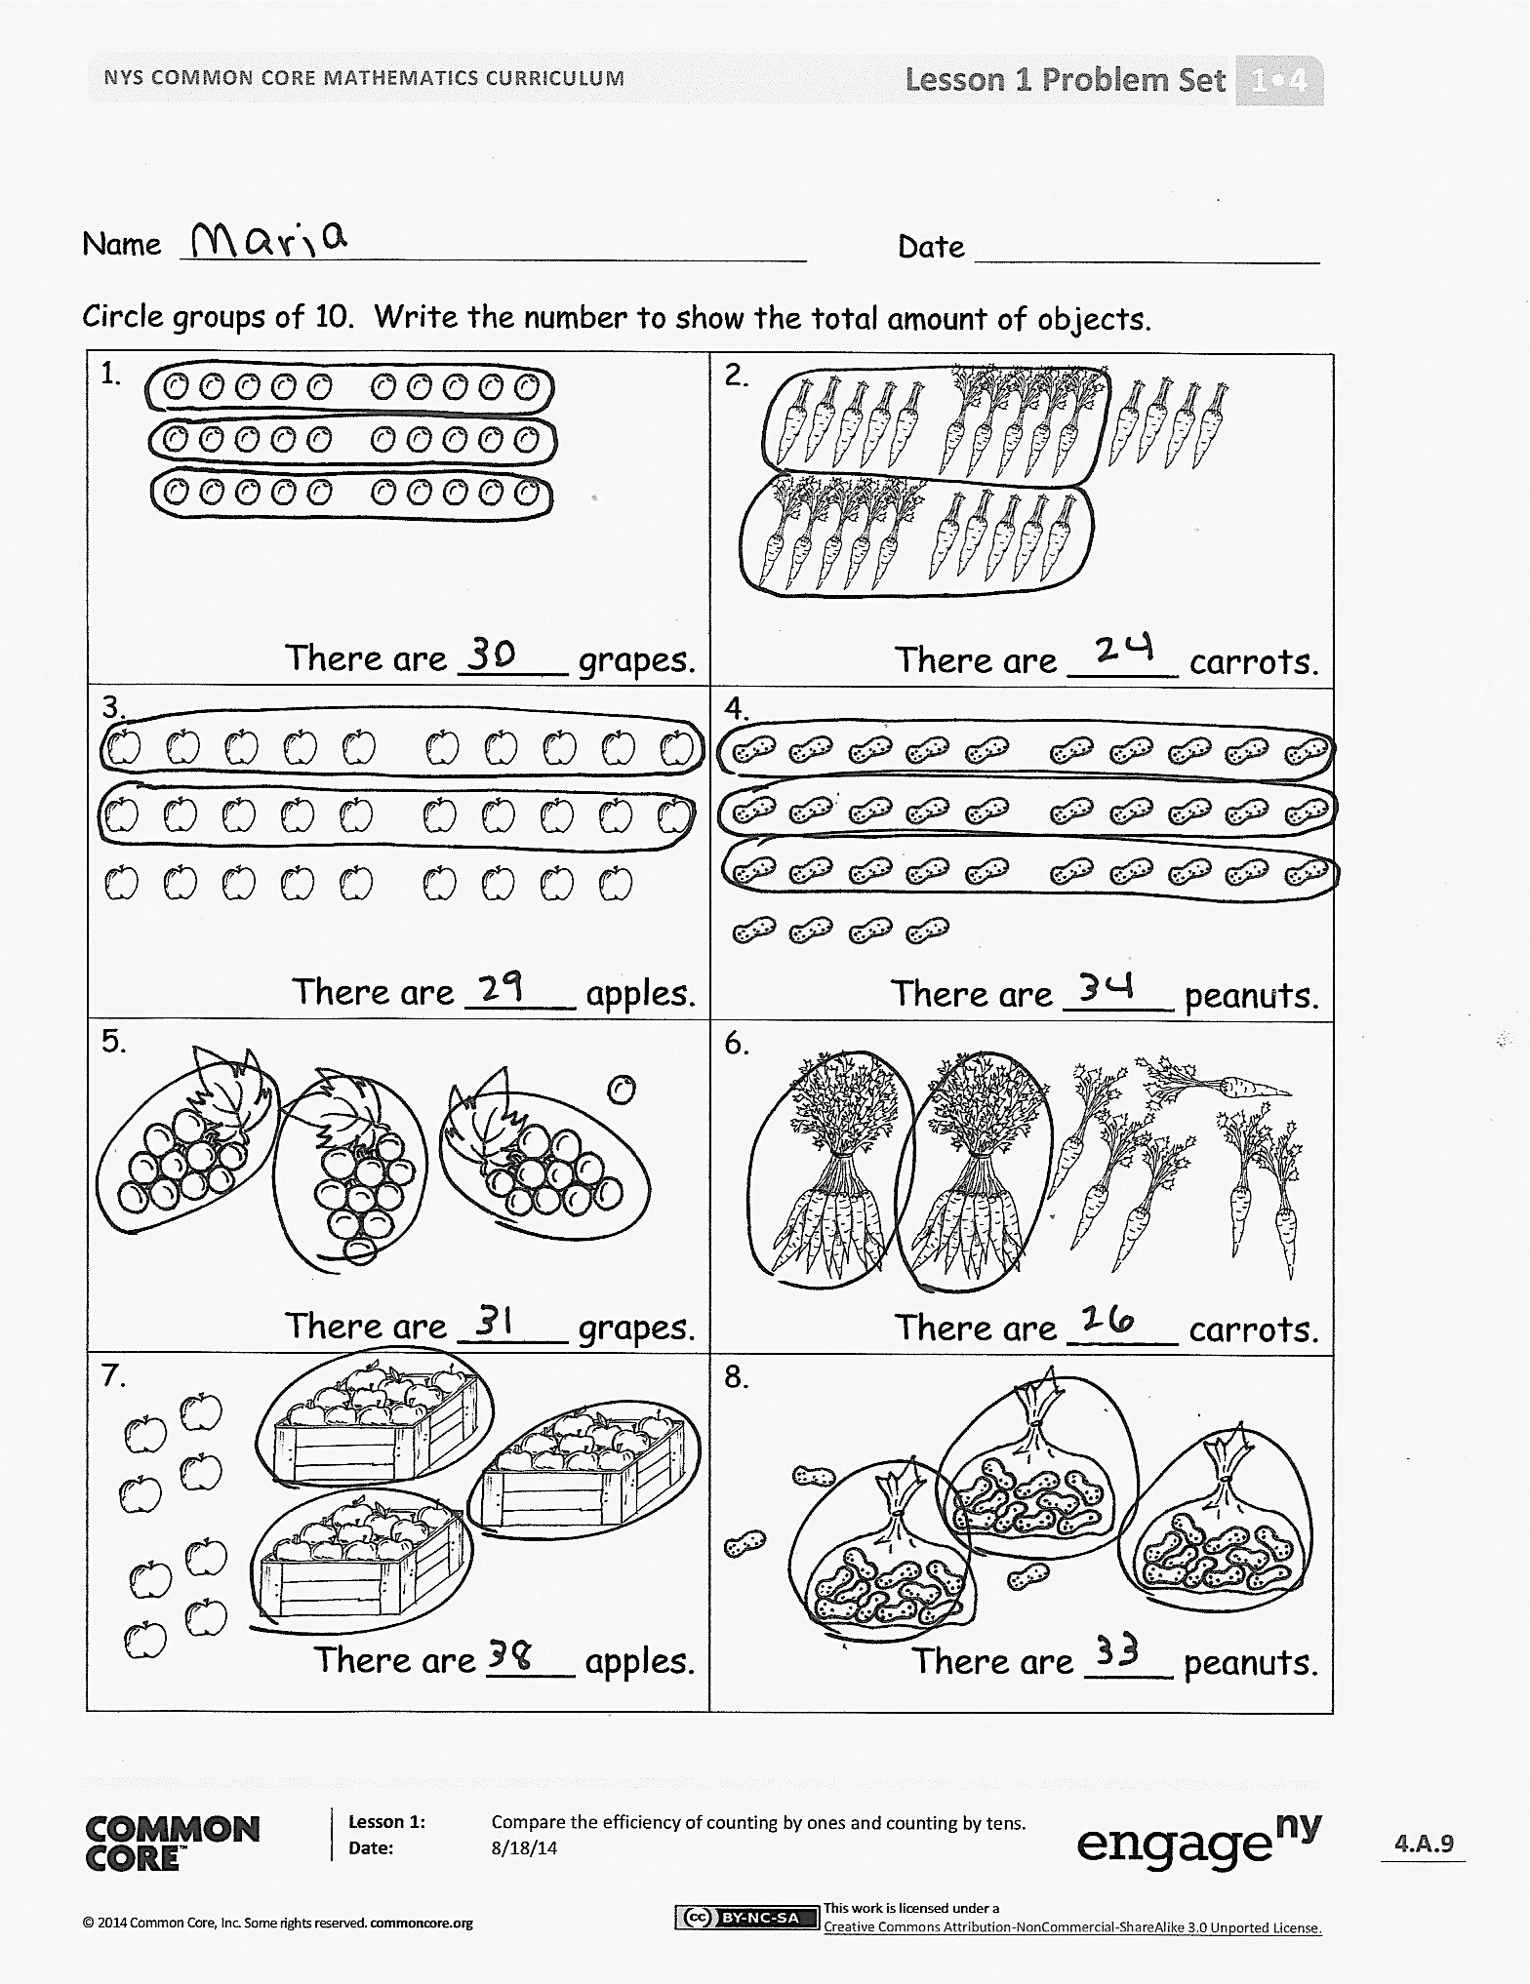
Lesson Objective: Compare the efficiency of counting by ones and counting by tens.
The Student Debrief is intended to invite reflection and active processing of the total lesson experience.
Invite students to review their solutions for the Problem Set. They should check work by comparing answers with a partner before going over answers as a class. Look for misconceptions or misunderstandings that can be addressed in the Debrief. Guide students in a conversation to debrief the Problem Set and process the lesson.
Any combination of the questions below may be used to lead the discussion.
- Compare your answer to Problem 15 with your partner’s. Did you get the same answer? What are the parts of your number bond? Explain your thinking. (Accept any variation that aligns with the picture. For example, students may correctly bond as 20 and 10, or 30 and 0.)
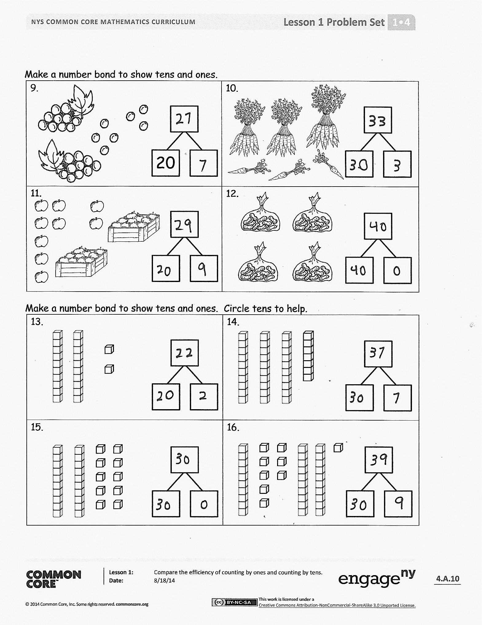
- What did you do to solve Problem 16? (Similar to Problem 15, there may be multiple correct answers.)
- What are the different ways we can group objects to make counting easier?
- How does organizing objects in groups of 10 help us?
- How did the Application Problem connect to today’s lesson?

Exit Ticket (3 minutes)
After the Student Debrief, instruct students to complete the Exit Ticket. A review of their work will help with assessing students’ understanding of the concepts that were presented in today’s lesson and planning more effectively for future lessons. The questions may be read aloud to the students.

Name Date

Circle groups of 10. Write the number to show the total amount of objects.
1.  There are _____ grapes. | 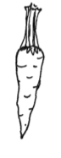  2.  There are _____ carrots.
3.  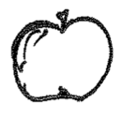  There are _____ apples. | 4.  There are _____ peanuts.
5.  There are _____ grapes. | 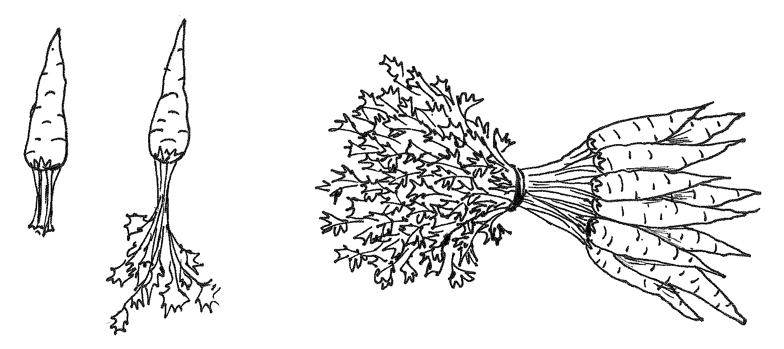  6.  There are _____ carrots.
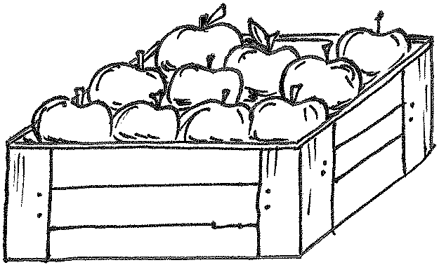  7.  There are ____ apples. | 8.  There are ____ peanuts.
Make a number bond to show tens and ones.
9.  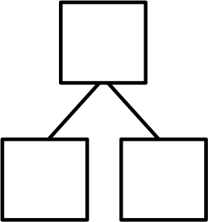  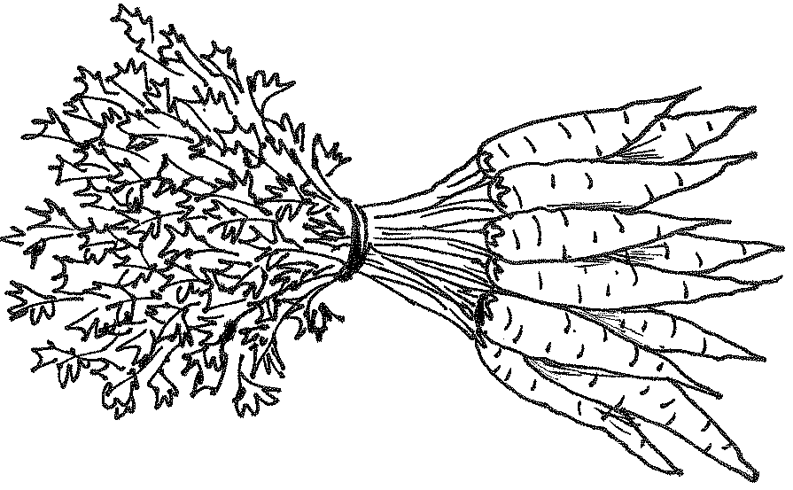  20 | 10.
11. | 12.
Make a number bond to show tens and ones. Circle tens to help.
13. | 14.
15. | 16.

Name Date
Complete the number bonds.
1. | 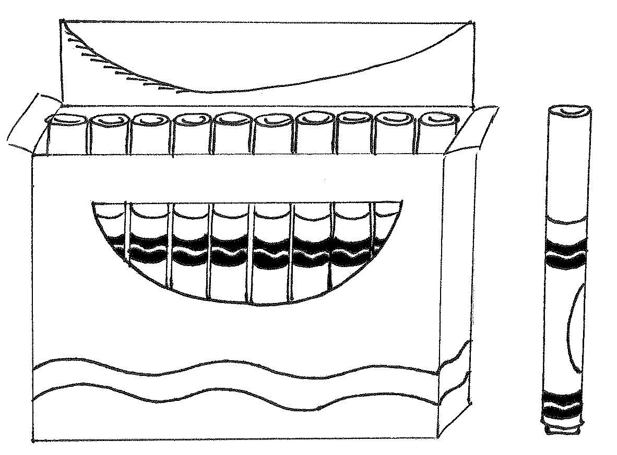  2.
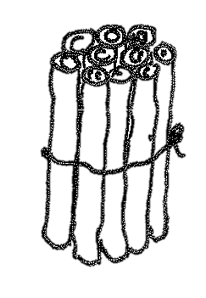  3. | 4.

Name Date

Circle groups of 10. Write the number to show the total amount of objects.
1.  There are _______ marbles. | 2.  There are _______ balloons.
3.  There are _______ straws. | 4.  There are _______ cubes.

Make a number bond to show tens and ones. Circle tens to help. Write the number to show the total amount of objects.
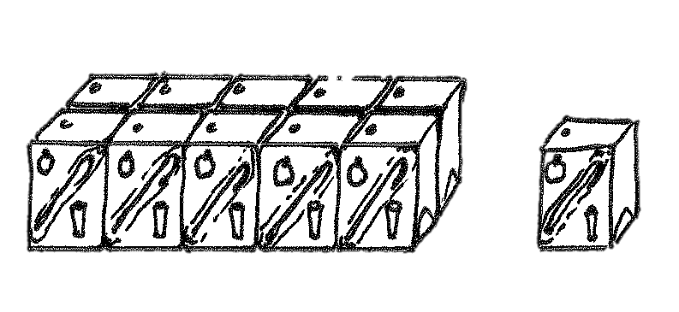  5.  There are _______ juice boxes. | 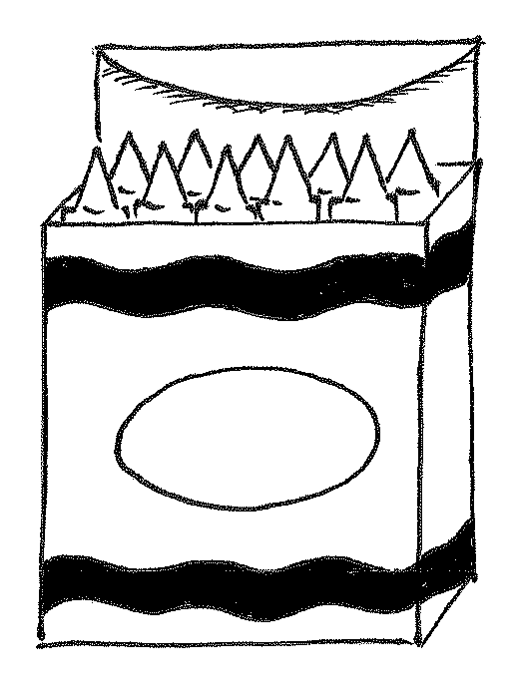  6.  There are _______ crayons.
Make a number bond to show tens and ones. Circle tens to help. Write the number to show the total amount of objects.
7.  There are _______ cubes. | 8.  There are _______ cubes.
9.  There are _______ cubes. | 10.  There are _______ cubes.

Make or complete a math drawing to show tens and ones. Complete the number bonds.
11. 12.
30
3
18
10

9
9
9
9
9
8
8
8
8
8
7
7
7
7
6
6
6
6
5
5
5

break apart numbers

