Lesson 11: Volume of a Sphere

Classwork
Exercises 1–3
- What is the volume of a cylinder?

- What is the height of the cylinder?

- If $volume\left(sphere\right)=\frac{2}{3}volume(cylinder with same diameter and height)$, what is the formula for the volume of a sphere?

Example 1
Compute the exact volume for the sphere shown below.
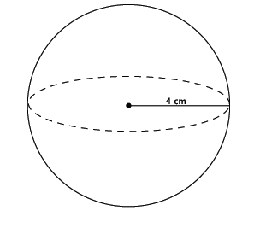

Example 2
A cylinder has a diameter of $16$ inches and a height of $14$ inches. What is the volume of the largest sphere that will fit into the cylinder?
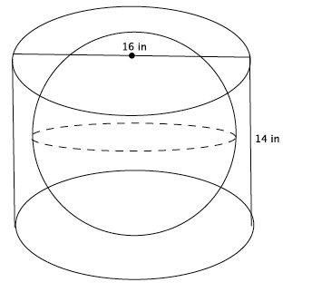

Exercises 4–8
- Use the diagram and the general formula to find the volume of the sphere.
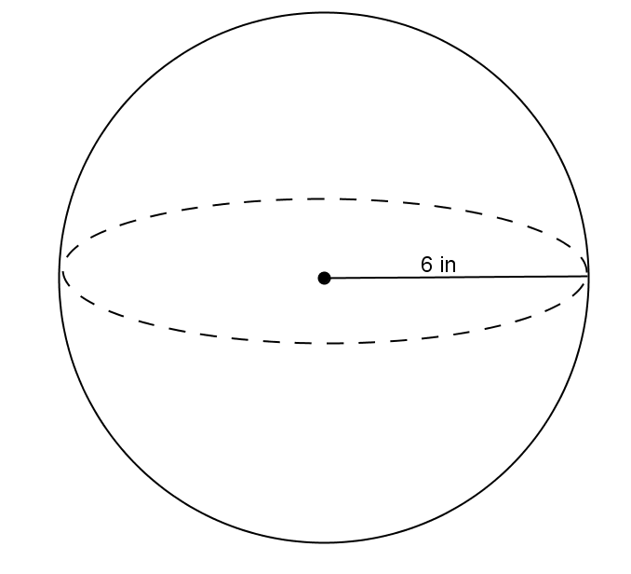

- The average basketball has a diameter of $9.5$ inches. What is the volume of an average basketball? Round your answer to the tenths place.

- A spherical fish tank has a radius of $8$ inches. Assuming the entire tank could be filled with water, what would the volume of the tank be? Round your answer to the tenths place.

- Use the diagram to answer the questions.

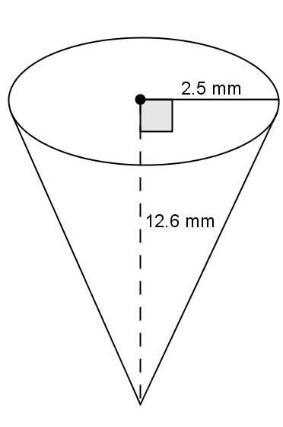
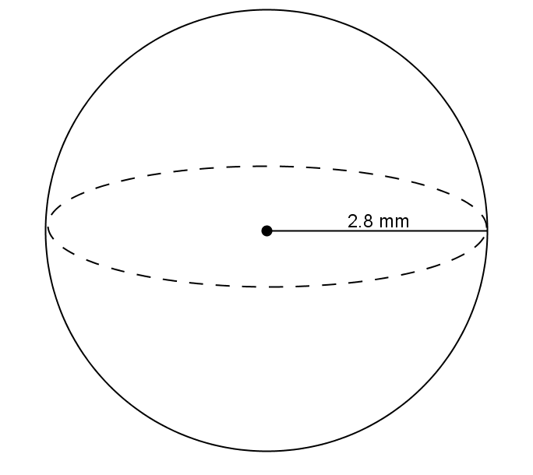

  - Predict which of the figures shown above has the greater volume. Explain.

  - Use the diagram to find the volume of each, and determine which has the greater volume.

- One of two half spheres formed by a plane through the sphere’s center is called a hemisphere. What is the formula for the volume of a hemisphere?
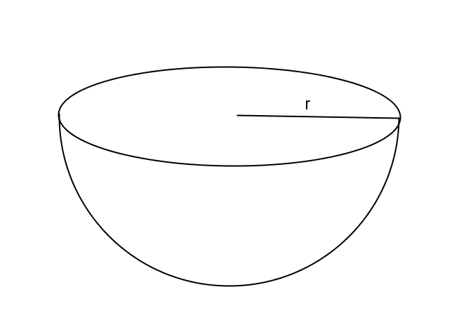

Problem Set
Lesson Summary
The formula to find the volume of a sphere is directly related to that of the right circular cylinder. Given a right circular cylinder with radius $r$ and height $h$, which is equal to $2r$, a sphere with the same radius $r$ has a volume that is exactly two-thirds of the cylinder.
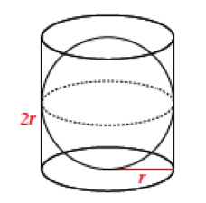
Therefore, the volume of a sphere with radius $r$ has a volume given by the formula $V=\frac{4}{3}πr^{3}$.
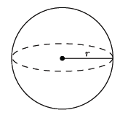
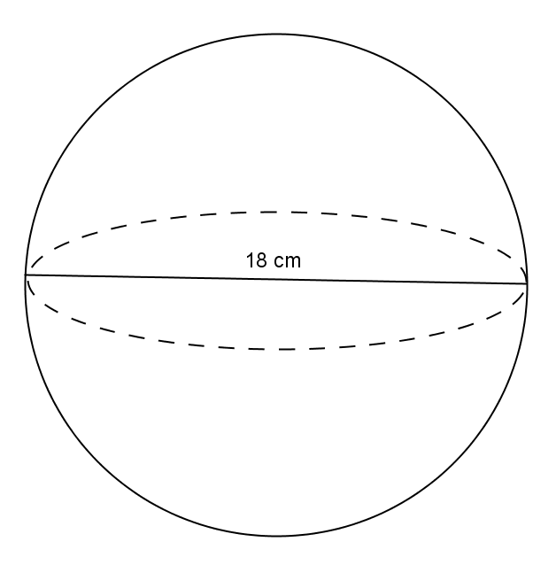
- Use the diagram to find the volume of the sphere.

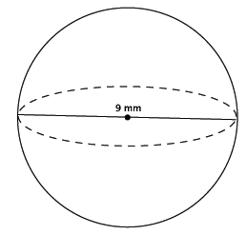
- Determine the volume of a sphere with diameter $9$mm, shown below.

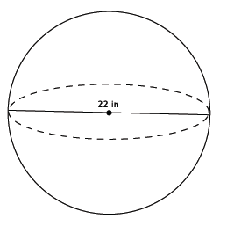
- Determine the volume of a sphere with diameter $22$in., shown below.

- Which of the two figures below has the lesser volume?
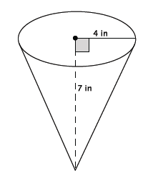
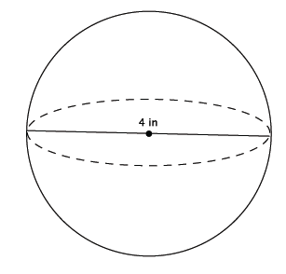

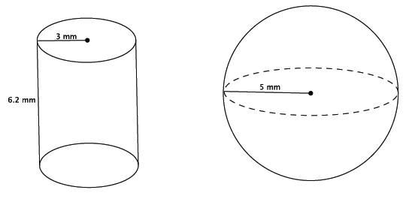
- Which of the two figures below has the greater volume?

- Bridget wants to determine which ice cream option is the best choice. The chart below gives the description and prices for her options. Use the space below each item to record your findings.
$$\$2.00$$ | $$\$3.00$$ | $$\$4.00$$
$1$scoop in a cup | $2$ scoops in a cup | $3$ scoops in a cup
Half a scoop on a cone filled with ice cream |  | A cup filled with ice cream (level to the top of the cup)
A scoop of ice cream is considered a perfect sphere and has a $2$-inch diameter. A cone has a $2$-inch diameter and a height of $4.5$ inches. A cup, considered a right circular cylinder, has a $3$-inch diameter and a height of $2$ inches.
  - Determine the volume of each choice. Use $3.14$ to approximate$π$.
  - Determine which choice is the best value for her money. Explain your reasoning.

