Lesson 11: Volume of a Sphere

Student Outcomes
- Students know the volume formula for a sphere as it relates to a right circular cylinder with the same diameter and height.
- Students apply the formula for the volume of a sphere to real-world and mathematical problems.

Lesson Notes
The demonstrations in this lesson require a sphere (preferably one that can be filled with water, sand, or rice and a right circular cylinder with the same diameter and height as the diameter of the sphere. We want to demonstrate to students that the volume of a sphere is two-thirds the volume of the circumscribing cylinder. If this demonstration is impossible, a video link is included to show a demonstration.

Classwork
Discussion (10 minutes)
Show students pictures of the spheres shown below (or use real objects). Ask the class to come up with a mathematical definition on their own.
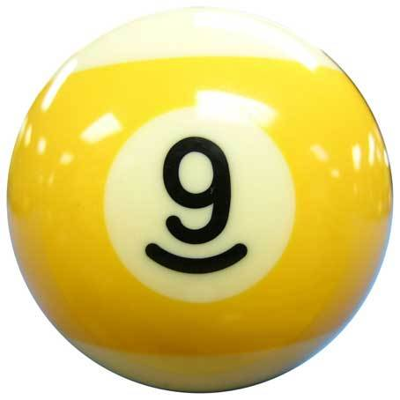
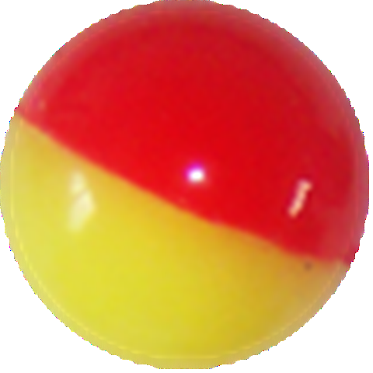
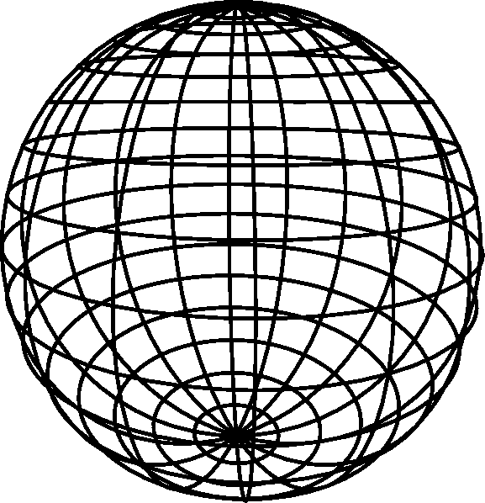
Scaffolding:
Consider using a small bit of clay to represent the center and toothpicks to represent the radius of a sphere.
- Finally, we come to the volume of a sphere of radius $r$. First recall that a sphere of radius$r$ is the set of all the points in three-dimensional space of distance$r$ from a fixed point, called the center of the sphere. So a sphere is, by definition, a surface, or a two-dimensional object. When we talk about the volume of a sphere, we mean the volume of the solid inside this surface.
- The discovery of this formula was a major event in ancient mathematics. The first person to discover the formula was Archimedes (287–212 BC), but it was also independently discovered in China by Zu Chongshi (429–501 AD) and his son Zu Geng (circa 450–520 AD) by essentially the same method. This method has come to be known as Cavalieri’s Principle. Cavalieri (1598–1647) was one of the forerunners of calculus, and he announced the method at a time when he had an audience.

Show students a cylinder. Convince them that the diameter of the sphere is the same as the diameter and the height of the cylinder. Give students time to make a conjecture about how much of the volume of the cylinder is taken up by the sphere. Ask students to share their guesses and their reasoning. Consider having the class vote on the correct answer before proceeding with the discussion.
- The derivation of this formula and its understanding requires advanced mathematics, so we will not derive it at this time.
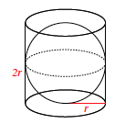
If possible, do a physical demonstration where you can show that the volume of a sphere is exactly $\frac{2}{3}$ the volume of a cylinder with the same diameter and height. You could also show the following $1:17$-minute video: http://www.youtube.com/watch?v=aLyQddyY8ik.
- Based on the demonstration (or video) we can say that:
$Volume\left(sphere\right)=\frac{2}{3}volume(cylinder with same diameter and height of the sphere)$.

Exercises 1–3 (5 minutes)
Students work independently or in pairs using the general formula for the volume of a sphere. Verify that students were able to compute the formula for the volume of a sphere.
MP.2
Exercises 1–3
- What is the volume of a cylinder?
$$V=πr^{2}h$$

- What is the height of the cylinder?
The height of the cylinder is the same as the diameter of the sphere. The diameter is$2r$.

- If $volume\left(sphere\right)=\frac{2}{3}volume(cylinder with same diameter and height)$, what is the formula for the volume of a sphere?
$$Volume(sphere)=\frac{2}{3}(πr^{2}h) \\ Volume(sphere)=\frac{2}{3}(πr^{2}2r) \\ Volume(sphere)=\frac{4}{3}(πr^{3})$$
Example 1 (4 minutes)
- When working with circular two- and three-dimensional figures, we can express our answers in two ways. One is exact and will contain the symbol for pi, $π.$ The other is an approximation, which usually uses $3.14$ for $π.$ Unless noted otherwise, we will have exact answers that contain the pi symbol.
- For Examples 1 and 2, use the formula from Exercise 3 to compute the exact volume for the sphere shown below.

Example 1
Compute the exact volume for the sphere shown below.
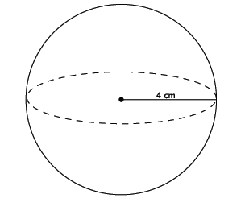

Provide students time to work; then, have them share their solutions.
  - Sample student work:
$$V=\frac{4}{3}πr^{3} \\ =\frac{4}{3}π\left(4^{3}\right) \\ =\frac{4}{3}π\left(64\right) \\ =\frac{256}{3}π \\ =85\frac{1}{3}π$$
The volume of the sphere is $85\frac{1}{3}π {cm}^{3}$.

Example 2 (6 minutes)

Example 2
A cylinder has a diameter of $16$ inches and a height of $14$ inches. What is the volume of the largest sphere that will fit into the cylinder?
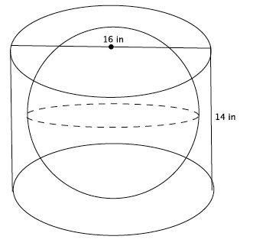

- What is the radius of the base of the cylinder?
  - The radius of the base of the cylinder is $8$ inches.
- Could the sphere have a radius of $8$ inches? Explain.
  - No. If the sphere had a radius of $8$ inches, then it would not fit into the cylinder because the height is only $14$ inches. With a radius of $8$ inches, the sphere would have a height of $2r$, or $16$ inches. Since the cylinder is only $14$ inches high, the radius of the sphere cannot be $8$ inches.
- What size radius for the sphere would fit into the cylinder? Explain.
  - A radius of $7$ inches would fit into the cylinder because $2r$ is $14$, which means the sphere would touch the top and bottom of the cylinder. A radius of $7$ means the radius of the sphere would not touch the sides of the cylinder, but would fit into it.
- Now that we know the radius of the largest sphere is $7$ inches. What is the volume of the sphere?
  - Sample student work:
$$V=\frac{4}{3}πr^{3} \\ =\frac{4}{3}π\left(7^{3}\right) \\ =\frac{4}{3}π\left(343\right) \\ =\frac{1372}{3}π \\ =457\frac{1}{3}π$$
The volume of the sphere is $457\frac{1}{3}π {cm}^{3}.$
Exercises 4–8 (10 minutes)
Students work independently or in pairs to use the general formula for the volume of a sphere.

Exercises 4–8
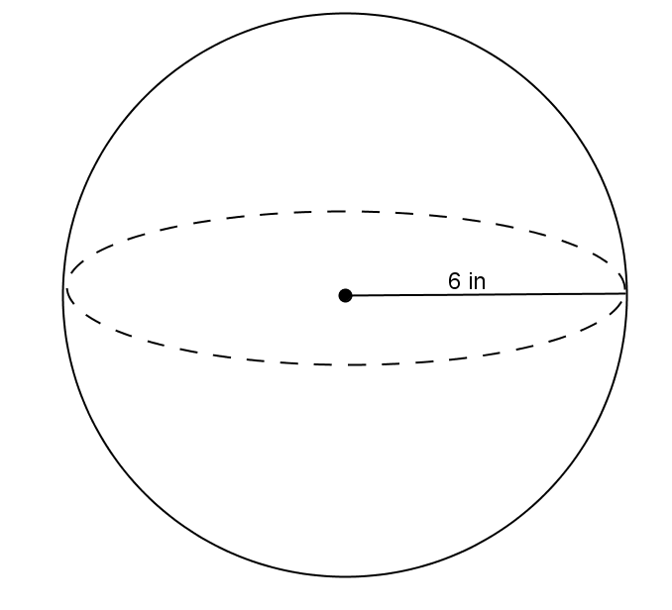
- Use the diagram and the general formula to find the volume of the sphere.
$$V=\frac{4}{3}πr^{3} \\ V=\frac{4}{3}π\left(6^{3}\right) \\ V=288π$$
The volume of the sphere is $288π in^{3}$.

- The average basketball has a diameter of $9.5$ inches. What is the volume of an average basketball? Round your answer to the tenths place.
$$V=\frac{4}{3}πr^{3} \\ V=\frac{4}{3}π\left(4.75^{3}\right) \\ V=\frac{4}{3}π\left(107.17\right) \\ V=142.9π$$
The volume of an average basketball is $142.9π in^{3}$.

- A spherical fish tank has a radius of $8$ inches. Assuming the entire tank could be filled with water, what would the volume of the tank be? Round your answer to the tenths place.
$$V=\frac{4}{3}πr^{3} \\ V=\frac{4}{3}π\left(8^{3}\right) \\ V=\frac{4}{3}π\left(512\right) \\ V=682.7π$$
The volume of the fish tank is $682.7π in^{3}$.

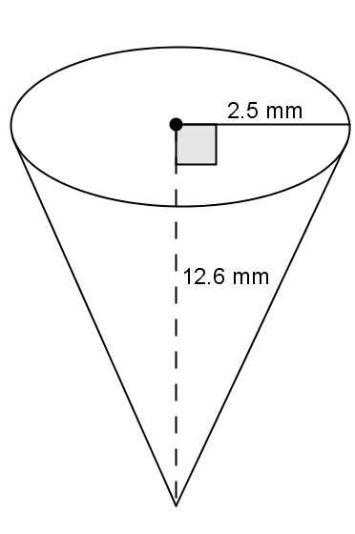
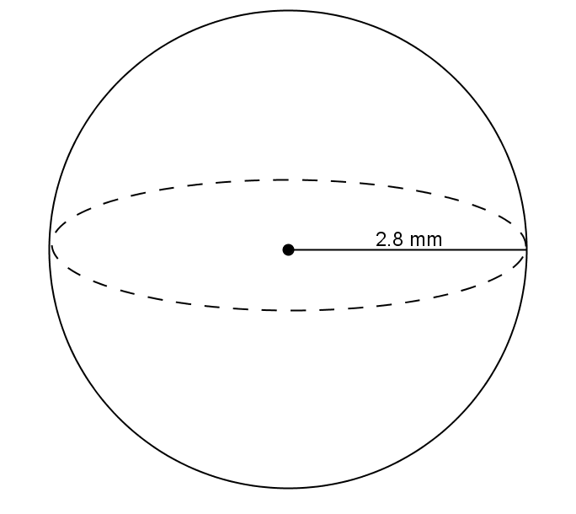
- Use the diagram to answer the questions.

  - Predict which of the figures shown above has the greater volume. Explain.
Student answers will vary. Students will probably say the cone has more volume because it looks larger.

  - Use the diagram to find the volume of each, and determine which has the greater volume.
$$V=\frac{1}{3}πr^{2}h \\ V=\frac{1}{3}π({2.5}^{2})(12.6) \\ V=26.25π$$
The volume of the cone is $26.25π mm^{3}$.
$$V=\frac{4}{3}πr^{3} \\ V=\frac{4}{3}π({2.8}^{3}) \\ V=29.269333….π$$
The volume of the sphere is about $29.27π mm^{3}$. The volume of the sphere is greater than the volume of the cone.

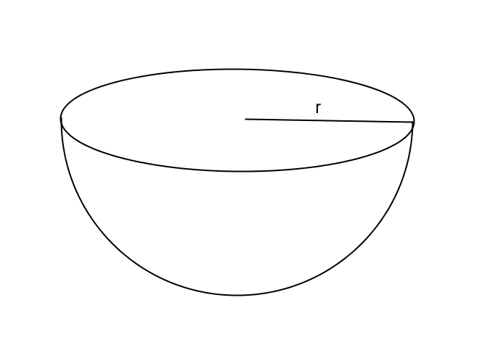
- One of two half spheres formed by a plane through the sphere’s center is called a hemisphere. What is the formula for the volume of a hemisphere?
Since a hemisphere is half a sphere, the $volume\left(hemisphere\right)=\frac{1}{2}\left(volume of sphere\right).$
$$V=\frac{1}{2}\left(\frac{4}{3}πr^{3}\right) \\ V=\frac{2}{3}πr^{3}$$
Closing (5 minutes)
Summarize, or ask students to summarize, the main points from the lesson:
- Students know the volume formula for a sphere with relation to a right circular cylinder.
- Students know the volume formula for a hemisphere.
- Students can apply the volume of a sphere to solve mathematical problems.
Lesson Summary
The formula to find the volume of a sphere is directly related to that of the right circular cylinder. Given a right circular cylinder with radius $r$ and height $h$, which is equal to $2r$, a sphere with the same radius $r$ has a volume that is exactly two-thirds of the cylinder.
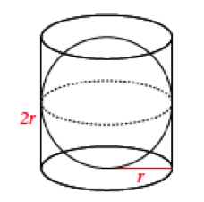
Therefore, the volume of a sphere with radius $r$ has a volume given by the formula $V=\frac{4}{3}πr^{3}$.
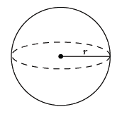

Exit Ticket (5 minutes)
Name Date
Lesson 11: Volume of a Sphere

Exit Ticket

- What is the volume of the sphere shown below?
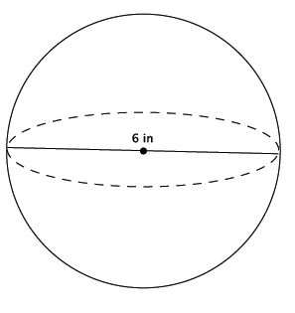

- Which of the two figures below has the greater volume?
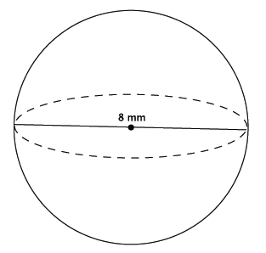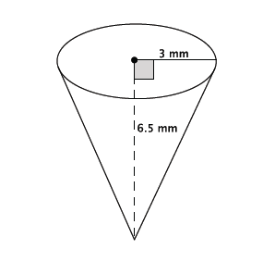

Exit Ticket Sample Solutions

- What is the volume of the sphere shown below?
$$V=\frac{4}{3}πr^{3} \\ =\frac{4}{3}π\left(3^{3}\right) \\ =\frac{108}{3}π \\ =36π$$
The volume of the sphere is $36π in^{3}$.

- Which of the two figures below has the greater volume?

$$V=\frac{4}{3}πr^{3} \\ =\frac{4}{3}π\left(4^{3}\right) \\ =\frac{256}{3}π \\ =85\frac{1}{3}π$$
The volume of the sphere is $85\frac{1}{3}π mm^{3}$.
$$V=\frac{1}{3}πr^{2}h \\ =\frac{1}{3}π\left(3^{2}\right)\left(6.5\right) \\ =\frac{58.5}{3}π \\ =19.5π$$
The volume of the cone is $19.5π mm^{3}$. The sphere has the greater volume.

Problem Set Sample Solutions

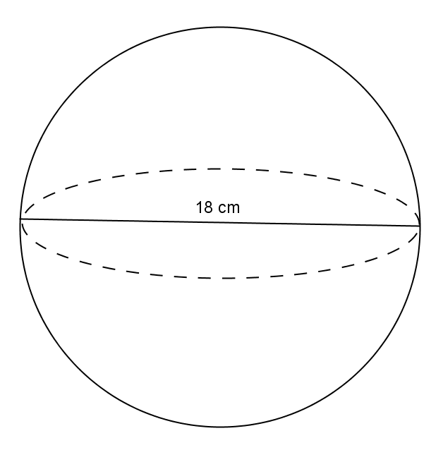
- Use the diagram to find the volume of the sphere.

$$V=\frac{4}{3}πr^{3} \\ V=\frac{4}{3}π(9^{3}) \\ V=972π$$
The volume of the sphere is $972π cm^{3}$.

- Determine the volume of a sphere with diameter $9 mm$, shown below.
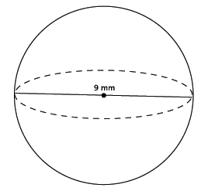
$$V=\frac{4}{3}πr^{3} \\ =\frac{4}{3}π\left({4.5}^{3}\right) \\ =\frac{364.5}{3}π \\ =121.5π$$
The volume of the sphere is $121.5π mm^{3}$.

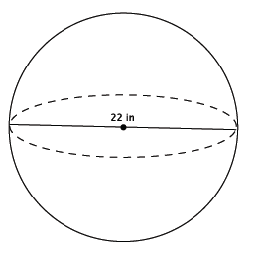
- Determine the volume of a sphere with diameter $in.$, shown below.

$$V=\frac{4}{3}πr^{3} \\ =\frac{4}{3}π\left({11}^{3}\right) \\ =\frac{5324}{3}π \\ =1774\frac{2}{3}π$$
The volume of the sphere is$1774 \frac{2}{3}π in^{3}$.

- Which of the two figures below has the lesser volume?
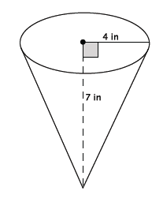 | 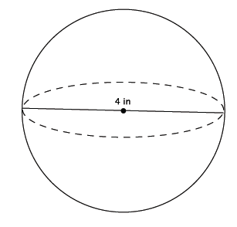
The volume of the cone:  $$V=\frac{1}{3}πr^{2}h \\ =\frac{1}{3}π\left(16\right)\left(7\right) \\ =\frac{112}{3}π \\ =37\frac{1}{3}π {in}^{3}$$ | The volume of the sphere:  $$V=\frac{4}{3}πr^{3} \\ =\frac{4}{3}π\left(2^{3}\right) \\ =\frac{32}{3}π \\ =10\frac{2}{3} π {in}^{3}$$
The sphere has less volume.

- Which of the two figures below has the greater volume?
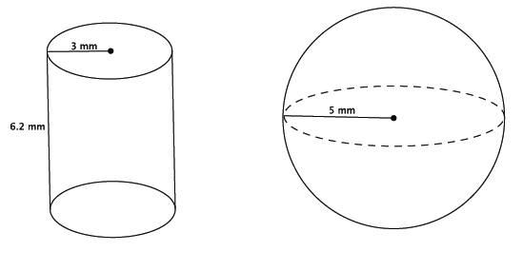
The volume of the cylinder:  $$V=πr^{2}h \\ =π\left(3^{2}\right)\left(6.2\right) \\ =55.8π {mm}^{3}$$ | The volume of the sphere:  $$V=\frac{4}{3}πr^{3} \\ =\frac{4}{3}π\left(5^{3}\right) \\ =\frac{500}{3}π \\ =166\frac{2}{3}π {mm}^{3}$$
The sphere has the greater volume.

- Bridget wants to determine which ice cream option is the best choice. The chart below gives the description and prices for her options. Use the space below each item to record your findings.
$$\$2.00$$ | $$\$3.00$$ | $$\$4.00$$
One scoop in a cup | Two scoops in a cup | Three scoops in a cup
$$V≈4.19 in^{3}$$ | $$V≈8.37 in^{3}$$ | $$V≈12.56 in^{3}$$
Half a scoop on a cone filled with ice cream |  | A cup filled with ice cream (level to the top of the cup)
$$V≈6.8 in^{3}$$ |  | $$V≈14.13 in^{3}$$
A scoop of ice cream is considered a perfect sphere and has a $2$-inch diameter. A cone has a $2$-inch diameter and a height of $4.5$ inches. A cup, considered a right circular cylinder, has a $3$-inch diameter and a height of $2$ inches.
  - Determine the volume of each choice. Use $3.14$ to approximate$π$.
First, find the volume of one scoop of ice cream.
$$Volume of one scoop=\frac{4}{3}π{(1}^{3})$$
The volume of one scoop of ice cream is $\frac{4}{3}π$ $in^{3}$, or approximately $4.19 in^{3}$.
The volume of two scoops of ice cream is $\frac{8}{3}π$ $in^{3}$, or approximately $8.37 in^{3}$.
The volume of three scoops of ice cream is $\frac{12}{3}π in^{3}$, or approximately $12.56 in^{3}$.
$$Volume of half scoop=\frac{2}{3}π{(1}^{3})$$
The volume of half a scoop of ice cream is $\frac{2}{3}π$ $in^{3}$, or approximately $2.09 in^{3}$.
$$Volume of cone=\frac{1}{3}\left(πr^{2}\right)h \\ V=\frac{1}{3}\left(π1^{2}\right)4.5 \\ V=1.5π$$
The volume of the cone is $1.5π in^{3}$, or approximately$4.71 in^{3}$. Then, the cone with half a scoop of ice cream on top is approximately$6.8 in^{3}$.
$$V=πr^{2}h \\ V=π{1.5}^{2}(2) \\ V=4.5π$$
The volume of the cup is $4.5π in^{3}$, or approximately$14.13 in^{3}$.

  - Determine which choice is the best value for her money. Explain your reasoning.
Student answers may vary.
Checking the cost for every $in^{3}$ of each choice:
$$\frac{2}{4.19}≈0.47723… \\ \frac{2}{6.8}≈0.29411… \\ \frac{3}{8.37}≈0.35842… \\ \frac{4}{12.56}≈0.31847… \\ \frac{4}{14.13}≈0.28308…$$
The best value for her money is the cup filled with ice cream since it costs about $28$ cents for every $in^{3}$.

