Lesson 10: Volumes of Familiar Solids—Cones and Cylinders

Classwork
Opening Exercise

    - Write an equation to determine the volume of the rectangular prism shown below.
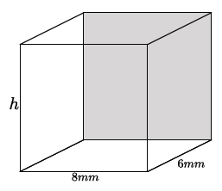

    - Write an equation to determine the volume of the rectangular prism shown below.
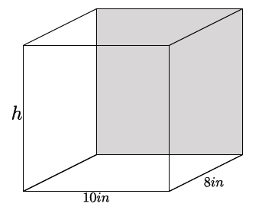

    - Write an equation to determine the volume of the rectangular prism shown below.
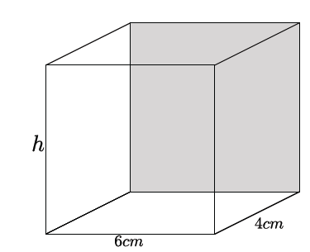

    - Write an equation for volume, $V$, in terms of the area of the base, $B.$

  - Using what you learned in part (a), write an equation to determine the volume of the cylinder shown below.
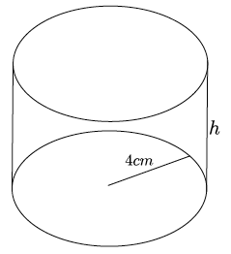

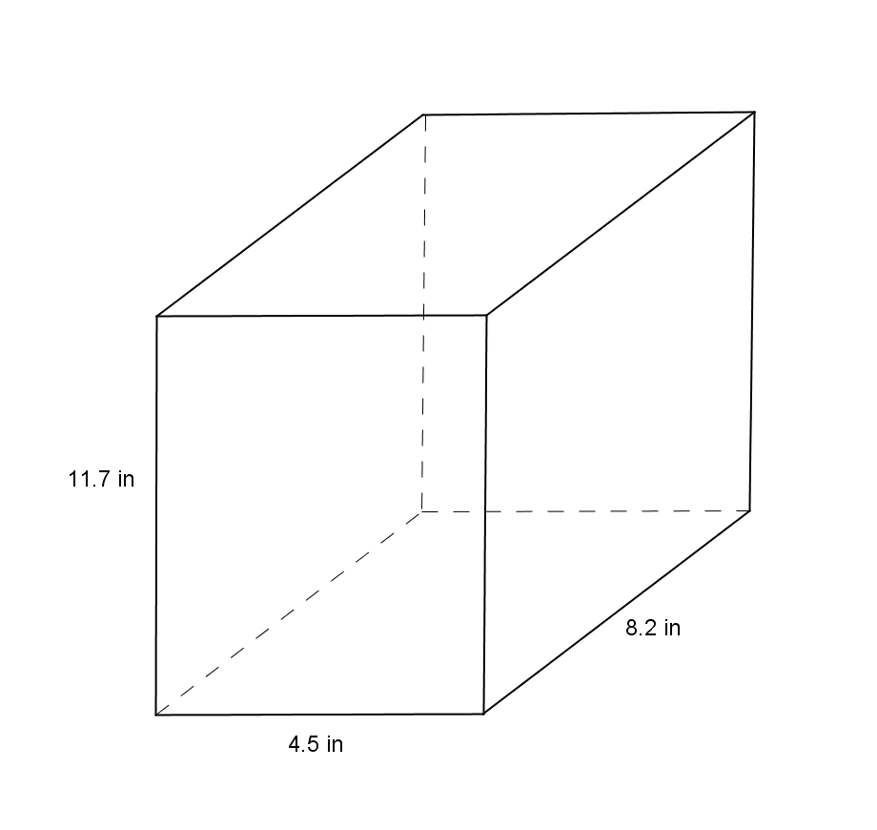
Exercises 1–6
- Use the diagram at right to answer the questions.
  - What is the area of the base?

  - What is the height?

  - What is the volume of the rectangular prism?

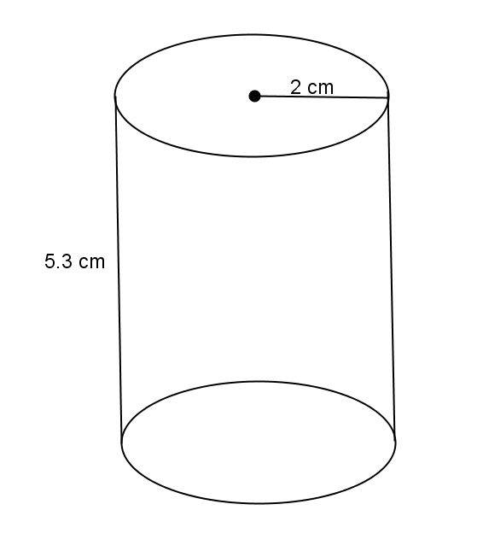
- Use the diagram at right to answer the questions.
  - What is the area of the base?

  - What is the height?

  - What is the volume of the right circular cylinder?

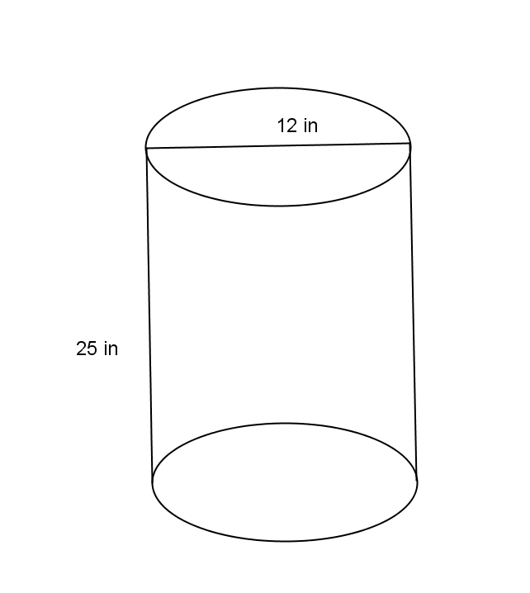
- Use the diagram at right to answer the questions.
  - What is the area of the base?

  - What is the height?

  - What is the volume of the right circular cylinder?

- Use the diagram to find the volume of the right circular cone.
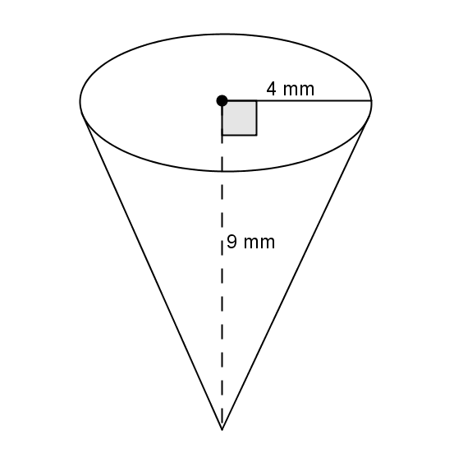

- Use the diagram to find the volume of the right circular cone.
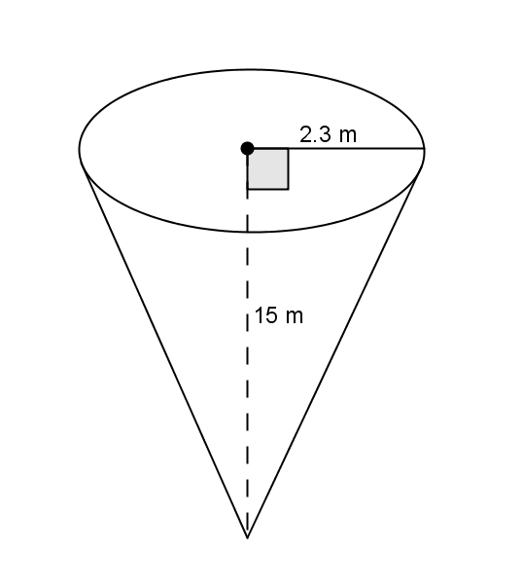

- Challenge: A container in the shape of a right circular cone has height $h$, and base of radius $r$, as shown. It is filled with water (in its upright position) to half the height. Assume that the surface of the water is parallel to the base of the inverted cone. Use the diagram to answer the following questions:
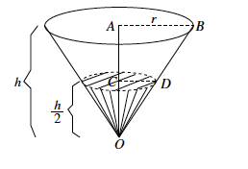
  - What do we know about the lengths of $AB$ and $AO$?

  - What do we know about the measure of $∠OAB$ and $∠OCD$?

  - What can you say about $ΔOAB$and $ΔOCD$?

  - What is the ratio of the volume of water to the volume of the container itself?

Problem Set
Lesson Summary
The formula to find the volume, $V$, of a right circular cylinder is $V=πr^{2}h=Bh$, where $B$ is the area of the base.
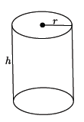
The formula to find the volume of a cone is directly related to that of the cylinder. Given a right circular cylinder with radius $r$ and height $h,$ the volume of a cone with those same dimensions is one-third of the cylinder. The formula for the volume, $V,$ of a cone is $V=\frac{1}{3}πr^{2}h=\frac{1}{3}Bh,$ where $B$ is the area of the base.
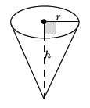
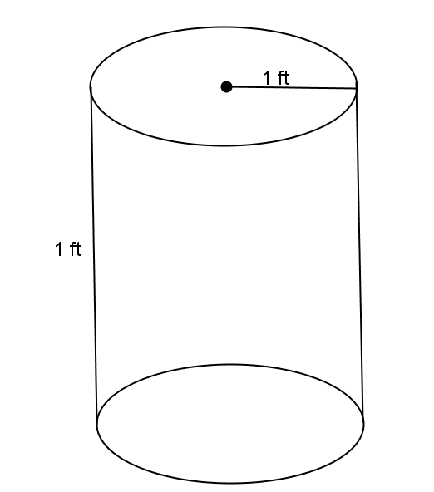
- Use the diagram to help you find the volume of the right circular cylinder.

- Use the diagram to help you find the volume of the right circular cone.
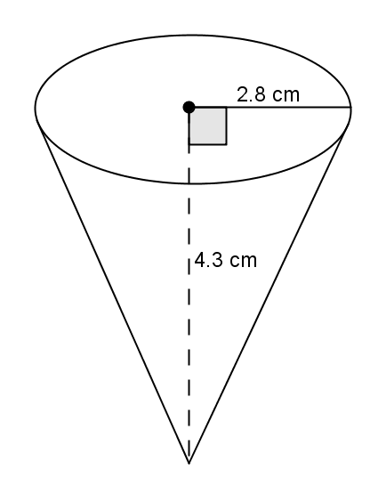

- Use the diagram to help you find the volume of the right circular cylinder.
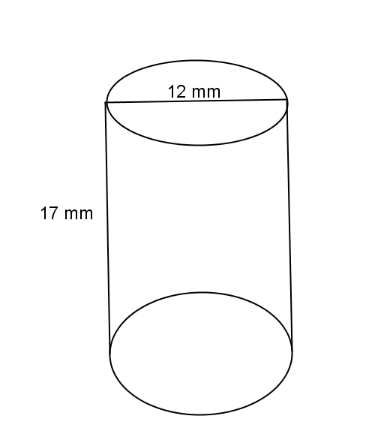

- Use the diagram to help you find the volume of the right circular cone.
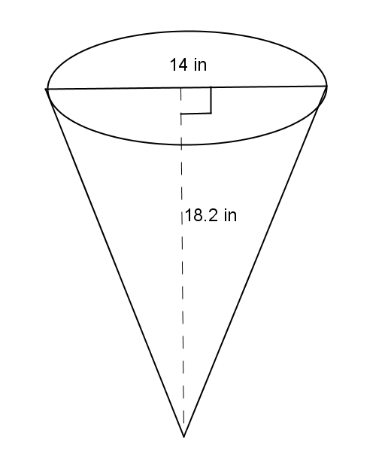

- Oscar wants to fill with water a bucket that is the shape of a right circular cylinder. It has a $6$-inch radius and
$12$-inch height. He uses a shovel that has the shape of right circular cone with a $3$-inch radius and $4$-inch height. How many shovelfuls will it take Oscar to fill the bucket up level with the top?

- A cylindrical tank (with dimensions shown below) contains water that is $1$-foot deep. If water is poured into the tank at a constant rate of $20 \frac{{ft}^{3}}{min}$ for $20$ min., will the tank overflow? Use $3.14$ to estimate $π.$

