Lesson 10: Volumes of Familiar Solids―Cones and Cylinders

Student Outcomes
- Students know the volume formulas for cones and cylinders.
- Students apply the formulas for volume to real-world and mathematical problems.

Lesson Notes
For the demonstrations in this lesson, you will need a stack of the same-sized note cards, a stack of the same-sized round disks, a cylinder and cone of the same dimensions, and something to fill the cone with (e.g., rice, sand, or water). Demonstrate to students that the volume of a rectangular prism is like finding the sum of the areas of congruent rectangles, stacked one on top of the next. A similar demonstration will be useful for the volume of a cylinder. To demonstrate that the volume of a cone is one-third that of the volume of a cylinder with the same dimension, you will need to fill a cone with rice, sand, or water, and show students that it takes exactly three cones to equal the volume of the cylinder.

Classwork
Opening Exercise (3 minutes)
Students complete the Opening Exercise independently. Revisit the Opening Exercise once the discussion below is finished.

Opening Exercise
MP.1 &
MP.7
    - Write an equation to determine the volume of the rectangular prism shown below.
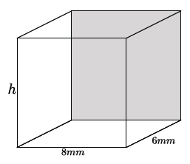
$$V=8\left(6\right)\left(h\right) \\ =48h mm^{3}$$

    - Write an equation to determine the volume of the rectangular prism shown below.
MP.1 &
MP.7
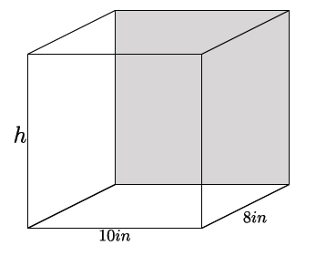
$$V=10\left(8\right)\left(h\right) \\ =80h in^{3}$$

    - Write an equation to determine the volume of the rectangular prism shown below.
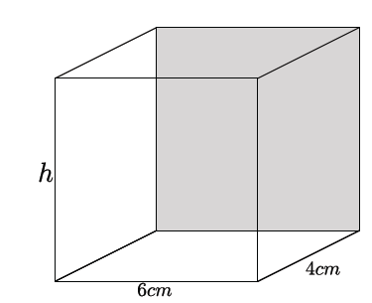

$$V=6\left(4\right)\left(h\right) \\ =24h cm^{3}$$

    - Write an equation for volume, $V$, in terms of the area of the base, $B$.
$$V=Bh$$

  - Using what you learned in part (a), write an equation to determine the volume of the cylinder shown below.
MP.1 &
MP.7
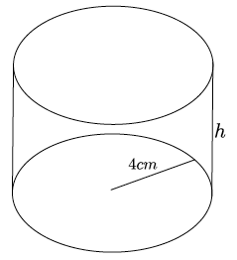
$$V=Bh \\ =4^{2}πh \\ =16πh cm^{3}$$

Students do not know the formula to determine the volume of a cylinder, so some may not be able to respond to this exercise until after the discussion below. This is an exercise for students to make sense of problems and persevere in solving them.

Discussion (10 minutes)
- We will continue with an intuitive discussion of volume. The volume formula from the last lesson says that if the dimensions of a rectangular prism are $l$,$w$, $h$, then the volume of the rectangular prism is $V=l∙w∙h$.
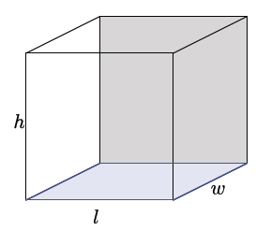
Scaffolding:
Demonstrate the volume of a rectangular prism using a stack of note cards. The volume of the rectangular prism increases as the height of the stack increases. Note that the rectangles (note cards) are congruent.
- Referring to the picture, we call the blue rectangle at the bottom of the rectangular prism the base, and the length of any one of the edges perpendicular to the base the height of the rectangular prism. Then, the formula says
$$V=\left(area of base\right)∙height.$$

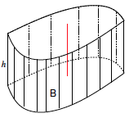
- Examine the volume of a cylinder with base $B$ and height $h$. Is the solid (i.e., the totality of all the line segments) of length $h$ lying above the plane so that each segment is perpendicular to the plane, and is its lower endpoint lying on the base $B$ (as shown)?
Scaffolding:
Clearly stating the meanings of symbols may present challenges for English language learners, and as such, students may benefit from a menu of phrases to support their statements. They will require detailed instruction and support in learning the non-negotiable vocabulary terms and phrases.
- Do you know a name for the shape of the base?
  - No, it is some curvy shape.
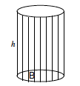
- Let’s examine another cylinder.
- Do we know the name of the shape of the base?
  - It appears to be a circle.
- What do you notice about the line segments intersecting the base?
  - The line segments appear to be perpendicular to the base.
- What angle does the line segment appear to make with the base?
  - The angle appears to be a right angle.
- When the base of a diagram is the shape of a circle and the line segments on the base are perpendicular to the base, then the shape of the diagram is called a right circular cylinder.
We want to use the general formula for volume of a prism to apply to this shape of a right circular cylinder.
MP.8
Scaffolding:
Demonstrate the volume of a cylinder using a stack of round disks. The volume of the cylinder increases as the height of the stack increases, just like the rectangular prism. Note that the disks are congruent.
- What is the general formula for finding the volume of a prism?
  - $V=(area of base)∙height$
- What is the area for the base of the right circular cylinder?
  - The area of a circle is $A=πr^{2}$.
- What information do we need to find the area of a circle?
  - We need to know the radius of the circle.
- What would be the volume of a right circular cylinder?
  - $V=\left(πr^{2}\right)h$

- What information is needed to find the volume of a right circular cylinder?
MP.8
  - We would need to know the radius of the base and the height of the cylinder.

Exercises 1–3 (8 minutes)
Students work independently or in pairs to complete Exercises 1–3.
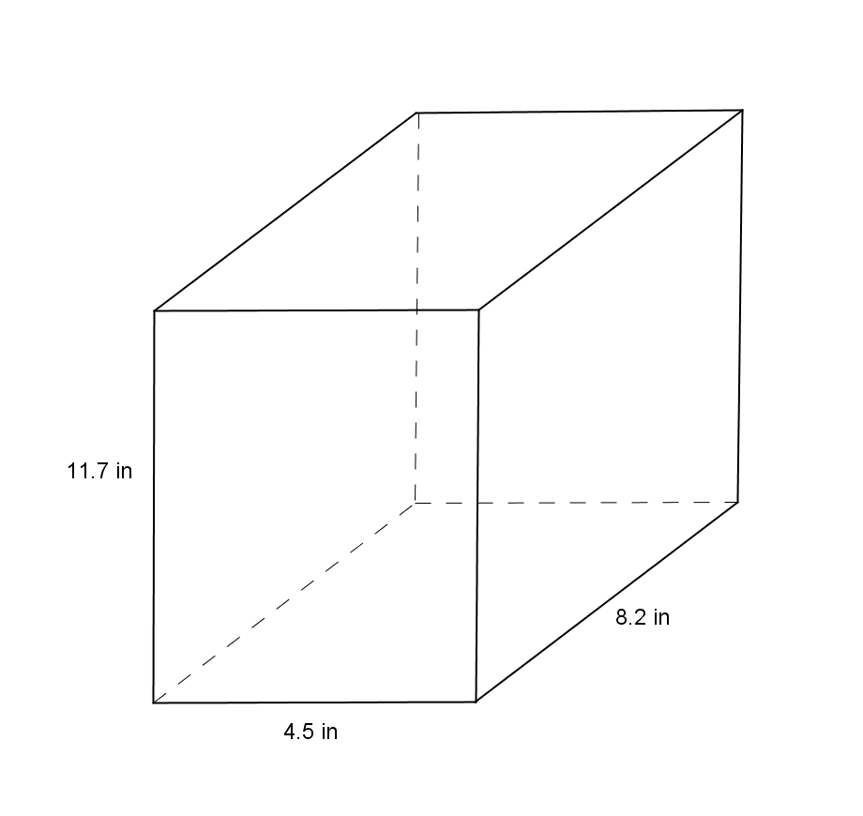
Exercises 1–6
- Use the diagram at right to answer the questions.
  - What is the area of the base?
The area of the base is $(4.5)(8.2)=36.9 in^{2}$.

  - What is the height?
The height of the rectangular prism is $11.7 in$.

  - What is the volume of the rectangular prism?
The volume of the rectangular prism is $431.73 in^{3}$.

- Use the diagram at right to answer the questions.
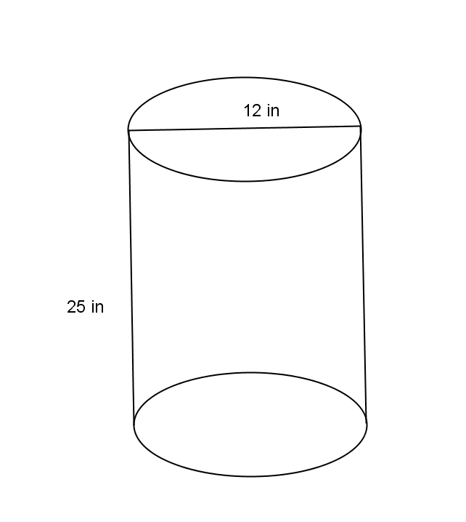
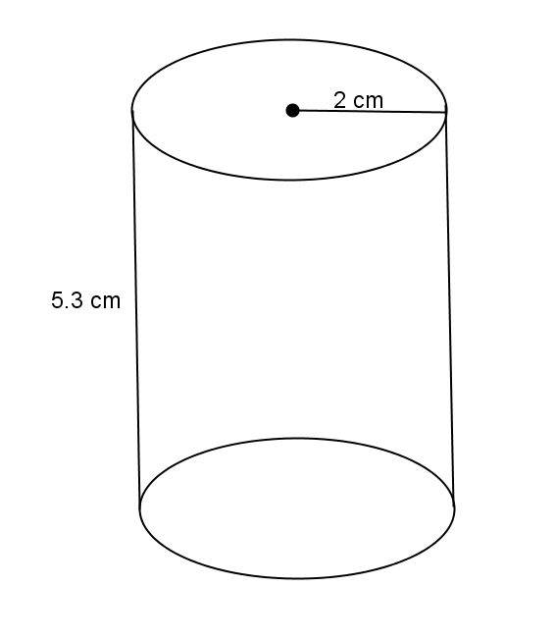
  - What is the area of the base?
$$A=π2^{2} \\ A=4π$$
The area of the base is $4π cm^{2}$.

  - What is the height?
The height of the right circular cylinder is $5.3 cm$.

  - What is the volume of the right circular cylinder?
$$V=\left(πr^{2}\right)h \\ V=\left(4π\right)5.3 \\ V=21.2π$$
The volume of the right circular cylinder is $21.2π cm^{3}$.

- Use the diagram at right to answer the questions.
  - What is the area of the base?
$$A=π6^{2} \\ A=36π$$The area of the base is$36π in^{2}$.

  - What is the height?
The height of the right circular cylinder is $25 in$.
  - What is the volume of the right circular cylinder?
$$V=\left(36π\right)25 \\ V=900π$$The volume of the right circular cylinder is $900π in^{3}$.

Discussion (10 minutes)
- Next, we introduce the concept of a cone. We start with the general concept of a cylinder. Let$P$be a point in the plane that contains the top of a cylinder or height, $h$. Then, the totality of all the segments joining $P t$o a point on the base $B$ is a solid, called a cone, with base$B$ and height $h$. The point $P$ is the top vertex of the cone. Here are two examples of such cones.
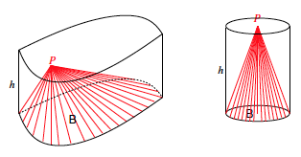
- Let’s examine the diagram on the right more closely. What is the shape of the base?
  - It appears to be the shape of a circle.
- Where does the line segment from the vertex to the base appear to intersect the base?
  - It appears to intersect at the center of the circle.
- What type of angle do the line segment and base appear to make?
  - It appears to be a right angle.
- If the vertex of a circular cone happens to lie on the line perpendicular to the circular base at its center, then the cone is called a right circular cone.
- We want to develop a general formula for volume of right circular cones from our general formula for cylinders.
MP.3
- If we were to fill a cone of height, $h$, and radius, $r$, with rice (or sand or water), how many cones do you think it would take to fill up a cylinder of the same height, $h$, and radius, $r$?
Show students a cone filled with rice (or sand or water). Show students a cylinder of the same height and radius. Give students time to make a conjecture about how many cones it will take to fill the cylinder. Ask students to share their guesses and their reasoning to justify their claims. Consider having the class vote on the correct answer before the demonstration or showing the video. Demonstrate that it would take the volume of three cones to fill up the cylinder, or show the following short, one-minute video http://youtu.be/0ZACAU4SGyM.
- What would the general formula for the volume of a right cone be? Explain.
Provide students time to work in pairs to develop the formula for the volume of a cone.
  - Since it took three cones to fill up a cylinder with the same dimensions, then the volume of the cone is one-third that of the cylinder. We know the volume for a cylinder already, so the cone’s volume will be $\frac{1}{3}$ of the volume of a cylinder with the same base and same height. Therefore, the formula will be
$V=\frac{1}{3}\left(πr^{2}\right)h.$

Exercises 4–6 (5 minutes)
Students work independently or in pairs to complete Exercises 4–6 using the general formula for the volume of a cone. Exercise 8 is a challenge problem.

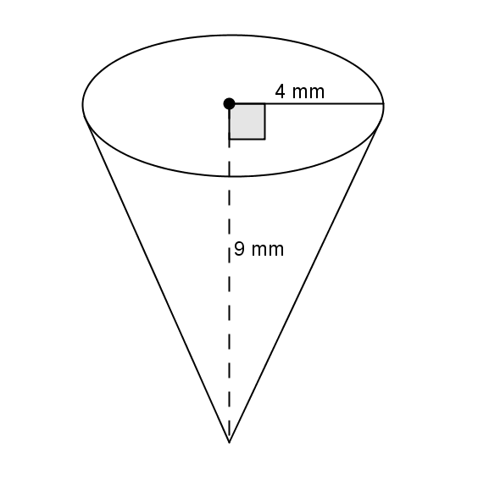
- Use the diagram to find the volume of the right circular cone.
$$V=\frac{1}{3}\left(πr^{2}\right)h \\ V=\frac{1}{3}\left(π4^{2}\right)9 \\ V=48π$$
The volume of the right circular cone is $48π mm^{3}$.

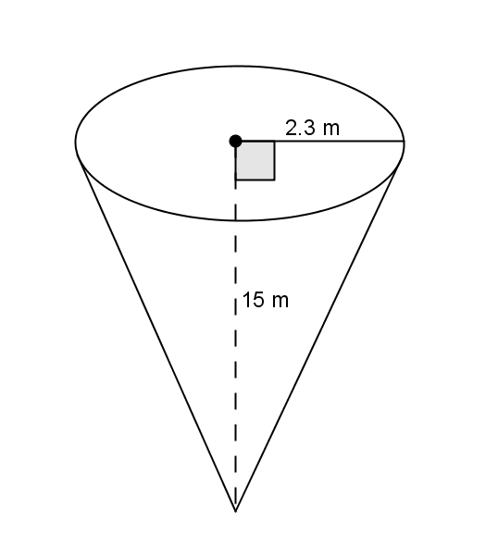
- Use the diagram to find the volume of the right circular cone.
$$V=\frac{1}{3}\left(πr^{2}\right)h \\ V=\frac{1}{3}\left(π{2.3}^{2}\right)15 \\ V=26.45π$$
The volume of the right circular cone is $26.45π mm^{3}$.

- Challenge: A container in the shape of a right circular cone has height $h$, and base of radius$r$, as shown. It is filled with water (in its upright position) to half the height. Assume that the surface of the water is parallel to the base of the inverted cone. Use the diagram to answer the following questions:
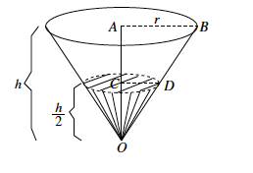
  - What do we know about the lengths of $AB$ and $AO$?
Then we know that $\left|AB\right|=r$, and $\left|AO\right|=h$.

  - What do we know about the measure of $∠OAB$ and $∠OCD$?
$∠OAB$and $∠OCD$ are both right angles.

  - What can you say about $△OAB$and $△OCD$?
We have two similar triangles, $△OAB$and $△OCD$ by AA criterion.

  - What is the ratio of the volume of water to the volume of the container itself?
Since $\frac{\left|AB\right|}{\left|CD\right|}=\frac{\left|AO\right|}{\left|CO\right|}$, and $\left|OA\right|=2\left|OC\right|$, we have $\frac{\left|AB\right|}{\left|CD\right|}=\frac{2\left|OC\right|}{\left|CO\right|}$ .
Then $\left|AB\right|=2\left|CD\right|$.
Using the volume formula, we have $V=\frac{1}{3}π{\left|AB\right|}^{2}\left|AO\right|$.
$$V=\frac{1}{3}π\left(2{\left|CD\right|}^{2}\right)2\left|OC\right|$$
$V=8\left(\frac{1}{3}π{\left|CD\right|}^{2}\left|OC\right|\right)$, where $\frac{1}{3}π{\left|CD\right|}^{2}\left|OC\right|$ gives the volume of the portion of the container that is filled with water.
Therefore, the volume of the water to the volume of the container is $8:1$.

Closing (4 minutes)
Summarize, or ask students to summarize, the main points from the lesson:
- Students know the volume formulas for right circular cylinders.
- Students know the volume formula for right circular cones with relation to right circular cylinders.
- Students can apply the formulas for volume of right circular cylinders and cones.
Lesson Summary
The formula to find the volume, $V$, of a right circular cylinder is $V=πr^{2}h=Bh$, where $B$ is the area of the base.
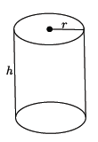
The formula to find the volume of a cone is directly related to that of the cylinder. Given a right circular cylinder with radius $r$ and height $h,$ the volume of a cone with those same dimensions is one-third of the cylinder. The formula for the volume, $V$, of a cone is $V=\frac{1}{3}πr^{2}h=\frac{1}{3}Bh$, where $B$ is the area of the base.
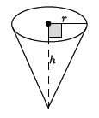

Exit Ticket (5 minutes)
Name Date
Lesson 10: Volumes of Familiar Solids—Cones and Cylinders

Exit Ticket

- Use the diagram to find the total volume of the three cones shown below.
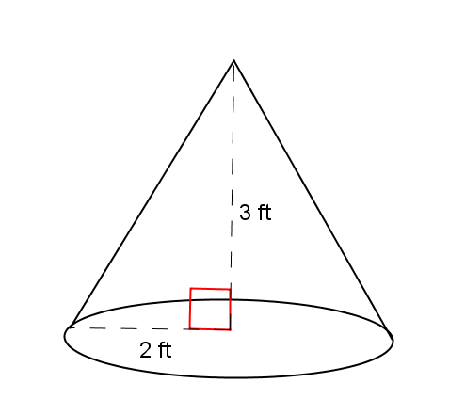

- Use the diagram below to determine which has the greater volume, the cone or the cylinder.
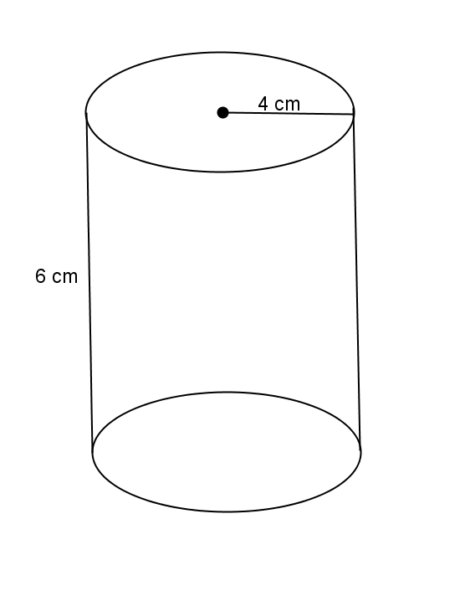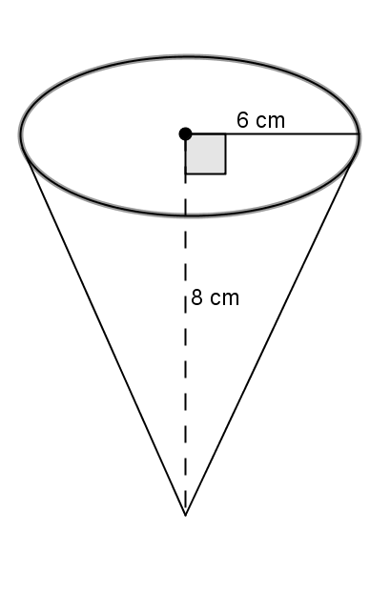

Exit Ticket Sample Solutions

- Use the diagram to find the total volume of the three cones shown below.
Since all three cones have the same base and height, the volume of the three cones will be the same as finding the volume of a cylinder with the same base radius and same height.
$$V=πr^{2}h \\ V=π{\left(2\right)}^{2}3 \\ V=12π$$
The volume of all three cones is $12π ft^{3}$.

- Use the diagram below to determine which has the greater volume, the cone or the cylinder.
The volume of the cylinder is$$V=πr^{2}h \\ V=π4^{2}6 \\ V=96π.$$
The volume of the cone is
$$V=\frac{1}{3}πr^{2}h \\ V=\frac{1}{3}π6^{2}8 \\ V=96π.$$
The volume of the cylinder and the volume of the cone are the same, $96π cm^{3}$.

Problem Set Sample Solutions

- Use the diagram to help you find the volume of the right circular cylinder.
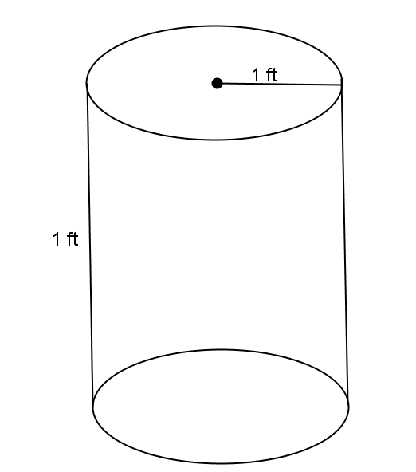
$$V=πr^{2}h \\ V=π{\left(1\right)}^{2}\left(1\right) \\ V=π$$
The volume of the right circular cylinder is $π ft^{3}$.

- Use the diagram to help you find the volume of the right circular cone.
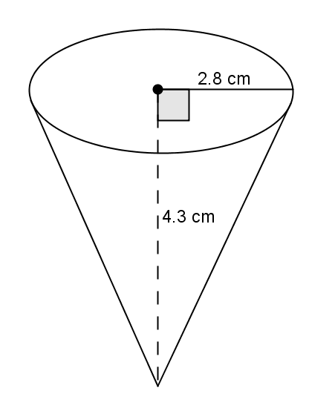
$$V=\frac{1}{3}πr^{2}h \\ V=\frac{1}{3}π{(2.8)}^{2}(4.3) \\ V=11.237333…π$$
The volume of the right circular cone is about$11.2π cm^{3}$.

- Use the diagram to help you find the volume of the right circular cylinder.
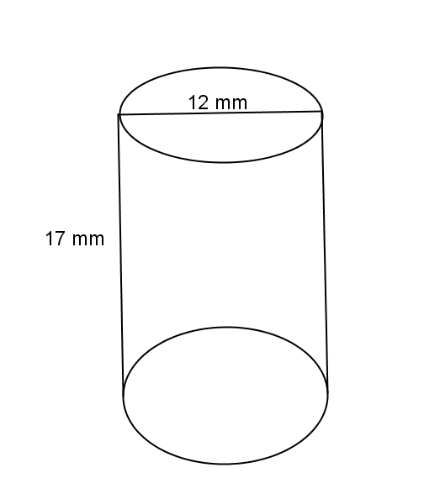
If the diameter is $12 mm$, then the radius is $6 mm$.
$$V=πr^{2}h \\ V=π({6)}^{2}(17) \\ V=612π$$
The volume of the right circular cylinder is $612π mm^{3}$.

- Use the diagram to help you find the volume of the right circular cone.
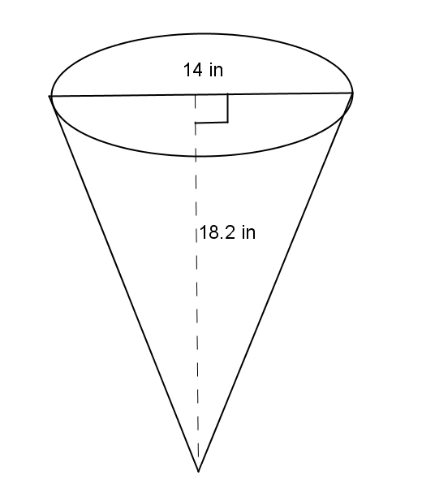
If the diameter is $14 in.$, then the radius is $7 in$.
$$V=\frac{1}{3}πr^{2}h \\ V=\frac{1}{3}π{\left(7\right)}^{2}(18.2) \\ V=297.26666…π$$
The volume of the right cone is about $297.3π in^{3}$.

- Oscar wants to fill with water a bucket that is the shape of a right circular cylinder. It has a $6$-inch radius and $12$-inch height. He uses a shovel that has the shape of right circular cone with a $3$-inch radius and $4$-inch height. How many shovelfuls will it take Oscar to fill the bucket up level with the top?
$$V=πr^{2}h \\ V=π({6)}^{2}(12) \\ V=432π$$
The volume of the bucket is $432π in^{3}$.
$$V=\frac{1}{3}πr^{2}h \\ V=\frac{1}{3}π{\left(3\right)}^{2}(4) \\ V=12π$$
The volume of shovel is $12π in^{3}$.
$$\frac{432π}{12π}=36$$
It would take $36$ shovelfuls of water to fill up the bucket.

- A cylindrical tank (with dimensions shown below) contains water that is $1$-foot deep. If water is poured into the tank at a constant rate of $20 \frac{{ft}^{3}}{min}$ for $20$ min., will the tank overflow? Use $3.14$ to estimate $π.$
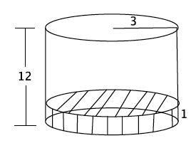
$$V=πr^{2}h \\ V=π({3)}^{2}(12) \\ V=108π$$
The volume of the tank is about $339.12 ft$³.
$$V=πr^{2}h \\ V=π{\left(3\right)}^{2}(1) \\ V=9π$$
There is about $28.26 ft^{3}$ of water already in the tank. There is about $310.86 ft^{3}$ of space left in the tank. If the water is poured at a constant rate for $20$ min., $400 ft^{3}$ will be poured into the tank, and the tank will overflow.

