Lesson 9: Examples of Functions from Geometry

Classwork
Exercises
As you complete Exercises 1–4, record the information in the table below.

 | Side length $(s)$ | Area $(A)$ | Expression that describes area of border
Exercise 1
Exercise 2
Exercise 3
Exercise 4

- Use the figure below to answer parts (a)–(f).
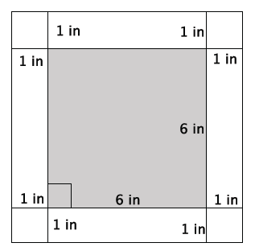

  - What is the length of one side of the smaller, inner square?

  - What is the area of the smaller, inner square?

  - What is the length of one side of the larger, outer square?

  - What is the area of the larger, outer square?

  - Use your answers in parts (b) and (d) to determine the area of the $1$-inch white border of the figure.

  - Explain your strategy for finding the area of the white border.

- Use the figure below to answer parts (a)–(f).
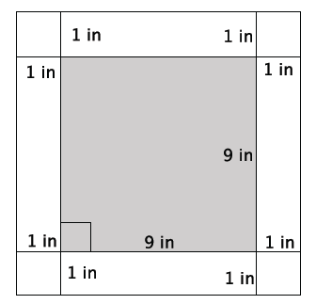

  - What is the length of one side of the smaller, inner square?

  - What is the area of the smaller, inner square?

  - What is the length of one side of the larger, outer square?

  - What is the area of the larger, outer square?

  - Use your answers in parts (b) and (d) to determine the area of the $1$-inch white border of the figure.

  - Explain your strategy for finding the area of the white border.

- Use the figure below to answer parts (a)–(f).
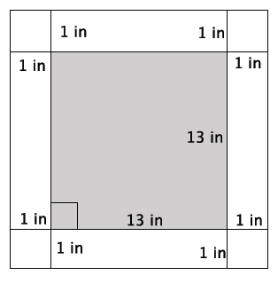

  - What is the length of one side of the smaller, inner square?

  - What is the area of the smaller, inner square?

  - What is the length of one side of the larger, outer square?

  - What is the area of the larger, outer square?

  - Use your answers in parts (b) and (d) to determine the area of the $1$-inch white border of the figure.

  - Explain your strategy for finding the area of the white border.

- Write a function that would allow you to calculate the area of a $1$-inch white border for any sized square picture measured in inches.
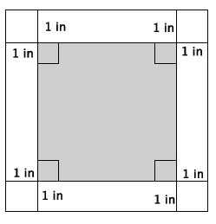

  - Write an expression that represents the side length of the smaller, inner square.

  - Write an expression that represents the area of the smaller, inner square.

  - Write an expression that represents the side lengths of the larger, outer square.

  - Write an expression that represents the area of the larger, outer square.

  - Use your expressions in parts (b) and (d) to write a function for the area $A$ of the $1$-inch white border for any sized square picture measured in inches.

- The volume of the prism shown below is $61.6$ in³. What is the height of the prism?

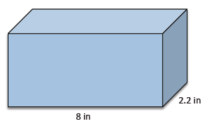

- Find the value of the ratio that compares the volume of the larger prism to the smaller prism.

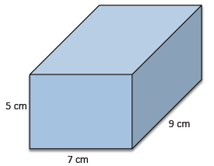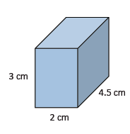

As you complete Exercises 7–10, record the information in the table below. Note that base refers to the bottom of the prism.
 | Area of base $(B)$ | Height $(h)$ | Volume
Exercise 7
Exercise 8
Exercise 9
Exercise 10

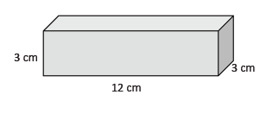
- Use the figure to the right to answer parts (a)–(c).
  - What is the area of the base?

  - What is the height of the figure?

  - What is the volume of the figure?

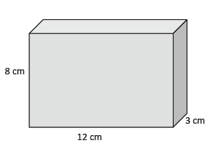
- Use the figure to the right to answer parts (a)–(c).
  - What is the area of the base?

  - What is the height of the figure?

  - What is the volume of the figure?

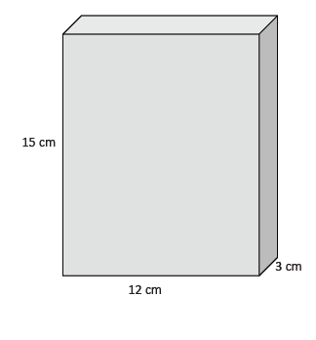
- Use the figure to the right to answer parts (a)–(c).
  - What is the area of the base?

  - What is the height of the figure?

  - What is the volume of the figure?

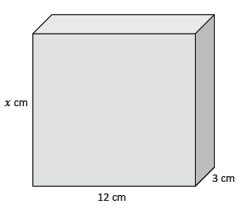
- Use the figure to the right to answer parts (a)–(c).
  - What is the area of the base?

  - What is the height of the figure?

  - Write and describe a function that will allow you to determine the volume of any rectangular prism that has a base area of $36$cm².

Problem Set
Lesson Summary
Rules can be written to describe functions by observing patterns and then generalizing those patterns using symbolic notation.
There are a few basic assumptions that are made when working with volume:
- The volume of a solid is always a number $≥0$.
- The volume of a unit cube (i.e., a rectangular prism whose edges all have a length of $1$) is by definition $1$ cubic unit.
- If two solids are identical, then their volumes are equal.
- If two solids have (at most) their boundaries in common, then their total volume can be calculated by adding the individual volumes together. (These figures are sometimes referred to as composite solids.)

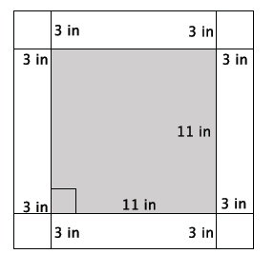
- Calculate the area of the $3$-inch white border of the square figure below.

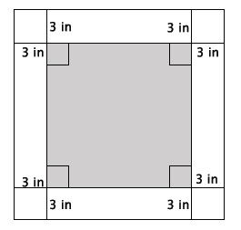
- Write a function that would allow you to calculate the area, $A$, of a $3$-inch white border for any sized square picture measured in inches.

- Dartboards typically have an outer ring of numbers that represent the number of points a player can score for getting a dart in that section. A simplified dartboard is shown below. The center of the circle is point $A.$ Calculate the area of the outer ring. Write an exact answer that uses $π$ (do not approximate your answer by using $3.14$ for $π$).
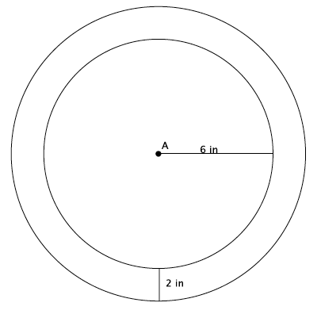

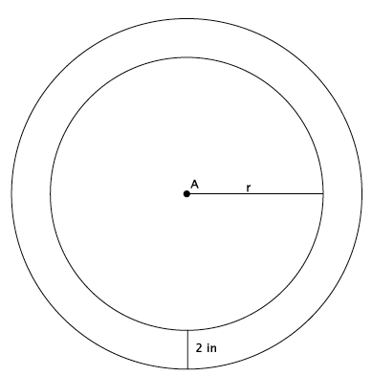
- Write a function that would allow you to calculate the area, $A$, of the outer ring for any sized dartboard with radius $r$. Write an exact answer that uses $π$ (do not approximate your answer by using $3.14$ for $π$).

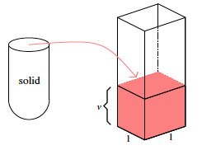
- The shell of the solid shown was filled with water and then poured into the standard rectangular prism, as shown. The height that the volume reaches is $14.2 in.$ What is the volume of the solid?
- Determine the volume of the rectangular prism shown below.
$6.4$in.
$5.1$in.
$10.2$in.

- The volume of the prism shown below is $972$cm³. What is its length?
- The volume of the prism shown below is $32.7375$ ft³. What is its width?
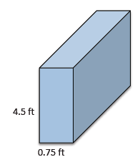

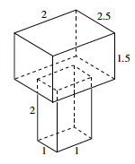
- Determine the volume of the $3$-dimensional figure below. Explain how you got your answer.

