Lesson 9: Examples of Functions from Geometry

Student Outcomes
- Students write rules to express functions related to geometry.
- Students review what they know about volume with respect to rectangular prisms and further develop their conceptual understanding of volume by comparing the liquid contained within a solid to the volume of a standard rectangular prism (i.e., a prism with base area equal to one).

Classwork
Exploratory Challenge 1/Exercises 1–4 (10 minutes)
Students work independently or in pairs to complete Exercises 1–4. Once students are finished, debrief the activity. Ask students to think about real-life situations that might require using the function they developed in Exercise 4. Some sample responses may include area of wood needed to make a $1$-inch frame for a picture, area required to make a sidewalk border (likely larger than $1$-inch) around a park or playground, or the area of a planter around a tree.
Exercises
As you complete Exercises 1–4, record the information in the table below.

 | Side length $(s)$ | Area $(A)$ | Expression that describes area of border
Exercise 1 | $$6$$ | $$36$$ | $$64-36$$
 | $$8$$ | $$64$$
Exercise 2 | $$9$$ | $$81$$ | $$121-81$$
 | $$11$$ | $$121$$
Exercise 3 | $$13$$ | $$169$$ | $$225-169$$
 | $$15$$ | $$225$$
Exercise 4 | $$s$$ | $$s^{2}$$ | $${\left(s+2\right)}^{2}-s^{2}$$
 | $$s+2$$ | $${\left(s+2\right)}^{2}$$

- Use the figure below to answer parts (a)–(f).
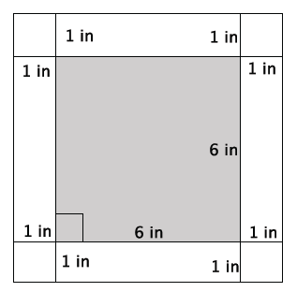

  - What is the length of one side of the smaller, inner square?
The length of one side of the smaller square is $6 in$.

  - What is the area of the smaller, inner square?
$$6^{2}=36$$
The area of the smaller square is $36 in^{2}$.

  - What is the length of one side of the larger, outer square?
The length of one side of the larger square is $8 in$.

  - What is the area of the larger, outer square?
$$8^{2}=64$$
The area of the larger square is $64 in^{2}$.

  - Use your answers in parts (b) and (d) to determine the area of the $1$-inch white border of the figure.
$$64-36=28$$
The area of the $1$-inch white border is $28 in^{2}$.

  - Explain your strategy for finding the area of the white border.
First, I had to determine the length of one side of the larger, outer square. Since the inner square is $6 in.$ and the border is $1 in.$ on all sides, then the length of one side of the larger square is $6+2=8 in$. Then, the area of the larger square is $64 in^{2}$. Then, I found the area of the smaller, inner square. Since one side length is
$6 in.$, the area is $36 in^{2}$. To find the area of the white border, I needed to subtract the area of the inner square from the area of the outer square.

- Use the figure below to answer parts (a)–(f).
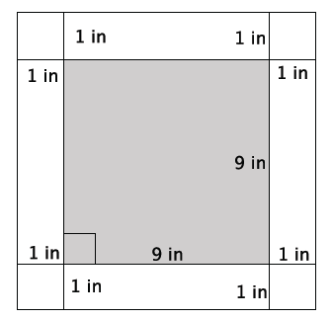

  - What is the length of one side of the smaller, inner square?
The length of one side of the smaller square is $9 in.$

  - What is the area of the smaller, inner square?
$$9^{2}=81$$
The area of the smaller square is $81 in^{2}$.

  - What is the length of one side of the larger, outer square?
The length of one side of the larger square is $11 in.$

  - What is the area of the larger, outer square?
$${11}^{2}=121$$
The area of the larger square is $121 in^{2}$.

  - Use your answers in parts (b) and (d) to determine the area of the $1$-inch white border of the figure.
$$121-81=40$$
The area of the $1$-inch white border is $40 in^{2}$.

  - Explain your strategy for finding the area of the white border.
First, I had to determine the length of one side of the larger, outer square. Since the inner square is $9 in.$ and the border is $1$ $in.$ on all sides, the length of one side of the larger square is $+2=11$ $in$. Therefore, the area of the larger square is $121 in^{2}$. Then, I found the area of the smaller, inner square. Since one side length is $9 in$., the area is $81 in^{2}$. To find the area of the white border, I needed to subtract the area of the inner square from the area of the outer square.

- Use the figure below to answer parts (a)–(f).
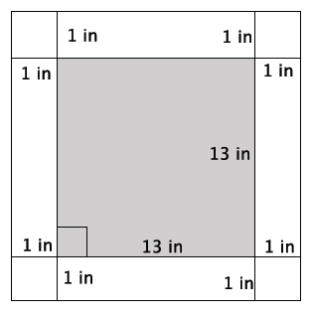

  - What is the length of one side of the smaller, inner square?
The length of one side of the smaller square is $13 in$.

  - What is the area of the smaller, inner square?
$${13}^{2}=169$$
The area of the smaller square is $169 in^{2}$.

  - What is the length of one side of the larger, outer square?
The length of one side of the larger square is $15 in$.

  - What is the area of the larger, outer square?
$${15}^{2}=225$$
The area of the larger square is $225 in^{2}$.

  - Use your answers in parts (b) and (d) to determine the area of the $1$-inch white border of the figure.
$$225-169=56$$
The area of the $1$-inch white border is $56 in^{2}$.

  - Explain your strategy for finding the area of the white border.
First, I had to determine the length of one side of the larger, outer square. Since the inner square is $13 in.$ and the border is $1$ $in.$ on all sides, the length of one side of the larger square is $13+2=15 in$. Therefore, the area of the larger square is $225 in^{2}$. Then, I found the area of the smaller, inner square. Since one side length is $13 in$., the area is $169 in^{2}$. To find the area of the white border I needed to subtract the area of the inner square from the area of the outer square.

- Write a function that would allow you to calculate the area of a $1$-inch white border for any sized square picture measured in inches.
MP.8
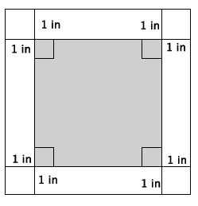
  - Write an expression that represents the side length of the smaller, inner square.
Symbols used will vary. Expect students to use $s$ or $x$ to represent one side of the smaller, inner square. Answers that follow will use $s$ as the symbol to represent one side of the smaller, inner square.

  - Write an expression that represents the area of the smaller, inner square.
$$s^{2}$$

  - Write an expression that represents the side lengths of the larger, outer square.
$$s+2$$

  - Write an expression that represents the area of the larger, outer square.
$${\left(s+2\right)}^{2}$$

  - Use your expressions in parts (b) and (d) to write a function for the area $A$ of the $1$-inch white border for any sized square picture measured in inches.
$$A={\left(s+2\right)}^{2}-s^{2}$$

Discussion (6 minutes)
This discussion prepares students for the volume problems that they will work in the next two lessons. The goal is to remind students of the concept of volume using a rectangular prism, and then have them describe the volume in terms of a function.
- Recall the concept of volume. How do you describe the volume of a three-dimensional figure? Give an example, if necessary.
  - Volume is the space that a three-dimensional figure can occupy. The volume of a glass is the amount of liquid it can hold.
- In Grade 6 you learned the formula to determine the volume of a rectangular prism. The volume $V$ of a rectangular prism is a function of the edge lengths, $l$,$w$, and $h$. That is, the function that allows us to determine the volume of a rectangular prism can be described by the following rule:
$$V=lwh.$$
- Generally, we interpret volume in the following way:
- Fill the shell of the solid with water, and pour water into a three-dimensional figure, in this case a standard rectangular prism (i.e., a prism with bases side lengths of one), as shown.

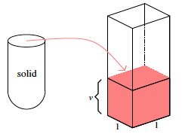
Scaffolding:
- Concrete and hands-on experiences with volume would be useful.
- Students may know the formulas for volume, but with different letters to represent the values (linked to their first language).

- Then, the volume of the shell of the solid is the height $v$ of the water in the standard rectangular prism. Why is the volume, $v$, the height of the water?
  - The volume is equal to the height of the water because the area of the base is $1$. Thus, whatever the height, $v$, is multiplied by, $1$ will be equal to $v.$

- If the height of water in the standard rectangular prism is $16.7 ft.$, what is the volume of the shell of the solid? Explain.
  - The volume of the shell of the solid would be $16.7 {ft}^{3}$ because the height, $16.7 ft.$, multiplied by the area of the base, $1 ft^{2}$, is $16.7 ft^{3}$.

- There are a few basic assumptions that we make when we discuss volume. Have students paraphrase each assumption after you state it to make sure they understand the concept.
- The volume of a solid is always a number $≥0$.
- The volume of a unit cube (i.e., a rectangular prism whose edges all have length $1$) is by definition $1$ cubic unit.
- If two solids are identical, then their volumes are equal.
- If two solids have (at most) their boundaries in common, then their total volume can be calculated by adding the individual volumes together. (These figures are sometimes referred to as composite solids.)

Exercises 5–6 (5 minutes)

- The volume of the prism shown below is $61.6 in^{3}$. What is the height of the prism?
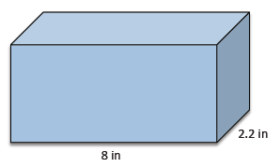
Let $x$ represent the height of the prism.
$$61.6=8\left(2.2\right)x \\ 61.6=17.6x \\ 3.5=x$$
The height of the prism is $3.5 in$.

- Find the value of the ratio that compares the volume of the larger prism to the smaller prism.
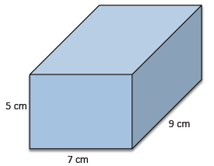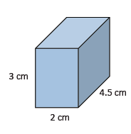
Volume of larger prism:
$$V=7(9)(5) \\ =315 cm^{3}$$
Volume of smaller prism:
$$V=2\left(4.5\right)\left(3\right) \\ =27 cm^{3}$$
The ratio that compares the volume of the larger prism to the smaller prism is $315:27$. The value of the ratio is $\frac{315}{27}=\frac{35}{3}$.

Exploratory Challenge 2/Exercises 7–10 (14 minutes)
Students work independently or in pairs to complete Exercises 7–10. Ensure that students know that when base is referenced, it means the bottom of the prism.
As you complete Exercises 7–10, record the information in the table below. Note that base refers to the bottom of the prism.
 | Area of base ($B$) | Height ($h$) | Volume
Exercise 7 | $$36$$ | $$3$$ | $$108$$
Exercise 8 | $$36$$ | $$8$$ | $$288$$
Exercise 9 | $$36$$ | $$15$$ | $$540$$
Exercise 10 | $$36$$ | $$x$$ | $$36x$$

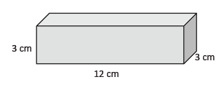
- Use the figure to the right to answer parts (a)–(c).
  - What is the area of the base?
The area of the base is $36 cm^{2}$.

  - What is the height of the figure?
The height is $3 cm$.

  - What is the volume of the figure?
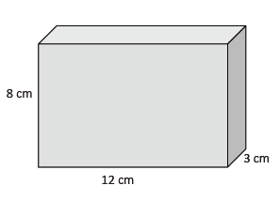
The volume of the rectangular prism is $108 cm^{3}$.

- Use the figure to the right to answer parts (a)–(c).
  - What is the area of the base?
The area of the base is $36 cm^{2}$.

  - What is the height of the figure?
The height is $8 cm$.

  - What is the volume of the figure?
The volume of the rectangular prism is $288 cm^{3}$.
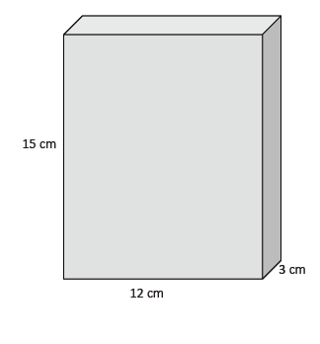
- Use the figure to the right to answer parts (a)–(c).
  - What is the area of the base?
The area of the base is $36 cm^{2}$.

  - What is the height of the figure?
The height is $15 cm$.

  - What is the volume of the figure?
The volume of the rectangular prism is $540 cm^{3}$.
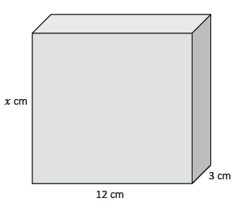
- Use the figure to the right to answer parts (a)–(c).
  - What is the area of the base?
The area of the base is $36 cm^{2}$.

  - What is the height of the figure?
The height is $x cm$.
MP.8
  - Write and describe a function that will allow you to determine the volume of any rectangular prism that has a base area of
$36 cm^{2}$.
The rule that describes the function is $V=36x$, where $V$ is the volume and $x$ is the height of the rectangular prism. The volume of a rectangular prism with a base area of $36 cm^{2}$ is a function of its height.

Closing (5 minutes)
Summarize, or ask students to summarize, the main points from the lesson:
- We know how to write functions to determine area or volume of a figure.
- We know that we can add volumes together as long as they only touch at a boundary.
- We know that identical solids will be equal in volume.
- We were reminded of the volume formula for a rectangular prism, and we used the formula to determine the volume of rectangular prisms.
Lesson Summary
Rules can be written to describe functions by observing patterns and then generalizing those patterns using symbolic notation.
There are a few basic assumptions that are made when working with volume:
- The volume of a solid is always a number $≥0$.
- The volume of a unit cube (i.e., a rectangular prism whose edges all have a length of $1$) is by definition $1$ cubic unit.
- If two solids are identical, then their volumes are equal.
- If two solids have (at most) their boundaries in common, then their total volume can be calculated by adding the individual volumes together. (These figures are sometimes referred to as composite solids.)

Exit Ticket (5 minutes)
Name Date
Lesson 9: Examples of Functions from Geometry

Exit Ticket

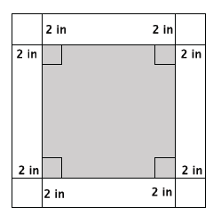
- Write a function that would allow you to calculate the area, $A$, of a $2$-inch white border for any sized square figure with sides of length $s$ measured in inches.

- The volume of the rectangular prism is $295.68 {in}^{3}$. What is its width?
$$11 in.$$
$$6.4 in.$$
Exit Ticket Sample Solutions

- Write a function that would allow you to calculate the area, $A$, of a $2$-inch white border for any sized square figure with sides of length $s$ measured in inches.

Let $s$ represent the side length of the inner square. Then, the area of the inner square is $s^{2}$. The side length of the larger square is $s+4$, and the area is ${\left(s+4\right)}^{2}$. If $A$ is the area of the $2$-inch border, then the function that describes $A$ is
$$A={\left(s+4\right)}^{2}-s^{2}.$$

- The volume of the rectangular prism is $295.68 in^{3}$. What is its width?
$$11 in.$$
$$6.4 in.$$
Let $x$ represent the width of the prism.
$$295.68=11\left(6.4\right)x \\ 295.68=70.4x \\ 4.2=x$$
The width of the prism is $4.2 in$.

Problem Set Sample Solutions

- Calculate the area of the $3$-inch white border of the square figure below.
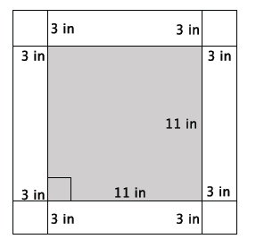
$$17^{2}=289 \\ 11^{2}=121$$
The area of the $3$-inch white border is $168 in^{2}$.

- Write a function that would allow you to calculate the area, $A$, of a $3$-inch white border for any sized square picture measured in inches.
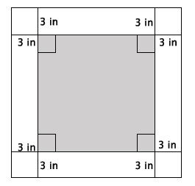
Let $s$ represent the side length of the inner square. Then, the area of the inner square is $s^{2}$. The side length of the outer square is $s+6$, which means that the area of the outer square is ${\left(s+6\right)}^{2}$. The function that describes the area, $A$, of the $3$-inch border is
$$A={\left(s+6\right)}^{2}-s^{2}.$$

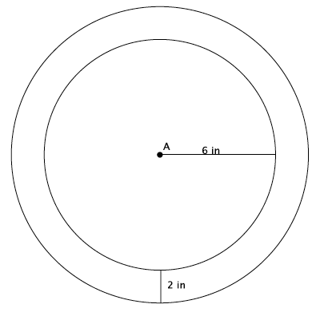
- Dartboards typically have an outer ring of numbers that represent the number of points a player can score for getting a dart in that section. A simplified dartboard is shown below. The center of the circle is point $A$. Calculate the area of the outer ring. Write an exact answer that uses $π$ (do not approximate your answer by using $3.14$ for $π$).

The inner ring has an area of $36π$. The area of the inner ring including the border is $64π$. The difference is the area of the border, $28π in^{2}$.

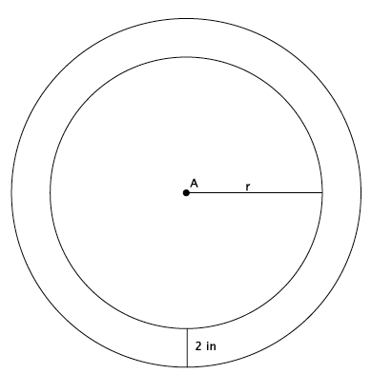
- Write a function that would allow you to calculate the area, $A$, of the outer ring for any sized dartboard with radius $r$. Write an exact answer that uses $π$ (do not approximate your answer by using $3.14$ for $π$).

The inner ring has an area of $πr^{2}$. The area of the inner ring including the border is $π{\left(r+2\right)}^{2}$. Let $A$ be the area of the outer ring. Then, the function that would describe that area is
$$A=π{\left(r+2\right)}^{2}-πr^{2}.$$

- The shell of the solid shown was filled with water and then poured into the standard rectangular prism, as shown. The height that the volume reaches is $14.2 in$. What is the volume of the shell of the solid?

The volume of the shell of the solid is $14.2 in^{3}$.

- Determine the volume of the rectangular prism shown below.
$$6.4 in.$$
$$5.1 in.$$
$$10.2 in.$$
The volume of the prism is
$6.4×5.1×10.2=332.928 in^{3}$.

- The volume of the prism shown below is $972 cm^{3}$. What is its length?
Let $x$ represent the length of the prism.
$$972=8.1\left(5\right)x \\ 972=40.5x \\ 24=x$$
The length of the prism is $24 cm$.

- The volume of the prism shown below is $32.7375$ft³. What is its width?
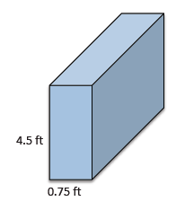

Let $x$ represent the width.
$$32.7375=\left(0.75\right)\left(4.5\right)x \\ 32.7375=3.375x \\ 9.7=x$$
The width of the prism is $9.7 ft$.

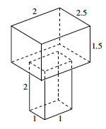
- Determine the volume of the three-dimensional figure below. Explain how you got your answer.

$$2×2.5×1.5=7.5 \\ 2×1×1=2$$
The volume of the top rectangular prism is $7.5 units^{3}$. The volume of the bottom rectangular prism is $2 units^{3}$. The figure is made of two rectangular prisms, and since the rectangular prisms only touch at their boundaries, we can add their volumes together to obtain the volume of the figure. The total volume of the three-dimensional figure is $9.5 units^{3}$.

