Lesson 8: Graphs of Simple Nonlinear Functions

Classwork
Exercises
- A function has the rule so that each input of $x$ is assigned an output of $x^{2}$.
  - Do you think the function is linear or nonlinear? Explain.

  - Develop a list of inputs and outputs for this function. Organize your work using the table below. Then, answer the questions that follow.
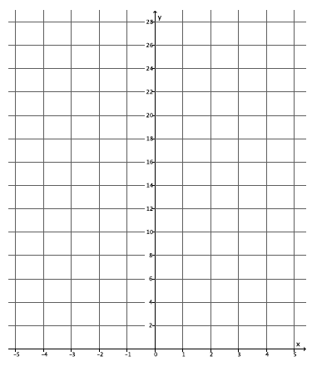
Input $(x)$ | Output $\left(x^{2}\right)$
$$-5$$
$$-4$$
$$-3$$
$$-2$$
$$-1$$
$$0$$
$$1$$
$$2$$
$$3$$
$$4$$
$$5$$

  - Plot the inputs and outputs as points on the coordinate plane where the output is the $y$-coordinate.

  - What shape does the graph of the points appear to take?

  - Find the rate of change using rows 1 and 2 from the table above.

  - Find the rate of change using rows 2 and 3 from the above table.

  - Find the rate of change using any two other rows from the above table.

  - Return to your initial claim about the function. Is it linear or nonlinear? Justify your answer with as many pieces of evidence as possible.

- A function has the rule so that each input of $x$ is assigned an output of $x^{3}$.
  - Do you think the function is linear or nonlinear? Explain.

  - Develop a list of inputs and outputs for this function. Organize your work using the table below. Then, answer the questions that follow.
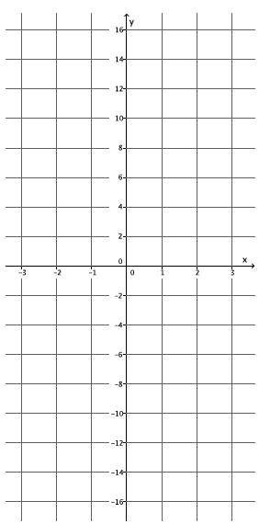
Input $(x)$ | Output $\left(x^{3}\right)$
$$-2.5$$
$$-2$$
$$-1.5$$
$$-1$$
$$-0.5$$
$$0$$
$$0.5$$
$$1$$
$$1.5$$
$$2$$
$$2.5$$

  - Plot the inputs and outputs as points on the coordinate
plane where the output is the $y$-coordinate.

  - What shape does the graph of the points appear to take?

  - Find the rate of change using rows 2 and 3 from the table above.

  - Find the rate of change using rows 3 and 4 from the table above.

  - Find the rate of change using rows 8 and 9 from the table above.

  - Return to your initial claim about the function. Is it linear or nonlinear? Justify your answer with as many pieces of evidence as possible.

- A function has the rule so that each input of $x$ is assigned an output of $\frac{1}{x}$ for values of $x>0$.
  - Do you think the function is linear or nonlinear? Explain.

  - Develop a list of inputs and outputs for this function. Organize your work using the table below. Then, answer the questions that follow.
Input $(x)$ | Output $\left(\frac{1}{x}\right)$
$$0.1$$
$$0.2$$
$$0.4$$
$$0.5$$
$$0.8$$
$$1$$
$$1.6$$
$$2$$
$$2.5$$
$$4$$
$$5$$

  - Plot the inputs and outputs as points on the coordinate
plane where the output is the $y$-coordinate.
  - What shape does the graph of the points appear to take?

  - Find the rate of change using rows 1 and 2 from the table above.

  - Find the rate of change using rows 2 and 3 from the table above.

  - Find the rate of change using any two other rows from the table above.

  - Return to your initial claim about the function. Is it linear or nonlinear? Justify your answer with as many pieces of evidence as possible.

In Exercises 4–10, the rule that describes a function is given. If necessary, use a table to organize pairs of inputs and outputs, and then plot each on a coordinate plane to help answer the questions.
- What shape do you expect the graph of the function described by$y=x$ to take? Is it a linear or nonlinear function?

- What shape do you expect the graph of the function described by$y={2x}^{2}-x$ to take? Is it a linear or nonlinear function?

- What shape do you expect the graph of the function described by$3x+7y=8$ to take? Is it a linear or nonlinear function?

- What shape do you expect the graph of the function described by$y=4x^{3}$ to take? Is it a linear or nonlinear function?

- What shape do you expect the graph of the function described by$\frac{3}{x}=y$ to take? Is it a linear or nonlinear function?

- What shape do you expect the graph of the function described by$\frac{4}{x^{2}}=y$ to take? Is it a linear or nonlinear function?

- What shape do you expect the graph of the equation${ x}^{2}+y^{2}=36$ to take? Is it a linear or nonlinear? Is it a function? Explain.

Problem Set
Lesson Summary
One way to determine if a function is linear or nonlinear is by inspecting the rate of change using a table of values. Another way is to examine its graph. Functions described by nonlinear equations do not have a constant rate of change. Because some functions can be described by equations, an examination of the equation allows you to determine if the function is linear or nonlinear. Just like with equations, when the exponent of the variable $x$ is not equal to $1$, then the equation is nonlinear; therefore, the graph of the function described by a nonlinear equation will graph as some kind of curve, i.e., not a line.

- A function has the rule so that each input of $x$ is assigned an output of $x^{2}-4$.
Input $(x)$ | Output $(x^{2}-4)$
$$-3$$
$$-2$$
$$-1$$
$$0$$
$$1$$
$$2$$
$$3$$
  - Do you think the function is linear or nonlinear? Explain.
  - What shape do you expect the graph of the function to be?
  - Develop a list of inputs and outputs for this function. Plot the inputs and outputs as points on the coordinate plane where the output is the $y$-coordinate.
  - Was your prediction correct?

- A function has the rule so that each input of $x$ is assigned an output of $\frac{1}{x+3}$.
Input $(x)$ | Output $\left(\frac{1}{x+3}\right)$
$$-2$$
$$-1$$
$$0$$
$$1$$
$$2$$
$$3$$
  - Is the function linear or nonlinear? Explain.
  - What shape do you expect the graph of the function to take?
  - Given the inputs in the table below, use the rule of the function to determine the corresponding outputs. Plot the inputs and outputs as points on the coordinate plane where the output is the $y$-coordinate.
  - Was your prediction correct?

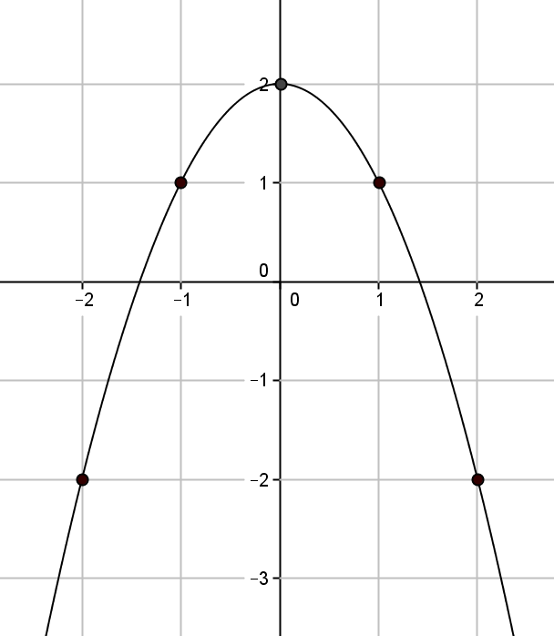
- Is the function that is represented by this graph linear or nonlinear? Explain. Show work that supports your claim.

