|  |
| --- |
|  |

Lesson 8: Graphs of Simple Nonlinear Functions

Student Outcomes

* Students examine the average rate of change for nonlinear functions and learn that, unlike linear functions, nonlinear functions do not have a constant rate of change.
* Students determine whether an equation is linear or nonlinear by examining the rate of change.

Lesson Notes

In Exercises 4–10,students are given the option to sketch the graph of an equation to verify their claim about the equation describing a linear or nonlinear function. For this reason, students may need graph paper to complete these exercises. Students will need graph paper to complete the Problem Set.

Classwork

Exploratory Challenge/Exercises 1–3 (19 minutes)

Students work independently or in pairs to complete Exercises 1–3.

Exercises

*Scaffolding:*

Students may benefit from exploring these exercises in small groups.

1. A function has the rule so that each input of is assigned an output of .
   1. Do you think the function is linear or nonlinear? Explain.

I think the function is nonlinear because nonlinear expressions have variables with exponents that are greater than one.

* 1. Develop a list of inputs and outputs for this function. Organize your work using the table below. Then, answer the questions that follow.

|  |  |
| --- | --- |
| Input () | Output () |
|  |  |
|  |  |
|  |  |
|  |  |
|  |  |
|  |  |
|  |  |
|  |  |
|  |  |
|  |  |
|  |  |

* 1. Plot the inputs and outputs as points on the coordinate plane where the output is the -coordinate.

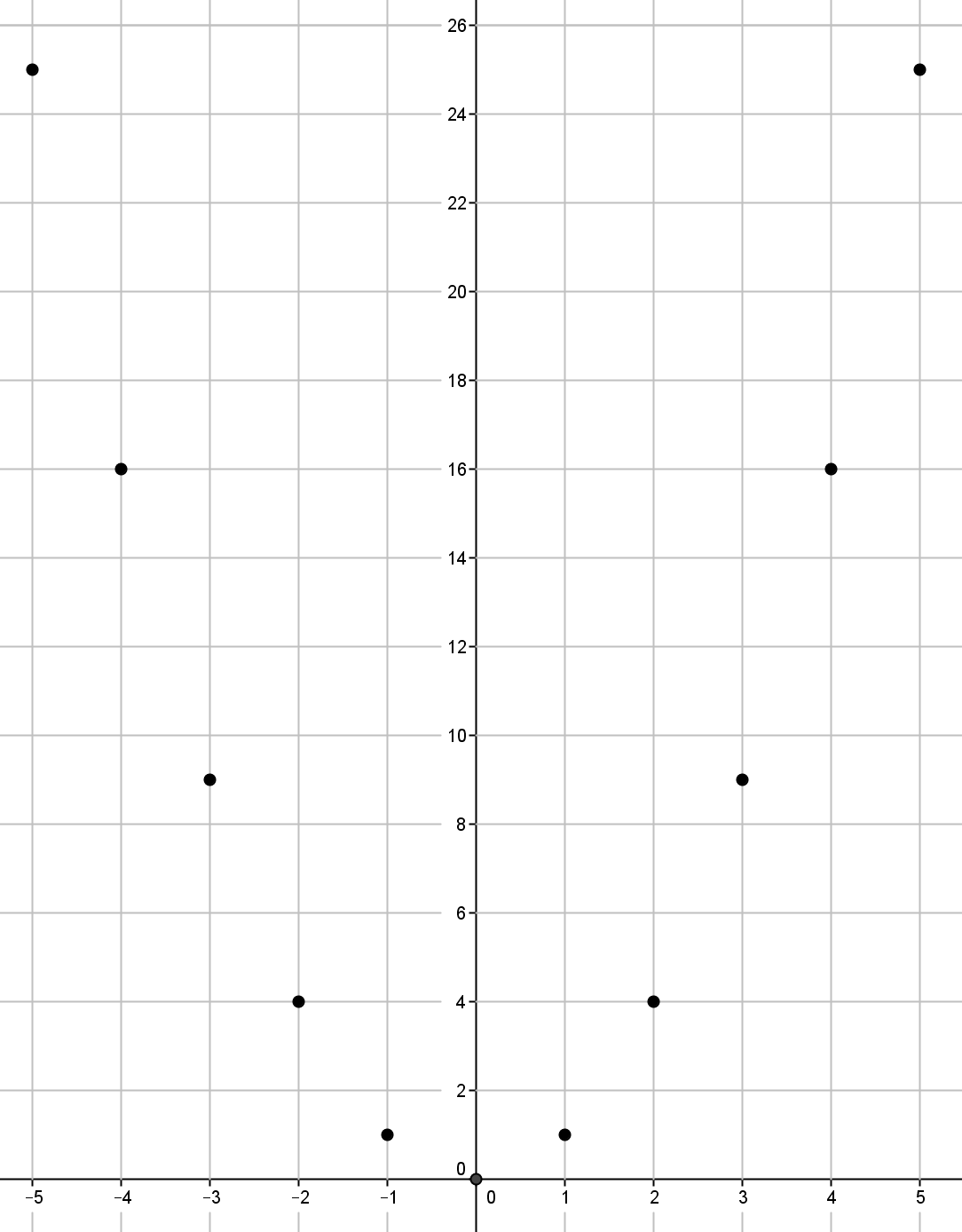

* 1. What shape does the graph of the points appear to take?

It appears to take the shape of a curve.

* 1. Find the rate of change using rows 1 and 2 from the table above.
  2. Find the rate of change using rows 2 and from the above table.
  3. Find the rate of change using any two other rows from the above table.

Student work will vary.

* 1. Return to your initial claim about the function. Is it linear or nonlinear? Justify your answer with as many pieces of evidence as possible.

This is definitely a nonlinear function because the rate of change is not a constant for any interval of inputs. Also, we would expect the graph of a linear function to be a line, and this graph is not a line. As was stated before, the expression is nonlinear.

1. A function has the rule so that each input of is assigned an output of .
   1. Do you think the function is linear or nonlinear? Explain.

I think the function is nonlinear because nonlinear expressions have variables with exponents that are greater than one.

* 1. Develop a list of inputs and outputs for this function. Organize your work using the table below. Then, answer the questions that follow.

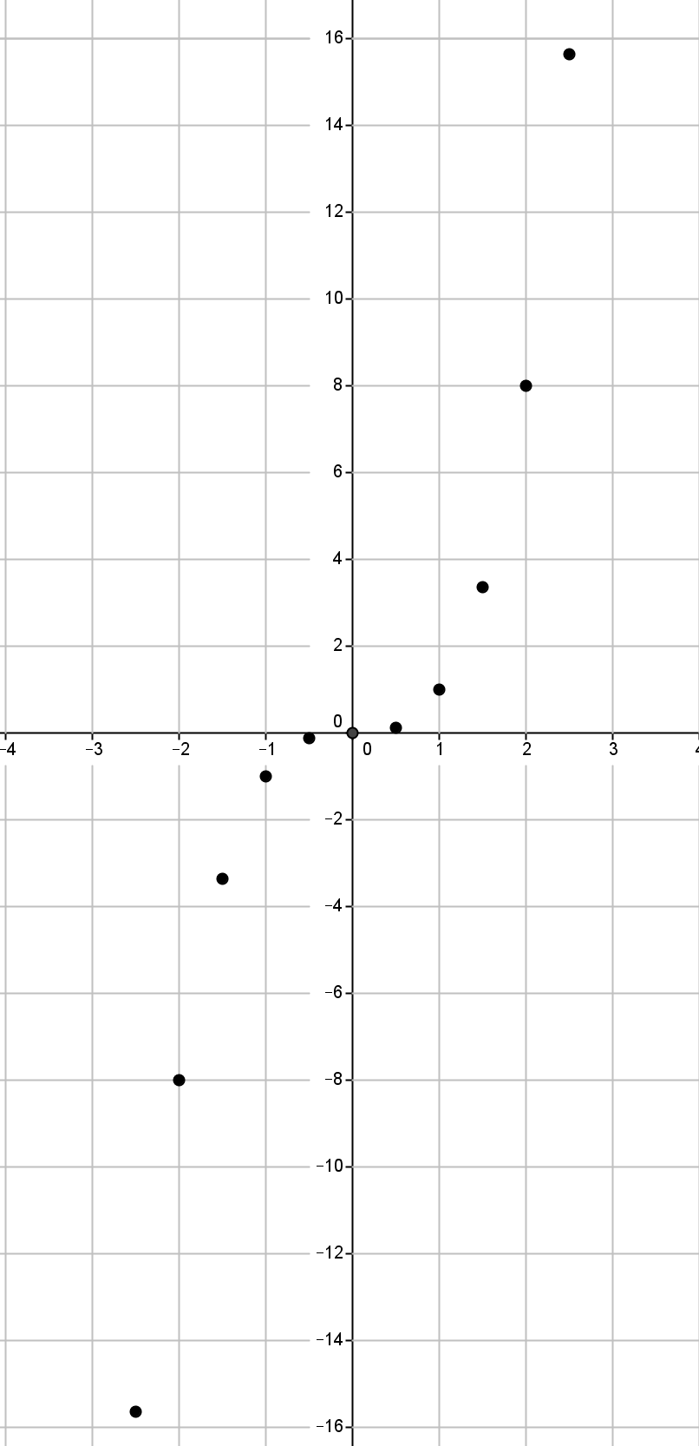

|  |  |
| --- | --- |
| Input () | Output () |
|  |  |
|  |  |
|  |  |
|  |  |
|  |  |
|  |  |
|  |  |
|  |  |
|  |  |
|  |  |
|  |  |

* 1. Plot the inputs and outputs as points on the coordinate plane where the output is the -coordinate.
  2. What shape does the graph of the points appear to take?

It appears to take the shape of a curve.

* 1. Find the rate of change using rows 2 and 3 from the table above.
  2. Find the rate of change using rows 3 and 4 from the table above.
  3. Find the rate of change using rows 8 and 9 from the table above.
  4. Return to your initial claim about the function. Is it linear or nonlinear? Justify your answer with as many pieces of evidence as possible.

This is definitely a nonlinear function because the rate of change is not a constant for any interval of inputs. Also, we would expect the graph of a linear function to be a line, and this graph is not a line. As was stated before, the expression is nonlinear.

1. A function has the rule so that each input of is assigned an output of for values of .
   1. Do you think the function is linear or nonlinear? Explain.

I think the function is nonlinear because nonlinear expressions have exponents that are less than one.

* 1. Develop a list of inputs and outputs for this function. Organize your work using the table. Then, answer the questions that follow.

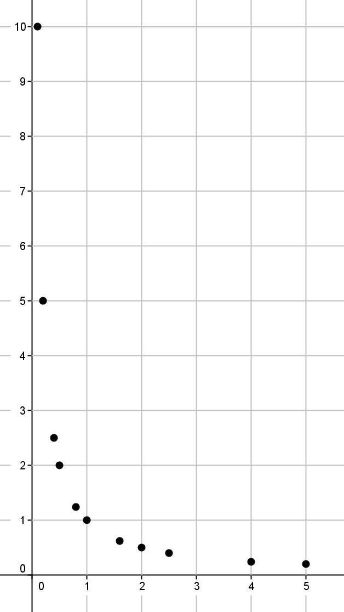

|  |  |
| --- | --- |
| Input | Output |
|  |  |
|  |  |
|  |  |
|  |  |
|  |  |
|  |  |
|  |  |
|  |  |
|  |  |
|  |  |
|  |  |

* 1. Plot the inputs and outputs as points on the   
     coordinate plane where the output is the -coordinate.
  2. What shape does the graph of the points appear to take?

It appears to take the shape of a curve.

* 1. Find the rate of change using rows 1 and 2 from the table above.
  2. Find the rate of change using rows 2 and from the table above.
  3. Find the rate of change using any two other rows from the table above.

Student work will vary.

* 1. Return to your initial claim about the function. Is it linear or nonlinear? Justify your answer with as many pieces of evidence as possible.

This is definitely a nonlinear function because the rate of change is not a constant for any interval of inputs. Also, we would expect the graph of a linear function to be a line, and this graph is not a line. As was stated before, the expression is nonlinear.

**Discussion (4 minutes)**

* What did you notice about the rates of change in the preceding three problems?
  + *The rates of change were not all the same for each problem.*
* In Lesson 6, we learned that if the rate of change for pairs of inputs and corresponding outputs is the same for each pair, then what do we know about the function?
  + *We know the function is linear.*
* Therefore, if we know a rate of change for pairs of inputs and corresponding outputs is not the same for each pair, what do we know about the function?
  + *We know the function is nonlinear.*
* What did you notice about the exponent of in the preceding three problems?
  + *The equations and have variables with exponents that are greater than one, while the equation has an exponent of that is less than one.*
* What is another way to identify equations that are nonlinear?
  + *We know the function is nonlinear when the exponent of is not equal to one.*

**Exercises 4–10 (12 minutes)**

Students work independently or in pairs to complete Exercises 4–10.

In Exercises 4–10, the rule that describes a function is given. If necessary, use a table to organize pairs of inputs and outputs, and then plot each on a coordinate plane to help answer the questions.

1. Macintosh HD:Users:stefaniehassan:Desktop:exercise4.pdfWhat shape do you expect the graph of the function described by to take? Is it a linear or nonlinear function?

I expect the shape of the graph to be a line. This function is a linear function described by the linear equation . The graph of this function is a line.

Macintosh HD:Users:stefaniehassan:Desktop:exercise5.pdf

1. What shape do you expect the graph of the function described by to take? Is it a linear or nonlinear function?

I expect the shape of the graph to be something other than a line. This function is nonlinear because its graph is not a line, and the exponent of is greater than one.

1. Macintosh HD:Users:stefaniehassan:Desktop:exercise6.pdfWhat shape do you expect the graph of the function described by to take? Is it a linear or nonlinear function?

I expect the shape of the graph to be a line. This function is a linear function described by the linear equation . The graph of this function is a line.

Macintosh HD:Users:stefaniehassan:Desktop:exercise7.pdf

1. What shape do you expect the graph of the function described by to take? Is it a linear or nonlinear function?

I expect the shape of the graph to be something other than a line. This function is nonlinear because its graph is not a line, and the exponent of is greater than one.

1. Macintosh HD:Users:stefaniehassan:Desktop:exercise9.pdfWhat shape do you expect the graph of the function described by to take? Is it a linear or nonlinear function?

I expect the shape of the graph to be something other than a line. This function is nonlinear because its graph is not a line, and the exponent of is less than one.

Macintosh HD:Users:stefaniehassan:Desktop:exercise10.pdf

1. What shape do you expect the graph of the function described by to take? Is it a linear or nonlinear function?

I expect the shape of the graph to be something other than a line. This function is nonlinear because its graph is not a line, and the exponent of is less than one.

1. Macintosh HD:Users:stefaniehassan:Desktop:exercise8.pdfWhat shape do you expect the graph of the equation to take? Is it a linear or nonlinear? Is it a function? Explain.

I expect the shape of the graph to be something other than a line. It is nonlinear because its graph is not a line, and the exponent of is greater than one. It is not a function because there is more than one output for any given value of in the interval . For example, at the -value is both and . This does not fit the definition of function because functions assign to each input exactly one output. Since there is at least one instance where an input has two outputs, it is not a function.

Closing (5 minutes)

Summarize, or ask students to summarize, the main points from the lesson.

* Students understand that, unlike linear functions, nonlinear functions do not have a constant rate of change.
* Students know that if the exponent of is not equal to one, the graph will not be linear.
* Students expect the graph of nonlinear functions to be some sort of curve.

Lesson Summary

**One way to determine if a function is linear or nonlinear is by inspecting the rate of change using a table of values. Another way is to examine its graph. Functions described by nonlinear equations do not have a constant rate of change. Because some functions can be described by equations, an examination of the equation allows you to determine if the function is linear or nonlinear. Just like with equations, when the exponent of the variable is not equal to , then the equation is nonlinear; therefore, the graph of the function described by a nonlinear equation will graph as some kind of curve, i.e., not a line.**

Exit Ticket (5 minutes)

Name Date

Lesson 8: Graphs of Simple Nonlinear Functions

Exit Ticket

1. The graph below is the graph of a function. Do you think the function is linear or nonlinear? Show work in your explanation that supports your answer.

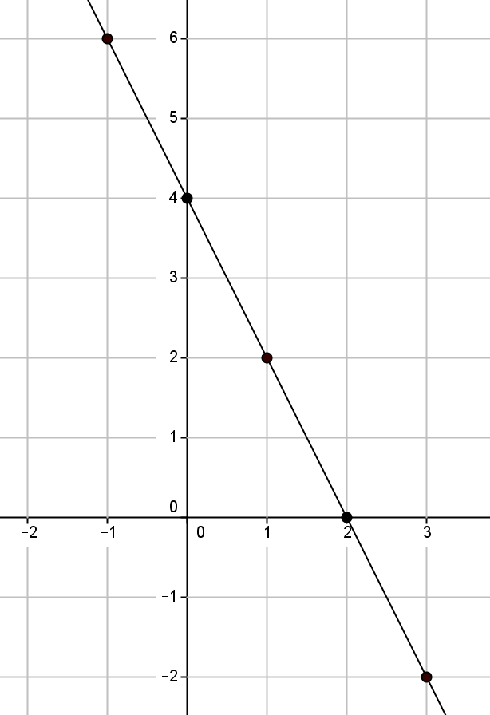

1. A function has the rule so that each input of is assigned an output of Do you think the graph of the function will be linear or nonlinear? What shape do you expect the graph to take? Explain.

Exit Ticket Sample Solutions

1. The graph below is the graph of a function. Do you think the function is linear or nonlinear? Show work in your explanation that supports your answer.



Student work may vary. Accept any answer that shows the rate of change is not the same for two or more sets of coordinates.

|  |  |
| --- | --- |
| The rate of change of the coordinates and : | The rate of change of the coordinates and : |

When I check the rate of change for any two coordinates, they are the same; therefore, the graph of the equation is linear.

1. A function has the rule so that each input of is assigned an output of. Do you think the graph of the function will be linear or nonlinear? What shape do you expect the graph to be? Explain.

The equation is nonlinear because the exponent of is greater than . I expect the graph to be some sort of curve.

Problem Set Sample Solutions

1. A function has the rule so that each input of is assigned an output of.
   1. Do you think the function is linear or nonlinear? Explain.

No, I do not think the equation is linear. The exponent of is greater than one.

* 1. What shape do you expect the graph of the function to be?

I think the shape of the graph will be a curve.

* 1. Develop a list of inputs and outputs for this function. Plot the inputs and outputs as points on the coordinate plane where the output is the -coordinate.

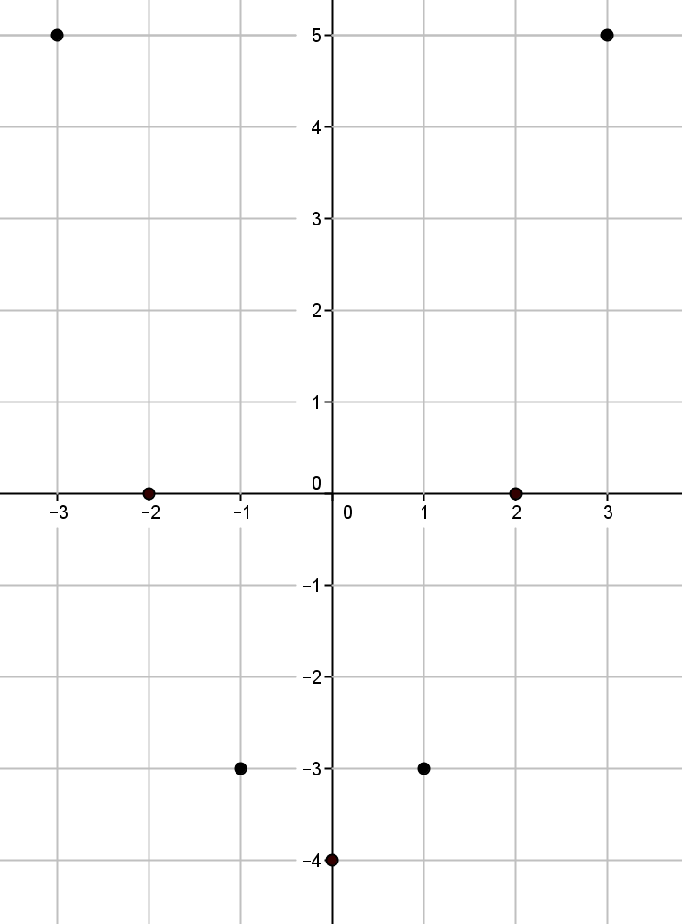

|  |  |
| --- | --- |
| Input | Output |
|  |  |
|  |  |
|  |  |
|  |  |
|  |  |
|  |  |
|  |  |

* 1. Was your prediction correct?

Yes, the graph appears to be taking the shape   
of some type of curve.

1. A function has the rule so that each input of is assigned an output of.
   1. Is the function linear or nonlinear? Explain.

No, I do not think the function is linear. The exponent of is less than one.

* 1. What shape do you expect the graph of the function to take?

I think the shape of the graph will be a curve.

* 1. Given the inputs in the table below, use the rule of the function to determine the corresponding outputs. Plot the inputs and outputs as points on the coordinate plane where the output is the -coordinate.

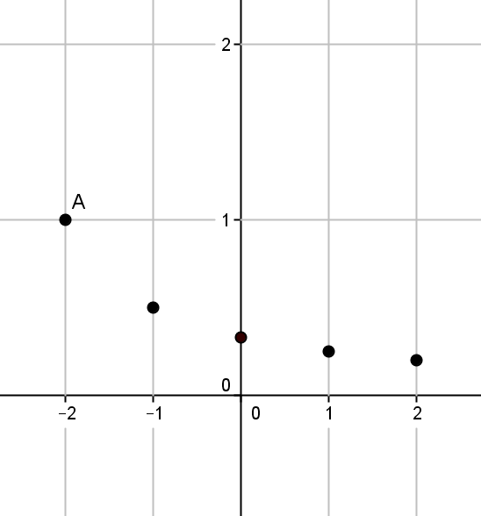

|  |  |
| --- | --- |
| Input | Output |
|  |  |
|  |  |
|  |  |
|  |  |
|  |  |
|  |  |

* 1. Was your prediction correct?

Yes, the graph appears to be taking the shape of some type of curve.

1. 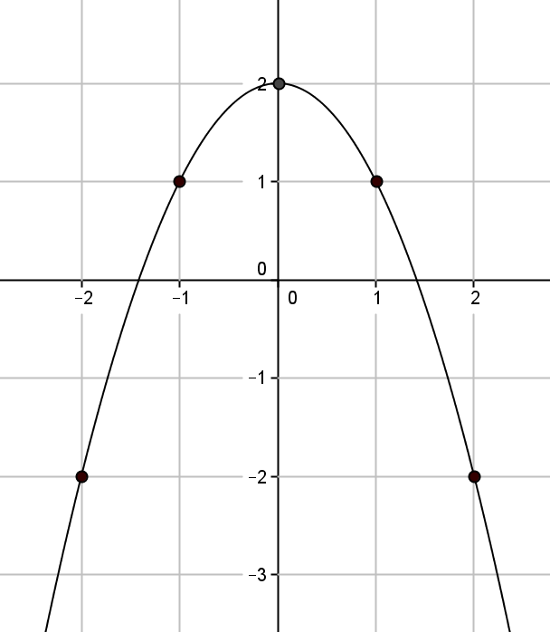Is the function that is represented by this graph linear or nonlinear? Explain. Show work that supports your conclusion.

Student work may vary. Accept any answer that shows the rate of change is not the same for two or more sets of coordinates.

It does not appear to be linear.

The rate of change for the coordinates and :

The rate of change for the coordinates and :

No, the graph is not linear; therefore, the function is not linear. When I check the rate of change for any two sets of coordinates, they are not the same.