Lesson 7: Comparing Linear Functions and Graphs

Classwork
Exercises
Exercises 1–4 provide information about functions. Use that information to help you compare the functions and answer the questions.
- Alan and Margot drive from City A to City B, a distance of $147$ miles. They take the same route and drive at constant speeds. Alan begins driving at 1:40 p.m. and arrives at City B at 4:15 p.m. Margot’s trip from City A to City B can be described with the equation $y=64x$, where $y$is the distance traveled and $x$ is the time in minutes spent traveling. Who gets from City A to City B faster?
- You have recently begun researching phone billing plans. Phone Company A charges a flat rate of $\$75$ a month. A flat rate means that your bill will be $\$75$ each month with no additional costs. The billing plan for Phone Company B is a linear function of the number of texts that you send that month. That is, the total cost of the bill changes each month depending on how many texts you send. The table below represents the inputs and the corresponding outputs that the function assigns.
Input  (number of texts) | Output  (cost of bill)
$$50$$ | $$\$50$$
$$150$$ | $$\$60$$
$$200$$ | $$\$65$$
$$500$$ | $$\$95$$

At what number of texts would the bill from each phone plan be the same? At what number of texts is Phone Company A the better choice? At what number of texts is Phone Company B the better choice?

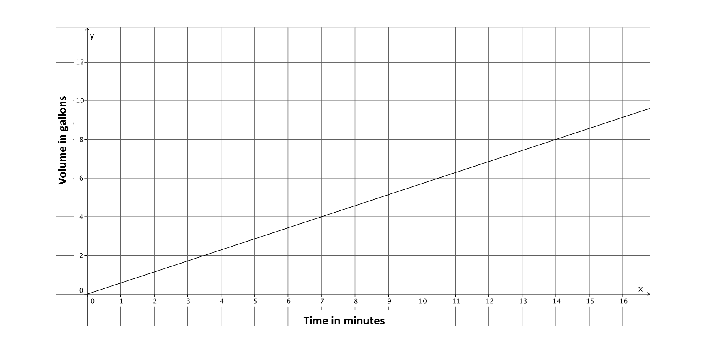
- A function describes the volume of water, $y$, that flows from Faucet $A$ in gallons for $x$ minutes. The graph below is the graph of this linear function. Faucet B’s water flow can be described by the equation $y=\frac{5}{6}x$, where $y$ is the volume of water in gallons that flows from the faucet in $x$ minutes. Assume the flow of water from each faucet is constant. Which faucet has a faster rate of flow of water? Each faucet is being used to fill tubs with a volume of $50$ gallons. How long will it take each faucet to fill the tub? How do you know? The tub that is filled by Faucet A already has $15$ gallons in it. If both faucets are turned on at the same time, which faucet will fill its tub faster?

- Two people, Adam and Bianca, are competing to see who can save the most money in one month. Use the table and the graph below to determine who will save more money at the end of the month. State how much money each person had at the start of the competition.
Bianca’s Savings:

Input  (Number of Days) | Output  (Total amount of money)
$$5$$ | $$\$17$$
$$8$$ | $$\$26$$
$$12$$ | $$\$38$$
$$20$$ | $$\$62$$

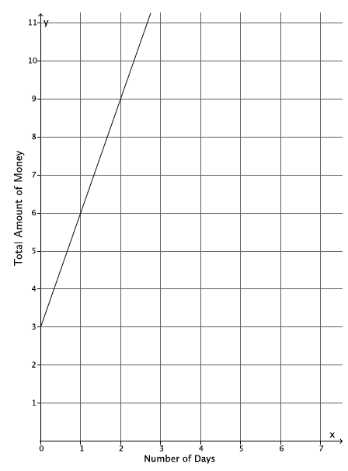
Adam’s Savings:

Problem Set

- The graph below represents the distance$,$ $y$, Car A travels in $x$ minutes. The table represents the distance, $y$, Car B travels in $x$ minutes. Which car is traveling at a greater speed? How do you know?
Car A:
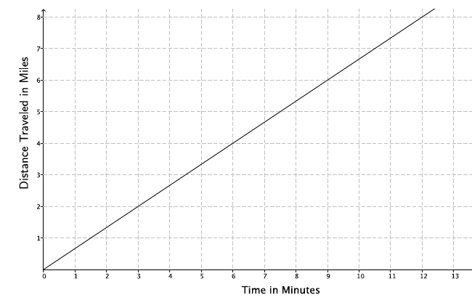
Car B:
Time in minutes  $$\left(x\right)$$ | Distance  $$(y)$$
$$15$$ | $$12.5$$
$$30$$ | $$25$$
$$45$$ | $$37.5$$

- The local park needs to replace an existing fence that is 6 feet high. Fence Company A charges $\$7,000$ for building materials and $\$200$ per foot for the length of the fence. Fence Company B charges based on the length of the fence. That is, the total cost of the six-foot high fence will depend on how long the fence is. The table below represents the inputs and the corresponding outputs that the function assigns for Fence Company B.
Input  (length of fence) | Output  (cost of bill)
$$100$$ | $$\$26,000$$
$$120$$ | $$\$31,200$$
$$180$$ | $$\$46,800$$
$$250$$ | $$\$65,000$$
  - Which company charges a higher rate per foot of fencing? How do you know?
  - At what number of the length of the fence would the cost from each fence company be the same? What will the cost be when the companies charge the same amount? If the fence you need is $190$ feet in length, which company would be a better choice?
- The rule $y=123x$ is used to describe the function for the number of minutes needed, $x$, to produce $y$ toys at Toys Plus. Another company, #1 Toys, has a similar function that assigned the values shown in the table below. Which company produces toys at a slower rate? Explain.
Time in minutes  ($x$) | Toys Produced  ($y$)
$$5$$ | $$600$$
$$11$$ | $$1,320$$
$$13$$ | $$1,560$$

- A function describes the number of miles a train can travel, $y$, for the number of hours, $x$. The figure shows the graph of this function. Assume that the train travels at a constant speed. The train is traveling from City A to City B (a distance of $320$ miles). After $4$ hours, the train slows down to a constant speed of $48$ miles per hour.

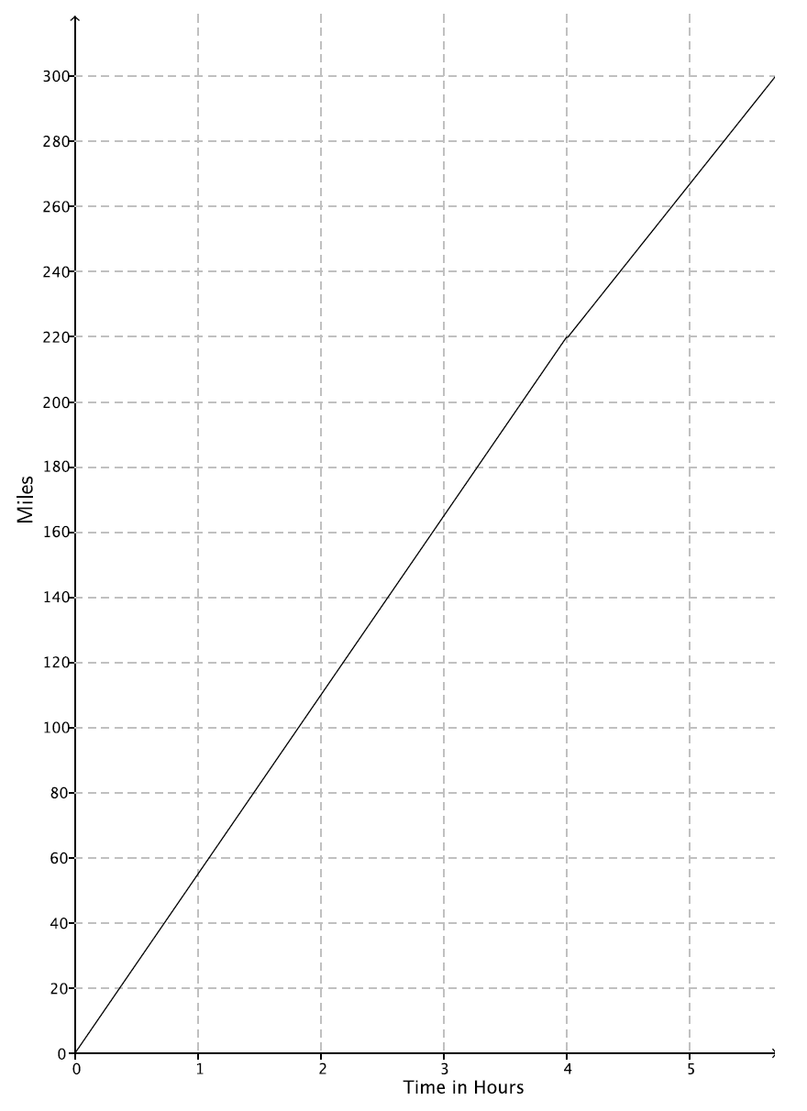

  - How long will it take the train to reach its destination?
  - If the train had not slowed down after $4$ hours, how long would it have taken to reach its destination?
  - Suppose after $4$ hours, the train increased its constant speed. How fast would the train have to travel to complete the destination in $1.5$ hours?
  - A hose is used to fill up a $1,200$ gallon water truck at a constant rate. After $10$ minutes, there are $65$ gallons of water in the truck. After $15$ minutes, there are $82$ gallons of water in the truck. How long will it take to fill up the water truck?
  - The driver of the truck realizes that something is wrong with the hose he is using. After $30$ minutes, he shuts off the hose and tries a different hose. The second hose has a constant rate of $18$ gallons per minute. How long does it take the second hose to fill up the truck?
  - Could there ever be a time when the first hose and the second hose filled up the same amount of water?

