Lesson 7: Comparing Linear Functions and Graphs

Student Outcomes
- Students compare the properties of two functions represented in different ways, including tables, graphs, equations, and written descriptions.
- Students use rate of change to compare functions, determining which function has a greater rate of change.

Lesson Notes
The Fluency Exercise included in this lesson will take approximately $10$ minutes and should be assigned either at the beginning or at the end of the lesson.

Classwork
Exploratory Challenge/Exercises 1–4 (20 minutes)
Students work in small groups to complete Exercises 1–4. Groups can select a method of their choice to answer the questions, and their methods will be a topic of discussion once the Exploratory Challenge is completed. Encourage students to discuss the various methods (e.g., graphing, comparing rates of change, using algebra) as a group before they begin solving.
MP.1

Exercises
Exercises 1–4 provide information about functions. Use that information to help you compare the functions and answer the questions.
- Alan and Margot drive from City A to City B, a distance of $147$ miles. They take the same route and drive at constant speeds. Alan begins driving at 1:40 p.m. and arrives at City B at 4:15 p.m. Margot’s trip from City A to City B can be described with the equation $y=64x$, where $y$is the distance traveled in miles and $x$ is the time in minutes spent traveling. Who gets from City A to City B faster?
Student solutions will vary. Sample solution is provided.
Scaffolding:
Providing example language for students to reference will be useful. This might consist of sentence starters, sentence frames, or a word wall.
It takes Alan $155$ minutes to travel the $147$ miles. Therefore, his constant rate is $\frac{147}{155}$ miles per minute.
Margot drives $64$ miles per hour ($60$minutes). Therefore, her constant rate is $\frac{64}{60}$ miles per minute.
To determine who gets from City A to City B faster, we just need to compare their rates in miles per minutes:
$$\frac{147}{155}<\frac{64}{60}.$$
Since Margot’s rate is faster, she will get to City B faster than Alan.

- You have recently begun researching phone billing plans. Phone Company A charges a flat rate of $\$75$ a month. A flat rate means that your bill will be $\$75$ each month with no additional costs. The billing plan for Phone Company B is a linear function of the number of texts that you send that month. That is, the total cost of the bill changes each month depending on how many texts you send. The table below represents the inputs and the corresponding outputs that the function assigns.
Input  (number of texts) | Output  (cost of bill)
$$50$$ | $$\$50$$
$$150$$ | $$\$60$$
$$200$$ | $$\$65$$
$$500$$ | $$\$95$$

At what number of texts would the bill from each phone plan be the same? At what number of texts is Phone Company A the better choice? At what number of texts is Phone Company B the better choice?
Student solutions will vary. Sample solution is provided.
The equation that represents the function for Phone Company A is $y=75$.
To determine the equation that represents the function for Phone Company B, we need the rate of change:
$$\frac{60-50}{150-50}=\frac{10}{100} \\ =0.1$$ | $$\frac{65-60}{200-150}=\frac{5}{50} \\ =0.1$$ | $$\frac{95-65}{500-200}=\frac{30}{300} \\ =0.1$$
The equation for Phone Company B is shown below.
Using the assignment of $50$ to $50$,
$$50=0.1\left(50\right)+b \\ 50=5+b \\ 45=b.$$
The equation that represents the function for Phone Company B is $y=0.1x+45$.
We can determine at what point the phone companies charge the same amount by solving the system:
$$\left\{\begin{aligned}y=75 \\ y=0.1x+45\end{aligned}\right.$$
$$75=0.1x+45 \\ 30=0.1x \\ 300=x$$
After $300$ texts are sent, both companies would charge the same amount, $\$75$. More than $300$ texts means that the bill from Phone Company B will be higher than Phone Company A. Less than $300$ texts means the bill from Phone Company A will be higher.

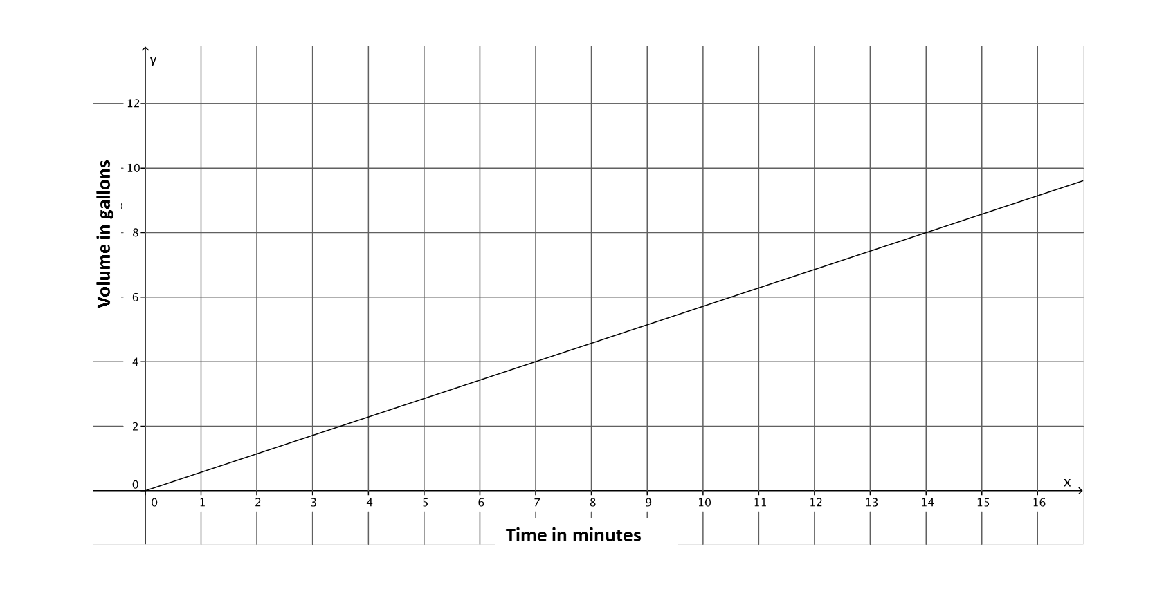
- A function describes the volume of water, $y$, that flows from Faucet A in gallons for $x$ minutes. The graph below is the graph of this linear function. Faucet B’s water flow can be described by the equation $y=\frac{5}{6}x$, where $y$ is the volume of water in gallons that flows from the faucet in $x$ minutes. Assume the flow of water from each faucet is constant. Which faucet has a faster rate of flow of water? Each faucet is being used to fill tubs with a volume of $50$ gallons. How long will it take each faucet to fill the tub? How do you know? The tub that is filled by Faucet A already has $15$ gallons in it. If both faucets are turned on at the same time, which faucet will fill its tub faster?
Student solutions will vary. Sample solution is provided.
The slope of the graph of the line is $\frac{4}{7}$because $(7, 4)$ is a point on the line that represents $4$ gallons of water that flows in $7$ minutes. Therefore, the rate of water flow for Faucet A is $\frac{4}{7}$. To determine which faucet has a faster flow of water, we can compare their rates.
$$\frac{4}{7}<\frac{5}{6}$$
Therefore, Faucet B has a faster rate of water flow.
Faucet A  $$50=\frac{4}{7}x \\ 50\left(\frac{7}{4}\right)=x \\ \frac{350}{4}=x \\ 87.5=x$$  It will take $87.5$ minutes to fill a tub of $50$ gallons. | Faucet B  $$y=\frac{5}{6}x \\ 50=\frac{5}{6}x \\ 50\left(\frac{6}{5}\right)=x \\ 60=x$$  It will take $60$ minutes to fill a tub of $50$ gallons. | The tub filled by Faucet A that already has $15$ gallons in it  $$50=\frac{4}{7}x+15 \\ 35=\frac{4}{7}x \\ 35\left(\frac{7}{4}\right)=x \\ 61.25=x$$  Faucet B will fill the tub first because it will take Faucet A $61.25$ minutes to fill the tub, even though it already has $15$ gallons in it.

- Two people, Adam and Bianca, are competing to see who can save the most money in one month. Use the table and the graph below to determine who will save more money at the end of the month. State how much money each person had at the start of the competition.
Adam’s Savings: Bianca’s Savings:
Input  (Number of Days) | Output  (Total amount of money)
$$5$$ | $$\$17$$
$$8$$ | $$\$26$$
$$12$$ | $$\$38$$
$$20$$ | $$\$62$$
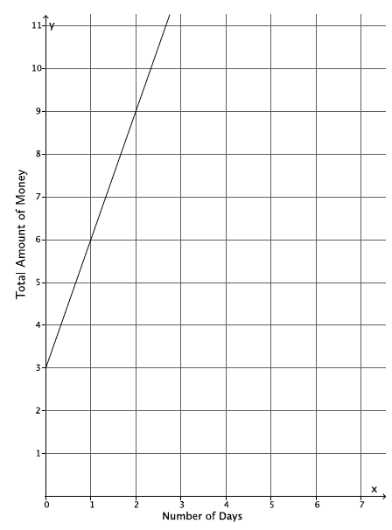

The slope of the line that represents Adam’s savings is $3$; therefore, the rate at which Adam is saving money is $\$3$ per day. According to the table of values for Bianca, she is also saving money at a rate of $\$3$ per day:
$$\frac{26-17}{8-5}=\frac{9}{3}=3$$
$$\frac{38-26}{12-8}=\frac{12}{4}=3$$
$$\frac{62-26}{20-8}=\frac{36}{12}=3$$
Therefore, at the end of the month, Adam and Bianca will both have saved the same amount of money.
According to the graph for Adam, the equation $y=3x+3$ represents the function of money saved each day. On day zero, he must have had $\$3$.
The equation that represents the function of money saved each day for Bianca is $y=3x+2$because using the assignment of $17$ to $5$:
$$17=3\left(5\right)+b \\ 17=15+b \\ 2=b.$$
The amount of money Bianca had on day zero is $\$2$.

Discussion (5 minutes)
To encourage students to compare different methods of solving problems and to make connections between them, ask students to describe their methods for determining the answers to Exercises 1–4. Use the following questions to guide the discussion.
MP.1
- Was one method more efficient than the other? Does everyone agree? Why or why not?
- How did you know which method was more efficient? Did you realize at the beginning of the problem or after they finished?
- Did you complete every problem using the same method? Why or why not?

Closing (5 minutes)
Summarize, or ask students to summarize, the main points from the lesson:
- We know that functions can be expressed as equations, graphs, tables, and using verbal descriptions. Regardless of the way that the function is expressed, we can compare it with another function.
- We know that we can compare two functions using different methods. Some methods are more efficient than others.

Exit Ticket (5 minutes)

Fluency Exercise (10 minutes): Multi-Step Equations II
RWBE: During this exercise, students will solve nine multi-step equations. Each equation should be solved in about a minute. Consider having students work on white boards, showing you their solutions after each problem is assigned. The nine equations and their answers are below. Refer to the Rapid White Board Exchanges section in the Module Overview for directions to administer a RWBE.

Name Date
Lesson 7: Comparing Linear Functions and Graphs

Exit Ticket

Brothers, Paul and Pete, walk $2$ miles to school from home. Paul can walk to school in $24$ minutes. Pete has slept in again and needs to run to school. Paul walks at constant rate, and Pete runs at a constant rate. The graph of the function that represents Pete’s run is shown below.
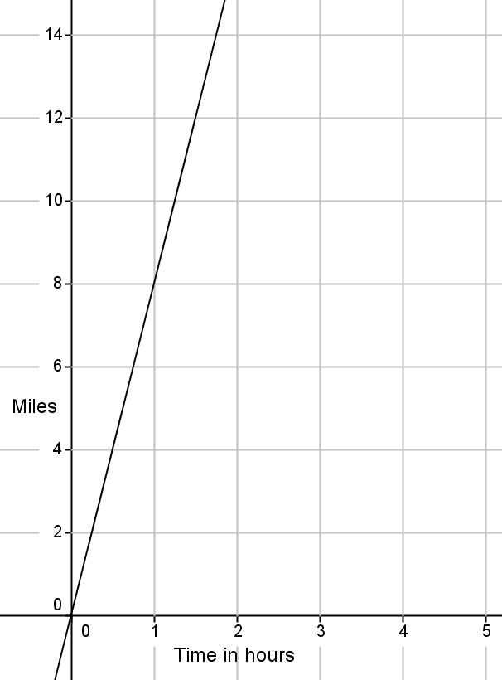
  - Which brother is moving at a greater rate? Explain how you know.

  - If Pete leaves $5$ minutes after Paul, will he catch Paul before they get to school?
Exit Ticket Sample Solutions

Brothers, Paul and Pete, walk $2$ miles to school from home. Paul can walk to school in $24$ minutes. Pete has slept in again and needs to run to school. Paul walks at constant rate, and Pete runs at a constant rate. The graph of the function that represents Pete’s run is shown below.
  - Which brother is moving at a greater rate? Explain how you know.
Paul takes $24$ minutes to walk $2$ miles; therefore, his rate is $\frac{1}{12}$.
Pete can run $8$ miles in $60$ minutes; therefore, his rate is $\frac{8}{60}$, or $\frac{2}{15}.$
Since $\frac{2}{15}>\frac{1}{12}$, Pete is moving at a greater rate.

  - If Pete leaves $5$ minutes after Paul, will he catch Paul before they get to school?
Student solution methods will vary. Sample answer is shown.
Since Pete slept in, we need to account for that fact. So, Pete’s time would be decreased. The equation that would represent the number of miles Pete walks, $y$, walked in $x$ minutes, would be
$y=\frac{2}{15}(x-5)$.
The equation that would represent the number of miles Paul runs, $y$, run in $x$ minutes, would be $y=\frac{1}{12}x.$
To find out when they meet, solve the system of equations:
$$\left\{\begin{aligned}y=\frac{2}{15}x-\frac{2}{3} \\ y=\frac{1}{12}x \end{aligned}\right.$$ |  | $$\frac{2}{15}x-\frac{2}{3}=\frac{1}{12}x \\ \frac{2}{15}x-\frac{2}{3}-\frac{1}{12}x+\frac{2}{3}=\frac{1}{12}x-\frac{1}{12}x+\frac{2}{3} \\ \frac{1}{20}x=\frac{2}{3} \\ \left(\frac{20}{1}\right)\frac{1}{20}x=\frac{2}{3}\left(\frac{20}{1}\right) \\ x=x\frac{40}{3}$$
$$y=\left(\frac{40}{3}\right)=\frac{10}{9}$$ | or |  | $$y=\frac{2}{15}\left(\frac{40}{3}\right)-\frac{2}{3}$$
Pete would catch up to Paul in $\frac{40}{9}$ minutes, which is equal to $\frac{10}{9}$ miles. Yes, he will catch Paul before they get to school because it is less than the total distance, two miles, to school.

Problem Set Sample Solutions

- The graph below represents the distance,$y$, Car A travels in $x$ minutes. The table represents the distance, $y$, Car B travels in $x$ minutes. Which car is traveling at a greater speed? How do you know?
Car A$:$
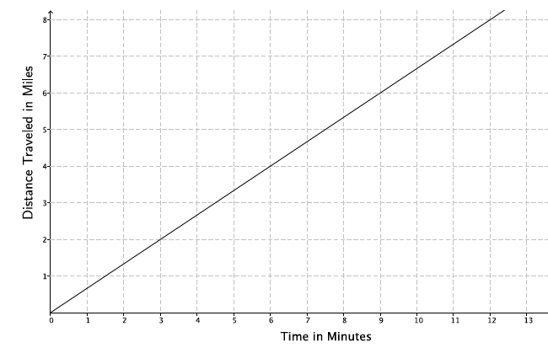
Car B:
Time in minutes  ($x$) | Distance  ($y$)
$$15$$ | $$12.5$$
$$30$$ | $$25$$
$$45$$ | $$37.5$$
Based on the graph, Car A is traveling at a rate of $2$ miles every $3$ minutes, $m=\frac{2}{3}$. From the table, the rate that Car B is traveling is constant, as shown below.
$$\frac{25-12.5}{30-15}=\frac{12.5}{15}=\frac{25}{30}=\frac{5}{6} \\ \frac{37.5-25}{45-30}=\frac{12.5}{15}=\frac{5}{6} \\ \frac{37.5-12.5}{45-15}=\frac{25}{30}=\frac{5}{6}$$
Since $\frac{5}{6}>\frac{2}{3}$, Car B is traveling at a greater speed.

- The local park needs to replace an existing fence that is $6$ feet high. Fence Company A charges $\$7,000$ for building materials and $\$200$ per foot for the length of the fence. Fence Company B charges based on the length of the fence. That is, the total cost of the $6$-foot high fence will depend on how long the fence is. The table below represents the inputs and the corresponding outputs that the function for Fence Company B assigns.
Input  (length of fence) | Output  (cost of bill)
$$100$$ | $$\$26,000$$
$$120$$ | $$\$31,200$$
$$180$$ | $$\$46,800$$
$$250$$ | $$\$65,000$$

  - Which company charges a higher rate per foot of fencing? How do you know?
Let $x$ represent the length of the fence and $y$ represent the total cost.
The equation that represents the function for Fence Company A is $y=200x+7,000$. So, the rate is $200$.
The rate of change for Fence Company B:
$$\frac{26,000-31,200}{100-120}=\frac{-5,200}{-20} \\ =260$$ | $$\frac{31,200-46,800}{120-180}=\frac{-15,600}{-60} \\ =260$$ | $$\frac{46,800-65,000}{180-250}=\frac{-18,200}{-70} \\ =260$$
Fence Company B charges a higher rate per foot because when you compare the rates, $260>200$.

  - At what number of the length of the fence would the cost from each fence company be the same? What will the cost be when the companies charge the same amount? If the fence you need is $190$ feet in length, which company would be a better choice?
Student solutions will vary. Sample solution is provided.
The equation for Fence Company B is
$y=260x$.
We can find out at what point the fence companies charge the same amount by solving the system:
$$\left\{\begin{aligned}y=200x+7000 \\ y=260x \end{aligned}\right.$$ | $$200x+7,000=260x \\ 7,000=60x \\ 116.6666…...=x \\ 116.6≈x$$
At $116.6$ feet of fencing, both companies would charge the same amount (about $\$30,320$). Less than $116.6$ feet of fencing means that the cost from Fence Company A will be more than Fence Company B. More than $116.6$ feet of fencing means that the cost from Fence Company B will be more than Fence Company A. So, for $190$ feet of fencing, Fence Company A is the better choice.

- The rule $y=123x$ is used to describe the function for the number of minutes needed, $x$, to produce $y$ toys at Toys Plus. Another company, #1 Toys, has a similar function that assigned the values shown in the table below. Which company produces toys at a slower rate? Explain.
Time in minutes  ($x$) | Toys Produced  ($y$)
$$5$$ | $$600$$
$$11$$ | $$1,320$$
$$13$$ | $$1,560$$
#1 Toys produces toys at a constant rate because the data in the table increases at a constant rate, as shown below.
$$\frac{1,320-600}{11-5}=\frac{720}{6} \\ =120$$ | $$\frac{1,560-600}{13-5}=\frac{960}{8} \\ =120$$ | $$\frac{1,560-1,320}{13-11}=\frac{240}{2} \\ =120$$
The rate of production for Toys Plus is $123$ and for #1 Toys is $120$. Since $120<123$, #1 Toys produces toys at a slower rate.

- A function describes the number of miles a train can travel, $y$, for the number of hours, $x$. The figure shows the graph of this function. Assume that the train travels at a constant speed. The train is traveling from City A to City B (a distance of $320$ miles). After $4$ hours, the train slows down to a constant speed of $48$ miles per hour.
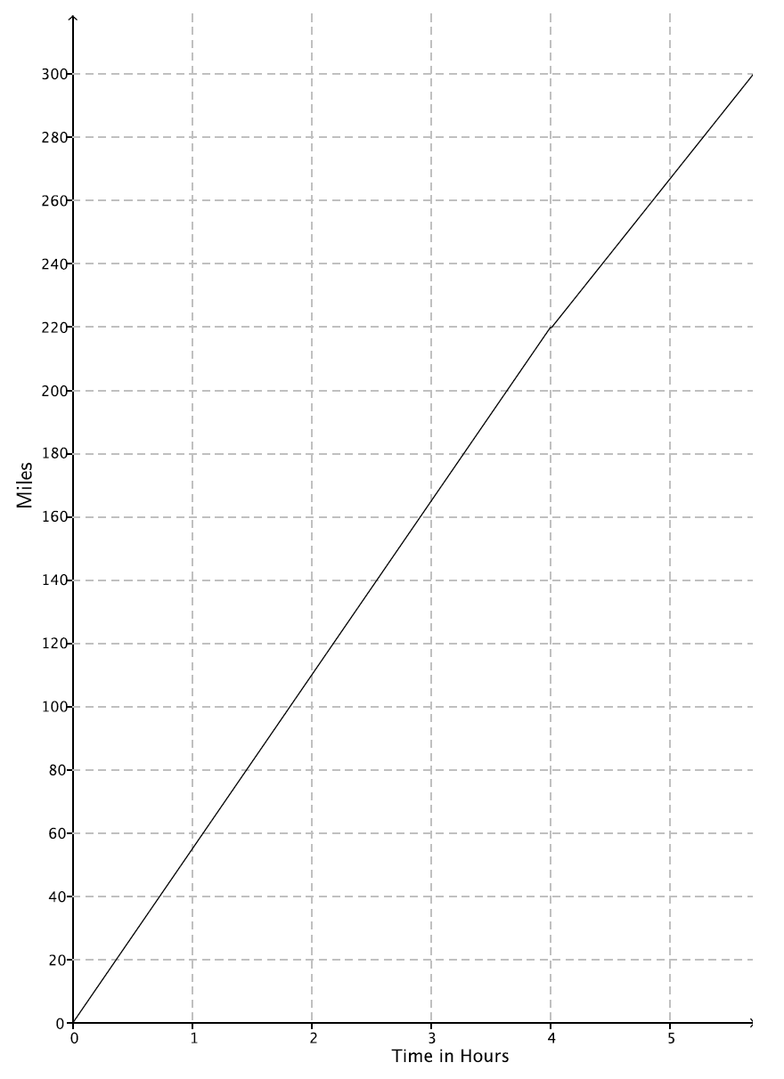

  - How long will it take the train to reach its destination?
Student solutions will vary. Sample solution is provided.
The equation for the graph is $y=55x$. If the train travels for $4$ hours at a rate of $55$ miles per hour, it will have travelled $220$ miles. That means it has $100$ miles to get to its destination. The equation for the second part of the journey is $y=48x$. Then,
$$100=48x \\ 2.08333….=x \\ 2≈x.$$
This means it will take about $6$ hours $\left(4+2=6\right)$ for the train to reach its destination.

  - If the train had not slowed down after $4$ hours, how long would it have taken to reach its destination?
$$320=55x \\ 5.8181818….=x \\ 5.8≈x$$
The train would have reached its destination in about $5.8$ hours had it not slowed down.

  - Suppose after $4$ hours, the train increased its constant speed. How fast would the train have to travel to complete the destination in $1.5$ hours?
Let $m$ represent the new constant speed of the train; then,
$$100=m\left(1.5\right) \\ 66.6666….=x \\ 66.6≈x.$$
The train would have to increase its speed to about $66.6$ miles per hour to arrive at its destination $1.5$ hours later.

  - A hose is used to fill up a $1,200$ gallon water truck at a constant rate. After $10$ minutes, there are $65$ gallons of water in the truck. After $15$minutes, there are $82$ gallons of water in the truck. How long will it take to fill up the water truck?
Student solutions will vary. Sample solution is provided.
Let $x$ represent the time in minutes it takes to pump $y$ gallons of water. Then, the rate can be found as follows:
Time in minutes ($x$) | Amount of water pumped in gallons ($y$)
$$10$$ | $$65$$
$$15$$ | $$82$$
$$\frac{65-82}{10-15}=\frac{-17}{-5} \\ =\frac{17}{5}$$
Since the water is pumping at a constant rate, we can assume the equation is linear. Therefore, the equation for the first hose is found by
$$\left\{\begin{aligned}10a+b=65 \\ 15a+b=82\end{aligned} \text{.}\right.$$
If we multiply the first equation by $-1$:
$$\left\{\begin{aligned}-10a-b=-65 \\ 15a+b=82\end{aligned}\right.$$
$$-10a-b+15a+b=-65+82 \\ 5a=17 \\ a=\frac{17}{5}$$
$$10\left(\frac{17}{5}\right)+b=65 \\ b=31$$
The equation for the first hose is $y=\frac{17}{5}x+31$. If the hose needs to pump $1,200$ gallons of water into the truck, then
$$1200=\frac{17}{5}x+31 \\ 1169=\frac{17}{5}x \\ 343.8235….=x \\ 343.8≈x\text{.}$$
It would take about $344$ minutes or about $5.7$ hours to fill up the truck.

  - The driver of the truck realizes that something is wrong with the hose he is using. After $30$ minutes, he shuts off the hose and tries a different hose. The second hose has a constant rate of $18$ gallons per minute. How long does it take the second hose to fill up the truck?
Since the first hose has been pumping for $30$ minutes, there are $133$ gallons of water already in the truck. That means the new hose only has to fill up $1,067$ gallons. Since the second hose fills up the truck at a constant rate of $18$ gallons per minute, the equation for the second hose is $y=18x$.
$$1,067=18x \\ 59.27=x$$
It will take the second hose $59.27$ minutes (or a little less than an hour) to finish the job.

  - Could there ever be a time when the first hose and the second hose filled up the same amount of water?
To see if the first hose and the second hose could have ever filled up the same amount of water, I would need to solve for the system:
$$\left\{\begin{aligned}y=18x \\ y=\frac{17}{5}x+31\end{aligned}\right. \\ 18x=\frac{17}{5}x+31 \\ \frac{73}{5}x=31 \\ x=\frac{155}{73} \\ x≈2.12$$
The second hose could have filled up the same amount of water as the first hose at about $2$ minutes.

Multi-Step Equations II

- $2\left(x+5\right)=3\left(x+6\right)$
$$x=-8$$

- $3\left(x+5\right)=4\left(x+6\right)$
$$x=-9$$

- $4\left(x+5\right)=5\left(x+6\right)$
$$x=-10$$

- $-\left(4x+1\right)=3\left(2x-1\right)$
$$x=\frac{1}{5}$$

- $3\left(4x+1\right)=-\left(2x-1\right)$
$$x=-\frac{1}{7}$$

- $-3\left(4x+1\right)=2x-1$
$$x=-\frac{1}{7}$$

- $15x-12=9x-6$
$$x=1$$

- $\frac{1}{3}\left(15x-12\right)=9x-6$
$$x=\frac{1}{2}$$

- $\frac{2}{3}\left(15x-12\right)=9x-6$
$$x=2$$

