Lesson 6: Graphs of Linear Functions and Rate of Change

Classwork
Opening Exercise
Functions $1$, $2$, and $3$ have the tables shown below. Examine each of them, make a conjecture about which will be linear, and justify your claim.

Input | Output |  | Input | Output |  | Input | Output
$$2$$ | $$5$$ |  | $$2$$ | $$4$$ |  | $$0$$ | $$-3$$
$$4$$ | $$7$$ |  | $$3$$ | $$9$$ |  | $$1$$ | $$1$$
$$5$$ | $$8$$ |  | $$4$$ | $$16$$ |  | $$2$$ | $$6$$
$$8$$ | $$11$$ |  | $$5$$ | $$25$$ |  | $$3$$ | $$9$$

Exercise
A function assigns the inputs and corresponding outputs shown in the table below.
Input | Output
$$1$$ | $$2$$
$$2$$ | $$-1$$
$$4$$ | $$-7$$
$$6$$ | $$-13$$
  - Is the function a linear function? Check at least three pairs of inputs and their corresponding outputs.

  - What equation describes the function?

  - What will the graph of the function look like? Explain.

Lesson Summary
When the rate of change is constant for pairs of inputs and their corresponding outputs, the function is a linear function.
We can write linear equations in the form of $y=mx+b$ to express a linear function.
From the last lesson we know that the graph of a function is the same as the graph of the equation that describes it. When a function can be described by the linear equation $y=mx+b$, the graph of the function will be a line because the graph of the equation $y=mx+b$ is a line.
Problem Set

- A function assigns the inputs and corresponding outputs shown in the table below.
Input | Output
$$3$$ | $$9$$
$$9$$ | $$17$$
$$12$$ | $$21$$
$$15$$ | $$25$$
  - Is the function a linear function? Check at least three pairs of inputs and their corresponding outputs.
  - What equation describes the function?
  - What will the graph of the function look like? Explain.

- A function assigns the inputs and corresponding outputs shown in the table below.
Input | Output
$$-1$$ | $$2$$
$$0$$ | $$0$$
$$1$$ | $$2$$
$$2$$ | $$8$$
$$3$$ | $$18$$
  - Is the function a linear function?
  - What equation describes the function?

- A function assigns the inputs and corresponding outputs shown in the table below.
Input | Output
$$0.2$$ | $$2$$
$$0.6$$ | $$6$$
$$1.5$$ | $$15$$
$$2.1$$ | $$21$$
  - Is the function a linear function? Check at least three pairs of inputs and their corresponding outputs.
  - What equation describes the function?
  - What will the graph of the function look like? Explain.

- Martin says that you only need to check the first and last input and output values to determine if the function is linear. Is he correct? Explain. Hint: Show an example with a table that is not a function.

- Is the following graph a graph of a linear function? How would you determine if it is a linear function?

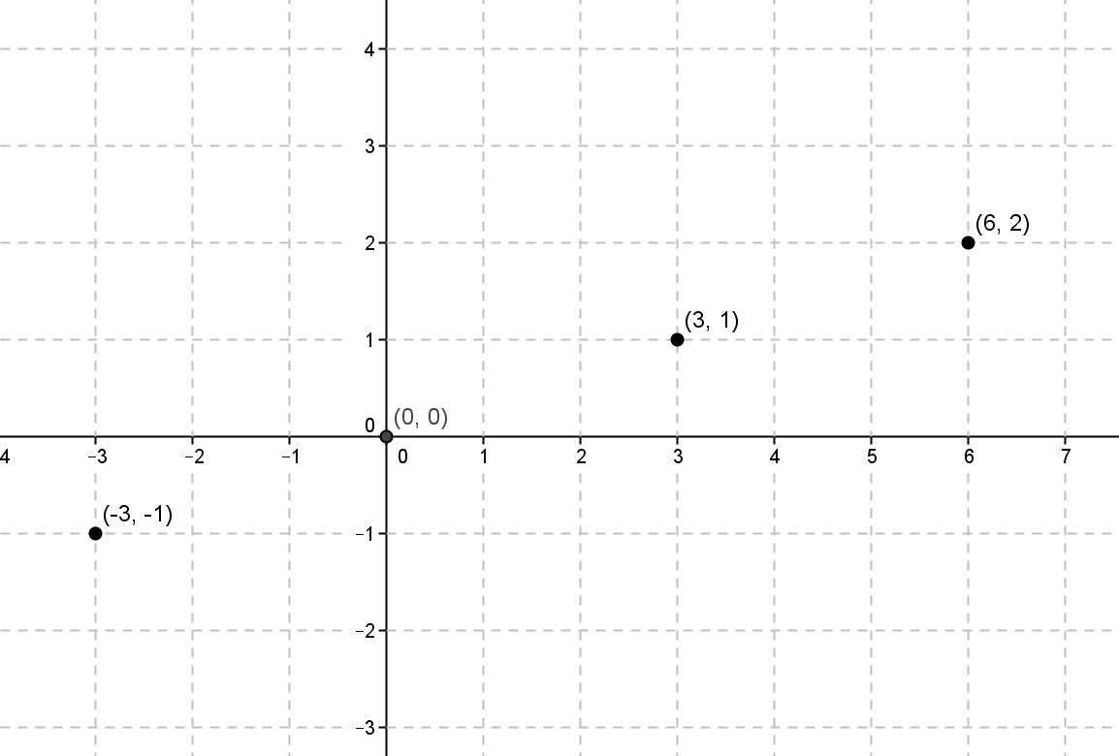

- A function assigns the inputs and corresponding outputs shown in the table below.
Input | Output
$$-6$$ | $$-6$$
$$-5$$ | $$-5$$
$$-4$$ | $$-4$$
$$-2$$ | $$-2$$
  - Is the function a linear function? Check at least three pairs of inputs and their corresponding outputs.
  - What equation describes the function?
  - What will the graph of the function look like? Explain.

