Lesson 1: The Concept of a Function

Student Outcomes
- Students know that a function allows us to make predictions about the distance an object moves in any time interval. Students calculate average speed of a moving object over specific time intervals.
- Students know that constant rate cannot be assumed for every situation and use proportions to analyze the reasoning involved.

Lesson Notes
In this and subsequent lessons, the data would ideally be gathered live using technology, making the data more real for students and creating an interactive element for the lessons. Time and resources permitting, consider gathering live data to represent the functions in this module.
Much of the discussion in this module is based on parts from the following sources:
H. Wu, Introduction to School Algebra, http://math.berkeley.edu/~wu/Algebrasummary.pdf
H. Wu, Teaching Geometry in Grade 8 and High School According to the Common Core Standards,
http://math.berkeley.edu/~wu/CCSS-Geometry.pdf

Classwork
Discussion (4 minutes)
- We have been studying numbers, and we seem to be able to do all the things we want to with numbers, so why do we need to learn about functions? The answer is that if we expand our vision and try to find out about things that we ought to know, then we discover that numbers are not enough. We experienced some of this when we wrote linear equations to describe a situation. For example, average speed and constant rate allowed us to write two variable linear equations that could then be used to predict the distance an object would travel for any desired length of time.
- Functions also allow us to make predictions. In some cases, functions simply allow us to classify the data in our environment. For example, a function might state a person’s age or gender. In these examples, a linear equation is unnecessary.
- In the last module, we focused on situations where the rate of change was always constant. That is, each situation could be expressed as a linear equation. However, there are many occasions for which the rate is not constant. Therefore, we must attend to each situation to determine whether or not the rate of change is constant and can be modeled with a linear equation.

Example 1 (7 minutes)
This example is used to point out that in much of our previous work, we assumed a constant rate. This is in contrast to the next example, where constant rate cannot be assumed. Encourage students to make sense of the problem and attempt to solve it on their own. The goal is for students to develop a sense of what predicting means in this context.
MP.1
Example 1
Suppose a moving object travels $256$ feet in $4$ seconds. Assume that the object travels at a constant speed; that is, the motion of the object is linear with a constant rate of change. Write a linear equation in two variables to represent the situation, and use it to make predictions about the distance traveled over various intervals of time.
Number of seconds  ($x$) | Distance traveled in feet  ($y$)
$$1$$ | $$64$$
$$2$$ | $$128$$
$$3$$ | $$192$$
$$4$$ | $$256$$

- Suppose a moving object travels $256$ feet in $4$ seconds. Assume that the object travels at a constant speed; that is, the motion of the object is linear with a constant rate of change. Write a linear equation in two variables to represent the situation, and use it to make predictions about the distance traveled over various intervals of time.
  - Let $x$ represent the time it takes to travel $y$ feet.
$$\frac{256}{4}=\frac{y}{x} \\ y=\frac{256}{4}x \\ y=64x$$
- What are some of the predictions that this equation allows us to make?
  - After one second, or when $x=1$, the distance traveled is $64$ feet.
Accept any reasonable predictions that the students make.
- Use your equation to complete the table.
- What is the average speed of the moving object from $0$ to $3$ seconds?
  - The average speed is $64$ feet per second. We know that the object has a constant rate of change; therefore, we expect the average speed to be the same over any time interval.

Example 2 (15 minutes)
- We have already made predictions about the location of a moving object. Now, here is some more information. The object is a stone, being dropped from a height of $256$ feet. It takes exactly $4$ seconds for the stone to hit the ground. How far does the stone drop in the first $3$ seconds? What about the last $3$ seconds? Can we assume constant speed in this situation? That is, can this situation be expressed using a linear equation?
Example 2
The object, a stone, is dropped from a height of $256$ feet. It takes exactly $4$ seconds for the stone to hit the ground. How far does the stone drop in the first $3$ seconds? What about the last $3$ seconds? Can we assume constant speed in this situation? That is, can this situation be expressed using a linear equation?
Number of seconds  ($x$) | Distance traveled in feet  ($y$)
$$1$$ | $$16$$
$$2$$ | $$64$$
$$3$$ | $$144$$
$$4$$ | $$256$$

Provide students time to discuss this in pairs. Lead a discussion in which students share their thoughts with the class. It is likely that they will say this is a situation that can be modeled with a linear equation, just like the moving object in Example 1. Continue with the discussion below.
- If this is a linear situation, then from the table we developed in Example 1 we already know the stone will drop $192$ feet in any $3$-second interval. That is, the stone drops $192$ feet in the first $3$ seconds and in the last $3$ seconds.
To provide a visual aid, consider viewing the $10$-second “ball drop” video at the following link: http://www.youtube.com/watch?v=KrX_zLuwOvc. You may need to show it more than once.
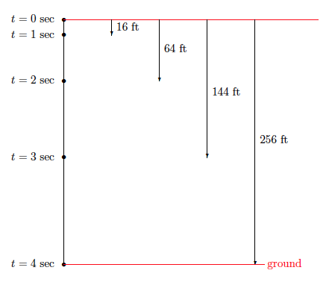
- If we were to slow the video down and record the distance the ball dropped after each second, we would collect the following data:
- Choose a prediction that was made about the distance traveled before we learned more about the situation. Was it accurate? How do you know?
Students who thought the stone is traveling at constant speed should realize that the predictions were not accurate for this situation. Guide their thinking using the discussion points below.
- According to the data, how many feet did the stone drop in $3$ seconds?
  - The stone dropped $144$ feet.
- How can that be? It must be that our initial assumption of constant rate was incorrect. Let’s organize the information from the diagram above in a table:
What predictions can we make now?
  - After one second, $x=1$; the stone dropped $16$ feet, etc.
- Let’s make a prediction based on a value of $x$ that is not listed in the table. How far did the stone drop in the first $3.5$ seconds? What have we done in the past to figure something like this out?
  - We wrote a proportion using the known times and distances.
Allow students time to work with their proportions. Encourage them to use more than one set of data to determine an answer.
MP.3
  - Sample student work:
Let $x$ be the distance, in feet, the stone drops in$3.5$ seconds.
$$\frac{16}{1}=\frac{x}{3.5} \\ x=56$$ | $$\frac{64}{2}=\frac{x}{3.5} \\ 2x=224 \\ x=112$$ | $$\frac{144}{3}=\frac{x}{3.5} \\ 3x=504 \\ x=168$$
- Is it reasonable that the stone would drop $56$ feet in $3$ seconds? Explain.
  - No, it is not reasonable. Our data shows that after $2$ seconds the stone has already dropped $64$ feet. Therefore, it is impossible that it could have only dropped $56$ feet in $3.5$ seconds.
- What about $112$ feet in $3.5$ seconds? How reasonable is that answer? Explain.
  - The answer of $112$ feet in $3.5$ seconds is not reasonable either. The data shows that the stone dropped $144$ feet in $3$ seconds.
- What about $168$ feet in $3.5$ seconds? What do you think about that answer? Explain.
  - That answer is the most likely because at least it is greater than the recorded $144$ feet in $3$ seconds.
- What makes you think that the work done with a third proportion will give us a correct answer when the first two did not? Can we rely on this method for determining an answer?
  - This does not seem to be a reliable method. If we had only done one computation and not evaluated the reasonableness of our answer, we would have been wrong.
- What this means is that the table we used does not tell the whole story about the falling stone. Suppose, by repeating the experiment and gathering more data of the motion, we obtained the following table:
Number of seconds ($x$) | Distance traveled in feet ($y$)
$$0.5$$ | $$4$$
$$1$$ | $$16$$
$$1.5$$ | $$36$$
$$2$$ | $$64$$
$$2.5$$ | $$100$$
$$3$$ | $$144$$
$$3.5$$ | $$196$$
$$4$$ | $$256$$
- Choose a prediction you made before this table. Was it accurate? Why might one want to be able to predict?
Students will likely have made predictions that were not accurate. Have a discussion with students about why we want to make predictions at all. They should recognize that making predictions helps us make sense of the world around us. Some scientific discoveries began with a prediction, then an experiment to prove or disprove the prediction, and then were followed by some conclusion.
- Now it is clear that none of our answers for the distance traveled in $3.5$ seconds were correct. In fact, the stone dropped $196$ feet in the first $3.5$ seconds. Does the above table capture the motion of the stone completely? Explain?
  - No. There are intervals of time between those in the table. For example, the distance it drops in $1.6$ seconds is not represented.
- If we were to record the data for every $0.1$ second that passed, would that be enough to capture the motion of the stone?
  - No. There would still be intervals of time not represented. For example, $1.61$ seconds.
- In fact, we would have to calculate to an infinite number of decimals to tell the whole story about the falling stone. To tell the whole story, we would need information about where the stone is after the first $t$ seconds for every $t$ satisfying $0≤t≤4.$
- This kind of information is more than just a few numbers. It is about all of the distances (in feet) the stone drops in $t$ seconds from a height of $256$ feet for all $t$ satisfying $0≤t≤4.$
- The inequality, $0≤t≤4$, helps us tell the whole story about the falling stone. The infinite collection of distances associated with every $t$ in $0≤t≤4$ is an example of a function. Only a function can tell the whole story, as you will soon learn.

Exercises 1–6 (10 minutes)
Students complete Exercises 1–6 in pairs or small groups.
Exercises 1–6
Use the table to answer Exercises 1–5.
Number of seconds ($x$) | Distance traveled in feet ($y$)
$$0.5$$ | $$4$$
$$1$$ | $$16$$
$$1.5$$ | $$36$$
$$2$$ | $$64$$
$$2.5$$ | $$100$$
$$3$$ | $$144$$
$$3.5$$ | $$196$$
$$4$$ | $$256$$

- Name two predictions you can make from this table.
Sample student responses:
After $2$ seconds, the object traveled $64$feet. After $3.5$seconds, the object traveled $196$ feet.
- Name a prediction that would require more information.
Sample student response:
We would need more information to predict the distance traveled after $3.75$ seconds.

- What is the average speed of the object between $0$ and $3$ seconds? How does this compare to the average speed calculated over the same interval in Example 1?
MP.2

$$Average Speed=\frac{distance traveled over a given time interval}{time interval}$$
The average speed is $48$ feet per second: $\frac{144}{3}=48$. This is different from the average speed calculated in Example 1. In Example 1, the average speed over an interval of $3$ seconds was $64$ feet per second.

- Take a closer look at the data for the falling stone by answering the questions below.
  - How many feet did the stone drop between $0$ and $1$ second?
The stone dropped $16$ feet between $0$ and $1$ second.

  - How many feet did the stone drop between $1$ and $2$ seconds?
The stone dropped $48$ feet between $1$ and $2$ seconds.

  - How many feet did the stone drop between $2$ and $3$ seconds?
The stone dropped $80$ feet between $2$ and $3$ seconds.

  - How many feet did the stone drop between $3$ and $4$ seconds?
The stone dropped $112$ feet between $3$ and $4$ seconds.

  - Compare the distances the stone dropped from one time interval to the next. What do you notice?
Over each interval, the difference in the distance was $32$ feet. For example, $16+32=48$, $48+32=80$, and $80+32=112.$

- What is the average speed of the stone in each interval $0.5$ second? For example, the average speed over the interval from $3.5$ seconds to $4$seconds is
$$\frac{distance traveled over a given time interval}{time interval}=\frac{256-196}{4-3.5}=\frac{ 60 }{0.5}=120 feet per second$$
Repeat this process for every half-second interval. Then, answer the question that follows.
- Interval between $0$ and $0.5$ second:  $$\frac{ 4 }{0.5}=8 feet per second$$ | - Interval between $0.5$ and $1$ second:  $$\frac{ 12 }{0.5}=24 feet per second$$
- Interval between $1$ and $1.5$ seconds:  $$\frac{ 20 }{0.5}=40 feet per second$$ | - Interval between $1.5$ and $2$ seconds:  $$\frac{ 28 }{0.5}=56 feet per second$$

- Interval between $2$ and $2.5$ seconds:  $$\frac{ 36 }{0.5}=72 feet per second$$ | - Interval between $2.5$ and $3$ seconds:  $$\frac{ 44 }{0.5}=88 feet per second$$
  - Interval between $3$ and $3.5$ seconds:
$$\frac{ 52 }{0.5}=104 feet per second$$

  - Compare the average speed between each time interval. What do you notice?
Over each interval, there is an increase in the average speed of $16$ feet per second. For example,
$8+16=24$, $24+16=40$, $40+16=56$, and so on.

- Is there any pattern to the data of the falling stone? Record your thoughts below.
Time of interval in seconds  ($t$) | $$1$$ | $$2$$ | $$3$$ | $$4$$
Distance stone fell in feet  ($y$) | $$16$$ | $$64$$ | $$144$$ | $$256$$
Accept any reasonable patterns that students notice as long as they can justify their claim. In the next lesson, students will learn that $y=16t^{2}$.
Each distance has $16$ as a factor. For example, $16=1\left(16\right)$, $64=4\left(16\right)$, $144=9\left(16\right)$, and $256=16\left(16\right)$.

Closing (4 minutes)
Summarize, or ask students to summarize, the main points from the lesson:
- We know that we cannot always assume that a motion is a constant rate.
- We know that a function can be used to describe a motion over any time interval, even the very small time intervals, such as $1.00001$.

Lesson Summary
Functions are used to make predictions about real-life situations. For example, a function allows you to predict the distance an object has traveled for any given time interval.
Constant rate cannot always be assumed. If not stated clearly, you can look at various intervals and inspect the average speed. When the average speed is the same over all time intervals, then you have constant rate. When the average speed is different, you do not have a constant rate.
$$Average Speed=\frac{distance traveled over a given time interval}{time interval}$$

Exit Ticket (5 minutes)
Name Date
Lesson 1: The Concept of a Function

Exit Ticket

A ball bounces across the school yard. It hits the ground at $(0,0)$ and bounces up and lands at $(1,0)$ and bounces again. The graph shows only one bounce.
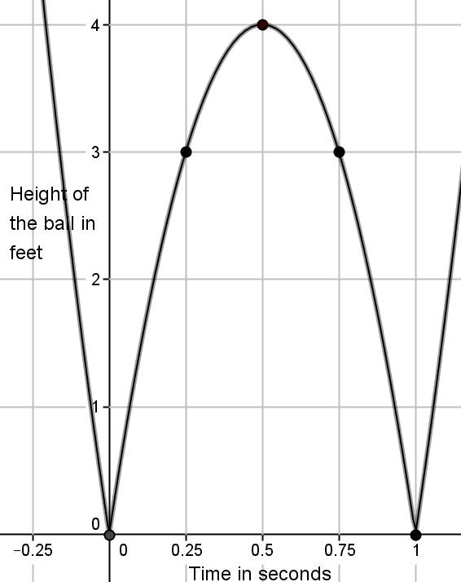

  - Identify the height of the ball at the following values of $t$: $0$,$0.25$,$0.5$,$0.75$,$1$.

  - What is the average speed of the ball over the first $0.25$second? What is the average speed of the ball over the next $0.25$ second (from$0.25$to$0.5$ second)?

  - Is the height of the ball changing at a constant rate?

Exit Ticket Sample Solutions

A ball is bouncing across the school yard. It hits the ground at $(0,0)$and bounces up and lands at $(1,0)$ and bounces again. The graph shows only one bounce.

  - Identify the height of the ball at the following time values: $0$,$0.25$,$0.5$,$0.75$,$1$.
When$t=0$, the height of the ball is $0$ feet above the ground. It has just hit the ground.
When$t=0.25$, the height of the ball is $3$ feet above the ground.
When$t=0.5$, the height of the ball is $4$ feet above the ground.
When$t=0.75$, the height of the ball is $3$ feet above the ground.
When$t=1$, the height of the ball is $0$ feet above the ground. It has hit the ground again.

  - What is the average speed of the ball over the first $0.25$ second? What is the average speed of the ball over the next $0.25$ second (from $0.25$ to $0.5$ second)?
$$\frac{distance traveled over a given time interval}{time interval}=\frac{3-0}{0.25-0}=\frac{ 3 }{0.25}=12 feet per second$$
$$\frac{distance traveled over a given time interval}{time interval}=\frac{4-3}{0.5-.25}=\frac{ 1 }{0.25}=4 feet per second$$

  - Is the height of the ball changing at a constant rate?
No, it is not. If the ball were traveling at a constant rate, the average speed would be the same over any time interval.

Problem Set Sample Solutions

- A ball is thrown across the field from point $A$ to point $B.$ It hits the ground at point $B.$ The path of the ball is shown in the diagram below. The $x$-axis shows the distance the ball travels, and the $y$-axis shows the height of the ball. Use the diagram to complete parts (a)–(g).
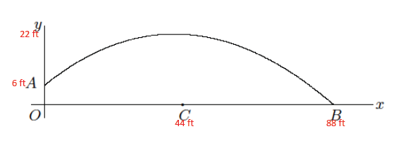
  - Suppose $A$ is approximately $6$ feet above ground and that at time $t=0$ the ball is at point $A$. Suppose the length of $OB$ is approximately $88$ feet. Include this information on the diagram.
Information noted on the diagram in red.

  - Suppose that after $1$ second, the ball is at its highest point of $22$ feet (above point $C$) and has traveled a distance of $44$ feet. Approximate the coordinates of the ball at the following values of $t:$ $0.25$,$0.5$, $0.75$, $1$, $1.25$,$1.5$,$1.75$, and $2.$
Most answers will vary because students are approximating the coordinates. The coordinates that must be correct because enough information was provided are denoted by a *.
At $t=0.25$, the coordinates are approximately $\left(11, 10\right)$.
At $t=0.5$, the coordinates are approximately $\left(22, 18\right)$.
At $t=0.75$, the coordinates are approximately $\left(33, 20\right)$.
*At $t=1$, the coordinates are approximately $\left(44, 22\right)$.
At $t=1.25$, the coordinates are approximately $\left(55, 19\right)$.
At $t=1.5$, the coordinates are approximately $\left(66, 14\right)$.
At $t=1.75$, the coordinates are approximately $\left(77, 8\right)$.
*At $t=2$ the coordinates are approximately $\left(88, 0\right)$.

  - Use your answer from part (b) to write two predictions.
Sample predictions:
At a distance of $44$ feet from where the ball was thrown, it is $22$ feet in the air. At a distance of $66$ feet from where the ball was thrown, it is $14$ feet in the air.

  - What is the meaning of the point $(88, 0)$?
At point $\left(88, 0\right),$the ball has traveled for $2$ seconds and has hit the ground a distance of $88$ feet from where the ball began.

  - Why do you think the ball is at point $\left(0, 6\right)$ when $t=0$? In other words, why isn’t the height of the ball $0$?
The ball is thrown from point $A$ to point $B$. The fact that the ball is at a height of $6$ feet means that the person throwing it must have released the ball from a height of $6$ feet.

  - Does the graph allow us to make predictions about the height of the ball at all points?
While we cannot predict exactly, the graph allows us to make approximate predictions of the height for any value of horizontal distance we choose.

- In your own words, explain the purpose of a function and why it is needed.
A function allows us to make predictions about a motion without relying on the assumption of constant rate. It is needed because the entire story of the movement of an object cannot be told with just a few data points. There are an infinite number of points in time in which a distance can be recorded, and a function allows us to calculate each one.

