Lesson 13

Objective: Ask and answer varied word problem types about a data set with three categories.

Suggested Lesson Structure

 Fluency Practice (18 minutes)

 Application Problem (5 minutes)

 Concept Development (27 minutes)

 Student Debrief (10 minutes)

**Total Time (60 minutes)**

Fluency Practice (18 minutes)

* Hide Zero Number Sentences **1.NBT.2, 1.NBT.4** (3 minutes)
* Add Three Numbers  **1.OA.2** (5 minutes)
* Sprint: Add Three Numbers **1.OA.2** (10 minutes)

Hide Zero Number Sentences (3 minutes)

Materials: (T) Hide Zero cards (Lesson 2 Fluency Template 1)

Note: This fluency activity strengthens the understanding of place value and prepares students for Module 4.

Show students a number from 10 to 40 with Hide Zero cards (e.g., 15). Students say an addition sentence with 10 as an addend (e.g., 10 + 5 = 15). As students say the sentence, pull apart the Hide Zero cards to model the equation. Alternate asking students to say the numbers the Say Ten way and the regular way.

Suggested sequence: 15, 25, 35; 14, 24, 34; 16, 26, 36; etc.

Add Three Numbers (5 minutes)

Materials: (S) 3 dice per pair, personal white board

Note: This fluency reviews adding three numbers.

Assign students partners. Partners take turns rolling the three dice and adding them together. The partner with the highest sum each round scores a point. If there is a tie, players should keep playing until one of them has the highest sum. The person with the highest sum after the tie scores two points. Students record points with tally marks on their personal white boards.

Sprint: Add Three Numbers (10 minutes)

Materials: (S) Add Three Numbers Sprint

Note: This Sprint provides students practice with adding three numbers within 20 and encourages students to apply properties of operations as strategies to add.

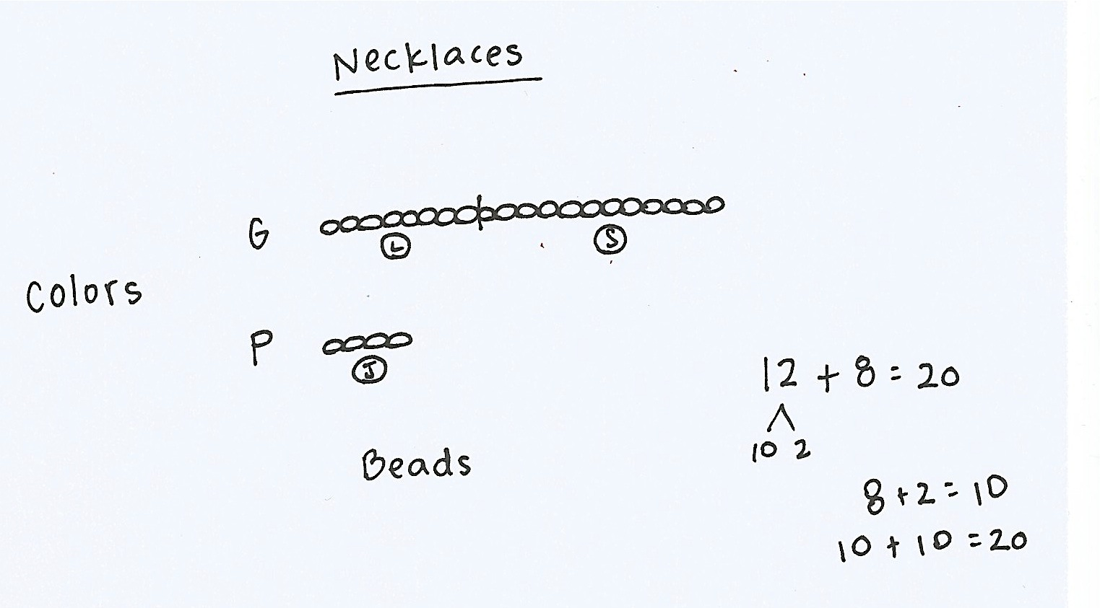Application Problem (5 minutes)

Zoe made friendship necklaces for her 3 closest friends. Make a graph to show the two colors of beads she used. She used 8 green beads for Lily, 4 purple beads for Jamilah, and 12 green beads for Sage. How many green beads did she use?

Note: As students finish, ask additional questions to help them interpret the data, focusing on Grade 1 problem types.

* How many more purple beads would need to be used to have the same amount as the green beads?
* How many fewer green beads does Lily have than Sage?
* If Lily added 3 green beads to her necklace, how many more green beads would she need to have the same amount as Sage?

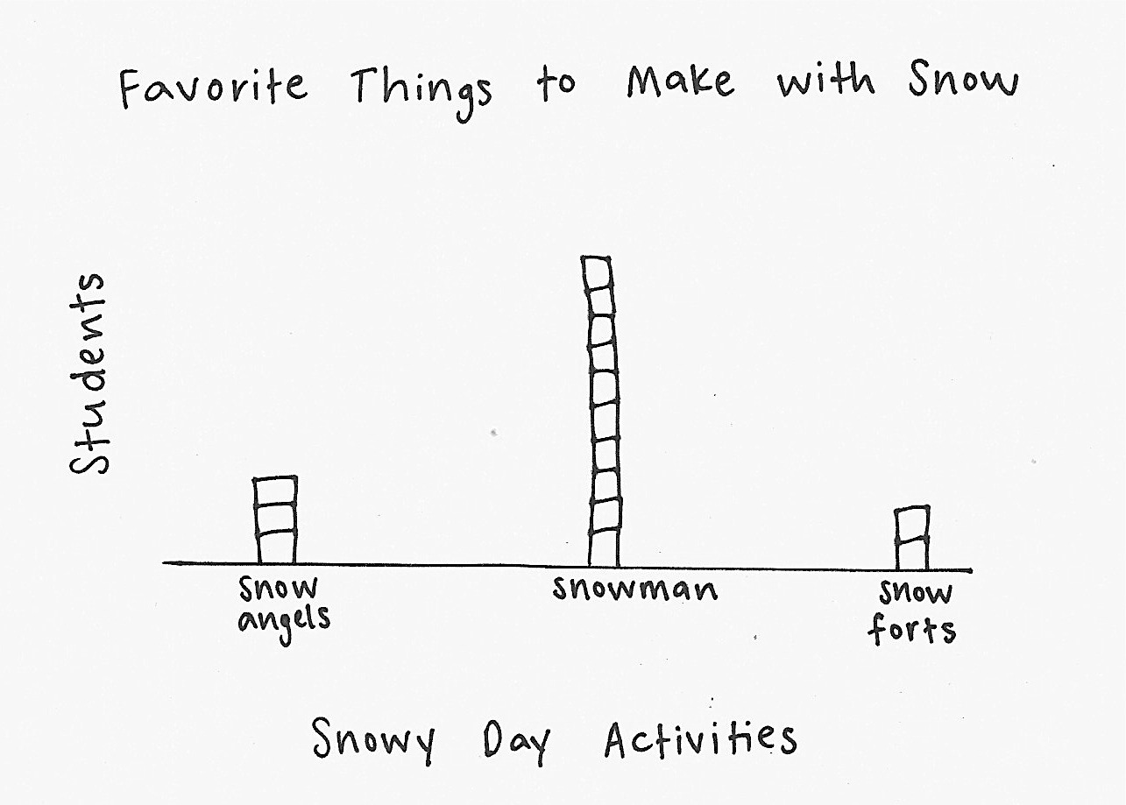Concept Development (27 minutes)

Materials: (T) Graph entitled *Favorite Things to Make with Snow* created on easel (data: snow angels—3, snowman—12, and snow forts—2) (S) Personal white board

Note: Adjust the Concept Development as necessary based on your observations of student successes and challenges during Lesson 12, as well as during the most recent Application Problems. Today’s Concept Development is an opportunity to continue supporting student understanding of the *compare with difference unknown* problem types using appropriate number sentences as they interpret the given data.

Have students gather in the meeting area in a semicircle formation with their personal white boards.

T: (Post the graph.) Here’s a graph I made yesterday after talking to the children in my neighborhood.   
I asked what they like to do in the snow. The graph shows how they answered my question. What do you notice about this graph that is different from the graphs we used yesterday? What is similar?

S: The starting point is on the bottom of this graph. Yesterday, we started from the top. Today, they are built like towers. 🡪 But it’s still following the rules. 🡪 No overlaps. 🡪 No gaps. 🡪 The same endpoints.

T: Turn and talk to your partner about what you notice. What information can you gather from reading this graph?

Answers may vary. Be sure to record how many votes each category received.

|  |  |
| --- | --- |
|  | NOTES ON  MULTIPLE MEANS  OF ACTION AND EXPRESSION: |
| Asking questions for comprehension during this lesson is important to guide students to evaluate their thinking. This provides students an opportunity to evaluate their process and analyze errors. | |

T: How many people prefer building a snowman over making snow angels? How did you figure it out?

S: I looked at the snowman and snow angels columns.   
I counted on from 4 since they both have 3 votes.   
🡪 I already know that there are 3 votes for snow angels and 12 votes for the snowman, so I took away 3 from 12 and got 9.

T: I noticed that yesterday, many students counted to figure out which had more or fewer votes.   
What subtraction sentence can you use to solve this problem?

S: 12 – 3 = 9.

T: Explain to your partner how both of these strategies are related.

T: No matter how you solve this, we can use the number sentence 12 – 3 = 9 as a way to show how we solved the problem.

Continue to ask *compare with difference unknown* and *put together with result unknown* problems, encouraging students to include a number sentence. For all problems, have students discuss how both counting on and using a subtraction sentence are related to one another. You may use the following suggested sequence:

* How many more children prefer making the snowman over building a fort? Making the snow angel over building a fort? Making the snowman or the snow angel?
* How many children took this **poll**? (Note: Students might not be familiar with the word *poll*. Explain that a poll is a situation in which people vote. The teacher can give the example that, in this case, students were polled about their favorite things to make with snow.)

In the next set of questions, encourage students to visualize how the graph might change based on the information presented in the following situations:

* How many more votes do we need if we want to make the number of votes for building the fort the same as the number of votes for making the snowman?

**MP.2**

* Some more children came by and answered the question. If there were 20 children total that answered the question, how many more children came by and voted?
* If 4 more children came along and said they like building snow forts the most, then how many votes would there be for building forts?

Use additional sticky notes or tiles for those students who need the concrete–visual support. Again, encourage students to use a number sentence to solve.

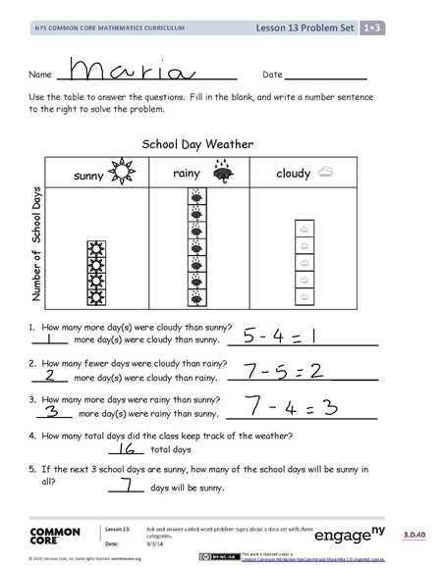Problem Set (10 minutes)

Students should do their personal best to complete the Problem Set within the allotted 10 minutes. For some classes, it may be appropriate to modify the assignment by specifying which problems they work on first.

Student Debrief (10 minutes)

**Lesson Objective:** Ask and answer varied word problem types about a data set with three categories.

The Student Debrief is intended to invite reflection and active processing of the total lesson experience.

Invite students to review their solutions for the Problem Set. They should check work by comparing answers with a partner before going over answers as a class. Look for misconceptions or misunderstandings that can be addressed in the Debrief. Guide students in a conversation to debrief the Problem Set and process the lesson.

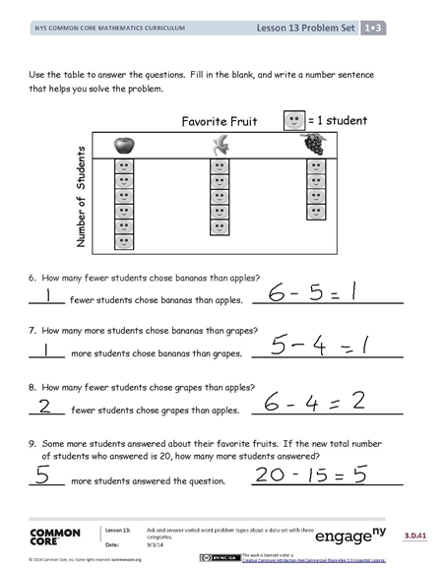You may choose to use any combination of the questions below to lead the discussion.

* How is using the counting on strategy related to using a subtraction sentence when looking for how many more or fewer votes one received when comparing two categories?
* How is using the counting on strategy related to using an addition sentence when combining the votes for two or more categories?
* When is it more efficient to use number combinations to solve rather than counting on?
* Look at Problem 1. Which problem on Page 2 connects to this one? How do you know?
* How are the *Favorite Fruit* and *School Day Weather* graphs set up differently?
* Explain to your partner how you solved Problem 9. Compare how each of you solved the problem.
* How did the Application Problem connect to today’s lesson?

Exit Ticket (3 minutes)

After the Student Debrief, instruct students to complete the Exit Ticket. A review of their work will help you assess the students’ understanding of the concepts that were presented in the lesson today and plan more effectively for future lessons. You may read the questions aloud to the students.

Name Date

Number Correct:

**A**

*Write the missing number.

|  |  |  |  |  |  |
| --- | --- | --- | --- | --- | --- |
| 1 | 9 + 1 + 3 = ☐ |  | 16 | 6 + 3 + 8 = ☐ |  |
| 2 | 9 + 2 + 1 = ☐ |  | 17 | 5 + 9 + 4 = ☐ |  |
| 3 | 5 + 5 + 3 = ☐ |  | 18 | 3 + 12 + 4 = ☐ |  |
| 4 | 5 + 2 + 5 = ☐ |  | 19 | 3 + 11 + 5 = ☐ |  |
| 5 | 4 + 5 + 5 = ☐ |  | 20 | 5 + 6 + 7 = ☐ |  |
| 6 | 8 + 2 + 4 = ☐ |  | 21 | 2 + 6 + 3 = ☐ |  |
| 7 | 8 + 3 + 2 = ☐ |  | 22 | 3 + 2 + 13 = ☐ |  |
| 8 | 12 + 2 + 2 = ☐ |  | 23 | 3 + 13 + 3 = ☐ |  |
| 9 | 3 + 3 + 12 = ☐ |  | 24 | 9 + 1 + ☐ = 14 |  |
| 10 | 4 + 4 + 5 = ☐ |  | 25 | 8 + 4 + ☐ = 16 |  |
| 11 | 2 + 15 + 2 = ☐ |  | 26 | ☐ + 8 + 6 = 19 |  |
| 12 | 7 + 3 + 3 = ☐ |  | 27 | 2 + ☐ + 7 = 18 |  |
| 13 | 1 + 17 + 1 = ☐ |  | 28 | 2 + 2 + ☐ = 18 |  |
| 14 | 14 + 2 + 2 = ☐ |  | 29 | 19 = 6 + ☐ + 9 |  |
| 15 | 4 + 12 + 4 = ☐ |  | 30 | 18 = 7 + ☐ + 6 |  |

Name Date

**B**

Number Correct:

*Write the missing number.

|  |  |  |  |  |  |
| --- | --- | --- | --- | --- | --- |
| 1 | 9 + 1 + 2 = ☐ |  | 16 | 6 + 3 + 9 = ☐ |  |
| 2 | 9 + 4 + 1 = ☐ |  | 17 | 4 + 9 + 2 = ☐ |  |
| 3 | 5 + 5 + 1 = ☐ |  | 18 | 2 + 12 + 4 = ☐ |  |
| 4 | 5 + 3 + 5 = ☐ |  | 19 | 2 + 11 + 5 = ☐ |  |
| 5 | 4 + 5 + 5 = ☐ |  | 20 | 6 + 6 + 7 = ☐ |  |
| 6 | 8 + 2 + 2 = ☐ |  | 21 | 2 + 6 + 5 = ☐ |  |
| 7 | 8 + 3 + 2 = ☐ |  | 22 | 3 + 3 + 13 = ☐ |  |
| 8 | 11 + 1 + 1 = ☐ |  | 23 | 3 + 14 + 3 = ☐ |  |
| 9 | 2 + 2 + 14 = ☐ |  | 24 | 9 + 1 + ☐ = 13 |  |
| 10 | 4 + 4 + 4 = ☐ |  | 25 | 8 + 4 + ☐ = 15 |  |
| 11 | 2 + 13 + 2 = ☐ |  | 26 | ☐ + 8 + 6 = 18 |  |
| 12 | 6 + 3 + 3 = ☐ |  | 27 | 2 + ☐ + 6 = 18 |  |
| 13 | 1 + 15 + 1 = ☐ |  | 28 | 2 + 5 + ☐ = 18 |  |
| 14 | 15 + 2 + 2 = ☐ |  | 29 | 19 = 5 + ☐ + 9 |  |

|  |  |  |  |  |  |
| --- | --- | --- | --- | --- | --- |
| 15 | 3 + 14 + 3 = ☐ |  | 30 | 19 = 7 + ☐ + 6 |  |

Name Date

Use the table to answer the questions. Fill in the blank, and write a number sentence to the right to solve the problem.

School Day Weather

|  |  |  |
| --- | --- | --- |
| sunny | rainy | cloudy |
|  |  |  |

Number of School Days



1. How many more day(s) were cloudy than sunny?

more day(s) were cloudy than sunny. 

1. How many fewer days were cloudy than rainy?

more day(s) were cloudy than rainy.

1. How many more days were rainy than sunny?

more day(s) were rainy than sunny.

1. How many total days did the class keep track of the weather?

total days

1. If the next 3 school days are sunny, how many of the school days will be sunny in all?

days will be sunny.

Use the table to answer the questions. Fill in the blank, and write a number sentence that helps you solve the problem.

= 1 student



Favorite Fruit

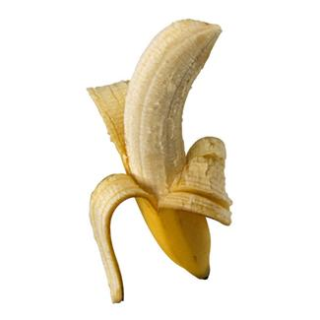



Number of Students







1. How many fewer students chose bananas than apples?

fewer students chose bananas than apples.

1. How many more students chose bananas than grapes?

more students chose bananas than grapes.

1. How many fewer students chose grapes than apples?

fewer students chose grapes than apples.

1. Some more students answered about their favorite fruits. If the new total number of students who answered is 20, how many more students answered?

more students answered the question.

Name Date

Use the table to answer the questions.

= 1 animal

Animals on Lily’s Farm

|  |  |  |
| --- | --- | --- |
| sheep | cows | pigs |
| Mac Drive:Applications:Microsoft Office 2011:Office:Media:Clipart: Animals.localized:AA028233.png | Mac Drive:Applications:Microsoft Office 2011:Office:Media:Clipart: Animals.localized:AA049692.pngMac Drive:Applications:Microsoft Office 2011:Office:Media:Clipart: Animals.localized:AA049692.pngMac Drive:Applications:Microsoft Office 2011:Office:Media:Clipart: Animals.localized:AA049692.pngMac Drive:Applications:Microsoft Office 2011:Office:Media:Clipart: Animals.localized:AA049692.pngMac Drive:Applications:Microsoft Office 2011:Office:Media:Clipart: Animals.localized:AA049692.pngMac Drive:Applications:Microsoft Office 2011:Office:Media:Clipart: Animals.localized:AA049692.png |  |

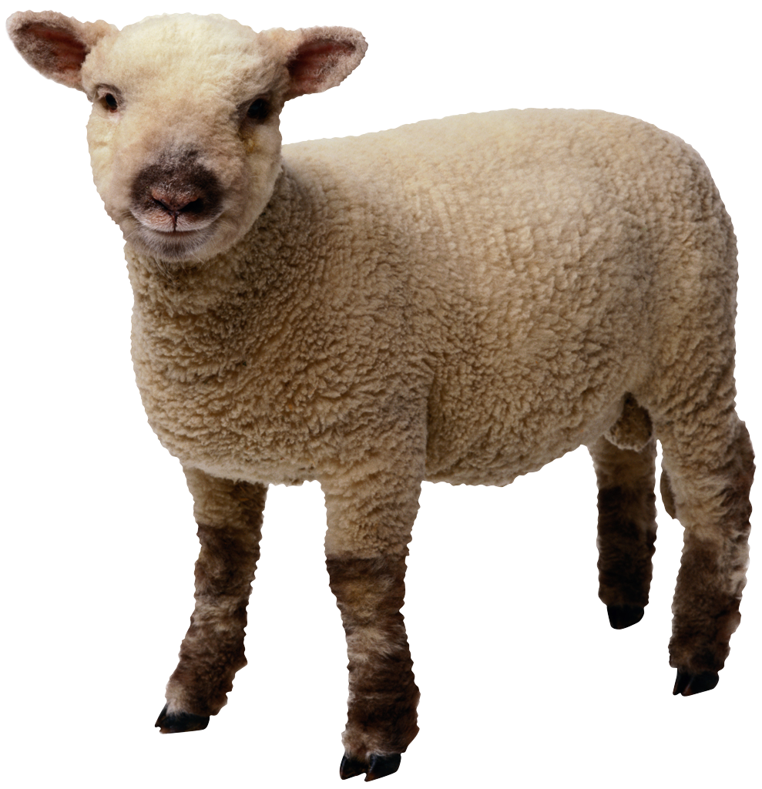

Number of Animals





1. How many animals are on Lily’s farm in all? _____________ animals
2. How many fewer sheep than pigs are on Lily’s farm? _____________ fewer sheep
3. How many more cows are on Lily’s farm than sheep? _____________ more cows

Name Date

Use the table to answer the questions. Fill in the blank, and write a number sentence.

School Lunch Order



= 1 student

|  |  |  |
| --- | --- | --- |
| hot lunch | sandwich | salad |
|  |  |  |

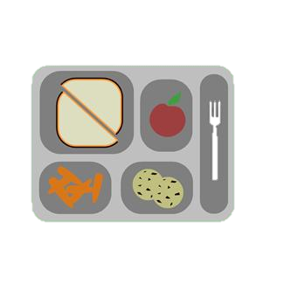



1. How many more hot lunch orders were there than sandwich orders?

_____ more hot lunch orders

1. How many fewer salad orders were there than hot lunch orders?

_______ fewer salad orders

1. If 5 more students order hot lunch, how many hot lunch orders will there be?

_______ hot lunch orders

Use the table to answer the questions. Fill in the blanks, and write a number sentence.

Favorite Type of Book

= 5 students

|  |  |
| --- | --- |
| fairy tales |  |
| science books |  |
| poetry books |  |

1. How many more students like fairy tales than science books?

_______ more students

1. How many fewer students like science books than poetry books?

_______ fewer students

1. How many students picked fairy tales or science books in all?

_______ students

1. How many more students would need to pick science books to have the same number of books as fairy tales?

_______ students

1. If 5 more students show up late and all pick fairy tales, will this be the most popular book? Use a number sentence to show your answer.