Lesson 31: System of Equations Leading to Pythagorean Triples

Student Outcomes
- Students know that a Pythagorean triple can be obtained by multiplying any known triple by a common whole number. Students use this method to generate Pythagorean triples.
- Students use a system of equations to find three numbers, $a$, $b$, and $c$, so that $a^{2}+b^{2}=c^{2}.$

Lesson Notes
This lesson is optional as it includes content related to the Pythagorean theorem. The purpose of this lesson is to demonstrate an application of systems of linear equations to other content in the curriculum. Though Pythagorean triples are not part of the standard for the grade, it is an interesting topic and should be shared with students if time permits.

Classwork
Discussion (10 minutes)
- A New York publicist, George Arthur Plimpton, bought a clay tablet from an archaeological dealer for $\$10$ in 1922. This tablet was donated to Columbia University in 1936 and became known by its catalog number, Plimpton $322$. What made this tablet so special was not just that it was $4,000$ years old but that it showed a method for finding Pythagorean triples. It was excavated near old Babylonia (which is now Iraq).
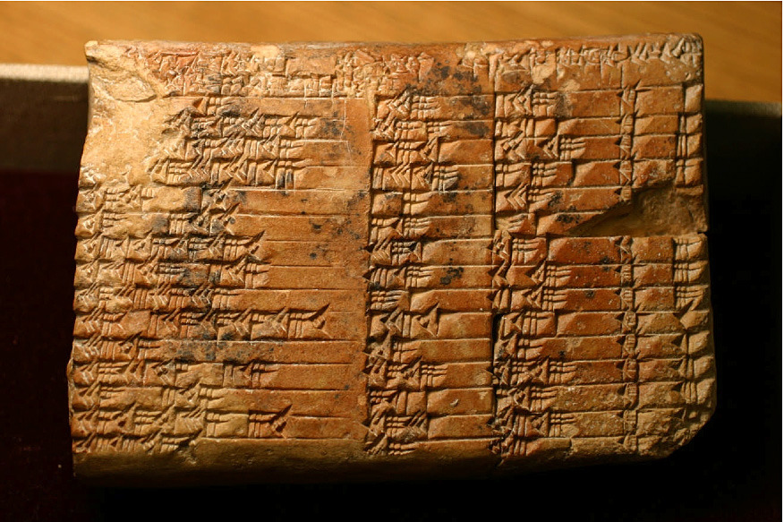
Image by Christine Proust. All rights reserved. “Columbia University Plimpton 322,” ISAW Images (Dev), accessed September 1, 2014, http://idp.atlantides.org/items/show/23.

- Any three numbers, $a$,$b$, $c$, that satisfy $a^{2}+b^{2}=c^{2}$ are considered a triple, but when the three numbers are positive integers, then they are known as Pythagorean triples. It is worth mentioning that one of the Pythagorean triples found on the tablet was $12709$, $13500$, $18541$.
- An easy-to-remember Pythagorean triple is $3$, $4$,$5.$ (Quickly verify for students that $3$,$4$,$5$ is a triple). To generate another Pythagorean triple, we need only to multiply each of the numbers $3$, $4$,$5$ by the same whole number. For example, the numbers $3$, $4$,$5$ when each is multiplied by $2$, the result is the triple $6$, $8$,$10.$ (Again, quickly verify that $6$,$8$,$10$ is a triple). Let’s think about why this is true in a geometric context.
Shown below are the two right triangles.
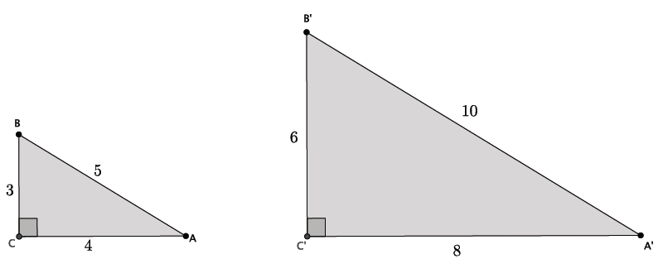
- Discuss with your partners how the method for finding Pythagorean triples can be explained mathematically.
  - Triangle $△A'B'C'$ can be obtained by dilating $△ABC$ by a scale factor of $2$. Each triangle has a right angle with corresponding sides that are equal in ratio to the same constant, $2$. That is how we know that these triangles are similar. The method for finding Pythagorean triples can be directly tied to our understanding of dilation and similarity. Each triple is just a set of numbers that represent a dilation of $△ABC$ by a whole-number scale factor.
- Of course, we can also find triples by using a scale factor $0<r<1$, but since it produces a set of numbers that are not whole numbers, they are not considered to be Pythagorean triples. For example, if $r=\frac{1}{10}$, then a triple using side lengths $3$, $4$, $5$ is $0.3$, $0.4$,$0.5$.

Exercises 1–3 (5 minutes)
Students complete Exercises 1–3 independently. Allow students to use a calculator to verify that they are identifying triples.
Exercises
- Identify two Pythagorean triples using the known triple $3$, $4$, $5$(other than $6$, $8$,$10$).
Answers will vary. Accept any triple that is a whole number multiple of $3$,$4$,$5$.

- Identify two Pythagorean triples using the known triple $5$, $12$, $13$.
Answers will vary. Accept any triple that is a whole number multiple of $5$,$12$, $13$.

- Identify two triples using either $3$, $4$, $5$ or $5$,$12$, $13$.
Answers will vary.
Discussion (10 minutes)
- Pythagorean triples can also be explained algebraically. For example, assume $a$,$b$, $c$ represent a Pythagorean triple. Let $m$ be a positive integer. Then by the Pythagorean theorem, $a^{2}+b^{2}=c^{2}:$
${\left(ma\right)}^{2}+{\left(mb\right)}^{2}=m^{2}a^{2}+m^{2}b^{2}$ By the second law of exponents $=m^{2}\left(a^{2}+b^{2}\right)$ By the distributive property
$=m^{2}c^{2}$ By substitution ($a^{2}+b^{2}=c^{2})$
$$={\left(mc\right)}^{2}$$
Our learning of systems of linear equations leads us to another method for finding Pythagorean triples, and it is actually the method that was discovered on the tablet Plimpton $322$.
- Consider the system of linear equations:
$$\left\{\begin{aligned}x+y=\frac{t}{s} \\ x-y=\frac{s}{t}\end{aligned}\right.$$
MP.6
where $s$ and $t$ are positive integers and $t>s.$ Incredibly, the solution to this system results in a Pythagorean triple. When the solution is written as fractions with the same denominator, $\left(\frac{c}{b},\frac{a}{b}\right)$ for example, the numbers $a$, $b$,$c$ are a Pythagorean triple.
- To make this simpler, let’s replace $s$ and $t$ with $1$ and $2$, respectively. Then we have
$$\left\{\begin{aligned}x+y=\frac{2}{1} \\ x-y=\frac{1}{2} \end{aligned}\right.$$
- Which method should we use to solve this system? Explain.
  - We should add the equations together to eliminate the variable $y$.
- By the elimination method we have
$$x+y+x-y=2+\frac{1}{2} \\ 2x=\frac{5}{2} \\ x=\frac{5}{4}$$
Now, we can substitute $x$ into one of the equations to find $y$.
$$\frac{5}{4}+y=2 \\ y=2-\frac{5}{4} \\ y=\frac{3}{4}$$
Then, the solution to the system is $\left(\frac{5}{4},\frac{3}{4}\right)$. When a solution is written as fractions with the same denominator, $\left(\frac{c}{b},\frac{a}{b}\right)$ for example, it represents the Pythagorean triple $a$,$b$,$c$. Therefore, our solution yields the triple $3$, $4$,$5$.
The remaining time can be used to complete Exercises 4–7 where students practice finding triples using the system of linear equations just described, or with the discussion below which shows the solution to the general system (without using concrete numbers for $s$ and $t$).

Exercises 4–7 (10 minutes)
These exercises are to be completed in place of the discussion below. Have students complete Exercises 4–7 independently.

Use the system$\left\{\begin{aligned}x+y=\frac{t}{s} \\ x-y=\frac{s}{t}\end{aligned}\right.$ to find Pythagorean triples for the given values of $s$ and $t$. Recall that the solution in the form of $\left(\frac{c}{b},\frac{a}{b}\right)$ is the triple $a$, $b$,$c$.
- $s=4$, $t=5$
$$\left\{\begin{aligned}x+y=\frac{5}{4} \\ x-y=\frac{4}{5}\end{aligned}\right.$$
$$x+y+x-y=\frac{5}{4}+\frac{4}{5} \\ 2x=\frac{5}{4}+\frac{4}{5} \\ 2x=\frac{41}{20} \\ x=\frac{41}{40}$$ | $$\frac{41}{40}+y=\frac{5}{4} \\ y=\frac{5}{4}-\frac{41}{40} \\ y=\frac{9}{40}$$
Then the solution is $\left(\frac{41}{40},\frac{9}{40}\right)$, and the triple is $9$, $40$, $41$.

- $s=7$, $t=10$
$$\left\{\begin{aligned}x+y=\frac{10}{7} \\ x-y=\frac{7}{10}\end{aligned}\right.$$
$$x+y+x-y=\frac{10}{7}+\frac{7}{10} \\ 2x=\frac{149}{70} \\ x=\frac{149}{140}$$ | $$\frac{149}{140}+y=\frac{10}{7} \\ y=\frac{10}{7}-\frac{149}{140} \\ y=\frac{51}{140}$$
Then the solution is $\left(\frac{149}{140},\frac{51}{140}\right)$, and the triple is $51$, $140$, $149$.

- $s=1$, $t=4$
$$\left\{\begin{aligned}x+y=\frac{4}{1} \\ x-y=\frac{1}{4}\end{aligned}\right.$$
$$x+y+x-y=4+\frac{1}{4} \\ 2x=\frac{17}{4} \\ x=\frac{17}{8}$$ | $$\frac{17}{8}+y=\frac{4}{1} \\ y=4-\frac{17}{8} \\ y=\frac{15}{8}$$
Then the solution is $\left(\frac{17}{8},\frac{15}{8}\right)$, and the triple is $15$, $8$, $17$.

- Use a calculator to verify that you found a Pythagorean triple in each of the Exercises 4–6. Show your work below.
For the triple $9$,$40$,$41$:
$$9^{2}+40^{2}=41^{2} \\ 81+1,600=1,681 \\ 1,681=1,681$$
For the triple $51$, $140$, $149$:
$$51^{2}+140^{2}=149^{2} \\ 2601+19,600=22,201 \\ 22,201=22,201$$
For the triple $15$, $8$,$17$:
$$15^{2}+8^{2}=17^{2} \\ 225+64=289 \\ 289=289$$

Discussion (10 minutes)
This discussion is optional and replaces Exercises 4–7 above.
- Now we solve the system generally.
$$\left\{\begin{aligned}x+y=\frac{t}{s} \\ x-y=\frac{s}{t}\end{aligned}\right.$$
- Which method should we use to solve this system? Explain.
  - We should add the equations together to eliminate the variable $y$.
- By the elimination method we have
$$x+y+x-y=\frac{t}{s}+\frac{s}{t} \\ 2x=\frac{t}{s}+\frac{s}{t}$$
To add the fractions we will need the denominators to be the same. So, we use what we know about equivalent fractions and multiply the first fraction by $\frac{t}{t}$ and the second fraction by $\frac{s}{s}$:
$$2x=\frac{t}{s}\left(\frac{t}{t}\right)+\frac{s}{t}\left(\frac{s}{s}\right) \\ 2x=\frac{t^{2}}{st}+\frac{s^{2}}{st} \\ 2x=\frac{t^{2}+s^{2}}{st}$$
Now, we multiply both sides of the equation by $\frac{1}{2}$:
$$\frac{1}{2}\left(2x\right)=\frac{1}{2}\left(\frac{t^{2}+s^{2}}{st}\right) \\ x=\frac{t^{2}+s^{2}}{2st}$$
Now that we have a value for $x$, we can solve for $y$ as usual, but it is simpler to go back to the system:
$$\left\{\begin{aligned}x+y=\frac{t}{s} \\ x-y=\frac{s}{t}\end{aligned}\right.$$
It is equivalent to the system:
$$\left\{\begin{aligned}x=\frac{t}{s}-y \\ x=\frac{s}{t}+y\end{aligned}\right.$$
$$\frac{t}{s}-y=\frac{s}{t}+y \\ \frac{t}{s}=\frac{s}{t}+2y \\ \frac{t}{s}-\frac{s}{t}=2y$$
Which is very similar to what we have done before when we solved for $x$. Therefore,
$$y=\frac{t^{2}-s^{2}}{2st}.$$
The solution to the system is $\left(\frac{t^{2}+s^{2}}{2st}, \frac{t^{2}-s^{2}}{2st}\right)$. When a solution is written as fractions with the same denominator, $\left(\frac{c}{b},\frac{a}{b}\right)$ for example, it represents the Pythagorean triple $a$,$b$,$c$. Therefore, our solution yields the triple $t^{2}-s^{2}$, $2st$,$t^{2}+s^{2}$.

Closing (5 minutes)
Summarize, or ask students to summarize, the main points from the lesson:
- We know how to find an infinite number of Pythagorean triples: Multiply a known triple by a whole number.
- We know that if the numbers $a$,$b$,$c$ are not whole numbers, they can still be considered a triple, just not a Pythagorean triple.
- We know how to use a system of linear equations, just like the Babylonians did $4,000$years ago, to find Pythagorean triples.
Lesson Summary
A Pythagorean triple is a set of three positive integers that satisfies the equation $a^{2}+b^{2}=c^{2}$.
An infinite number of Pythagorean triples can be found by multiplying the numbers of a known triple by a whole number. For example, $3$,$4$, $5$ is a Pythagorean triple. Multiply each number by $7$, then you have $21$,$28$,$35$, which is also a Pythagorean triple.
The system of linear equations, $\left\{\begin{aligned}x+y=\frac{t}{s} \\ x-y=\frac{s}{t}\end{aligned}\right.$ can be used to find Pythagorean triples, just like the Babylonians did $4,000$ years ago.

Exit Ticket (5 minutes)
Name Date
Lesson 31: System of Equations Leading to Pythagorean Triples

Exit Ticket

Use a calculator to complete Problems 1–3.
- Is $7$, $20$, $21$ a Pythagorean triple? Is $1$, $\frac{15}{8}$, $\frac{17}{8}$ a Pythagorean triple? Explain.

- Identify two Pythagorean triples using the known triple $9$, $40$,$41$.

- Use the system$\left\{\begin{aligned}x+y=\frac{t}{s} \\ x-y=\frac{s}{t}\end{aligned}\right.$ to find Pythagorean triples for the given values of $s=2$ and $t=3.$ Recall that the solution in the form of $\left(\frac{c}{b},\frac{a}{b}\right)$ is the triple $a$, $b$,$c.$ Verify your results.

Exit Ticket Sample Solutions

Use a calculator to complete Problems 1–3.
- Is $7$,$20$,$21$ a Pythagorean triple? Is $1$,$\frac{15}{8}$,$\frac{17}{8}$ a Pythagorean triple? Explain.
The set of numbers $7$, $20$,$21$ is not a Pythagorean triple because $7^{2}+{20}^{2}≠{21}^{2}$.
The set of numbers $1$,$\frac{15}{8}$,$\frac{17}{8}$ is not a Pythagorean triple because the numbers$\frac{15}{8}$ and$\frac{17}{8}$ are not whole numbers.
But, they are a triple because $1^{2}+{\left(\frac{15}{8}\right)}^{2}={\left(\frac{17}{8}\right)}^{2}$.

- Identify two Pythagorean triples using the known triple $9$,$40$,$41$.
Answers will vary. Accept any triple that is a whole number multiple of$9$,$40$,$41$.

- Use the system$\left\{\begin{aligned}x+y=\frac{t}{s} \\ x-y=\frac{s}{t}\end{aligned}\right.$ to find Pythagorean triples for the given values of $s=2$ and $t=3$. Recall that the solution in the form of $\left(\frac{c}{b},\frac{a}{b}\right)$ is the triple $a$,$b$,$c$. Verify your results.
$$\left\{\begin{aligned}x+y=\frac{3}{2} \\ x-y=\frac{2}{3}\end{aligned}\right.$$
$$x+y+x-y=\frac{3}{2}+\frac{2}{3} \\ 2x=\frac{13}{6} \\ x=\frac{13}{12}$$ | $$\frac{13}{12}+y=\frac{3}{2} \\ y=\frac{3}{2}-\frac{13}{12} \\ y=\frac{5}{12}$$
Then the solution is $\left(\frac{13}{12},\frac{5}{12}\right)$, and the triple is $5$, $12$, $13$.
$$5^{2}+{12}^{2}={13}^{2} \\ 25+144=169 \\ 169=169$$

Problem Set Sample Solutions
Students practice finding triples using both methods discussed in this lesson.

- Explain in terms of similar triangles why it is that when you multiply the known Pythagorean triple $3$,$4$,$5$ by $12$, it generates a Pythagorean triple.
The triangle with lengths $3$,$4$,$5$ is similar to the triangle with lengths $36$, $48$, $60$. They are both right triangles whose corresponding side lengths are equal to the same constant.
$$\frac{36}{3}=\frac{48}{4}=\frac{60}{5}=12$$
Therefore, the triangles are similar, and we can say that there is a dilation from some center with scale factor
$r=12$ that makes the triangles congruent.
- Identify three Pythagorean triples using the known triple $8$,$15$, $17$.
Answers will vary. Accept any triple that is a whole number multiple of $8$,$15$, $17$.

- Identify three triples (numbers that satisfy $a^{2}+b^{2}=c^{2}$, but $a$,$b$, $c$ are not whole numbers) using the triple $8$, $15$,$17$.
Answers will vary. Accept any triple that is not a set of whole numbers.

Use the system$\left\{\begin{aligned}x+y=\frac{t}{s} \\ x-y=\frac{s}{t}\end{aligned}\right.$ to find Pythagorean triples for the given values of $s$ and $t$. Recall that the solution, in the form of $\left(\frac{c}{b},\frac{a}{b}\right)$, is the triple, $a$,$b$,$c$.
- $s=2$, $t=9$
$$\left\{\begin{aligned}x+y=\frac{9}{2} \\ x-y=\frac{2}{9}\end{aligned}\right.$$
$$x+y+x-y=\frac{9}{2}+\frac{2}{9} \\ 2x=\frac{85}{18} \\ x=\frac{85}{36}$$ | $$\frac{85}{36}+y=\frac{9}{2} \\ y=\frac{9}{2}-\frac{85}{36} \\ y=\frac{77}{36}$$
Then the solution is $\left(\frac{85}{36},\frac{77}{36}\right)$, and the triple is $77$,$36$,$85$.

- $s=6$, $t=7$
$$\left\{\begin{aligned}x+y=\frac{7}{6} \\ x-y=\frac{6}{7}\end{aligned}\right.$$
$$x+y+x-y=\frac{7}{6}+\frac{6}{7} \\ 2x=\frac{85}{42} \\ x=\frac{85}{84}$$ | $$\frac{85}{84}+y=\frac{7}{6} \\ y=\frac{7}{6}-\frac{85}{84} \\ y=\frac{13}{84}$$
Then the solution is $\left(\frac{85}{84},\frac{13}{84}\right)$, and the triple is $13$,$84$,$85$.

- $s=3$, $t=4$
$$\left\{\begin{aligned}x+y=\frac{4}{3} \\ x-y=\frac{3}{4}\end{aligned}\right.$$
$$x+y+x-y=\frac{4}{3}+\frac{3}{4} \\ 2x=\frac{25}{12} \\ x=\frac{25}{24}$$ | $$\frac{25}{24}+y=\frac{4}{3} \\ y=\frac{4}{3}-\frac{25}{24} \\ y=\frac{7}{24}$$
Then the solution is $\left(\frac{25}{24},\frac{7}{24}\right)$, and the triple is $7$,$24$,$25$.

- Use a calculator to verify that you found a Pythagorean triple in each of the Problems 4–6. Show your work below.
For the triple $77$, $36$,$85$:
$${77}^{2}+36^{2}=85^{2} \\ 5929+1,296=7,225 \\ 7,225=7,225$$
For the triple $13$,$84$,$85$:
$$13^{2}+84^{2}=85^{2} \\ 169+7,056=7,225 \\ 7,225=7,225$$
For the triple $7$,$24$,$25$:
$$7^{2}+24^{2}=25^{2} \\ 49+576=625 \\ 625=625$$

