|  |
| --- |
|  |

Lesson 27: Nature of Solutions of a System of Linear Equations

Student Outcomes

* Students know that since two equations in the form and , when , *b*, and *c* are non-zero numbers, graph as the same line when *,* then the system of linear equations has infinitely many solutions.
* Students know a strategy for solving a system of linear equations algebraically.

Classwork

Exercises 1–3 (5 minutes)

Students complete Exercises 1–3 independently in preparation for the discussion that follows about infinitely many solutions.

Exercises

Determine the nature of the solution to each system of linear equations.

The slopes of these two distinct equations are the same, which means the graphs of these two equations are parallel lines. Therefore, this system will have no solutions.

The slopes of these two equations are different. That means the graphs of these two equations are distinct non-parallel lines and will intersect at one point. Therefore, this system has one solution.

The lines defined by the graph of this system of equations are the same line because they have the same slope and the same -intercept.

**Discussion (7 minutes)**

Ask students to summarize the nature of the solutions for each of the Exercises 1–3. Students should be able to state clearly what they observed in Exercise 1 and Exercise 2 as stated in (1) and (2) below.

* So far, our work with systems of linear equations has taught us that

1. If the lines defined by the equations in the system are parallel, then the system has no solutions.
2. If the lines defined by the equations in the system are not parallel, then the system has exactly one solution, and it is the point of intersection of the two lines.

Have students discuss their “solution” to Exercise 3. Ask students what they noticed, if anything, about the equations in Exercise 3. If necessary, show that the first equation can be obtained from the second equation by multiplying each term by . Then, the equations are exactly the same. Proceed with the second example below, along with the discussion points that follow.

* We now know there is a third possibility with respect to systems of equations. Consider the following system of linear equations below.

What do you notice about the constants ,, and of the first equation, compared to the constants , , and of the second equation?

* + *When you compare , they are equal to the same constant .*

MP.2

* If you multiplied each term of the first equation by the constant , what is the result?
  + *Sample student work:*

*When you multiply each term of the first equation by the constant , the result is the second equation.*

* What does this mean about the graphs of the equations in the system?
  + *It means that the lines defined by these equations are the same line. That is, they graph as the same line.*
* When the lines defined by two linear equations are the same line, it means that every solution to one equation is also a solution to the other equation. Since we can find an infinite number of solutions to any linear equation in two variables, systems that are comprised of equations that define the same line have infinitely many solutions.

Provide students with time to verify the fact that the system has infinitely many solutions. Instruct them to find at least two solutions to the first equation, and then show that the same ordered pairs satisfy the second equation as well.

* + *Sample student work:*

Two solutions to are and . Replacing the solutions in the second equation results in the true equations. When , and

and when and

* Since there is only one line passing through two distinct points, the lines defined by the two equations are the same line. That is, the system has infinitely many solutions.
* Therefore, the nature of the solutions of a system of linear equations is one of three possibilities: one solution, no solution, or infinitely many solutions. A system will have one solution when the graphs of the equations are distinct lines with different slopes. A system will have no solution when the equations have the same slope and different -intercepts, in other words, when the graphs are parallel lines. A system will have infinitely many solutions when the lines defined by the equations are the same line; these equations will have the same slope and same -intercept.

Example 1 (7 minutes)

In this example, students realize that graphing a system of equations will yield a solution, but the precise coordinates of the solution cannot be determined from the graph.

* Macintosh HD:Users:shassan:Desktop:example1.pdfThe following figure contains the graphs of the system .
* Though the graphs of the equations were easy to sketch, it is not easy to identify the solution to the system because the intersection of the lines does not have integer coordinates. Estimate the solution based on the graph.
  + *The solution looks like it could be*
* When we need a precise answer, we must use an alternative strategy for solving systems of linear equations.

Understanding the substitution method requires an understanding of the transitive property. One accessible way to introduce this to students at this level is through symbolic puzzles; one possible example follows:

If and , is it true that ? Why or why not? Allow students time to think about the symbol puzzle and share their thoughts with the class. Then, continue with the points below.

* When two linear expressions are equal to the same number, then the expressions are equal to each other, just like because both and are equal to . Look at the system of equations given in this example:

How is this like our puzzle about , , and ?

* + *Both of the equations in the system are equal to ; therefore, must be equal to*
* The equation is a linear equation in one variable. Solve it for
* *Sample student work:*
* Keep in mind that we are trying to identify the point of intersection of the lines, in other words, the solution that is common to both equations. What we have just found is the -coordinate of that solution, and we must now determine the -coordinate. To do so, we can substitute the value of into either of the two equations of the system to determine the value for .
* Verify that we would get the same value for using the second equation.
  + *Sample student work:*
* The solution to the system is Look at the graph. Does it look like this could be the solution?
  + *Yes, the coordinates look correct, and they are close to our estimated solution.*
* Our estimation was close to the actual answer but not as precise as when we solved the system algebraically.

Example 2 (4 minutes)

* Does the system have a solution?
  + *Yes, the slopes are different, which means they are not parallel and not the same line.*
* Now that we know that the system has a solution, we will solve it without graphing.
* Notice that in this example we do not have two linear expressions equal to the same number. However, we do know what is; it is equal to the expressions . Therefore, we can substitute the expression that is equal to in the second equation. Since , then:
* What does represent?
  + *It represents the -coordinate of the point of intersection of the graphs of the lines or the solution to the system.*
* How can we determine the -coordinate of the solution to the system?
  + *Since we know the -coordinate of the solution, we can substitute the value of into either equation to determine the value of the -coordinate.*
* Determine the -coordinate of the solution to the system.
  + *Sample student work:*
* The solution to this system is . What does the solution represent?
  + *The solution is the point of intersection of the graphs of the lines of the system. It is a solution that makes both equations of the system true.*

Example 3 (8 minutes)

* Does the system have a solution?
  + *Yes, the slopes are different, which means they are not parallel and not the same line.*
* Solve this system using substitution. Since we know what is equal to, we can replace that value with the expression in the first equation.
  + *Sample student work:*

*The solution to the system is*

* There is another option for solving this equation. We could multiply the second equation by . Then, we would have two linear equations equal to that could then be written as a single equation, as in Example 1. Or, we could multiply the first equation by . Then, we would have two linear equations equal to that could be written as a single equation, as in Example 1, again.
* For this system, let’s multiply the second equation by . Then, we have
* Now, the system can be written as , and we can write the two linear expressions and as equal to one another. Solve the system.
  + *Sample student work:*

*The solution to the system is*

* Compare the solution we got algebraically to the graph of the system of linear equations:

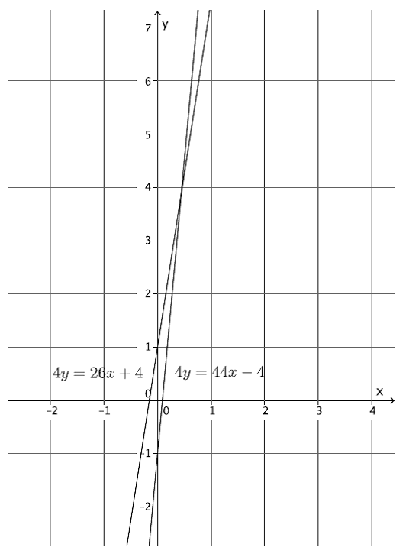

We can see that our answer is correct because it looks like the lines intersect at

Exercises 4–7 (7 minutes)

Students complete Exercises 4–7 independently.

Determine the nature of the solution to each system of linear equations. If the system has a solution, find it algebraically, and then verify that your solution is correct by graphing.



These equations define the same line. Therefore, this system will have infinitely many solutions.

Macintosh HD:Users:stefaniehassan:Desktop:exer6.pdfThe slopes of these two equations are unique. That means they graph as distinct lines and will intersect at one point. Therefore, this system has one solution.

The solution is .

The slopes of these two equations are unique. That means they graph as distinct lines and will intersect at one point. Therefore, this system has one solution.

The solution is .

Macintosh HD:Users:stefaniehassan:Desktop:exer5.pdf

1. Write a system of equations with as its solution.

Answers will vary. Verify that students have written a system of equations where is a solution to each equation in the system. Sample solution:

Closing (3 minutes)

Summarize, or ask students to summarize, the main points from the lesson:

* A system can have one solution, no solution, or infinitely many solutions. It will have one solution when the lines are distinct and their slopes are different; it will have no solution when the equations graph as distinct lines with the same slope; it will have infinitely many solutions when the equations define the same line.
* We learned a method for solving a system of linear equations algebraically. It requires us to write linear expressions equal to one another and substitution.

Lesson Summary

A system of linear equations can have a unique solution, no solutions, or infinitely many solutions.

Systems with a unique solution will be comprised of linear equations that have different slopes that graph as distinct lines, intersecting at only one point.

Systems with no solution will be comprised of linear equations that have the same slope that graph as parallel lines (no intersection).

Systems with infinitely many solutions will be comprised of linear equations that have the same slope and   
-intercept that graph as the same line.  When equations graph as the same line, every solution to one equation will also be a solution to the other equation.

A system of linear equations can be solved using a substitution method. That is, if two expressions are equal to the same value, then they can be written equal to one another.

Example:

Since both equations in the system are equal to , we can write the equation and use it to solve for and then the system.

Example:

Multiply each term of the equation by to produce the equivalent equation . As in the previous example, since both equations equal , we can write . This equation can be used to solve for and then the system.

Exit Ticket (4 minutes)

Name Date

Lesson 27: Nature of Solutions of a System of Linear Equations

Exit Ticket

Determine the nature of the solution to each system of linear equations. If the system has a solution, then find it without graphing.



Exit Ticket Sample Solutions

Determine the nature of the solution to each system of linear equations. If the system has a solution, then find it without graphing.

The slopes of these two equations are the same, and the -intercepts are different, which means they graph as parallel lines. Therefore, this system will have no solutions.

The slopes of these two equations are unique. That means they graph as distinct lines and will intersect at one point. Therefore, this system has one solution.

The solution is .

These equations define the same line. Therefore, this system will have infinitely many solutions.

Problem Set Sample Solutions

Students practice determining the nature of solutions of a system of linear equations and finding the solution for systems that have one.

Determine the nature of the solution to each system of linear equations. If the system has a solution, find it algebraically, and then verify that your solution is correct by graphing.

The slopes of these two equations are the same, and the -intercepts are different, which means they graph as parallel lines. Therefore, this system will have no solutions.

Macintosh HD:Users:stefaniehassan:Desktop:ps2.pdf

The solution is .

The solution is .

Macintosh HD:Users:stefaniehassan:Desktop:ps3.pdf

These equations define the same line. Therefore, this system will have infinitely many solutions.

|  |  |
| --- | --- |
|  |  |

The solution is .

Macintosh HD:Users:stefaniehassan:Desktop:ps5.pdf

Macintosh HD:Users:stefaniehassan:Desktop:ps6.pdf

|  |  |
| --- | --- |
|  |  |

The solution is .

These equations define the same line. Therefore, this system will have infinitely many solutions.

The slopes of these two equations are the same, and the -intercepts are different, which means they graph as parallel lines. Therefore, this system will have no solutions.

Macintosh HD:Users:stefaniehassan:Desktop:ps9.pdf

The solution is .

Macintosh HD:Users:stefaniehassan:Desktop:ps10.pdf

The solution is .

1. Write a system of linear equations with as its solution.

Answers will vary. Verify that students have written a system of equations where is a solution to each equation in the system. Sample solution: