Lesson 26: Characterization of Parallel Lines

Classwork

Exercises

1. Sketch the graphs of the system:

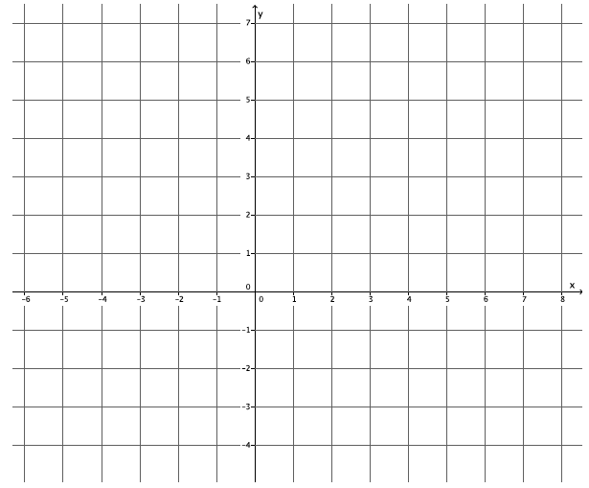

* 1. Identify the slope of each equation. What do you notice?
  2. Identify the -intercept of each equation. Are the -intercepts the same or different?

1. Sketch the graphs of the system:

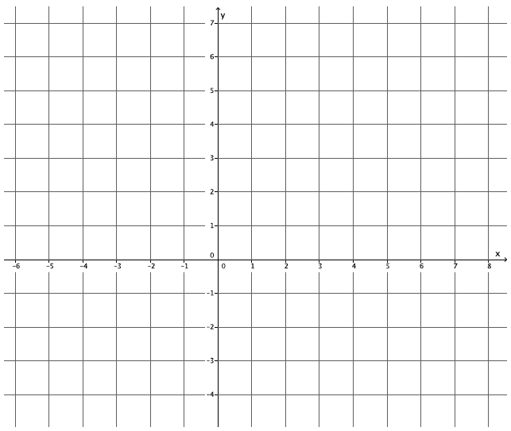

* 1. Identify the slope of each equation. What do you notice?
  2. Identify the -intercept of each equation. Are the -intercepts the same or different?

1. Sketch the graphs of the system:

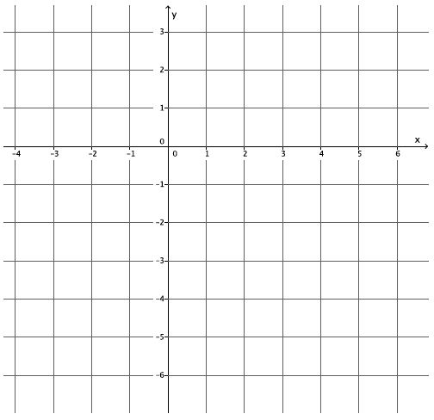

* 1. Identify the slope of each equation. What do you notice?
  2. Identify the -intercept of each equation. Are the -intercepts the same or different?

1. Write a system of equations that has no solution.
2. Write a system of equations that has as a solution.
3. How can you tell if a system of equations has a solution or not?
4. Does the system of linear equations shown below have a solution? Explain.
5. Does the system of linear equations shown below have a solution? Explain.
6. Does the system of linear equations shown below have a solution? Explain.
7. Genny babysits for two different families. One family pays her each hour and a bonus of at the end of the night. The other family pays her every half hour and a bonus of dollars at the end of the night. Write and solve the system of equations that represents this situation. At what number of hours do the two families pay the same for babysitting services from Genny?

Lesson Summary

By definition, parallel lines do not intersect; therefore, a system of linear equations whose graphs are parallel lines will have no solution.

Parallel lines have the same slope, but no common point. Verify that lines are parallel by comparing their slopes and their -intercepts.

Problem Set

Answer Problems 1–5 without graphing the equations.

1. Does the system of linear equations shown below have a solution? Explain.
2. Does the system of linear equations shown below have a solution? Explain.
3. Does the system of linear equations shown below have a solution? Explain.
4. Does the system of linear equations shown below have a solution? Explain.
5. Does the system of linear equations shown below have a solution? Explain.
6. Given the graphs of a system of linear equations below, is there a solution to the system that we cannot see on this portion of the coordinate plane? That is, will the lines intersect somewhere on the plane not represented in the picture? Explain.

Macintosh HD:Users:shassan:Desktop:ps1.pdf

1. Given the graphs of a system of linear equations below, is there a solution to the system that we cannot see on this portion of the coordinate plane? That is, will the lines intersect somewhere on the plane not represented in the picture? Explain.

Macintosh HD:Users:shassan:Desktop:ps2.pdf

1. Given the graphs of a system of linear equations below, is there a solution to the system that we cannot see on this portion of the coordinate plane? That is, will the lines intersect somewhere on the plane not represented in the picture? Explain.

Macintosh HD:Users:shassan:Desktop:ps3.pdf

1. Given the graphs of a system of linear equations below, is there a solution to the system that we cannot see on this portion of the coordinate plane? That is, will the lines intersect somewhere on the plane not represented in the picture? Explain.

Macintosh HD:Users:shassan:Desktop:ps4.pdf

1. Given the graphs of a system of linear equations below, is there a solution to the system that we cannot see on this portion of the coordinate plane? That is, will the lines intersect somewhere on the plane not represented in the picture? Explain.

