|  |
| --- |
|  |

Lesson 26: Characterization of Parallel Lines

Student Outcomes

* Students know that when a system of linear equations has no solution, i.e., no point of intersection of the lines, then the lines are parallel.

Lesson Notes

The discussion that begins on page 412 is an optional proof of the theorem about parallel lines. You can choose to discuss the proof with students or have students complete Exercises 4–10.

Classwork

Exercises 1–3 (10 minutes)

Students complete Exercises 1-3independently. Once students are finished, debrief their work using the questions in the discussion that follows the exercises.

Macintosh HD:Users:shassan:Desktop:exer1.pdf  
Exercises

1. Sketch the graphs of the system.
   1. Identify the slope of each equation. What do you notice?

***The slope of the first equation is , and the slope of the second equation is . The slopes are equal.***

* 1. Identify the -intercept of each equation. Are the -intercepts the same or different?

***The -intercepts are and . The -intercepts are different.***

1. Macintosh HD:Users:shassan:Desktop:exer2.pdfSketch the graphs of the system.
   1. Identify the slope of each equation. What do you notice?

***The slope of both equations is . The slopes are equal.***

* 1. Identify the -intercept of each equation. Are the -intercepts the same or different?

***The -intercepts are and . The -intercepts are different.***

1. Macintosh HD:Users:shassan:Desktop:exer3.pdfSketch the graphs of the system.
   1. Identify the slope of each equation. What do you notice?

***The slope of both equations is . The slopes are equal.***

* 1. Identify the -intercept of each equation. Are the -intercepts the same or different?

***The -intercepts are and . The -intercepts are different.***

**Discussion (10 minutes)**

* What did you notice about each of the systems you graphed in Exercises 1-3?

MP.3

&

MP.8

* + *For each exercise, the graphs of the given linear equations look like parallel lines.*
* What did you notice about the slopes in each system?
  + *Each time, the linear equations of the system had the same slope.*
* What did you notice about the -intercepts of the equations in each system?
  + *In each case, the -intercepts were different.*
* If the equations had the same -intercept and the same slope, what would we know about the graphs of the lines?
  + *There is only one line that can go through a given point with a given slope. If the equations had the same slope and -intercept, then their graphs are the same line.*

MP.3

&

MP.8

* For that reason, when we discuss lines with the same slope, we must make sure to identify them as distinct lines.
* Write a summary of the conclusions you have reached by completing Exercises 1–3.

Provide time for students to write their conclusions. Share the theorem with them, and have students compare the conclusions that they reached to the statements in the theorem.

* What you observed in Exercises 1–3can be stated as a theorem.

**Theorem:**

1. Two distinct, non-vertical lines in the plane are parallel if they have the same slope.
2. If two distinct, non-vertical lines have the same slope, then they are parallel.

* Suppose you have a pair of parallel lines on a coordinate plane. In how many places will those lines intersect?
  + *By definition, parallel lines never intersect.*
* Suppose you are given a system of linear equations whose graphs are parallel lines. How many solutions will the system have?
  + *Based on work in the previous lesson, students learned that the solutions of a system lie in the intersection of the lines defined by the linear equations of the system. Since parallel lines do not intersect, then a system containing linear equations that graph as parallel lines will have no solution.*
* What we want to find out is how to recognize when the lines defined by the equations are parallel. Then, we would know immediately that we have a system with no solution as long as the lines are different.
* A system can easily be recognized as having no solutions when it is in the form of or   
  Why is that so?
  + *Because the system graphs as two vertical lines. All vertical lines are parallel to the -axis and, therefore, are parallel to one another. Similarly, the system graphs as two horizontal lines. All horizontal lines are parallel to the -axis and, therefore, are parallel to one another.*
* We want to be able to recognize when we have a system of parallel lines that are not vertical or horizontal. What characteristics did each pair of equations have?
  + *Each pair of equations had the same slope but different -intercepts.*

**Discussion (15 minutes)**

The following Discussion is an optional proof of the theorem about parallel lines. Having this discussion with students is optional**.** Instead, you may have students complete Exercises 4–10beginning on page 415.

* We begin by proving (1). Recall that when we were shown that the slope between any two points would be equal to the same constant, , we used what we knew about similar triangles. We will do something similar to prove (1).
* Suppose we have two non-vertical and non-horizontal parallel lines and in the coordinate plane. Assume that the -intercept of is greater than the -intercept of (We could assume the opposite is true; it does not make a difference with respect to the proof. We just want to say something clearly so our diagram will make sense.) Let’s also assume that these lines are left-to-right inclining, i.e., positive slope.

Macintosh HD:Users:shassan:Desktop:socratica.pdf

* Macintosh HD:Users:shassan:Desktop:socraticb.pdfPick a point on and draw a vertical line from so that it intersects at point and the -axis at point From points and , draw horizontal lines so that they intersect lines and at points and , respectively.
* By construction, and are right angles. How do we know for sure?
  + *We drew a vertical line from point Therefore, the vertical line is parallel to the -axis and perpendicular to the -axis. Therefore, . Since we also drew horizontal lines, we know they are parallel. The vertical line through is then a transversal that intersects parallel lines, which means corresponding angles are congruent. Since corresponds to , then .*
* We want to show that , which means we need another pair of equal angles in order to use the AA criterion. Do we have another pair of equal angles? Explain.
  + *Yes. We know that lines*  *and* *are parallel. By using the vertical line through as the transversal, corresponding angles . Therefore,*

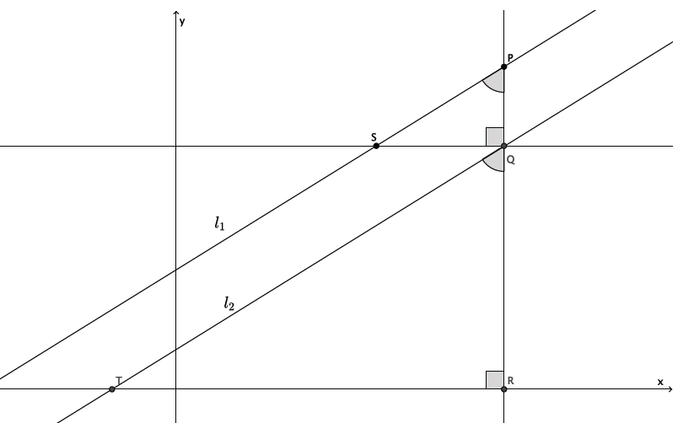

* To better see what we are doing, we will translate along vector as shown.

Macintosh HD:Users:shassan:Desktop:socraticd.pdf

* By definition of dilation, we know that:

Equivalently, by the multiplication property of equality:

Because translation preserves lengths of segments, we know that and , so we have

By definition of slope, is the slope of and is the slope of . Therefore, the slopes of and are equal and (1) is proved.

* To prove (2), use the same construction as we did for (1). The difference this time is that we know we have side lengths that are equal in ratio because we are given that the slopes are the same, so we are trying to prove that the lines and are parallel. Since we do not know the lines are parallel, we also do not know that , but we do know that and are right angles.

Macintosh HD:Users:shassan:Desktop:socratice.pdf

* Then again, we translate along vector as shown.

Macintosh HD:Users:shassan:Desktop:socraticd.pdf

* Since the corresponding sides are equal in ratio to the scale factor and share a common angle , by the fundamental theorem of similarity, we know that the lines containing and are parallel. Since the line containing is a translation of line , and translations preserve angle measures, then we know that line is parallel to line . Since the line containing is , and the line containing is line , then we can conclude that This finishes the proof of the theorem.

Exercises 4–10 (15 minutes)

Students complete Exercises 4–10independently. Once students are finished, debrief their work using the questions in the discussion that follow the exercises.

1. Write a system of equations that has no solution.

Answers will vary. Verify that the system that has been written has equations that have the same slope and unique -intercepts. Sample student solution:

1. Write a system of equations that has as a solution.

Answers will vary. Verify that students have written a system where is a solution to each equation. Sample student solution:

1. How can you tell if a system of equations has a solution or not?

If the slopes of the equations are different, the lines will intersect at some point, and there will be a solution to the system. If the slopes of the equations are the same, and the -intercepts are different, then the equations will graph as parallel lines, which means the system will not have a solution.

1. Does the system of linear equations shown below have a solution? Explain.

Yes, this system does have a solution. The slope of the first equation is , and the slope of the second equation is . Since the slopes are different, these equations will graph as non-parallel lines, which means they will intersect at some point.

1. Does the system of linear equations shown below have a solution? Explain.

No, this system does not have a solution. The slope of the first equation is , and the slope of the second equation is . Since the slopes are the same, but the lines are distinct, these equations will graph as parallel lines. Parallel lines never intersect, which means this system has no solution.

1. Does the system of linear equations shown below have a solution? Explain.

No, this system does not have a solution. The slope of the first equation is , and the slope of the second equation is . Since the slopes are the same, but the lines are distinct, these equations will graph as parallel lines. Parallel lines never intersect, which means this system has no solution.

1. Genny babysits for two different families. One family pays her each hour and a bonus of at the end of the night. The other family pays her every half hour and a bonus of dollars at the end of the night. Write and solve the system of equations that represents this situation. At what number of hours do the two families pay the same for babysitting services from Genny?

Let represent the total amount Genny is paid for babysitting hours. The first family pays . Since the other family pays by the half hour, would represent the amount Genny is paid each hour. So, the other family pays , which is the same as .

Since the equations in the system have the same slope and different -intercepts, there will not be a point of intersection. That means that there will not be a number of hours for when Genny is paid the same amount by both families. The second family will always pay her more than the first family.

Closing (5 minutes)

Summarize, or ask students to summarize, the main points from the lesson:

* We know that systems of linear equations whose graphs are two distinct vertical lines will have no solution because all vertical lines are parallel to the -axis and, therefore, are parallel to one another. Similarly, systems of linear equations whose graphs are two distinct horizontal lines will have no solution because all horizontal lines are parallel to the -axis and, therefore, are parallel to one another.
* We know that if a system contains linear equations whose graphs are distinct lines with the same slope, then the lines are parallel, and therefore, the system has no solution.

Lesson Summary

**By definition, parallel lines do not intersect; therefore, a system of linear equations whose graphs are parallel lines will have no solution.**

**Parallel lines have the same slope, but no common point. Verify that lines are parallel by comparing their slopes and their -intercepts.**

Exit Ticket (5 minutes)

Name Date

Lesson 26: Characterization of Parallel Lines

Exit Ticket

Does each system of linear equations have a solution? Explain your answer.



Exit Ticket Sample Solutions

Does each system of linear equations have a solution? Explain your answer.

No, this system does not have a solution. The slope of the first equation is , and the slope of the second equation is . Since the slopes are the same, and they are distinct lines, these equations will graph as parallel lines. Parallel lines never intersect; therefore, this system has no solution.

Yes, this system does have a solution. The slope of the first equation is , and the slope of the second equation is . Since the slopes are different, these equations will graph as non-parallel lines, which means they will intersect at some point.



No, this system does not have a solution. The slope of the first equation is , and the slope of the second equation is . Since the slopes are the same, and they are distinct lines, these equations will graph as parallel lines. Parallel lines never intersect; therefore, this system has no solution.

Problem Set Sample Solutions

Answer Problems 1–5without graphing the equations.

1. Does the system of linear equations shown below have a solution? Explain.

No, this system does not have a solution. The slope of the first equation is , and the slope of the second equation is , which is equivalent to . Since the slopes are the same, but the lines are distinct, these equations will graph as parallel lines. Parallel lines never intersect, which means this system has no solution.

1. Does the system of linear equations shown below have a solution? Explain.

Yes, this system does have a solution. The slope of the first equation is , and the slope of the second equation is . Since the slopes are different, these equations will graph as non-parallel lines, which means they will intersect at some point.

1. Does the system of linear equations shown below have a solution? Explain.

Yes, this system does have a solution. The slope of the first equation is , and the slope of the second equation is . Since the slopes are different, these equations will graph as nonparallel lines, which means they will intersect at some point.

1. Does the system of linear equations shown below have a solution? Explain.

No, this system does not have a solution. The slope of the first equation is , and the slope of the second equation is , which is equivalent to . Since the slopes are the same, but the lines are distinct, these equations will graph as parallel lines. Parallel lines never intersect, which means this system has no solution.

1. Does the system of linear equations shown below have a solution? Explain.

No, this system does not have a solution. The slope of the first equation is , and the slope of the second equation is . Since the slopes are the same, but the lines are distinct, these equations will graph as parallel lines. Parallel lines never intersect, which means this system has no solution.

1. Given the graphs of a system of linear equations below, is there a solution to the system that we cannot see on this portion of the coordinate plane? That is, will the lines intersect somewhere on the plane not represented in the picture? Explain.

Macintosh HD:Users:shassan:Desktop:ps1.pdf

The slope of is , and the slope of is . Since the slopes are different, these lines are nonparallel lines, which means they will intersect at some point. Therefore, the system of linear equations whose graphs are given lines will have a solution.

1. Given the graphs of a system of linear equations below, is there a solution to the system that we cannot see on this portion of the coordinate plane? That is, will the lines intersect somewhere on the plane not represented in the picture? Explain.

Macintosh HD:Users:shassan:Desktop:ps2.pdf

The slope of is , and the slope of is . Since the slopes are different, these lines are nonparallel lines, which means they will intersect at some point. Therefore, the system of linear equations whose graphs are given lines will have a solution.

1. Given the graphs of a system of linear equations below, is there a solution to the system that we cannot see on this portion of the coordinate plane? That is, will the lines intersect somewhere on the plane not represented in the picture? Explain.

Macintosh HD:Users:shassan:Desktop:ps3.pdf

The slope of is , and the slope of is . Since the slopes are the same, and the lines are parallel lines, which means they will not intersect. Therefore, the system of linear equations whose graphs are the given lines will have no solution.

1. Given the graphs of a system of linear equations below, is there a solution to the system that we cannot see on this portion of the coordinate plane? That is, will the lines intersect somewhere on the plane not represented in the picture? Explain.

Macintosh HD:Users:shassan:Desktop:ps4.pdf

The slope of is , and the slope of is . Since the slopes are different, these lines are non-parallel lines, which means they will intersect at some point. Therefore, the system of linear equations whose graphs are the given lines will have a solution.

1. Given the graphs of a system of linear equations below, is there a solution to the system that we cannot see on this portion of the coordinate plane? That is, will the lines intersect somewhere on the plane not represented in the picture? Explain.

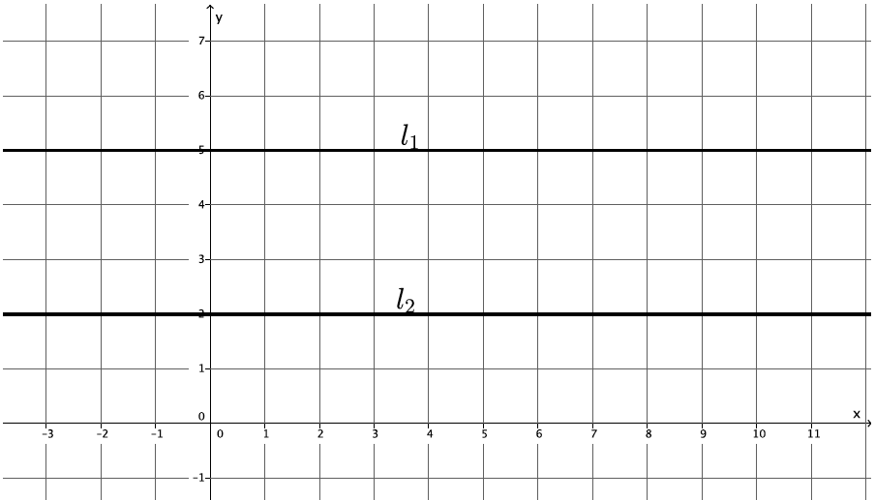

Lines and are horizontal lines. That means that they are both parallel to the -axis and, thus, are parallel to one another. Therefore, the system of linear equations whose graphs are the given lines will have no solution.