Lesson 25: Geometric Interpretation of the Solutions of a Linear System

Classwork
Exploratory Challenge/Exercises 1–5
- Sketch the graphs of the linear system on a coordinate plane: $\left\{\begin{aligned}2y+x=12 \\ y=\frac{5}{6}x-2 \end{aligned}\right.$
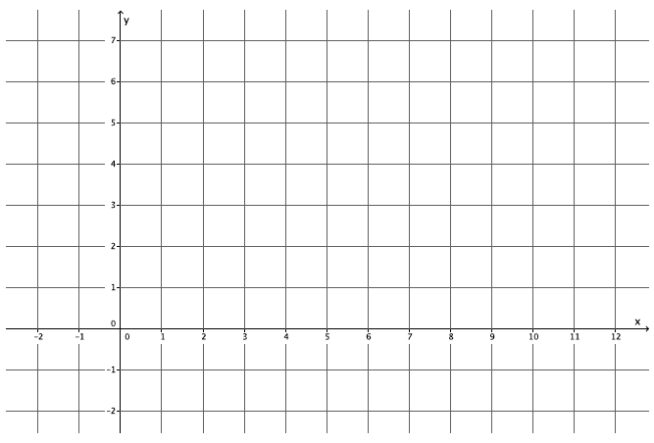

  - Name the ordered pair where the graphs of the two linear equations intersect.

  - Verify that the ordered pair named in part (a) is a solution to $2y+x=12.$

  - Verify that the ordered pair named in part (a) is a solution to $y=\frac{5}{6}x-2$.

  - Could the point $(4, 4)$ be a solution to the system of linear equations? That is, would $(4, 4)$ make both equations true? Why or why not?

- Sketch the graphs of the linear system on a coordinate plane: $\left\{\begin{aligned}x+y=-2 \\ y=4x+3 \end{aligned}\right.$
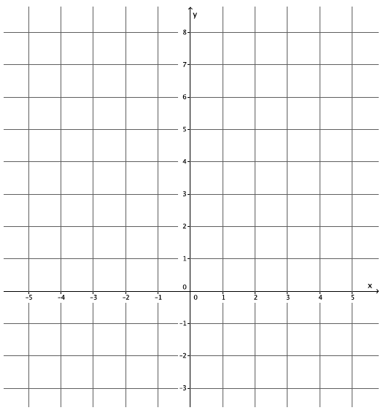

  - Name the ordered pair where the graphs of the two linear equations intersect.

  - Verify that the ordered pair named in part (a) is a solution to $x+y=-2.$

  - Verify that the ordered pair named in part (a) is a solution to $y=4x+3$.

  - Could the point $(-4, 2)$ be a solution to the system of linear equations? That is, would $(-4, 2)$ make both equations true? Why or why not?

- Sketch the graphs of the linear system on a coordinate plane: $\left\{\begin{aligned}3x+y=-3 \\ -2x+y=2\end{aligned}\right.$
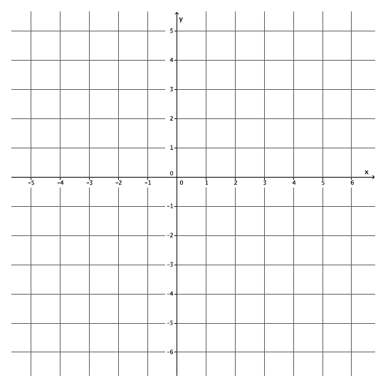

  - Name the ordered pair where the graphs of the two linear equations intersect.

  - Verify that the ordered pair named in part (a) is a solution to $3x+y=-3.$

  - Verify that the ordered pair named in part (a) is a solution to $-2x+y=2$.

  - Could the point $(1, 4)$ be a solution to the system of linear equations? That is, would $(1, 4)$ make both equations true? Why or why not?

- Sketch the graphs of the linear system on a coordinate plane: $\left\{\begin{aligned}2x-3y=18 \\ 2x+y=2 \end{aligned}\right.$
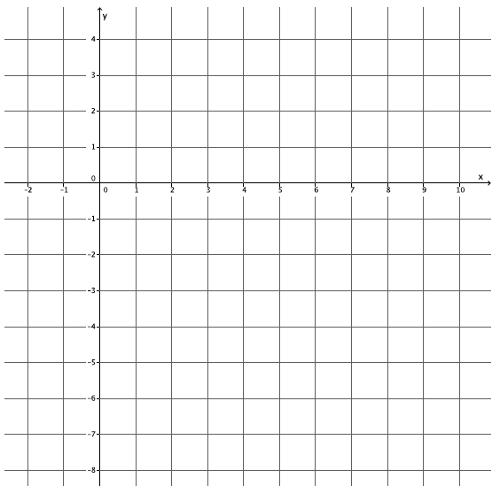
  - Name the ordered pair where the graphs of the two linear equations intersect.

  - Verify that the ordered pair named in part (a) is a solution to$2x-3y=18$.

  - Verify that the ordered pair named in part (a) is a solution to $2x+y=2$.

  - Could the point $(3, -1)$ be a solution to the system of linear equations? That is, would $(3, -1)$ make both equations true? Why or why not?

- Sketch the graphs of the linear system on a coordinate plane: $\left\{\begin{aligned}y-x=3 \\ y=-4x-2\end{aligned}\right.$
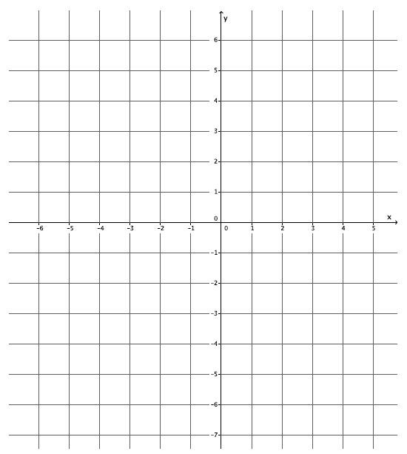

  - Name the ordered pair where the graphs of the two linear equations intersect.

  - Verify that the ordered pair named in part (a) is a solution to $y-x=3$.

  - Verify that the ordered pair named in part (a) is a solution to $y=-4x-2$.

  - Could the point $(-2, 6)$ be a solution to the system of linear equations? That is, would $(-2, 6)$ make both equations true? Why or why not?

Exercise 6
- Write two different systems of equations with $(1, -2)$ as the solution.

Lesson Summary
When the graphs of a system of linear equations are sketched, and if they are not parallel lines, then the point of intersection of the lines of the graph represents the solution to the system. Two distinct lines intersect at most at one point, if they intersect. The coordinates of that point $(x, y)$ represent values that make both equations of the system true.
Example: The system $\left\{\begin{aligned}x+y=3 \\ x-y=5\end{aligned}\right.$ graphs as shown below.
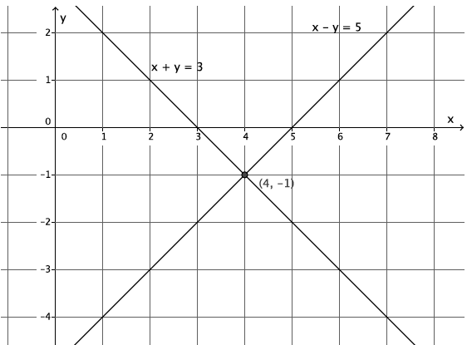
The lines intersect at $(4, -1)$. That means the equations in the system are true when $x=4$ and $y=-1$.
$$x+y=3 \\ 4+\left(-1\right)=3 \\ 3=3$$
$$x-y=5 \\ 4-\left(-1\right)=5 \\ 5=5$$
Problem Set

- Sketch the graphs of the linear system on a coordinate plane: $\left\{\begin{aligned}y=\frac{1}{3}x+1 \\ y=-3x+11\end{aligned}\right.$
  - Name the ordered pair where the graphs of the two linear equations intersect.
  - Verify that the ordered pair named in part (a) is a solution to $y=\frac{1}{3}x+1.$
  - Verify that the ordered pair named in part (a) is a solution to $y=-3x+11$.
- Sketch the graphs of the linear system on a coordinate plane: $\left\{\begin{aligned}y=\frac{1}{2}x+4 \\ x+4y=4\end{aligned}\right.$
  - Name the ordered pair where the graphs of the two linear equations intersect.
  - Verify that the ordered pair named in part (a) is a solution to $y=\frac{1}{2}x+4.$
  - Verify that the ordered pair named in part (a) is a solution to $x+4y=4$.

- Sketch the graphs of the linear system on a coordinate plane: $\left\{\begin{aligned}y=2 \\ x+2y=10\end{aligned}\right.$
  - Name the ordered pair where the graphs of the two linear equations intersect.
  - Verify that the ordered pair named in part (a) is a solution to $y=2.$
  - Verify that the ordered pair named in part (a) is a solution to $x+2y=10$.

- Sketch the graphs of the linear system on a coordinate plane: $\left\{\begin{aligned}-2x+3y=18 \\ 2x+3y=6 \end{aligned}\right.$
  - Name the ordered pair where the graphs of the two linear equations intersect.
  - Verify that the ordered pair named in part (a) is a solution to $-2x+3y=18.$
  - Verify that the ordered pair named in part (a) is a solution to $2x+3y=6$.

- Sketch the graphs of the linear system on a coordinate plane: $\left\{\begin{aligned}x+2y=2 \\ y=\frac{2}{3}x-6\end{aligned}\right.$
  - Name the ordered pair where the graphs of the two linear equations intersect.
  - Verify that the ordered pair named in part (a) is a solution to $x+2y=2.$
  - Verify that the ordered pair named in part (a) is a solution to $y=\frac{2}{3}x-6$.

- Without sketching the graph, name the ordered pair where the graphs of the two linear equations intersect.
$$\left\{\begin{aligned}x=2 \\ y=-3 \end{aligned}\right.$$

