Lesson 9
Objective: Answer compare with difference unknown problems about lengths of two different objects measured in centimeters.

Suggested Lesson Structure
 Fluency Practice (18 minutes)

A NOTE ON
STANDARDS ALIGNMENT:
In this lesson, students compare centimeter cubes as a concrete form of compare with difference unknown problem types. This bridges towards the Grade 2 standard of measuring to determine how much longer one object is than another (2.MD.4), although the lesson specifically focuses on comparing the concrete cubes rather than the more abstract numerical representations of the measurements.

 Application Problem (5 minutes)
 Concept Development (27 minutes)
 Student Debrief (10 minutes)
Total Time (60 minutes)
Fluency Practice (18 minutes)
- Race and Roll Addition 1.OA.6 (5 minutes)
- Sprint: Addition Within 20 1.OA.6 (10 minutes)
- Number Sentence Swap 1.OA.4 (3 minutes)
Race and Roll Addition (5 minutes)
Materials: (S) 1 die per pair
Note: This fluency activity reviews the grade level standard of adding within 20.
All students start at 0. Partners take turns rolling a die and then saying a number sentence by adding the number rolled to the total. (For example, Partner A rolls 6 and says, “0 + 6 = 6.” Partner B rolls 3 and says,
“6 + 3 = 9.”) They continue rapidly rolling and saying number sentences until they get to 20, without going over. (For example, if partners are at 18 and roll 5, they take turns rolling until one of them rolls 2 or 1 two times.) Partners stand when they reach 20.

NOTES ON
MULTIPLE MEANS
OF ENGAGEMENT:
While some students thrive during Sprints, others may not enjoy having to complete a timed task. Cultivate healthy personal best competition during Sprints so that students focus on their improvement.

Sprint: Addition Within 20 (10 minutes)
Materials: (S) Addition Within 20 Sprint
Note: This Sprint addresses the Grade 1 standard of adding and subtracting within 20. It is the same Sprint from Lesson 7, so students will likely do better today. Along with celebrating improvement between Sides A and B, celebrate improvement from the last time this Sprint was given.
Number Sentence Swap (3 minutes)
Say a subtraction sentence aloud, saying “the mystery number” for the unknown answer (e.g., 5 – 3 = the mystery number). Call on a student to rephrase the sentence as an addition sentence (e.g., 3 + the mystery number = 5). Pause to provide think time. Students solve for the mystery number on your signal.
Suggested sequence: 5 – 3, 15 – 3, 6 – 4, 16 – 4, etc.
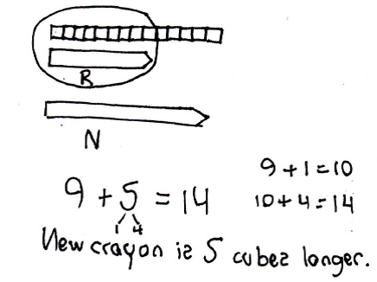
Application Problem (5 minutes)
Corey buys a super-cool, extra-long crayon that is 14 centimeters long. His regular crayon is 9 centimeters long. Use centimeter cubes to find out how much longer Corey’s new crayon is than his regular crayon.
Write a statement to answer the question.
Write a number sentence to show what you did.

Note: This problem continues to provide students with opportunities to concretely build various lengths with centimeter cubes. As students work towards solving compare with difference unknown problem types, experiences with concrete objects like centimeter cubes can strengthen understanding. Students will be exploring the comparison of centimeter cubes during today’s lesson. As students work, notice how they are solving and use your analysis during the Concept Development.

Concept Development (27 minutes)
Materials: (T) 2 different colors of centimeter cubes (e.g., blue and yellow), dry-erase marker, jumbo craft stick, crayon, glue stick, small paper clip, unsharpened pencil, new colored pencil, chart with measuring rules (Lesson 7) (S) Bag with 20 blue and 20 yellow centimeter cubes, bag with classroom materials (Lesson 4), new colored pencil
Note: Adjust the Concept Development as necessary based on your observations of student successes and challenges during Lesson 6, as well as during the most recent Application Problems. Today’s Concept Development is an opportunity to continue supporting student understanding of the compare with difference unknown problem types within the concrete context of comparing lengths of centimeter cubes. As addressed in the Note on Standards Alignment, the focus of the lesson should be on comparing the cubes themselves rather than the Grade 2 standard of comparing the measurements alone.
Gather students in the meeting area in a semicircle formation.
T: (Post the chart with measuring rules from Lesson 7.) The teacher next door and I were playing a game. Whoever found the longer object on our desks won, but the object could not be longer than a new pencil. For each extra centimeter in length, the person with the longer object got a point.
T: The teacher next door found a craft stick, and I found a dry-erase marker, just like the ones on our chart (point to the chart). My dry-erase marker measured 12 centimeters, and his craft stick measured 15 centimeters. He said he got 15 points, but I don’t think that’s right. Let’s lay the centimeter cubes down and compare them to see how many points he should have gotten in our game.
T: I have 12 centimeter cubes here in my hand. (Lay the two objects in the middle. Point to the chart.) The dry-erase marker is 12 centimeters long. Will I have enough cubes to measure my dry-erase marker?
S: Yes! It is 12 centimeters long, and you have 12 centimeter cubes.
T: (Lay down blue centimeter cubes along the dry-erase marker. Point to the craft stick measurement of 15 centimeters on the chart.) Will these same 12 cubes be enough to measure the craft stick?
S: No! There are only 12 centimeter cubes. The craft stick is 15 centimeters long.
T: (Lay down 12 blue centimeter cubes along the craft stick.) The teacher next door said he should get 15 points because it took 15 more centimeter cubes to measure the craft stick than the marker! Look at the marker and the centimeter cubes we laid down. Is he right? Did he need 15 more cubes along with the 12 cubes I needed? Talk with a partner: how many more cubes did the teacher next door need compared to the number of cubes I used? (Have partners share their thinking with the class.)
T: Now, let’s try the other teacher’s idea. (Add 15 more cubes, this time using yellow cubes.) Wow, this is too long! It’s much longer than the difference between what he already has and what he needs. What should I do?
S: Take away all of the extra cubes until they line up with the end of the craft stick.
T: (Three yellow cubes are left.) So, if I had 12 cubes and he had 15 cubes, how many more cubes did the teacher need compared to me?
MP.2
S: 3 more cubes.
T: How much longer is the teacher’s craft stick compared to my marker?
S: 3 centimeters.

NOTES ON
MULTIPLE MEANS
OF REPRESENTATION:
Reading word problems aloud facilitates problem solving for those students who have difficulty reading the text. Make sure students with reading difficulties are not held back by the reading when they are able to solve the math problems.

T: How much shorter is my marker compared to the teacher’s craft stick?
S: 3 centimeters.
T: So, for that round, the teacher got 3 points because his stick was 3 centimeters longer than my marker. The teacher tried to get 15 points for that one, but I’m glad we figured out that he only gets 3 points.
Repeat the process by having students work with their centimeter cubes, measuring using the following contexts. Model as much as appropriate.
- Measure a new colored pencil and an unsharpened pencil as in the game between the two teachers.
- Students measure and compare the lengths of a crayon and a glue stick to see which item is shorter and by how much.
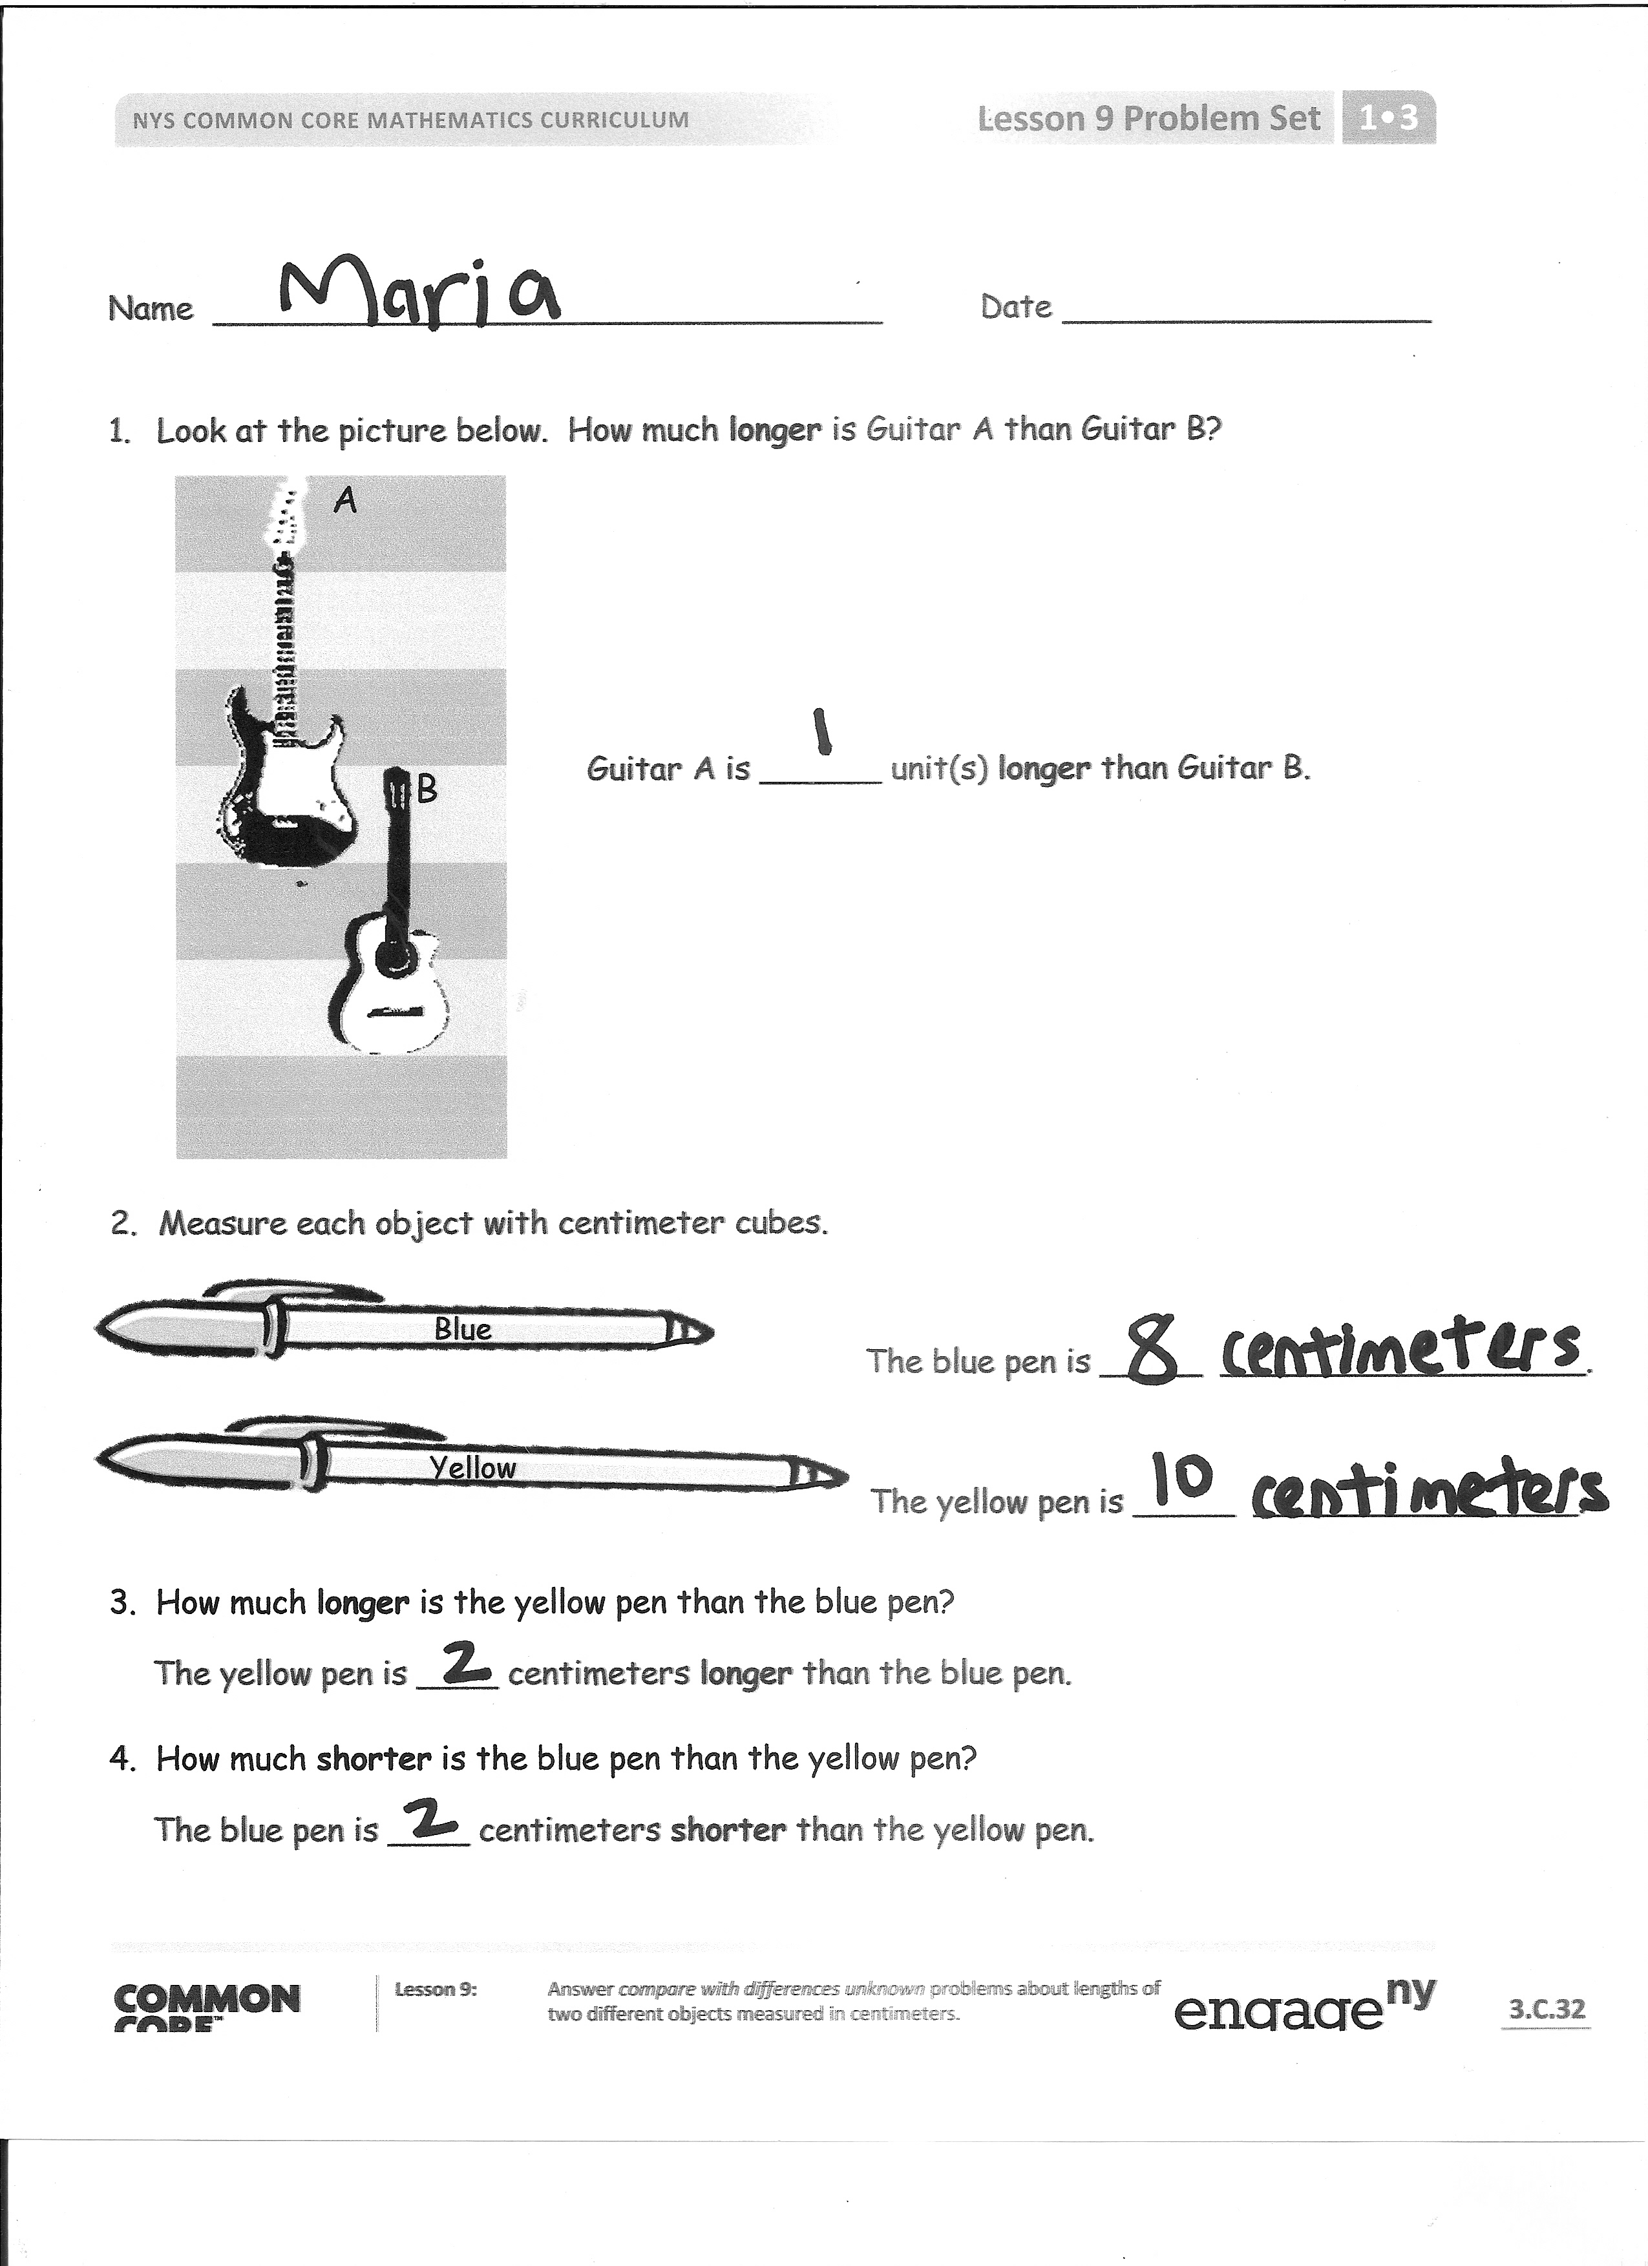
- Kelly is knitting a scarf for her doll. It needs to be 13 centimeters long. She has already knitted 9 centimeters. How many more centimeters need to be knitted?
Problem Set (10 minutes)
Students should do their personal best to complete the Problem Set within the allotted 10 minutes. For some classes, it may be appropriate to modify the assignment by specifying which problems they work on first.
Note: For the Problem Set, students use actual centimeter cubes to solve the problems.
Student Debrief (10 minutes)
Lesson Objective: Answer compare with difference unknown problems about lengths of two different objects measured in centimeters.
The Student Debrief is intended to invite reflection and active processing of the total lesson experience.
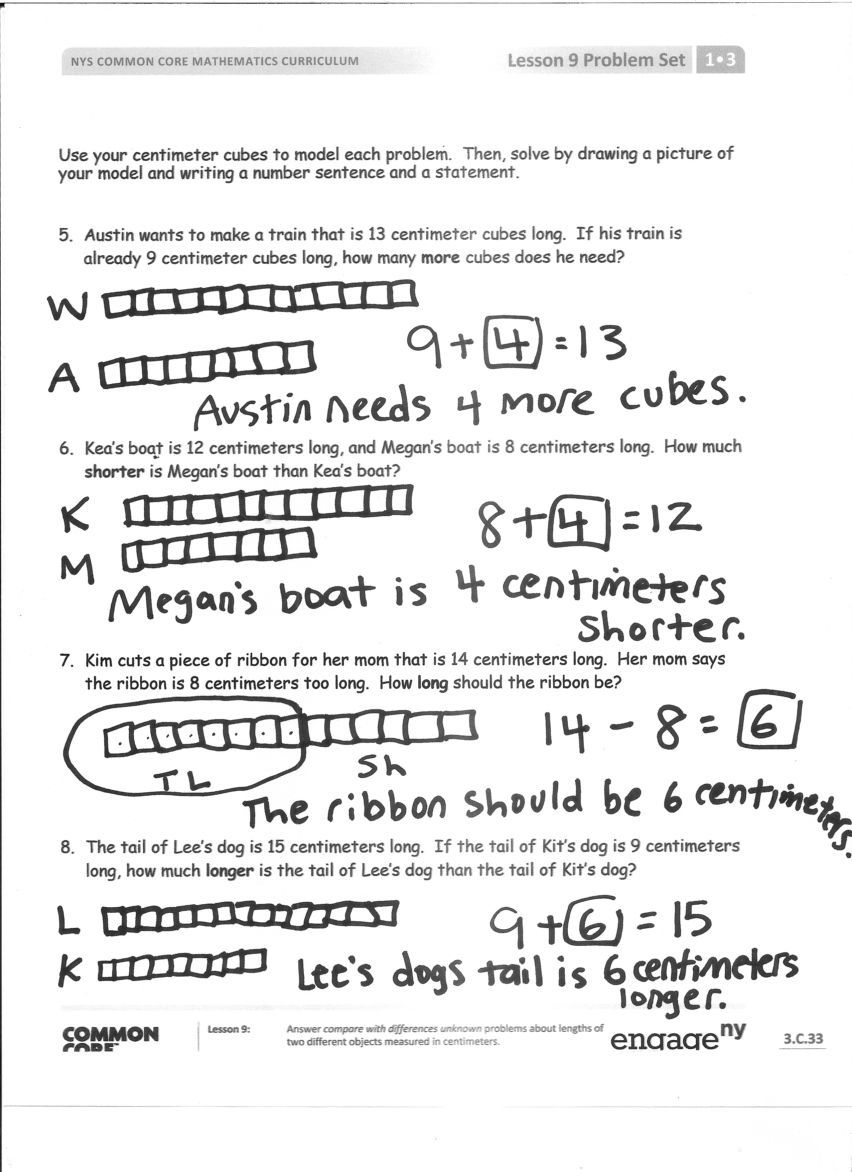
Invite students to review their solutions for the Problem Set. They should check work by comparing answers with a partner before going over answers as a class. Look for misconceptions or misunderstandings that can be addressed in the Debrief. Guide students in a conversation to debrief the Problem Set and process the lesson.
You may choose to use any combination of the questions below to lead the discussion.
- Look at Problems 3 and 4. What do you notice about the answers? Explain to your partner why this is so.
- Look at Problem 8. Can you think of a number sentence that can help you check your answer?
- What strategy helped you when you tried to find the difference between two objects?
- Look at today’s Application Problem. How does it apply to today’s lesson?
Note: Send the bags of centimeter cubes home with students for use in completing their homework.
Exit Ticket (3 minutes)
After the Student Debrief, instruct students to complete the Exit Ticket. A review of their work will help you assess the students’ understanding of the concepts that were presented in the lesson today and plan more effectively for future lessons. You may read the questions aloud to the students.
Name Date
A
Number Correct:

*Write the missing number.
1 | 17 + 1 = ☐ |  | 16 | 11 + 9 = ☐
2 | 15 + 1 = ☐ |  | 17 | 10 + 9 = ☐
3 | 18 + 1 = ☐ |  | 18 | 9 + 9 = ☐
4 | 15 + 2 = ☐ |  | 19 | 7 + 9 = ☐
5 | 17 + 2 = ☐ |  | 20 | 8 + 8 = ☐
6 | 18 + 2 = ☐ |  | 21 | 7 + 8 = ☐
7 | 15 + 3 = ☐ |  | 22 | 8 + 5 = ☐
8 | 5 + 13 = ☐ |  | 23 | 11 + 8 = ☐
9 | 15 + 2 = ☐ |  | 24 | 12 + ☐ = 17
10 | 5 + 12 = ☐ |  | 25 | 14 + ☐ = 17
11 | 12 + 4 = ☐ |  | 26 | 8 + ☐ = 17
12 | 13 + 4 = ☐ |  | 27 | ☐ + 7 = 16
13 | 3 + 14 = ☐ |  | 28 | ☐ + 7 = 15
14 | 17 + 2 = ☐ |  | 29 | 9 + 5 = 10 + ☐
15 | 12 + 7 = ☐ |  | 30 | 7 + 8 = ☐ + 9
Name Date
B
Number Correct:

*Write the missing number.
1 | 14 + 1 = ☐ |  | 16 | 11 + 9 = ☐
2 | 16 + 1 = ☐ |  | 17 | 10 + 9 = ☐
3 | 17 + 1 = ☐ |  | 18 | 8 + 9 = ☐
4 | 11 + 2 = ☐ |  | 19 | 9 + 9 = ☐
5 | 15 + 2 = ☐ |  | 20 | 9 + 8 = ☐
6 | 17 + 2 = ☐ |  | 21 | 8 + 8 = ☐
7 | 15 + 4 = ☐ |  | 22 | 8 + 5 = ☐
8 | 4 + 15 = ☐ |  | 23 | 11 + 7 = ☐
9 | 15 + 3 = ☐ |  | 24 | 12 + ☐ = 18
10 | 5 + 13 = ☐ |  | 25 | 14 + ☐ = 18
11 | 13 + 4 = ☐ |  | 26 | 8 + ☐ = 18
12 | 14 + 4 = ☐ |  | 27 | ☐ + 5 = 14
13 | 4 + 14 = ☐ |  | 28 | ☐ + 6 = 15
14 | 16 + 3 = ☐ |  | 29 | 9 + 6 = 10 + ☐
15 | 13 + 6 = ☐ |  | 30 | 6 + 7 = ☐ + 9

Name Date
- Look at the picture below. How much longer is Guitar A than Guitar B?

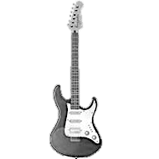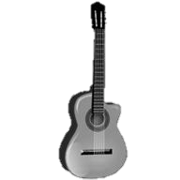
A
B

Guitar A is ______ unit(s) longer than Guitar B.

- Measure each object with centimeter cubes.
Blue
The blue pen is _____ __________________.
Yellow
The yellow pen is _____ ______________.
3. How much longer is the yellow pen than the blue pen?
The yellow pen is ____ centimeters longer than the blue pen.

4. How much shorter is the blue pen than the yellow pen?
The blue pen is ____ centimeters shorter than the yellow pen.

Use your centimeter cubes to model each problem. Then, solve by drawing a picture of your model and writing a number sentence and a statement.
- Austin wants to make a train that is 13 centimeter cubes long. If his train is already 9 centimeter cubes long, how many more cubes does he need?

- Kea’s boat is 12 centimeters long, and Megan’s boat is 8 centimeters long. How much shorter is Megan’s boat than Kea’s boat?

- Kim cuts a piece of ribbon for her mom that is 14 centimeters long. Her mom says the ribbon is 8 centimeters too long. How long should the ribbon be?

- The tail of Lee’s dog is 15 centimeters long. If the tail of Kit’s dog is 9 centimeters long, how much longer is the tail of Lee’s dog than the tail of Kit’s dog?
Name Date
Use your centimeter cubes to model the problem. Then, draw a picture of your model.
Mona’s hair grew 7 centimeters. Claire’s hair grew 15 centimeters. How much less did Mona’s hair grow than Claire’s hair?
Name Date
- Look at the picture below. How much shorter is Trophy A than Trophy B?

B
Trophy A is ______ units shorter
than Trophy B.

A

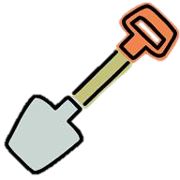
- Measure each object with centimeter cubes.

red
The red shovel is ____ __________________.

green

The green shovel is ____ __________________.
3. How much longer is the green shovel than the red shovel?
The green shovel is ____ centimeters longer than the red shovel.

Use your centimeter cubes to model each problem. Then, solve by drawing a picture of your model and writing a number sentence and a statement.
4. Susan grew 15 centimeters, and Tyler grew 11 centimeters. How much more did Susan grow than Tyler?

5. Bob’s straw is 13 centimeters long. If Tom’s straw is 6 centimeters long, how much shorter is Tom’s straw than Bob’s straw?

6. A purple card is 8 centimeters long. A red card is 12 centimeters long. How much longer is the red card than the purple card?

7. Carl’s bean plant grew to be 9 centimeters tall. Dan’s bean plant grew to be 14 centimeters tall. How much taller is Dan’s plant than Carl’s plant?

