Lesson 24: Introduction to Simultaneous Equations

Classwork
Exercises 1–3
- Derek scored $30$ points in the basketball game he played, and not once did he go to the free throw line. That means that Derek scored two-point shots and three-point shots. List as many combinations of two- and three-pointers as you can that would total $30$ points.
Number of Two-Pointers | Number of Three-Pointers

Write an equation to describe the data.

- Derek tells you that the number of two-point shots that he made is five more than the number of three-point shots. How many combinations can you come up with that fit this scenario? (Don’t worry about the total number of points.)
Number of Two-Pointers | Number of Three-Pointers

Write an equation to describe the data.

- Which pair of numbers from your table in Exercise 2 would show Derek’s actual score of $30$ points?

- Efrain and Fernie are on a road trip. Each of them drives at a constant speed. Efrain is a safe driver and travels $45$ miles per hour for the entire trip. Fernie is not such a safe driver. He drives $70$ miles per hour throughout the trip. Fernie and Efrain left from the same location, but Efrain left at $8:00$a.m., and Fernie left at $11:00$a.m. Assuming they take the same route, will Fernie ever catch up to Efrain? If so, approximately when?
  - Write the linear equation that represents Efrain’s constant speed. Make sure to include in your equation the extra time that Efrain was able to travel.

  - Write the linear equation that represents Fernie’s constant speed.

  - Write the system of linear equations that represents this situation.

  - Sketch the graphs of the two linear equations.

  - Will Fernie ever catch up to Efrain? If so, approximately when?

  - At approximately what point do the graphs of the lines intersect?

- Jessica and Karl run at constant speeds. Jessica can run $3$ miles in $15$ minutes. Karl can run $2$ miles in $8$ minutes. They decide to race each other. As soon as the race begins, Karl realizes that he did not tie his shoes properly and takes $1$ minute to fix them.
  - Write the linear equation that represents Jessica’s constant speed. Make sure to include in your equation the extra time that Jessica was able to run.

  - Write the linear equation that represents Karl’s constant speed.

  - Write the system of linear equations that represents this situation.

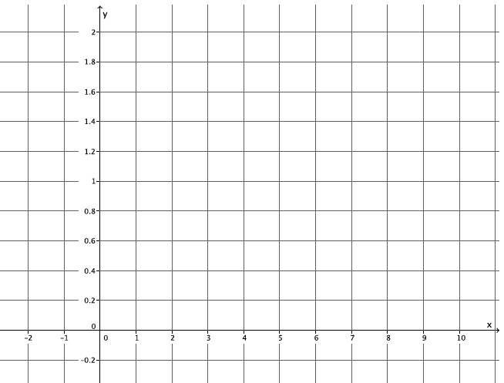
  - Sketch the graphs of the two linear equations.

  - Use the graph to answer the questions below.
    - If Jessica and Karl raced for $2$ miles, who would win? Explain.

    - If the winner of the race was the person who got to a distance of $\frac{1}{2}$mile first, who would the winner be? Explain.

    - At approximately what point would Jessica and Karl be tied? Explain.

Lesson Summary
Simultaneous linear equations, or a system of linear equations, is when two or more linear equations are involved in the same problem. Simultaneous linear equations are graphed on the same coordinate plane.
The solution to a system of linear equations is the set of all points that make the equations of the system true. If given two equations in the system, the solution(s) must make both equations true.
Systems of linear equations are identified by the notation used, for example: $\left\{\begin{aligned}y=\frac{1}{8}x+\frac{5}{2} \\ y=\frac{4}{25}x \end{aligned}\right..$

Problem Set

- Jeremy and Gerardo run at constant speeds. Jeremy can run $1$ mile in $8$ minutes and Gerardo can run $3$ miles in $33$ minutes. Jeremy started running $10$ minutes after Gerardo. Assuming they run the same path, when will Jeremy catch up to Gerardo?
  - Write the linear equation that represents Jeremy’s constant speed.
  - Write the linear equation that represents Gerardo’s constant speed. Make sure to include in your equation the extra time that Gerardo was able to run.
  - Write the system of linear equations that represents this situation.
  - Sketch the graphs of the two equations.
  - Will Jeremy ever catch up to Gerardo? If so, approximately when?
  - At approximately what point do the graphs of the lines intersect?

- Two cars drive from town A to town B at constant speeds. The blue car travels $25$ miles per hour and the red car travels $60$ miles per hour. The blue car leaves at $9:30$a.m., and the red car leaves at noon. The distance between the two towns is $150$ miles.
  - Who will get there first? Write and graph the system of linear equations that represents this situation.
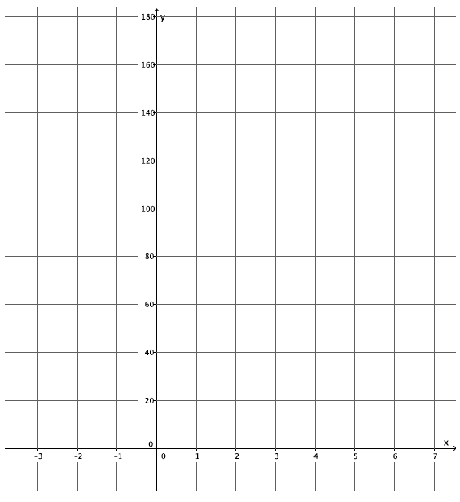
  - At approximately what point do the graphs of the lines intersect?

