|  |
| --- |
|  |

Lesson 24: Introduction to Simultaneous Equations

Student Outcomes

* Students know that a system of linear equations, also known as simultaneous equations, is when two or more equations are involved in the same problem and work must be completed on them simultaneously. Students also learn the notation for simultaneous equations.
* Students compare the graphs that comprise a system of linear equations in the context of constant rates to answer questions about time and distance.

Lesson Notes

Students complete Exercises 1–3 as an introduction to simultaneous linear equations in a familiar context. Example 1 demonstrates what happens to the graph of a line when there is change in the circumstances involving time with constant rate problems. It is in preparation for the examples that follow. It is not necessary that Example 1 be shown to students, but it is provided as a scaffold. If Example 1 is used, consider skipping Example 3.

Classwork

Exercises 1–3 (5 minutes)

Students complete Exercises 1–3 in pairs. Once students are finished, continue with the discussion about systems of linear equations.

Exercises 1–3

1. Derek scored points in the basketball game he played, and not once did he go to the free throw line. That means that Derek scored two-point shots and three-point shots. List as many combinations of two- and three-pointers as you can that would total points.

|  |  |
| --- | --- |
| Number of Two-Pointers | Number of Three-Pointers |
|  |  |
|  |  |
|  |  |
|  |  |
|  |  |
|  |  |

Write an equation to describe the data.

Let represent the number of pointers and represent the number of pointers.

1. Derek tells you that the number of two-point shots that he made is five more than the number of three-point shots. How many combinations can you come up with that fit this scenario? (Don’t worry about the total number of points.)

|  |  |
| --- | --- |
| Number of Two-Pointers | Number of Three-Pointers |
|  |  |
|  |  |
|  |  |
|  |  |
|  |  |
|  |  |

Write an equation to describe the data.

Let represent the number of two-pointers and represent the number of three-pointers.

1. Which pair of numbers from your table in Exercise 2 would show Derek’s actual score of points?

The pair and would show Derek’s actual score of points.

Discussion (5 minutes)

* There are situations where we need to work with two linear equations simultaneously. Hence, the phrase *simultaneous linear equations*. Sometimes a pair of linear equations is referred to as a *system of linear equations.*
* The situation with Derek can be represented as a system of linear equations.

Let represent the number of two-pointers and represent the number of three-pointers, then

* The notation for simultaneous linear equations lets us know that we are looking for the ordered pair that makes both equations true. That point is called the solution to the system.
* Just like equations in one variable, some systems of equations have exactly one solution, no solution, or infinitely many solutions. This is a topic for later lessons.
* Ultimately our goal is to determine the exact location on the coordinate plane where the graphs of the two linear equations intersect, giving us the ordered pair that is the solution to the system of equations. This too is a topic for a later lesson.
* We can graph both equations on the same coordinate plane.

Macintosh HD:Users:stefaniehassan:Desktop:opening.pdf

* Because we are graphing two distinct lines on the same graph, we identify the lines in some manner. In this case, we identify them by the equations.
* Note the point of intersection. Does it satisfy both equations in the system?
  + *The point of intersection of the two lines is*

*Yes, and satisfies both equations of the system.*

* Therefore, Derek made two-point shots and three-point shots.

Example 1 (6 minutes)

* Pia types at a constant rate of pages every minutes. Suppose she types pages in minutes. Pia’s constant rate can be expressed as the linear equation
* The following table displays the number of pages Pia typed at the end of certain time intervals.

|  |  |
| --- | --- |
| **Number of Minutes ()** | **Pages Typed ()** |
|  |  |
|  |  |
|  |  |
|  |  |
|  |  |
|  |  |

* The following is the graph of .

Macintosh HD:Users:shassan:Desktop:example3.pdf

* Pia typically begins work at a.m. every day. On our graph, her start time is reflected as the origin of the graph , that is, zero minutes worked and zero pages typed. For some reason, she started working   
   minutes earlier today. How can we reflect the extra minutes she worked on our graph?
  + *The -axis represents the time worked, so we need to do something on the -axis to reflect the additional minutes of work.*
* If we translate the graph of to the right units to reflect the additional minutes of work, then we have the following graph.

Macintosh HD:Users:shassan:Desktop:example3a.pdf

* Does a translation of units to the right reflect her working an additional minutes?
  + *No, it makes it look like she got nothing done the first minutes she was at work.*
* Let’s see what happens when we translate units to the left.

Macintosh HD:Users:shassan:Desktop:example3b.pdf

* Does a translation of units to the left reflect her working an additional minutes?
  + *Yes, it shows that she was able to type page by the time she normally begins work.*
* What is the equation that represents the graph of the translated line?
  + *The equation that represents the graph of the red line is .*
* Note again, that even though the graph has been translated, the slope of the line is still equal to the constant rate of typing.
* When we factor out from to give us, we can better see the additional minutes of work time. Pia typed for an additional minutes, so it makes sense that we are adding to the number of minutes, that she types. However, on the graph, we translated units to the left of zero. How can we make sense of that?
  + *Since her normal start time was a.m., then minutes before a.m. is minutes less than a.m., which means we would need to go to the left of a.m. (in this case the origin of the graph) to mark her start time.*
* If Pia started work minutes early, what equation would represent the number of pages she could type in minutes?
  + *The equation that represents the graph of the red line is*

Example 2 (8 minutes)

* Now we will look at an example of a situation that requires simultaneous linear equations.

Sandy and Charlie walk at constant speeds. Sandy walks from their school to the train station in minutes, and Charlie walks the same distance in minutes. Charlie starts minutes after Sandy left the school. Can Charlie catch up to Sandy? The distance between the school and the station is miles.

* What is Sandy’s average speed in minutes? Explain.
  + *Sandy’s average speed in minutes is miles per minute because she walks miles in minutes.*
* Since we know Sandy walks at a constant speed, then her constant speed is miles per minute.
* What is Charlie’s average speed in minutes? Explain.
  + *Charlie’s average speed in minutes is miles per minute, which is the same as miles per minute because he walks mile in minutes.*

MP.2

* Since we know Charlie walks at a constant speed, then his constant speed is miles per minute.
* Suppose the distance walked by Charlie in minutes is miles. Then we can write a linear equation to represent Charlie’s motion.
* Let’s put some information about Charlie’s walk in a table:

|  |  |
| --- | --- |
| **Number of Minutes ()** | **Miles Walked ()** |
|  |  |
|  |  |
|  |  |
|  |  |
|  |  |
|  |  |

* At minutes, Sandy has walked minutes longer than Charlie. Then the distance that Sandy walked in minutes is miles. Then the linear equation that represents Sandy’s motion is

MP.2

Let’s put some information about Sandy’s walk in a table:

|  |  |
| --- | --- |
| **Number of Minutes** | **Miles Walked** |
|  |  |
|  |  |
|  |  |
|  |  |
|  |  |
|  |  |

* Now let’s sketch the graphs of each linear equation on a coordinate plane.

Macintosh HD:Users:shassan:Dropbox:Module 4:Images:L24  Intro to systems:example 2.pdf

* A couple of comments about our graph:
  + The -intercept of the graph of Sandy’s walk shows the exact distance she has walked at the moment that Charlie starts walking. Notice that the -intercept of the graph of Sandy’s walk shows that she starts walking minutes before Charlie.
  + Since the -axis represents the distance traveled, then the point of intersection of the graphs of the two lines represents the moment they have both walked the same distance.
* Recall the original question that was asked: Can Charlie catch up to Sandy? Keep in mind that the train station is miles from the school.
  + *It looks like the lines intersect at a point between and miles; therefore, the answer is yes, Charlie can catch up to Sandy.*
* At approximately what point do the graphs of the lines intersect?
  + *The lines intersect at approximately .*
* A couple of comments about our equations, and
  + Notice that (the representation of time) is the same in both equations.
  + Notice that we are interested in finding out when because this is when the distance traveled by both Sandy and Charlie is the same (i.e., when Charlie catches up to Sandy).
  + We write the pair of simultaneous linear equations as

Example 3 (5 minutes)

* Randi and Craig ride their bikes at constant speeds. It takes Randi minutes to bike miles. Craig can bike miles in minutes. If Randi gives Craig a minute head start, about how long will it take Randi to catch up to Craig?
* We want to express the information about Randi and Craig in terms of a system of linear equations. Write the linear equations that represent their constant speeds.
  + *Randi’s average speed in minutes is miles per minute. Since Randi bikes at a constant speed, if we let be the distance Randi travels in minutes, then the linear equation that represents her motion is*
  + *Craig’s average speed in minutes is miles per minute, which is equivalent to miles per minute. Since Craig bikes at a constant speed, if we let be the distance Craig travels in minutes, then the linear equation that represent his motion is*
* We want to account for the head start that Craig is getting. Since Craig gets a head start of minutes, then we need to add that time to his total number of minutes traveled at his constant rate.
* The system of linear equations that represents this situation is
* Now we can sketch the graphs of the system of equations on a coordinate plane.

Macintosh HD:Users:shassan:Dropbox:Module 4:Images:L24  Intro to systems:example 1.pdf

* Notice again that the -intercept of Craig’s graph shows the distance that Craig was able to travel at the moment Randi began biking. Also notice that the -intercept of Craig’s graph shows us that he started biking minutes before Randi.
* Now, answer the question: About how long will it take Randi to catch up to Craig? We can give two answers: one in terms of time and the other in terms of distance. What are those answers?
  + *It will take Randi about minutes or about miles to catch up to Craig.*
* At approximately what point do the graphs of the lines intersect?
  + *The lines intersect at approximately*

Exercises 4–5 (7 minutes)

Students complete Exercises 4–5 individually or in pairs.

1. Efrain and Fernie are on a road trip. Each of them drives at a constant speed. Efrain is a safe driver and travels miles per hour for the entire trip. Fernie is not such a safe driver. He drives miles per hour throughout the trip. Fernie and Efrain left from the same location, but Efrain left at a.m., and Fernie left at a.m. Assuming they take the same route, will Fernie ever catch up to Efrain? If so, approximately when?
   1. Write the linear equation that represents Efrain’s constant speed. Make sure to include in your equation the extra time that Efrain was able to travel.

***Efrain’s average speed over one hour is miles per hour, which is the same as miles per hour. If represents the distance he travels in hours, then we have and the linear equation . To account for his additional hours of driving time that Efrain gets, we write the equation***

* 1. Write the linear equation that represents Fernie’s constant speed.

***Fernie’s average speed over one hour is miles per hour, which is the same as miles per hour. If represents the distance he travels in hours, then we have , and the linear equation .***

* 1. Write the system of linear equations that represents this situation.
  2. Sketch the graphs of the two linear equations.

Macintosh HD:Users:shassan:Desktop:exercise 1.pdf

* 1. Will Fernie ever catch up to Efrain? If so, approximately when?

Yes, Fernie will catch up to Efrain after about hours of driving or after traveling about miles.

* 1. At approximately what point do the graphs of the lines intersect?

The lines intersect at approximately .

1. Jessica and Karl run at constant speeds. Jessica can run miles in minutes. Karl can run miles in minutes. They decide to race each other. As soon as the race begins, Karl realizes that he did not tie his shoes properly and takes minute to fix them.
   1. Write the linear equation that represents Jessica’s constant speed. Make sure to include in your equation the extra time that Jessica was able to run.

***Jessica’s average speed over minutes is miles per minute, which is equivalent to miles per minute. If represents the distance she runs in minutes, then we have and the linear equation . To account for her additional minute of running that Jessica gets, we write the equation***

* 1. Write the linear equation that represents Karl’s constant speed.

***Karl’s average speed over minutes is miles per minute, which is the same as miles per minute. If represents the distance he runs in minutes, then we have and the linear equation .***

* 1. Write the system of linear equations that represents this situation.
  2. Sketch the graphs of the two linear equations.

Macintosh HD:Users:shassan:Desktop:exercise 2.pdf

* 1. Use the graph to answer the questions below.
     1. If Jessica and Karl raced for miles, who would win? Explain.

If the race were miles, then Karl would win. It only takes Karl minutes to run miles, but it takes Jessica minutes to run the distance of miles.

* + 1. If the winner of the race was the person who got to a distance of mile first, who would the winner be? Explain.

At miles, Jessica would be the winner. She would reach the distance of miles between and minutes, but Karl wouldn’t get there until about minutes have passed.

* + 1. At approximately what point would Jessica and Karl be tied? Explain.

Jessica and Karl would be tied after about minutes or a distance of mile. That is where the graphs of the lines intersect.

Closing (4 minutes)

Summarize, or ask students to summarize, the main points from the lesson:

* We know that some situations require two linear equations. In those cases, we have what is called a system of linear equations or simultaneous linear equations.
* The solution to a system of linear equations, similar to a linear equation, is all of the points that make the equations true.
* We can recognize a system of equations by the notation used, for example: .

Lesson Summary

Simultaneous linear equations, or a system of linear equations, is when two or more linear equations are involved in the same problem. Simultaneous linear equations are graphed on the same coordinate plane.

The solution to a system of linear equations is the set of all points that make the equations of the system true. If given two equations in the system, the solution(s) must make both equations true.

Systems of linear equations are identified by the notation used, for example: .

Exit Ticket (5 minutes)

Name Date

Lesson 24: Introduction to Simultaneous Equations

Exit Ticket

Darnell and Hector ride their bikes at constant speeds. Darnell leaves Hector’s house to bike home. He can bike the miles in minutes. Five minutes after Darnell leaves, Hector realizes that Darnell left his phone. Hector rides to catch up. He can ride to Darnell’s house in minutes. Assuming they bike the same path, will Hector catch up to Darnell before he gets home?

* 1. Write the linear equation that represents Darnell’s constant speed.
  2. Write the linear equation that represents Hector’s constant speed. Make sure to take into account that Hector left after Darnell.
  3. Write the system of linear equations that represents this situation.
  4. Sketch the graphs of the two equations.

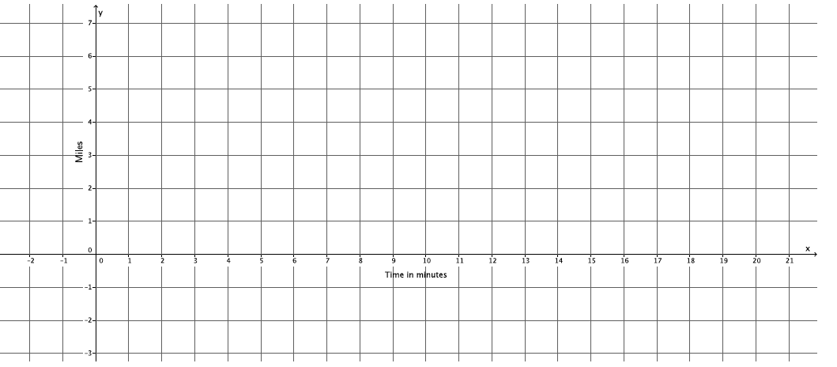

* 1. Will Hector catch up to Darnell before he gets home? If so, approximately when?
  2. At approximately what point do the graphs of the lines intersect?

Exit Ticket Sample Solutions

Darnell and Hector ride their bikes at constant speeds. Darnell leaves Hector’s house to bike home. He can bike the miles in minutes. Five minutes after Darnell leaves, Hector realizes that Darnell left his phone. Hector rides to catch up. He can ride to Darnell’s house in minutes. Assuming they bike the same path, will Hector catch up to Darnell before he gets home?

* 1. Write the linear equation that represents Darnell’s constant speed.

Darnell’s average speed over minutes is miles per minute. If represents the distance he bikes in minutes, then the linear equations is .

* 1. Write the linear equation that represents Hector’s constant speed. Make sure to take into account that Hector left after Darnell.

Hector’s average speed over minutes is miles per minute. If represents the distance he bikes in minutes, then the linear equation is . To account for the extra time Darnell has to bike, we write the equation

* 1. Write the system of linear equations that represents this situation.
  2. Sketch the graphs of the two equations.

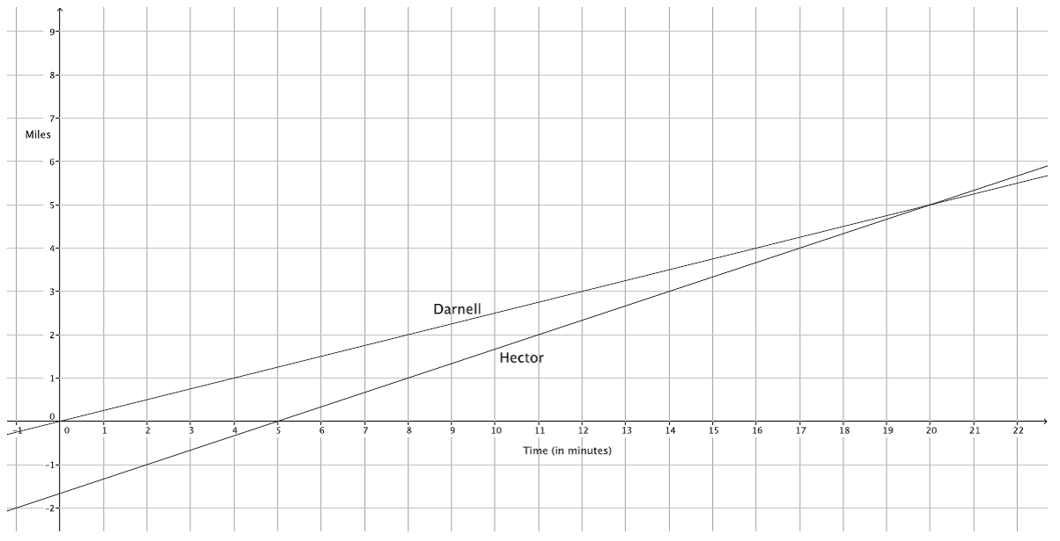

* 1. Will Hector catch up to Darnell before he gets home? If so, approximately when?

Hector will catch up minutes after Darnell left his house (or minutes of biking by Hector) or approximately miles.

* 1. At approximately what point do the graphs of the lines intersect?

The lines intersect at approximately .

Problem Set Sample Solutions

1. Jeremy and Gerardo run at constant speeds. Jeremy can run mile in minutes and Gerardo can run miles in minutes. Jeremy started running minutes after Gerardo. Assuming they run the same path, when will Jeremy catch up to Gerardo?
   1. Write the linear equation that represents Jeremy’s constant speed.

***Jeremy’s average speed over minutes is miles per minute. If represents the distance he runs in minutes, then we have and the linear equation .***

* 1. Write the linear equation that represents Gerardo’s constant speed. Make sure to include in your equation the extra time that Gerardo was able to run.

***Gerardo’s average speed over minutes is miles per minute, which is the same as miles per minute. If represents the distance he runs in minutes, then we have and the linear equation . To account for the extra time that Gerardo gets to run, we write the equation***

* 1. Write the system of linear equations that represents this situation.
  2. Macintosh HD:Users:shassan:Desktop:ps1.pdfSketch the graphs of the two equations.
  3. Will Jeremy ever catch up to Gerardo? If so, approximately when?

Yes, Jeremy will catch up to Gerardo after about minutes or about miles.

* 1. At approximately what point do the graphs of the lines intersect?

The lines intersect at approximately .

1. Two cars drive from town A to town B at constant speeds. The blue car travels miles per hour and the red car travels miles per hour. The blue car leaves at a.m., and the red car leaves at noon. The distance between the two towns is miles.
   1. Who will get there first? Write and graph the system of linear equations that represents this situation.

The linear equation that represents the motion of the blue car is , which is the same as   
. The linear equation that represents the motion of the red car is . The system of linear equations that represents this situation is

Macintosh HD:Users:shassan:Desktop:ps2.pdf

The red car will get to town B first.

* 1. At approximately what point do the graphs of the lines intersect?

The lines intersect at approximately .