Lesson 21: Some Facts about Graphs of Linear Equations in Two Variables

Classwork

**Example 1**

Let a line be given in the coordinate plane. What linear equation is the graph of line ?

Macintosh HD:Users:shassan:Desktop:ex1a.pdf

**Example 2**

Let a line be given in the coordinate plane. What linear equation is the graph of line ?

Macintosh HD:Users:shassan:Desktop:ex2a.pdf

**Example 3**

Let a line be given in the coordinate plane. What linear equation is the graph of line ?

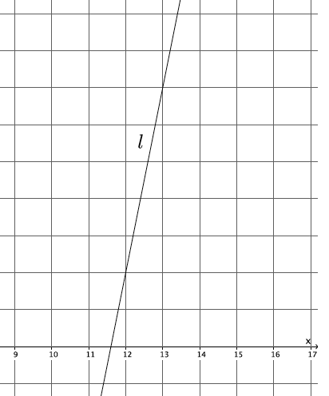

**Example 4**

Let a line be given in the coordinate plane. What linear equation is the graph of line ?

Macintosh HD:Users:shassan:Desktop:graph.pdf

Exercises

1. Write the equation for the line shown in the figure.

Macintosh HD:Users:shassan:Desktop:ps4.pdf

1. Write the equation for the line shown in the figure.

Macintosh HD:Users:shassan:Desktop:ps7.pdf

1. Determine the equation of the line that goes through points and .
2. Write the equation for the line shown in the figure.

Macintosh HD:Users:shassan:Desktop:ps5.pdf

1. A line goes through the point and has slope . Write the equation that represents the line.

Lesson Summary

Let and be the coordinates of two distinct points on a line . We find the slope of the line by

This version of the slope formula, using coordinates of and instead of and , is a commonly accepted version.

As soon as you multiply the slope by the denominator of the fraction above, you get the following equation:

This form of an equation is referred to as the point-slope form of a linear equation.

Given a known, then the equation is written as

The following is slope-intercept form of a line:

In this equation, is slope and is the -intercept.

To write the equation of a line you must have two points, one point and slope, or a graph of the line.

Problem Set

1. Write the equation for the line shown in the figure.

Macintosh HD:Users:shassan:Desktop:ps2.pdf

1. Write the equation for the line shown in the figure.

Macintosh HD:Users:shassan:Desktop:ps6.pdf

1. Write the equation for the line shown in the figure.

Macintosh HD:Users:shassan:Desktop:ps3.pdf

1. Triangle is made up of line segments formed from the intersection of lines ,, and . Write the equations that represent the lines that make up the triangle.

Macintosh HD:Users:shassan:Desktop:ps1.pdf

1. Write the equation for the line that goes through point with slope .
2. Write the equation for the line that goes through point with slope .
3. Write the equation for the line that goes through point with slope .
4. Determine the equation of the line that goes through points and .