|  |
| --- |
|  |

Lesson 21: Some Facts about Graphs of Linear Equations in Two Variables

Student Outcomes

* Students write the equation of a line given two points or the slope and a point on the line.
* Students know the traditional forms of the slope formula and slope-intercept equation.

Classwork

Example 1 (10 minutes)

Students determine the equation of a line from a graph by using information about slope and a point.

* Let a line be given in the coordinate plane. Our goal is to find the equation that represents the line . Can we use information about the slope and intercept to write the equation of the line like we did in the last lesson?

Provide students time to attempt to write the equation of the line. Ask students to share their equations and explanations. Consider having the class vote on whose explanation/equation they think is correct.

**MP.1**

*Scaffolding:*

If necessary, include another point, as demonstrated in Lesson 15, to help students determine the slope of the line.

Example 1

Let a line be given in the coordinate plane. What linear equation is the graph of line ?

Macintosh HD:Users:shassan:Desktop:ex1a.pdf

* + *We can pick two points to determine the slope, but the precise location of the -intercept cannot be determined from the graph.*
* Calculate the slope of the line.
  + *Using points, and , the slope of the line is*
* Now we need to determine the -intercept of the line. We know that it is a point with coordinates and we know that the line that goes through points and and has slope Using this information, we can determine the coordinates of the -intercept and the value of that we need in order to write the equation of the line.
* Recall what it means for a point to be on a line; the point is a solution to the equation. In the equation , , is a solution and is the slope. Can we find the value of ? Explain.
  + *Yes, we can substitute one of the points and the slope into the equation and solve for*
* Do you think it matters which point we choose to substitute into the equation? That is, will we get a different equation if we use the point compared to ?
  + *No, because there can be only one line with a given slope that goes through a point.*
* Verify this claim by using and to find the equation of the line, and then by using and to see if the result is the same equation.
  + *Sample student work:*

*The -intercept is at and the equation of the line is*

* The equation of the line is
* Write it in standard form.
  + *Sample student work:*

Example 2 (5 minutes)

Students determine the equation of a line from a graph by using information about slope and a point.

* Let a line be given in the coordinate plane. What information do we need to write the equation of the line?
  + *We need to know the slope, so we must identify two points we can use to calculate the slope. Then we can use the slope and a point to determine the equation of the line.*

Example 2

Macintosh HD:Users:shassan:Desktop:ex2a.pdfLet a line be given in the coordinate plane. What linear equation is the graph of line ?

* Determine the slope of the line.
  + *Using points and , the slope of the line is*
* Determine the -intercept of the line.
  + *Sample student work:*

*The -intercept is at*

* Now that we know the slope, , and the -intercept, , write the equation of the line in slope-intercept form.
* Transform the equation so that it is written in standard form.
  + *Sample student work:*

Example 3 (5 minutes)

Students determine the equation of a line from a graph by using information about slope and a point.

* Let a line be given in the coordinate plane. Assume the -axis intervals are units of one (like the visible   
  -axis). What information do we need to write the equation of the line?
  + *We need to know the slope, so we must identify two points we can use to calculate the slope. Then we can use the slope and a point to determine the equation of the line.*

Example 3

Let a line be given in the coordinate plane. What linear equation is the graph of line ?

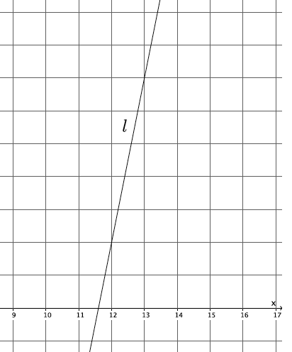

* + *Using points and , the slope of the line is*
* Now, determine the -intercept of the line, and write the equation of the line in slope-intercept form.
  + *Sample student work:*

*The -intercept is at and the equation of the line is .*

* Now that we know the slope, , and the -intercept, , write the equation of the line in standard form.
  + *Sample student work:*

Example 4 (3 minutes)

Students determine the equation of a line from a graph by using information about slope and a point.

Macintosh HD:Users:shassan:Desktop:graph.pdf  
Example 4

Let a line be given in the coordinate plane. What linear equation is the graph of line ?

Using points and , the slope of the line is

The -intercept is at , and the equation of the line is .

* The -intercept is the origin of the graph. What value does have when this occurs?
  + *When the line goes through the origin, the value of is zero.*
* All linear equations that go through the origin have the form or simply . We have done a lot of work with equations in this form. Which do you remember?
  + *All problems that describe constant rate proportional relationships have equations of this form.*

**Concept Development (5 minutes)**

* The following are some facts about graphs of linear equations in two variables.
* Let and be the coordinates of two distinct points on the graph of a line . We find the slope of the line by

This version of the slope formula, using coordinates of and instead of and , is a commonly accepted version.

* As soon as you multiply the slope by the denominator of the fraction above, you get the following equation:

This form of an equation is referred to as the point-slope form of a linear equation. As you can see, it does not convey any more information than the slope formula. It is just another way to look at it.

* Given a known, then the equation is written as
* The following is the slope-intercept form of a line:

In this equation, is slope and is the -intercept.

* What information must you have in order to write the equation of a line?
  + *We need two points or one point and slope.*
* The names and symbols used are not nearly as important as your understanding of the concepts. Basically, if you can remember a few simple facts about lines, namely the slope formula and the fact that slope is the same between any two points on a line, you can derive the equation of any line.

Exercises 1–5 (7 minutes)

Students complete Exercises 1–5 independently.

Exercises

1. Write the equation for the line shown in the figure.

Macintosh HD:Users:shassan:Desktop:ps4.pdfUsing the points and , the slope of the line is

The equation of the line is .

1. Write the equation for the line shown in the figure.

Macintosh HD:Users:shassan:Desktop:ps7.pdfUsing the points and , the slope of the line is

The equation of the line is .

1. Determine the equation of the line that goes through points and .

The slope of the line is

The -intercept of the line is

The equation of the line is .

1. Write the equation for the line shown in the figure.

Macintosh HD:Users:shassan:Desktop:ps5.pdfUsing the points and , the slope of the line is

The equation of the line is .

1. A line goes through the point and has slope . Write the equation that represents the line.

The equation of the line is .

Closing (5 minutes)

Summarize, or ask students to summarize, the main points from the lesson:

* We know how to write an equation for a line from a graph, even if the line does not intersect the -axis at integer coordinates.
* We know how to write the equation for a line given two points or one point and the slope of the line.
* We know other versions of the formulas and equations that we have been using related to linear equations.

Lesson Summary

Let and be the coordinates of two distinct points on a line . We find the slope of the line by

This version of the slope formula, using coordinates of and instead of and , is a commonly accepted version.

As soon as you multiply the slope by the denominator of the fraction above, you get the following equation:

This form of an equation is referred to as the point-slope form of a linear equation.

Given a known, then the equation is written as

The following is slope-intercept form of a line:

In this equation, is slope and is the -intercept.

To write the equation of a line you must have two points, one point and slope, or a graph of the line.

Exit Ticket (5 minutes)

Name Date

Lesson 21: Some Facts about Graphs of Linear Equations in Two Variables

Exit Ticket

1. Write the equation for the line shown in the figure below.

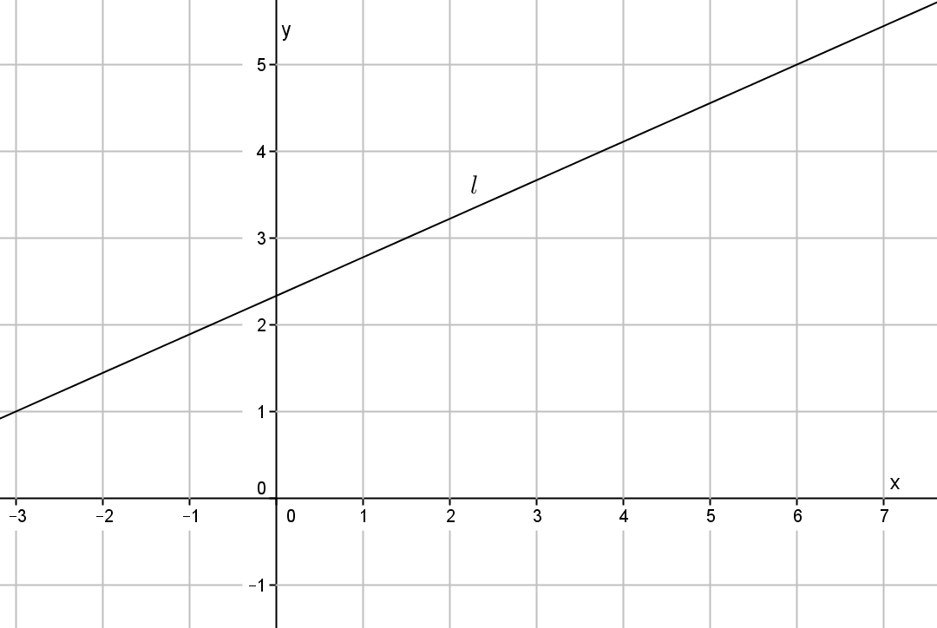

1. A line goes through the point and has slope . Write the equation that represents the line.

Exit Ticket Sample Solutions

Note that some students may write equations in standard form.

1. Write the equation for the line shown in the figure below.

Using the points and , the slope of the line is

The equation of the line is .

1. A line goes through the point and has slope . Write the equation that represents the line.

The equation of the line is .

Problem Set Sample Solutions

Students practice writing equations from graphs of lines. Students write the equation of a line given only the slope and a point.

1. Write the equation for the line shown in the figure.

Macintosh HD:Users:shassan:Desktop:ps2.pdfUsing the points and , the slope of the line is

The equation of the line is .

1. Write the equation for the line shown in the figure.

Macintosh HD:Users:shassan:Desktop:ps6.pdfUsing the points and , the slope of the line is

The equation of the line is .

1. Write the equation for the line shown in the figure.

Macintosh HD:Users:shassan:Desktop:ps3.pdfUsing the points and , the slope of the line is

The equation of the line is .

1. Macintosh HD:Users:shassan:Desktop:ps1.pdfTriangle is made up of line segments formed from the intersection of lines , , and . Write the equations that represent the lines that make up the triangle.

, ,

The slope of :

The slope of :

The equation of is .

The equation of is .

The slope of :

The equation of is .

1. Write the equation for the line that goes through point with slope .

The equation of the line is .

1. Write the equation for the line that goes through point with slope .

The equation of the line is .

1. Write the equation for the line that goes through point with slope .

The equation of the line is .

1. Determine the equation of the line that goes through points and .

The slope of the line is

The -intercept of the line is

The equation of the line is .