|  |
| --- |
|  |

Lesson 13: The Graph of a Linear Equation in Two Variables

Student Outcomes

* Students predict the shape of a graph of a linear equation by finding and plotting solutions on a coordinate plane.
* Students informally explain why the graph of a linear equation is not curved in terms of solutions to the given linear equation.

Classwork

**Discussion (20 minutes)**

* In the last lesson, we saw that the solutions of a linear equation in two variables can be plotted on a coordinate plane as points. The collection of all points in the coordinate plane so that each is a solution of is called the graph of
* Do you think it is possible to plot *all* of the solutions of a linear equation on a coordinate plane?
  + *No, it is not possible. There are an infinite number of values we can use to fix one of the variables.*
* For that reason, we cannot draw the graph of a linear equation. What we can do is plot a few points of an equation and make predictions about what the graph should look like.
* Let’s find five solutions to the linear equation and plot the points on a coordinate plane. Name a solution.

As students provide solutions (samples provided below), organize them in an - table, as shown. It is most likely that students will give whole number solutions only. Accept them for now.

|  |  |
| --- | --- |
|  |  |
|  |  |
|  |  |
|  |  |
|  |  |
|  |  |

* Now let’s plot these points of the graph of on a coordinate plane.

Macintosh HD:Users:shassan:Desktop:socratic1.pdf

* Can you predict the shape of the graph of this linear equation based on just the five points we have so far?
  + *It looks like the points lie on a line.*
* Yes, at this point it looks like the graph of the equation is a line, but for all we know, there can be some curved parts between some of these points.

For all we know, the graph of could be the following curve. Notice that this curve passes through the selected five points.

Macintosh HD:Users:shassan:Desktop:Lesson 13 Images:socratic1a.pdf

* The only thing we can do at this point is find more solutions that would show what the graph looks like between the existing points. That means we will have to look at some points with coordinates that are fractions. Name a solution that will plot as a point between the points we already have on the graph.

Add to the *-* table. Sample solutions provided below.

|  |  |
| --- | --- |
|  |  |
|  |  |
|  |  |
|  |  |
|  |  |
|  |  |
|  |  |
|  |  |
|  |  |
|  |  |
|  |  |

* Now let’s add these points of the graph of on our coordinate plane.

Macintosh HD:Users:shassan:Desktop:socratic1c.pdf

* Are you convinced that the graph of the linear equation is a line? You shouldn’t be! What if it looked like this.

Again, draw curves between each of the points on the graph to show what the graph could look like. Make sure to have curves in quadrants II and IV to illustrate the need to find points that fit (or do not fit) the pattern of the graph when- and -values are negative.

* Now it is time to find more solutions. This time, we will need to come up with solutions where the -value is negative or the -value is negative.

Add to the *-* table. Sample solutions are provided below.

|  |  |
| --- | --- |
|  |  |
|  |  |
|  |  |
|  |  |
|  |  |
|  |  |
|  |  |
|  |  |
|  |  |
|  |  |
|  |  |
|  |  |
|  |  |
|  |  |
|  |  |
|  |  |

* Macintosh HD:Users:shassan:Desktop:socratic1d.pdfNow we have solutions to the equation. Are you convinced that the graph of this equation is a line?
  + *Students should say that they are still unsure; even though it looks like the graph is forming a line, there is a possibility for a curve between some of the existing points.*
* Based on the look of the graph, does the point belong to the graph of the linear equation ? Why or why not?
  + *It looks like should be on the graph of the linear equation because it looks like the point would follow the pattern of the rest of the points, i.e., be on the line.*
* Just by looking at the graph, we cannot be sure. We can predict that is on the graph of because it looks like it should be. What can we do to find out for sure?
  + *Since each point on the graph represents a solution to the equation and, if , which it does, then we can say, for sure, that is a point on the graph of*
* Just by looking at the graph, would you say that is a point on the graph of ?
  + *Based on the graph, it does not look like the point would be on the graph of .*
* How do you know that the graph does not curve down at that point? How can you be sure?
  + *I would have to see if is a solution to ; it is not a solution because , not . Therefore, the point is not a solution to the equation.*
* At this point, we can predict that the graph of this linear equation is a line. Does that mean that the graph of every linear equation is a line? Might there be some linear equations so that the graphs of those linear equations are not lines? For now, our only method of proving or disproving our prediction is plotting solutions on a coordinate plane. The more we learn about linear equations, the better we will be able to answer the questions just asked.

Exercises 1–6 (15 minutes)

Students will need graph paper to complete Exercises 1–2. Students work independently on Exercises 1–2 for the first 10 minutes. Then, they share their solutions with their partners and plot more points on their graphs. As students work, verify through discussion that they are choosing a variety of rational numbers to get a good idea of what the graph of the linear equation will look like. Exercise 6 is an optional exercise because it challenges students to come up with an equation that does not graph as a line.

Exercises

1. Find at least ten solutions to the linear equation , and plot the points on a coordinate plane.

|  |  |  |
| --- | --- | --- |
|  | Linear Equation: |  |
|  |  |  |
|  |  |  |
|  |  |  |
|  |  |  |
|  |  |  |
|  |  |  |
|  |  |  |
|  |  |  |
|  |  |  |
|  |  |  |

Macintosh HD:Users:shassan:Desktop:exer1.pdf

What shape is the graph of the linear equation taking?

***The graph appears to be the shape of a line.***

1. Find at least ten solutions to the linear equation , and plot the points on a coordinate plane.

|  |  |  |
| --- | --- | --- |
|  | Linear Equation: |  |
|  |  |  |
|  |  |  |
|  |  |  |
|  |  |  |
|  |  |  |

|  |  |  |
| --- | --- | --- |
|  |  |  |
|  |  |  |
|  |  |  |
|  |  |  |
|  |  |  |

Macintosh HD:Users:shassan:Desktop:exer2.pdf

What shape is the graph of the linear equation taking?

***The graph appears to be the shape of a line.***

1. Compare the solutions you found in Exercise 1 with a partner. Add their solutions to your graph.

Is the prediction you made about the shape of the graph still true? Explain.

***Yes. With the additional points, the graph still appears to be the shape of a line.***

1. Compare the solutions you found in Exercise 2 with a partner. Add their solutions to your graph.

Is the prediction you made about the shape of the graph still true? Explain.

***Yes. With the additional points, the graph still appears to be the shape of a line.***

1. Joey predicts that the graph of will look like the graph shown below. Do you agree? Explain why or why not.

Macintosh HD:Users:shassan:Desktop:ex5l13.pdf

***No, I do not agree with Joey. The graph that Joey drew contains the point . If is on the graph of the linear equation, then it will be a solution to the equation; however, it is not. Therefore, the point cannot be on the graph of the equation, which means Joey’s prediction is incorrect.***

1. We have looked at some equations that appear to be lines. Can you write an equation that has solutions that do not form a line? Try to come up with one and prove your assertion on the coordinate plane.

**MP.3**

Answers will vary. Any nonlinear equation that students write will graph as something other than a line. For example, the graph of or the graph of will not be a line.

Closing (5 minutes)

Summarize, or ask students to summarize, the main points from the lesson:

* All of the graphs of linear equations we have done so far appear to take the shape of a line.
* We can show whether or not a point is on the graph of an equation by checking to see if it is a solution to the equation.

Lesson Summary

One way to determine if a given point is on the graph of a linear equation is by checking to see if it is a solution to the equation. At this point, all graphs of linear equations appear to be lines.

Exit Ticket (5 minutes)

Name Date

Lesson 13: The Graph of a Linear Equation in Two Variables

Exit Ticket

1. Ethan found solutions to the linear equation and graphed them. What shape is the graph of the linear equation taking?

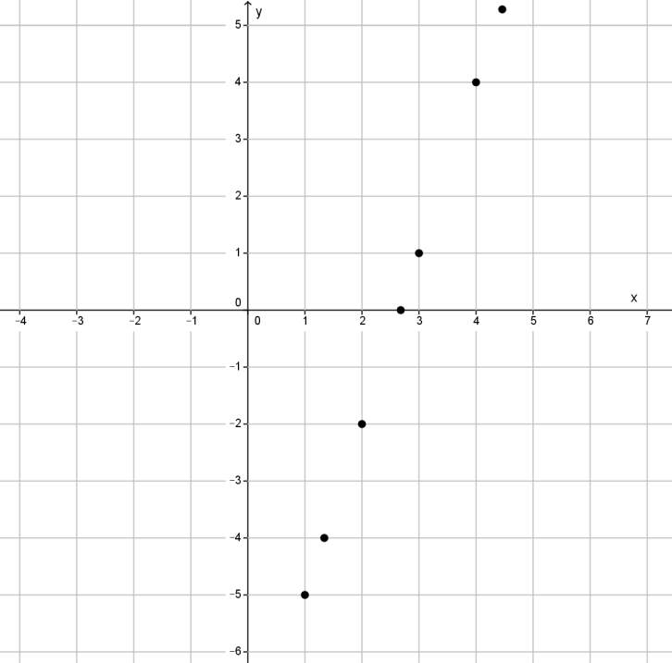

1. Could the following points be on the graph of?

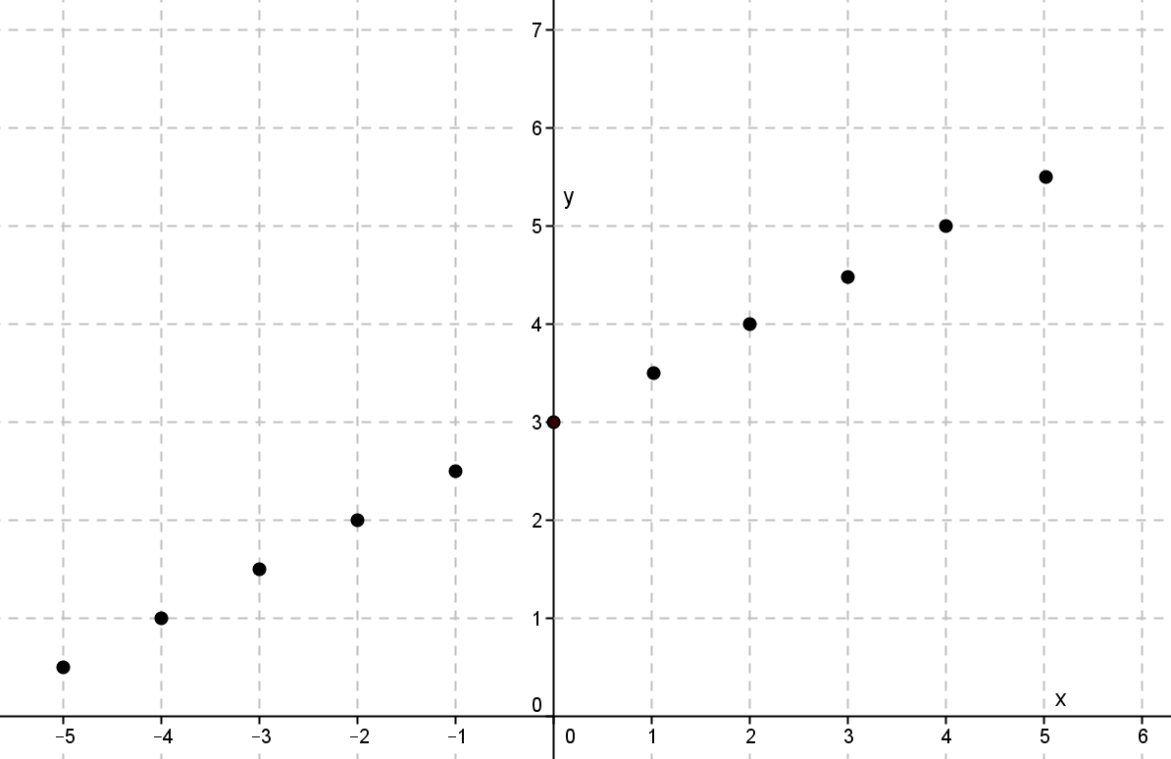

Exit Ticket Sample Solutions

1. Ethan found solutions to the linear equation and graphed them. What shape is the graph of the linear equation taking?



It appears to take the shape of a line.

1. Could the following points be on the graph of?



Student may have chosen any point to make the claim that this is not the graph of the equation

Although the graph appears to be a line, the graph contains the point . The point is not a solution to the linear equation; therefore, this is not the graph of.

Note to teacher: Accept any point as not being a solution to the linear equation.

Problem Set Sample Solutions

In Problem 1, students graph linear equations by plotting points that represent solutions. For that reason, they will need graph paper. Students informally explain why the graph of a linear equation is not curved by showing that a point on the curve is not a solution to the linear equation.

1. Find at least ten solutions to the linear equation , and plot the points on a coordinate plane.

|  |  |  |
| --- | --- | --- |
|  | Linear Equation: |  |
|  |  |  |
|  |  |  |
|  |  |  |
|  |  |  |
|  |  |  |
|  |  |  |
|  |  |  |
|  |  |  |

|  |  |  |
| --- | --- | --- |
|  |  |  |
|  |  |  |

Macintosh HD:Users:shassan:Desktop:ps1.pdf

What shape is the graph of the linear equation taking?

***The graph appears to be the shape of a line.***

1. Can the following points be on the graph of the equation ? Explain.

Macintosh HD:Users:shassan:Desktop:ps2.pdf

The graph shown contains the point . If is on the graph of the linear equation, then it will be a solution to the equation. It is not; therefore, the point cannot be on the graph of the equation, which means the graph shown cannot be the graph of the equation .

1. Can the following points be on the graph of the equation ? Explain.

Macintosh HD:Users:shassan:Desktop:ps3.pdf

***The graph shown contains the point . If is on the graph of the linear equation, then it will be a solution to the equation. It is not; therefore, the point cannot be on the graph of the equation, which means the graph shown cannot be the graph of the equation*** .

1. Can the following points be on the graph of the equation ? Explain.

Macintosh HD:Users:shassan:Desktop:ps 4.pdf

Yes, because each point on the graph represents a solution to the linear equation.

1. Can the following points be on the graph of the equation ? Explain.

Macintosh HD:Users:shassan:Desktop:ps5.pdf

Yes, because each point on the graph represents a solution to the linear equation.

1. Can the following points be on the graph of the equation ? Explain.

Macintosh HD:Users:shassan:Desktop:ps6.pdf

Yes, because each point on the graph represents a solution to the linear equation .

1. Can the following points be on the graph of the equation ? Explain.

Macintosh HD:Users:shassan:Desktop:ps7.pdf

***The graph*** shown ***contains the point . If is on the graph of the linear equation, then it will be a solution to the equation. It is not; therefore, the point cannot be on the graph of the equation, which means the graph shown cannot be the graph of the equation***.