Lesson 9: An Application of Linear Equations

Classwork
Exercises 1–2
- Write the equation for the $15$^{th} step.

- How many people would see the photo after $15$ steps? Use a calculator if needed.

Exercises 3–11
- Marvin paid an entrance fee of $\$5$ plus an additional $\$1.25$ per game at a local arcade. Altogether, he spent $\$26.25$. Write and solve an equation to determine how many games Marvin played.

- The sum of four consecutive integers is $-26$. What are the integers?

- A book has $x$ pages. How many pages are in the book if Maria read $45$ pages of a book on Monday, $\frac{1}{2}$ the book on Tuesday, and the remaining $72$ pages on Wednesday?

- A number increased by $5$and divided by $2$ is equal to $75$. What is the number?

- The sum of thirteen and twice a number is seven less than six times a number. What is the number?

- The width of a rectangle is $7$ less than twice the length. If the perimeter of the rectangle is $43.6$ inches, what is the area of the rectangle?

- Two hundred and fifty tickets are available for sale for a school dance. On Monday, $35$ tickets were sold. An equal number of tickets were sold each day for the next five days. How many tickets were sold on one of those days?

- Shonna skateboarded for some number of minutes on Monday. On Tuesday, she skateboarded for twice as many minutes as she did on Monday, and on Wednesday, she skateboarded for half the sum of minutes from Monday and Tuesday. Altogether, she skateboarded for a total of three hours. How many minutes did she skateboard each day?

- In the diagram below, $△ABC \sim △A^{'}B^{'}C^{'}$. Determine the length of $AC$and $BC$.
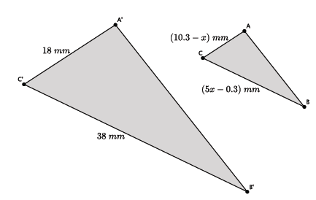

Problem Set

- You forward an e-card that you found online to three of your friends. They liked it so much that they forwarded it on to four of their friends, who then forwarded it on to four of their friends, and so on. The number of people who saw the e-card is shown below. Let $S_{1}$ represent the number of people who saw the e-card after one step, let $S_{2}$ represent the number of people who saw the e-card after two steps, and so on.
$$S_{1}=3 \\ S_{2}=3+3⋅4 \\ S_{3}=3+3⋅4+3⋅4^{2} \\ S_{4}=3+3⋅4+3⋅4^{2}+3⋅4^{3}$$
  - Find the pattern in the equations.
  - Assuming the trend continues, how many people will have seen the e-card after $10$ steps?
  - How many people will have seen the e-card after $n$ steps?

For each of the following questions, write an equation and solve to find each answer.
- Lisa has a certain amount of money. She spent $\$39$ and has $\frac{3}{4}$ of the original amount left. How much money did she have originally?

- The length of a rectangle is $4$ more than $3$ times the width. If the perimeter of the rectangle is $18.4$ cm, what is the area of the rectangle?

- Eight times the result of subtracting $3$ from a number is equal to the number increased by $25$. What is the number?

- Three consecutive odd integers have a sum of $3$. What are the numbers?

- Each month, Liz pays $\$35$ to her phone company just to use the phone. Each text she sends costs her an additional $\$0.05$. In March, her phone bill was $\$72.60$. In April, her phone bill was $\$65.85$. How many texts did she send each month?

- Claudia is reading a book that has $360$ pages. She read some of the book last week. She plans to read $46$ pages today. When she does, she will be $\frac{4}{5}$ of the way through the book. How many pages did she read last week?

- In the diagram below, $△ABC \sim △A^{'}B^{'}C^{'}.$ Determine the measure of $∠A$.
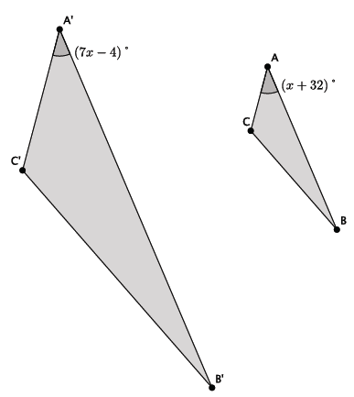

- In the diagram below, $△ABC \sim △A^{'}B^{'}C^{'}$. Determine the measure of $∠A$.
