Lesson 8: Linear Equations in Disguise

Classwork
Example 3
Can this equation be solved?
$$\frac{6+x}{7x+\frac{2}{3}}=\frac{3}{8}$$

Example 4
Can this equation be solved?
$$\frac{7}{3x+9}=\frac{1}{8}$$

Example 5
In the diagram below, $△ABC \sim △A^{'}B^{'}C^{'}$. Using what we know about similar triangles, we can determine the value of $x$.
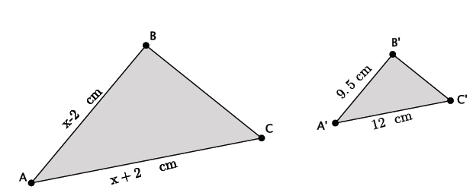

Exercises
Solve the following equations of rational expressions, if possible.
- $\frac{2x + 1}{9}=\frac{1 - x}{6}$

- $\frac{5 + 2x}{3x - 1}=\frac{6}{7}$

- $\frac{x + 9}{12}=\frac{-2x - \frac{1}{2}}{3}$

- $\frac{8}{3 - 4x}=\frac{5}{2x + \frac{1}{4}}$

Lesson Summary
Some proportions are linear equations in disguise and are solved the same way we normally solve proportions.
When multiplying a fraction with more than one term in the numerator and/or denominator by a number, put the expressions with more than one term in parentheses so you remember to use the distributive property when transforming the equation. For example:
$$\frac{x+4}{2x-5}=\frac{3}{5} \\ 5\left(x+4\right)=3\left(2x-5\right).$$
The equation $5\left(x+4\right)=3(2x-5)$ is now clearly a linear equation and can be solved using the properties of equality.
Problem Set

Solve the following equations of rational expressions, if possible. If the equation cannot be solved, explain why.
- $\frac{5}{6x - 2}=\frac{-1}{x + 1}$ | - $\frac{2x + 5}{2}=\frac{3x - 2}{6}$
- $\frac{4 - x}{8}=\frac{7x - 1}{3}$ | - $\frac{6x + 1}{3}=\frac{9 - x}{7}$
- $\frac{3x}{x + 2}=\frac{5}{9}$ | - $\frac{\frac{1}{3}x - 8}{12}=\frac{-2 - x}{15}$
- $\frac{\frac{1}{2}x + 6}{3}=\frac{x - 3}{2}$ | - $\frac{3 - x}{1 - x}=\frac{3}{2}$
- $\frac{7 - 2x}{6}=\frac{x - 5}{1}$

- In the diagram below, $△ABC \sim △A^{'}B^{'}C^{'}.$ Determine the lengths of $AC$ and $BC$.
