Lesson 13: Proof of the Pythagorean Theorem

Classwork
Exercises 1–3
Use the Pythagorean Theorem to determine the unknown length of the right triangle.
- Determine the length of side $c$ in each of the triangles below.
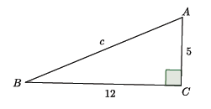

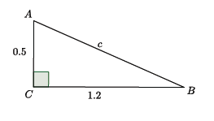

- Determine the length of side $b$ in each of the triangles below.
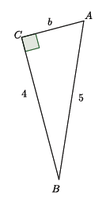

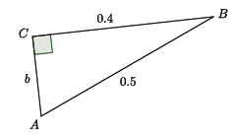

- Determine the length of $QS$. (Hint: Use the Pythagorean Theorem twice.)

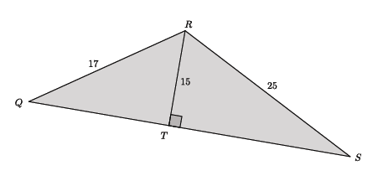

Problem Set

Use the Pythagorean Theorem to determine the unknown length of the right triangle.
- Determine the length of side $c$ in each of the triangles below.
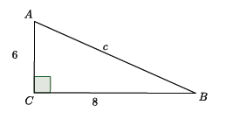

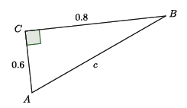

- Determine the length of side $a$ in each of the triangles below.
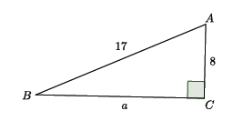

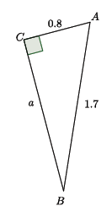

- Determine the length of side $b$ in each of the triangles below.
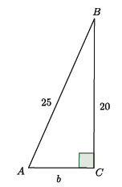

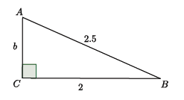

- Determine the length of side $a$ in each of the triangles below.
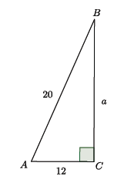

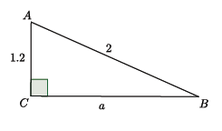

- What did you notice in each of the pairs of Problems 1–4? How might what you noticed be helpful in solving problems like these?

