Lesson 13: Proof of the Pythagorean Theorem

Student Outcomes
- Students practice applying the Pythagorean Theorem to find lengths of sides of right triangles in two dimensions.

Lesson Notes
Since 8.G.B.6 and 8.G.B.7 are post-test standards, this lesson is designated as an extension lesson for this module. However, the content within this lesson is prerequisite knowledge for Module 7. If this lesson is not used with students as part of the work within Module 3, it must be used with students prior to beginning work on Module 7. Please realize that many mathematicians agree that the Pythagorean Theorem is the most important theorem in geometry and has immense implications in much of high school mathematics in general (e.g., learning of quadratics, trigonometry, etc.). It is crucial that students see the teacher explain several proofs of the Pythagorean Theorem and practice using it before being expected to produce a proof on their own.

Classwork
Discussion (20 minutes)
The following proof of the Pythagorean Theorem is based on the fact that similarity is transitive. It begins with the right triangle, shown on the next page, split into two other right triangles. The three triangles are placed in the same orientation, and students verify that a pair of triangles is similar using the AA criterion, then a second pair of triangles is shown to be similar using the AA criterion, and then finally all three triangle pairs are shown to be similar by the fact that similarity is transitive. Once it is shown that all three triangles are in fact similar, the theorem is proved by comparing the ratios of corresponding side lengths. Because some of the triangles share side lengths that are the same (or sums of lengths), then the formula $a^{2}+b^{2}=c^{2}$ is derived. Symbolic notation is used explicitly for the lengths of sides. Therefore, it may be beneficial to do this proof simultaneously with triangles that have concrete numbers for side lengths. Another option to prepare students for the proof is showing the video presentation first, and then working through this Discussion.
- The concept of similarity can be used to prove one of the great theorems in mathematics, the Pythagorean Theorem. What do you recall about the Pythagorean Theorem from our previous work?
  - The Pythagorean Theorem is a theorem about the lengths of the legs and the hypotenuse of right triangles. Specifically, if $a$ and $b$ are the lengths of legs of a right triangle and $c$ is the length of the hypotenuse, then $a^{2}+b^{2}=c^{2}$. The hypotenuse is the longest side of the triangle, and it is opposite the right angle.

- In this lesson we are going to take a right triangle, $△ABC$, and use what we know about similarity of triangles to prove $a^{2}+b^{2}=c^{2}$.
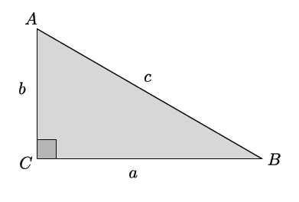
- For the proof, we will draw a line from vertex $C$ to a point $D$ so that the line is perpendicular to side $AB$.
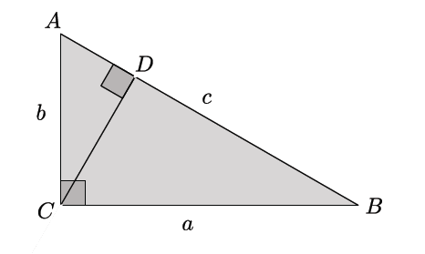
- We draw this particular line, line $CD$, because it divides the original triangle into three similar triangles. Before we move on, can you name the three triangles?
  - The three triangles are $△ABC$, $△ACD$, and$△CBD.$
- Let’s look at the triangles in a different orientation in order to see why they are similar. We can use our basic rigid motions to separate the three triangles. Doing so ensures that the lengths of segments and measures of angles are preserved.
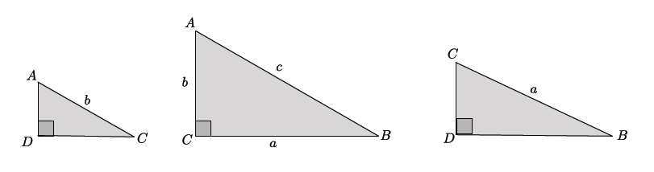
- To have similar triangles by the AA criterion, the triangles must have two common angles. Which angles prove that $△ADC$ and $△ACB$ similar?
  - It is true that $△ADC∽ △ACB$ because they each have a right angle and $∠A$, which is not the right angle, is common to both triangles.
- What does that tell us about $∠C$ from $△ADC$ and $∠B$ from $△ACB$?
  - It means that the angles correspond and must be equal in measure because of the triangle sum theorem.
- Which angles prove that $△ACB$ and $△CDB$ are similar?
  - It is true that $△ACB∽ △CDB$ because they each have a right angle and $∠B$, which is not the right angle, is common to both triangles.
- What does that tell us about $∠A$ from $△ACB$ and $∠C$ from $△CDB$?
  - The angles correspond and must be equal in measure because of the triangle sum theorem.
- If $△ADC∽ △ACB$ and $△ACB∽ △CDB$, is it true that $△ADC∽ △CDB$? How do you know?
  - Yes, because similarity is a transitive relation.
- When we have similar triangles, we know that their side lengths are proportional. Therefore, if we consider
$△ADC$ and $△ACB$, we can write
$$\frac{\left|AC\right|}{\left|AB\right|}=\frac{\left|AD\right|}{\left|AC\right|}.$$
By the cross-multiplication algorithm,
${\left|AC\right|}^{2}=\left|AB\right|∙\left|AD\right|$.
By considering $△ACB$ and $△CDB$, we can write
$$\frac{\left|BA\right|}{\left|BC\right|}=\frac{\left|BC\right|}{\left|BD\right|}.$$
Which again by the cross-multiplication algorithm,
Scaffolding:
Use concrete numbers to quickly convince students that adding two equations together leads to another true equation. For example: $5=3+2$ and $8=4+4$; therefore, $5+8=3+2+4+4$.
$${\left|BC\right|}^{2}=\left|BA\right|∙\left|BD\right|.$$
If we add the two equations together, we get
$${\left|AC\right|}^{2}+{\left|BC\right|}^{2}=\left|AB\right|∙\left|AD\right|+\left|BA\right|∙\left|BD\right|.$$
By the distributive property, we can rewrite the right side of the equation because there is a common factor of $\left|AB\right|$. Now we have
$${\left|AC\right|}^{2}+{\left|BC\right|}^{2}=\left|AB\right|\left(\left|AD\right|+\left|BD\right|\right).$$
Keeping our goal in mind, we want to prove that $a^{2}+b^{2}=c^{2}$; let’s see how close we are.
- Using our diagram where three triangles are within one, (shown below), what side lengths are represented by ${\left|AC\right|}^{2}+{\left|BC\right|}^{2}$?
  - $AC$ is side length $b$, and $BC$ is side length $a$, so the left side of our equation represents $a^{2}+b^{2}$.
- Now let’s examine the right side of our equation: $\left|AB\right|\left(\left|AD\right|+\left|BD\right|\right).$We want this to be equal to $c^{2}$; is it?
  - If we add the side length $AD$ and side length $BD$, we get the entire side length of $AB$; therefore, we have $\left|AB\right|\left(\left|AD\right|+\left|BD\right|\right)=\left|AB\right|∙\left|AB\right|={\left|AB\right|}^{2}=c^{2}$.
- We have just proven the Pythagorean Theorem using what we learned about similarity. At this point we have seen the proof of the theorem in terms of congruence and now similarity.
Video Presentation (7 minutes)
The video located at the following link is an animation of the preceding proof using similar triangles: http://www.youtube.com/watch?v=QCyvxYLFSfU.

Exercises 1–3 (8 minutes)
Students work independently to complete Exercises 1–3.
Exercises 1–3
Use the Pythagorean Theorem to determine the unknown length of the right triangle.
- Determine the length of side $c$ in each of the triangles below.
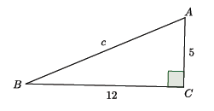
$$5^{2}+{12}^{2}=c^{2} \\ 25+144=c^{2} \\ 169=c^{2} \\ 13=c$$
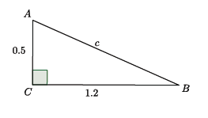

$${0.5}^{2}+{1.2}^{2}=c^{2} \\ 0.25+1.44=c^{2} \\ 1.69=c^{2} \\ 1.3=c$$

- Determine the length of side $b$ in each of the triangles below.
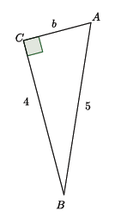

$$4^{2}+b^{2}=5^{2} \\ 16+b^{2}=25 \\ 16-16+b^{2}=25-16 \\ { b}^{2}=9 \\ b=3$$

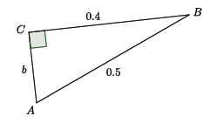
$$0.4^{2}+b^{2}={0.5}^{2} \\ 1.6+b^{2}=2.5 \\ 1.6-1.6+b^{2}=2.5-1.6 \\ { b}^{2}=0.9 \\ b=0.3$$

- Determine the length of $QS$. (Hint: Use the Pythagorean Theorem twice.)

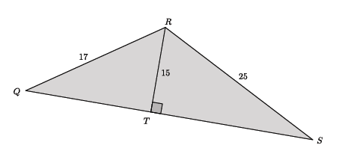
$${15}^{2}+{\left|QT\right|}^{2}={17}^{2} \\ 225+{\left|QT\right|}^{2}=289 \\ 225-225+{\left|QT\right|}^{2}=289-225 \\ { \left|QT\right|}^{2}=64 \\ \left|QT\right|=8$$ | $${15}^{2}+{\left|TS\right|}^{2}={25}^{2} \\ 225+{\left|TS\right|}^{2}=625 \\ 225-225+{\left|TS\right|}^{2}=625-225 \\ { \left|TS\right|}^{2}=400 \\ \left|TS\right|=20$$
Since $\left|QT\right|+\left|TS\right|=\left|QS\right|$, then the length of side $QS$ is $8+20$, which is $28$.

Closing (5 minutes)
Summarize, or ask students to summarize, the main points from the lesson.
- We have now seen another proof of the Pythagorean Theorem, but this time we used what we knew about similarity, specifically similar triangles.
- We practiced using the Pythagorean Theorem to find unknown lengths of right triangles.

Exit Ticket (5 minutes)

Name ___________________________________________________ Date____________________
Lesson 13: Proof of the Pythagorean Theorem

Exit Ticket

Determine the length of side $BD$ in the triangle below.

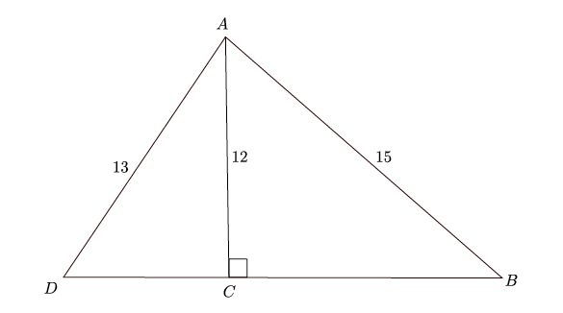

Exit Ticket Sample Solutions

Determine the length of side $BD$ in the triangle below.
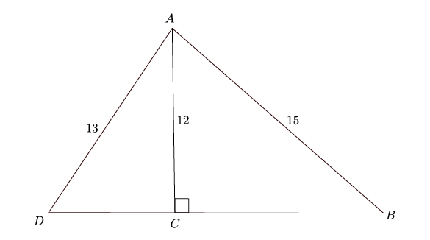
First determine the length of side $BC$.
$$12^{2}+BC^{2}=15^{2} \\ 144+BC^{2}=225 \\ BC^{2}=225-144 \\ BC^{2}=81 \\ BC=9$$

Then determine the length of side $CD$.
$$12^{2}+{CD}^{2}=13^{2} \\ 144+{CD}^{2}=169 \\ {CD}^{2}=169-144 \\ {CD}^{2}=25 \\ CD=5$$
Adding the lengths of sides $BC$ and $CD$ will determine the length of side $BD$; therefore, $5+9=14$. $BD$ has a length of $14$.

Problem Set Sample Solutions
Students practice using the Pythagorean Theorem to find unknown lengths of right triangles.

Use the Pythagorean Theorem to determine the unknown length of the right triangle.
- Determine the length of side $c$ in each of the triangles below.
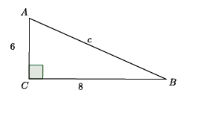
$$6^{2}+8^{2}=c^{2} \\ 36+64=c^{2} \\ 100=c^{2} \\ 10=c$$

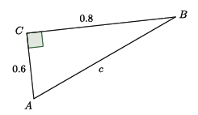
$$0.6^{2}+{0.8}^{2}=c^{2} \\ 0.36+0.64=c^{2} \\ 1=c^{2} \\ 1=c$$

- Determine the length of side $a$ in each of the triangles below.
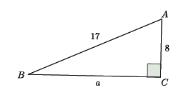
$$a^{2}+8^{2}={17}^{2} \\ a^{2}+64=289 \\ a^{2}+64-64=289-64 \\ { a}^{2}=225 \\ a=15$$
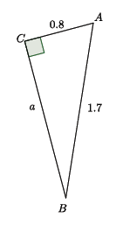

$$a^{2}+0.8^{2}={1.7}^{2} \\ a^{2}+0.64=2.89 \\ a^{2}+0.64-0.64=2.89-0.64 \\ a^{2}=2.25 \\ a=1.5$$

- Determine the length of side $b$ in each of the triangles below.
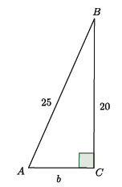

$${20}^{2}+b^{2}={25}^{2} \\ 400+b^{2}=625 \\ 400-400+b^{2}=625-400 \\ { b}^{2}=225 \\ b=15$$

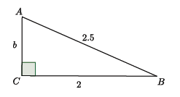
$$2^{2}+b^{2}={2.5}^{2} \\ 4+b^{2}=6.25 \\ 4-4+b^{2}=6.25-4 \\ b^{2}=2.25 \\ b=1.5$$

- Determine the length of side $a$ in each of the triangles below.
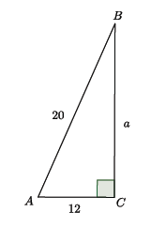
$$a^{2}+{12}^{2}={20}^{2} \\ a^{2}+144=400 \\ a^{2}+144-144=400-144 \\ a^{2}=256 \\ a=16$$

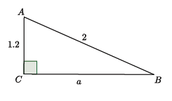
$$a^{2}+{1.2}^{2}=2^{2} \\ a^{2}+1.44=4 \\ a^{2}+1.44-1.44=4-1.44 \\ a^{2}=2.56 \\ a=1.6$$

- What did you notice in each of the pairs of Problems 1–4? How might what you noticed be helpful in solving problems like these?
In each pair of problems, the problems and solutions were similar. For example, in Problem 1, part (a) showed the sides of the triangle were $6$,$8$, and $10$, and in part (b), they were $0.6$, $0.8$, and $1$. The side lengths in part (b) were a tenth of the value of the lengths in part (a). The same could be said about parts (a) and (b) of Problems 2–4. This might be helpful for solving problems in the future. If I am given sides lengths that are decimals, then I could multiply them by a factor of $10$ to make whole numbers, which are easier to work with. Also, if I know common numbers that satisfy the Pythagorean Theorem, like side lengths of $3$, $4$, and$5$, then I will recognize them more easily in their decimal forms, i.e., $0.3$, $0.4$, and $0.5$.

Animation developed by Larry Francis.

