Lesson 11: More About Similar Triangles

Classwork
Exercises
- In the diagram below, you have $△ABC$ and $△AB^{'}C^{'}.$Use this information to answer parts (a)–(d).

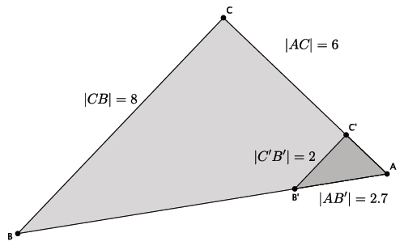
  - Based on the information given, is $△ABC\sim △AB^{'}C^{'}$? Explain.

  - Assume line $BC$ is parallel to line $B'C'$. With this information, can you say that $△ABC\sim △AB^{'}C^{'}$? Explain.

  - Given that $△ABC\sim △AB^{'}C^{'}$, determine the length of side $AC'$.

  - Given that $△ABC\sim △AB^{'}C^{'}$, determine the length of side $AB$.

- In the diagram below, you have $△ABC$ and $△A{'B}^{'}C^{'}$. Use this information to answer parts (a)–(c).

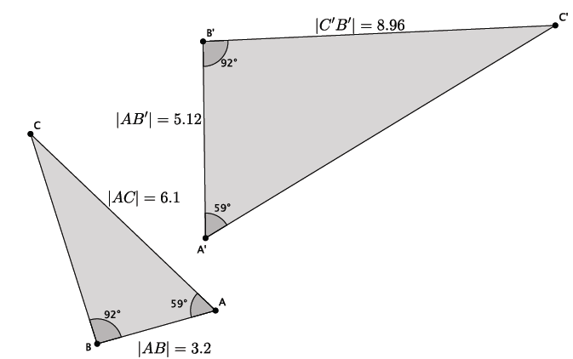

  - Based on the information given, is $△ABC\sim △A'B^{'}C^{'}$? Explain.

  - Given that $△ABC\sim △A'B^{'}C^{'}$, determine the length of side $A'C'$.

  - Given that $△ABC\sim △A'B^{'}C^{'}$, determine the length of side $BC$.

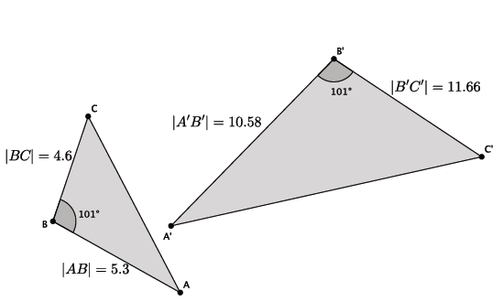
- In the diagram below, you have $△ABC$ and $△A{'B}^{'}C^{'}$. Use this information to answer the question below.

Based on the information given, is $△ABC\sim △A'B^{'}C^{'}$? Explain.

$\left|∠A\right|=\left|∠D\right|$ and $\frac{1}{2}=\frac{3}{6}=r$; therefore, $△ABC\sim △DEF.$
Lesson Summary
Given just one pair of corresponding angles of a triangle as equal, use the side lengths along the given angle to determine if triangles are in fact similar.
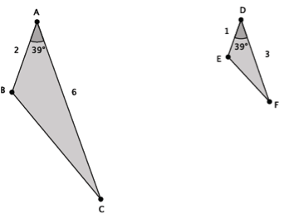
Given similar triangles, use the fact that ratios of corresponding sides are equal to find any missing measurements.

Problem Set

- In the diagram below, you have $△ABC$ and $△A'B^{'}C^{'}$. Use this information to answer parts (a)–(b).

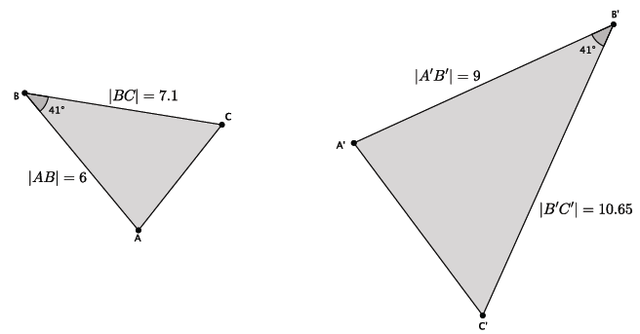

  - Based on the information given, is $△ABC\sim △A{'B}^{'}C^{'}$? Explain.
  - Assume the length of side $AC$ is $4.3$. What is the length of side $A^{'}C^{'}$?

- In the diagram below, you have $△ABC$ and $△AB^{'}C^{'}$. Use this information to answer parts (a)–(d).
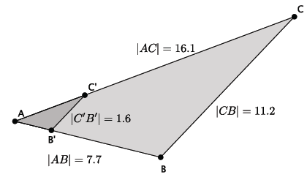

  - Based on the information given, is $△ABC\sim △AB^{'}C^{'}$? Explain.
  - Assume line $BC$ is parallel to line $B'C'$. With this information, can you say that $△ABC\sim △AB^{'}C^{'}$? Explain.
  - Given that $△ABC\sim △AB^{'}C^{'}$, determine the length of side $AC^{'}$.
  - Given that $△ABC\sim △AB^{'}C^{'}$, determine the length of side $AB^{'}$.

- In the diagram below, you have $△ABC$ and $△A'B^{'}C^{'}$. Use this information to answer parts (a)–(c).
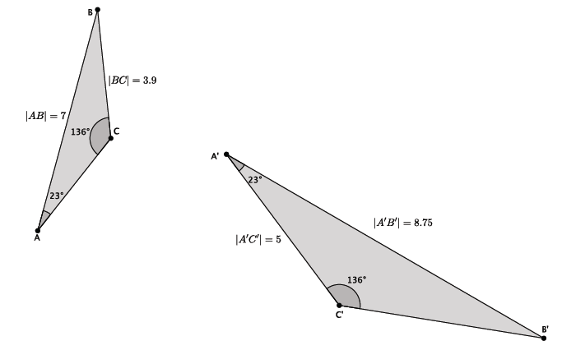
  - Based on the information given, is $△ABC\sim △A'B^{'}C^{'}$? Explain.
  - Given that $△ABC\sim △A'B^{'}C^{'}$, determine the length of side $B^{'}C^{'}$.
  - Given that $△ABC\sim △A'B^{'}C^{'}$, determine the length of side $AC$.
- In the diagram below, you have $△ABC$ and $△AB^{'}C^{'}$. Use this information to answer the question below.
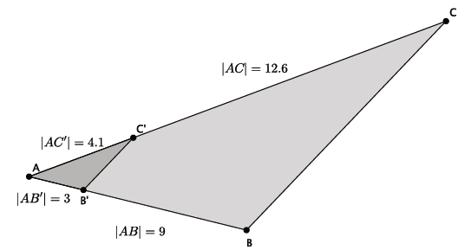

Based on the information given, is $△ABC\sim △AB^{'}C^{'}$? Explain.

- In the diagram below, you have $△ABC$ and $△A{'B}^{'}C^{'}$. Use this information to answer parts (a)–(b).
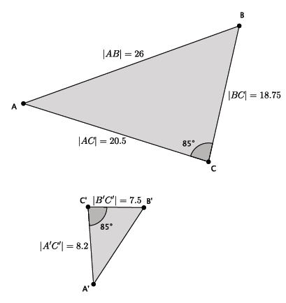
  - Based on the information given, is $△ABC\sim △A{'B}^{'}C^{'}$? Explain.
  - Given that $△ABC\sim △A{'B}^{'}C^{'},$determine the length of side $A^{'}B^{'}$.

