Lesson 11: More About Similar Triangles

Student Outcomes
- Students present informal arguments as to whether or not two triangles are similar.
- Students practice finding lengths of corresponding sides of similar triangles.

Lesson Notes
This lesson synthesizes the knowledge gained thus far in Module 3. Students use what they know about dilation, congruence, the Fundamental Theorem of Similarity (FTS), and the angle-angle (AA) criterion to determine if two triangles are similar. In the first two examples, students use informal arguments to decide if a pair of triangles are similar. To do so, they look for pairs of corresponding angles that are equal (wanting to use the AA criterion). When they realize that information is not given, they compare lengths of corresponding sides to see if the sides could be dilations with the same scale factor. After a dilation and congruence are performed, students see that a pair of triangles are similar (or not) and then continue to give more proof as to why they must be. For example, by FTS, a specific pair of lines are parallel, and the corresponding angles cut by a transversal must be equal; therefore, we can use AA criterion to state that two triangles are similar. Once students know how to determine whether two triangles are similar, they apply this knowledge to finding lengths of segments of triangles that are unknown in Examples 3–5.

Classwork
Example 1 (6 minutes)
MP.1
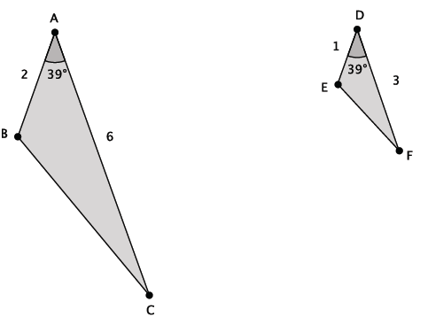
- Given the information provided, is $△ABC\sim △DEF$? (Give students a minute or two to discuss with a partner.)
  - Students will likely say that they cannot tell if the triangles are similar because there is only information for one angle provided. In the previous lesson, students could determine if two triangles were similar using AA criterion.
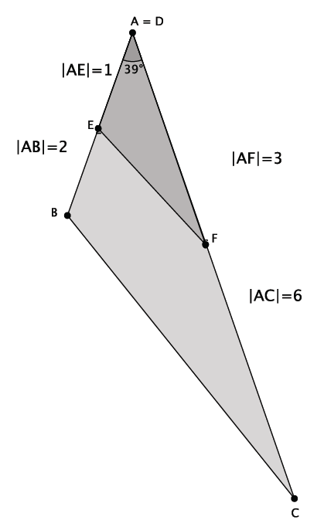
- What if we combined our knowledge of dilation and similarity? That is, we know we can translate $△ABC$ so that the measure of $∠A$ is equal in measure to $∠D$. Then our picture would look like this:
MP.1
- Can we tell if the triangles are similar now?
  - We still do not have information about the angles, but we can use what we know about dilation and FTS to find out if side $EF$ is parallel to side $BC$. If they are, then $△ABC\sim △DEF$ because the corresponding angles of parallel lines are equal.

- We do not have the information we need about corresponding angles. So let’s examine the information we are provided. Compare the given side lengths to see if the ratios of corresponding sides are equal:
Is $\frac{\left|AE\right|}{\left|AB\right|}=\frac{\left|AF\right|}{\left|AC\right|}$? That’s the same as asking if $\frac{1}{2}=\frac{3}{6}$. Since the ratios of corresponding sides are equal, then there exists a dilation from center $A$ with scale factor $r=\frac{1}{2}$that maps $△ABC$to $△DEF.$ Since the ratios of corresponding sides are equal, then by FTS, we know side $EF$ is parallel to side $BC$ and the corresponding angles of the parallel lines are also equal in measure.

- This example illustrates another way for us to determine if two triangles are similar. That is, if they have one pair of equal corresponding angles, and the ratio of corresponding sides (along each side of the given angle) are equal, then the triangles are similar.

Example 2 (4 minutes)
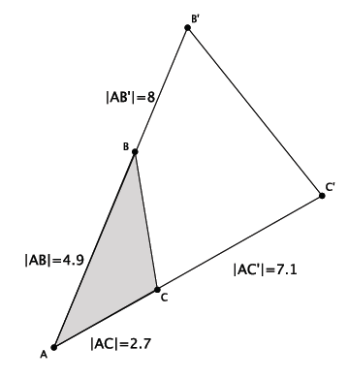
- Given the information provided, is $△ABC\sim △AB'C'$? Explain. (Give students a minute or two to discuss with a partner.)

If students say that the triangles are not similar because lines $BC$ and $B'C'$are not parallel, ask them how they know this. If they say, “They don’t look parallel”, tell students that the way they look is not good enough. They must prove mathematically that the lines are not parallel. Therefore, the following response is more legitimate.
  - We do not have information about two pairs of corresponding angles, so we will need to examine the ratios of corresponding side lengths. If the ratios are equal, then the triangles are similar.

- If the ratios of the corresponding sides are equal, it means that the lengths were dilated by the same scale factor. Write the ratios of the corresponding sides.
  - The ratios of corresponding sides are $\frac{\left|{AC}^{'}\right|}{\left|AC\right|}=\frac{\left|{AB}^{'}\right|}{\left|AB\right|}$.

- Does $\frac{\left|{AC}^{'}\right|}{\left|AC\right|}=\frac{\left|{AB}^{'}\right|}{\left|AB\right|}$ ? That is the same as asking if $\frac{7.1}{2.7}$ and$\frac{8}{4.9}$ are equivalent fractions. One possible way of verifying if the fractions are equal is by multiplying the numerator of each fraction by the denominator of the other. If the products are equal, then we know the fractions are equivalent.
  - The products are $34.79$and $21.6.$ Since $34.79≠21.6$, the fractions are not equivalent, and the triangles are not similar.
Example 3 (4 minutes)
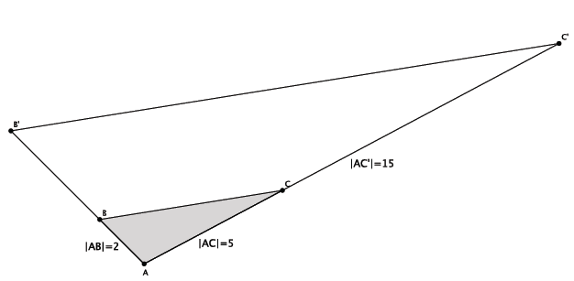
- Given that $△ABC\sim △AB'C'$, could we determine the length of $AB'$? What does it mean to say that
$△ABC\sim △AB'C'$? (Give students a minute or two to discuss with a partner.)

  - It means that the measures of corresponding angles are equal; the ratios of corresponding sides are equal, i.e., $\frac{\left|{AC}^{'}\right|}{\left|AC\right|}=\frac{\left|{AB}^{'}\right|}{\left|AB\right|}=\frac{\left|B^{'}C^{'}\right|}{\left|BC\right|}$, and lines $BC$ and $B'C'$ are parallel.

- How can we use what we know about similar triangles to determine the length of $AB'$?
  - The lengths of corresponding sides are supposed to be equal in ratio: $\frac{\left|{AC}^{'}\right|}{\left|AC\right|}=\frac{\left|{AB}^{'}\right|}{\left|AB\right|}$ is the same as $\frac{15}{5}=\frac{\left|{AB}^{'}\right|}{2}$.

- Since we know that for equivalent fractions, when we multiply the numerator of each fraction by the denominator of the other fraction, the products are equal, we can use that fact to find the length of side $AB'$. Let $x$represent the length of $AB'$; then $\frac{15}{5}=\frac{\left|{AB}^{'}\right|}{2}$ is the same as $\frac{15}{5}=\frac{x}{2}$. Equivalently, we get $30=5x$. The value of $x$ that makes the statement true is $x=6.$ Therefore, the length of side $AB'$ is $6$.

Example 4 (4 minutes)
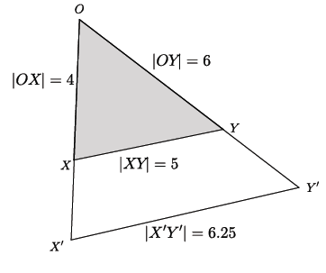
- If we suppose $XY$ is parallel to $X'Y'$, can we use the information provided to determine if $△OXY\sim △OX^{'}Y^{'}$? Explain. (Give students a minute or two to discuss with a partner.)

  - Since we assume $XY||X'Y'$, then we know we have similar triangles because each triangle shares $∠O$ and the corresponding angles are congruent: $∠OXY≅∠OX^{'}Y^{'}$, and $∠OYX≅∠OY^{'}X^{'}$. By the AA criterion, we can conclude that $△OXY\sim △OX^{'}Y^{'}$.

- Now that we know the triangles are similar, can we determine the length of side $OX'$? Explain.
  - By the converse of FTS, since we are given parallel lines and the lengths of the corresponding sides $XY$ and $X'Y'$, we can write the ratio that represents the scale factor and compute using the fact that cross products must be equal to determine the length of side $OX'$.

- Write the ratio for the known side lengths $XY$ and $X'Y'$ and the ratio that would contain the side length we are looking for. Then use the cross products to find the length of side $OX'$.
  - $\frac{\left|X^{'}Y^{'}\right|}{\left|XY\right|}=\frac{\left|{OX}^{'}\right|}{\left|OX\right|}$ is the same as $\frac{6.25}{5}=\frac{\left|{OX}^{'}\right|}{4}$. Let $z$ represent the length of side $OX'$. Then we have $\frac{6.25}{5}=\frac{z}{4}$ or equivalently, $5z=25$ and $z=5$. Therefore, the length of side $OX'$ is $5$.

- Now find the length of $OY'$.
  - $\frac{\left|X^{'}Y^{'}\right|}{\left|XY\right|}=\frac{\left|{OY}^{'}\right|}{\left|OY\right|}$ is the same as $\frac{6.25}{5}=\frac{\left|{OY}^{'}\right|}{6}$. Let $w$ represent the length of side $OY'$. Then we have $\frac{6.25}{5}=\frac{w}{6}$ or equivalently, $5w=37.5$ and $w=7.5$. Therefore, the length of side $OY'$is $7.5$.

Example 5 (3 minutes)
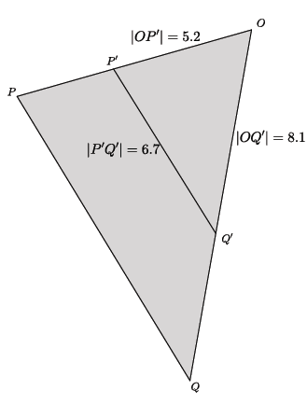
- Given the information provided, can you determine if $△OPQ\sim △OP^{'}Q^{'}$? Explain. (Give students a minute or two to discuss with a partner.)

  - No, in order to determine if $△OPQ\sim △OP^{'}Q^{'}$ we need information about two pairs of corresponding angles. As is, we only know that the two triangles have one equal angle, the common angle at $O$. We would have corresponding angles that were equal if we knew that sides $PQ∥P^{'}Q^{'}$. Our other option is to compare the ratio of the sides that comprise the common angle. However, we do not have information about the lengths sides $OP$ or $OQ$. For that reason, we cannot determine whether or not
$$△OPQ\sim △OP^{'}Q^{'}.$$

Exercises 1–3 (14 minutes)
Students can work independently or in pairs to complete Exercises 1–3.
Exercises
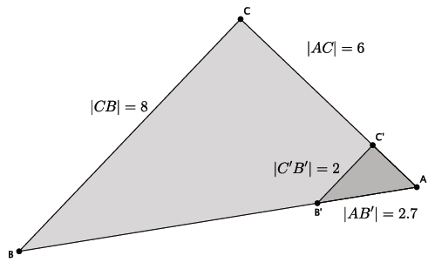
- In the diagram below, you have $△ABC$ and $△AB^{'}C^{'}$. Use this information to answer parts (a)–(d).

  - Based on the information given, is $△ABC\sim △AB^{'}C^{'}$? Explain.
There is not enough information provided to determine if the triangles are similar. We would need information about a pair of corresponding angles or more information about the side lengths of each of the triangles.

  - Assume line $BC$ is parallel to line $B'C'$. With this information, can you say that $△ABC\sim △AB^{'}C^{'}$? Explain.
If line $BC$ is parallel to line $B'C'$, then $△ABC\sim △AB^{'}C^{'}$. Both triangles share $∠A$. Another pair of equal angles is $∠AB'C'$and $∠ABC.$ They are equal because they are corresponding angles of parallel lines. By the AA criterion, $△ABC\sim △AB^{'}C^{'}$.

  - Given that $△ABC\sim △AB^{'}C^{'}$, determine the length of side $AC'$.
Let $x$ represent the length of side $AC'$.
$$\frac{x}{6}=\frac{2}{8}$$
We are looking for the value of $x$ that makes the fractions equivalent. Therefore, $8x=12,$ and $x=1.5.$ The length of side $AC'$ is $1.5$.

  - Given that $△ABC\sim △AB^{'}C^{'}$, determine the length of side $AB$.
Let $y$ represent the length of side $AB$.
$$\frac{2.7}{y}=\frac{2}{8}$$
We are looking for the value of $y$ that makes the fractions equivalent. Therefore, $2y=21.6$ and $y=10.8$. The length of side $AB$ is $10.8$.

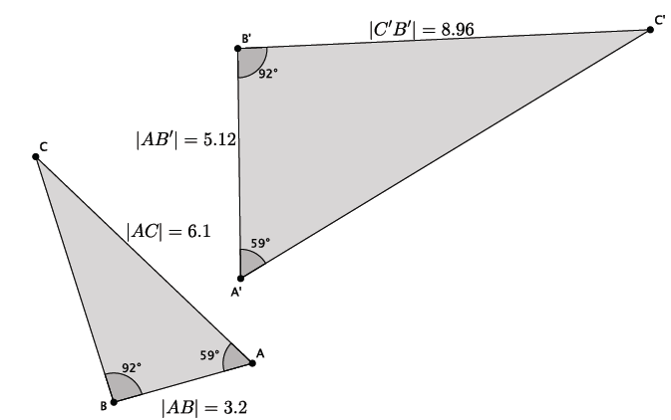
- In the diagram below, you have $△ABC$ and $△A{'B}^{'}C^{'}$. Use this information to answer parts (a)–(c).

  - Based on the information given, is $△ABC\sim △A'B^{'}C^{'}$? Explain.
Yes, $△ABC\sim △A^{'}B'C'$. There are two pairs of corresponding angles that are equal in measure. Namely, $∠A=∠A^{'}=59°$, and $∠B=∠B^{'}=92°$. By the AA criterion, these triangles are similar.

  - Given that $△ABC\sim △A'B^{'}C^{'}$, determine the length of side $A'C'$.
Let $x$ represent the length of side $A'C'$.
$$\frac{x}{6.1}=\frac{5.12}{3.2}$$
We are looking for the value of $x$ that makes the fractions equivalent. Therefore, $3.2x=31.232$, and
$x=9.76$. The length of side $A'C'$ is $9.76$.

  - Given that $△ABC\sim △A'B^{'}C^{'}$, determine the length of side $BC$.
Let $y$ represent the length of side $BC$.
$$\frac{8.96}{y}=\frac{5.12}{3.2}$$
We are looking for the value of $y$ that makes the fractions equivalent. Therefore, $5.12y=28.672$, and
$y=5.6$. The length of side $BC$ is $5.6$.

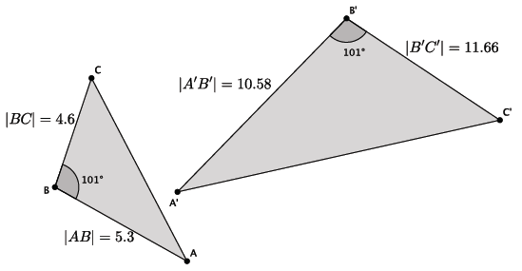
- In the diagram below, you have $△ABC$ and $△A{'B}^{'}C^{'}$. Use this information to answer the question below.
Based on the information given, is $△ABC\sim △A'B^{'}C^{'}$? Explain.
No, $△ABC$ is not similar to $△A^{'}B^{'}C^{'}$. Since there is only information about one pair of corresponding angles, then we must check to see that the corresponding sides have equal ratios. That is, the following must be true:
$$\frac{10.58}{5.3}=\frac{11.66}{4.6}.$$
When we compare products of each numerator with the denominator of the other fraction, we see that $48.668 ≠ 61.798$. Since the corresponding sides do not have equal ratios, then the fractions are not equivalent, and the triangles are not similar.

Closing (5 minutes)
Summarize, or ask students to summarize, the main points from the lesson.
- We know that if we are given just one pair of corresponding angles as equal, we can use the side lengths along the given angle to determine if triangles are in fact similar.
- If we know that we are given similar triangles, then we can use the fact that ratios of corresponding sides are equal to find any missing measurements.
Lesson Summary
Given just one pair of corresponding angles of a triangle as equal, use the side lengths along the given angle to determine if triangles are in fact similar.
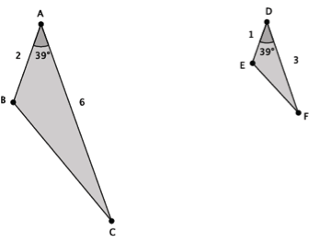
Given similar triangles, use the fact that ratios of corresponding sides are equal to find any missing measurements.

$\left|∠A\right|=\left|∠D\right|$ and $\frac{1}{2}=\frac{3}{6}=r$; therefore,
$△ABC\sim △DEF$.

Exit Ticket (5 minutes)
Name ___________________________________________________ Date____________________
Lesson 11: More About Similar Triangles

Exit Ticket

- In the diagram below, you have $△ABC$ and$△A'B^{'}C^{'}$. Based on the information given, is $△ABC\sim △A'B^{'}C^{'}$? Explain.
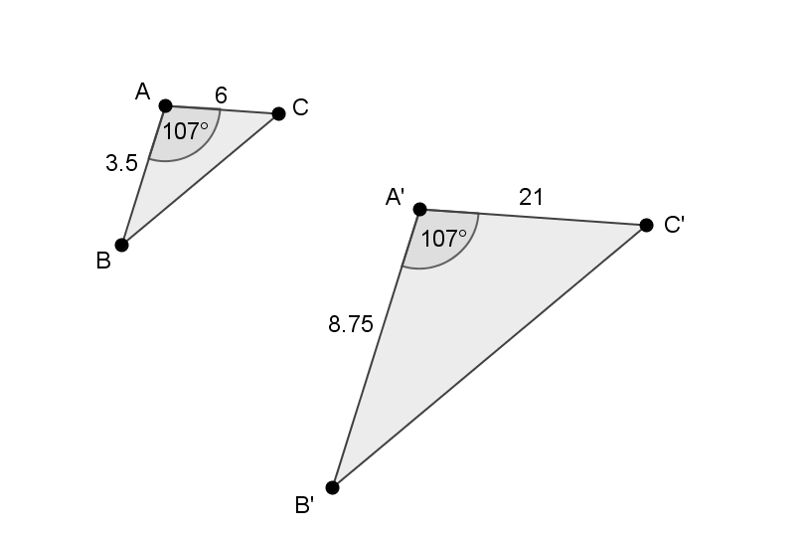

- In the diagram below, $△ABC\sim △DEF.$Use the information to answer parts (a)–(b).
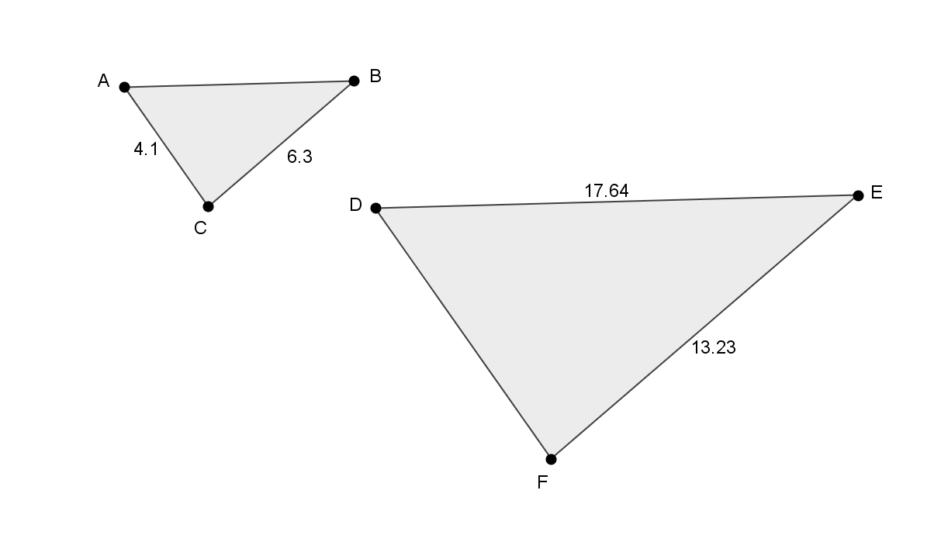
  - Determine the length of side $AB$. Show work that leads to your answer.

  - Determine the length of side $DF$. Show work that leads to your answer.
Exit Ticket Sample Solutions

- In the diagram below, you have $△ABC$ and$△A'B^{'}C^{'}$. Based on the information given, is $△ABC\sim △A'B^{'}C^{'}$? Explain.
Since there is only information about one pair of corresponding angles, we need to check to see if corresponding sides have equal ratios. That is, does $\frac{\left|AB\right|}{\left|A^{'}B^{'}\right|}=\frac{\left|AC\right|}{\left|A^{'}C^{'}\right|}$, or does $\frac{3.5}{8.75}=\frac{6}{21}$? The products are not equal, $73.5≠52.5$. Since the corresponding sides do not have equal ratios, the triangles are not similar.

- In the diagram below, $△ABC\sim △DEF.$Use the information to answer parts (a)–(b).
  - Determine the length of side $AB$. Show work that leads to your answer.
Let $x$ represent the length of side $AB$.
Then $\frac{x}{17.64}=\frac{6.3}{13.23}$. We are looking for the value of $x$ that makes the fractions equivalent. Therefore,
$111.132=13.23x$, and $x=8.4$. The length of side $AB$ is $8.4$.

  - Determine the length of side $DF$. Show work that leads to your answer.
Let $y$ represent the length of side $DF$.
Then $\frac{4.1}{y}=\frac{6.3}{13.23}$. We are looking for the value of $y$ that makes the fractions equivalent. Therefore,
$54.243=6.3y$, and $8.61=y$. The length of side $DF$ is $8.61$.

Problem Set Sample Solutions
Students practice presenting informal arguments as to whether or not two given triangles are similar. Students practice finding measurements of similar triangles.

- In the diagram below, you have $△ABC$ and $△A'B^{'}C^{'}$. Use this information to answer parts (a)–(b).
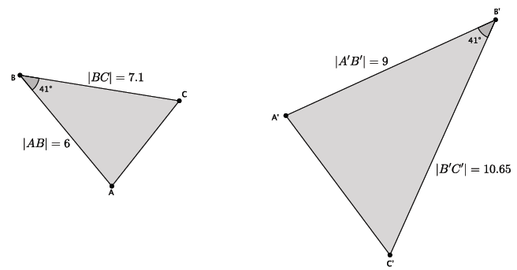
  - Based on the information given, is $△ABC\sim △A{'B}^{'}C^{'}$? Explain.
Yes, $△ABC\sim △A{'B}^{'}C^{'}$. Since there is only information about one pair of corresponding angles being equal, then the corresponding sides must be checked to see if their ratios are equal.
$$\frac{10.65}{7.1}=\frac{9}{6} \\ 63.9=63.9$$
Since the cross products are equal, the triangles are similar.

  - Assume the length of side $AC$ is $4.3$. What is the length of side $A^{'}C^{'}$?
Let $x$ represent the length of $A^{'}C^{'}$.
$$\frac{x}{4.3}=\frac{9}{6}$$
We are looking for the value of $x$ that makes the fractions equivalent. Therefore, $6x=38.7$, and $x=6.45$. The length of side $A^{'}C^{'}$ is $6.45$.

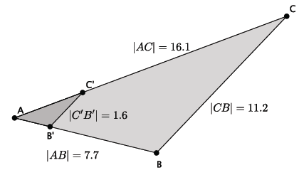
- In the diagram below, you have $△ABC$ and $△AB^{'}C^{'}$. Use this information to answer parts (a)–(d).

  - Based on the information given, is $△ABC\sim △AB^{'}C^{'}$? Explain.
There is not enough information provided to determine if the triangles are similar. We would need information about a pair of corresponding angles or more information about the side lengths of each of the triangles.
  - Assume line $BC$ is parallel to line $B'C'$. With this information, can you say that $△ABC\sim △AB^{'}C^{'}$? Explain.
If line $BC$ is parallel to line $B'C'$, then $△ABC\sim △AB^{'}C^{'}$. Both triangles share $∠A$. Another pair of equal angles is $∠AB'C'$ and $∠ABC$. They are equal because they are corresponding angles of parallel lines. By the AA criterion, $△ABC\sim △AB^{'}C^{'}$.

  - Given that $△ABC\sim △AB^{'}C^{'}$, determine the length of side $AC^{'}$.
Let $x$ represent the length of $AC^{'}$.
$$\frac{x}{16.1}=\frac{1.6}{11.2}$$
We are looking for the value of $x$ that makes the fractions equivalent. Therefore, $11.2x=25.76$, and
$x=2.3$. The length of $AC'$ is $2.3$.

  - Given that $△ABC\sim △AB^{'}C^{'}$, determine the length of side $AB^{'}$.
Let $y$ represent the length of $AB'$.
$$\frac{y}{7.7}=\frac{1.6}{11.2}$$
We are looking for the value of $y$ that makes the fractions equivalent. Therefore, $11.2y=12.32$, and
$y=1.1$. The length of side $AB^{'}$ is $1.1$.

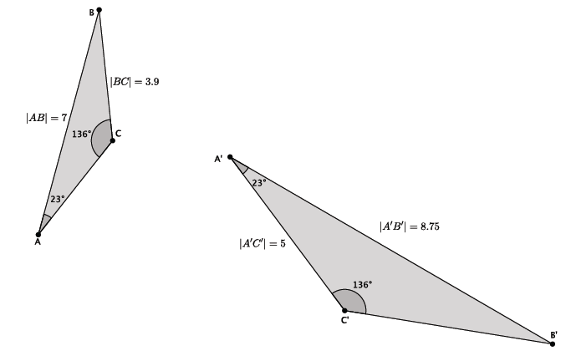
- In the diagram below, you have $△ABC$ and $△A'B^{'}C^{'}$. Use this information to answer parts (a)–(c).

  - Based on the information given, is $△ABC\sim △A'B^{'}C^{'}$? Explain.
Yes, $△ABC\sim △A^{'}B'C'$. There are two pairs of corresponding angles that are equal in measure. Namely, $∠A=∠A^{'}=23°$, and $∠C=∠C^{'}=136°$. By the AA criterion, these triangles are similar.

  - Given that $△ABC\sim △A'B^{'}C^{'}$, determine the length of side $B^{'}C^{'}$.
Let $x$ represent the length of $B^{'}C^{'}$.
$$\frac{x}{3.9}=\frac{8.75}{7}$$
We are looking for the value of $x$ that makes the fractions equivalent. Therefore, $7x=34.125$, and
$x=4.875$. The length of side $B^{'}C^{'}$ is $4.875$.

  - Given that $△ABC\sim △A'B^{'}C^{'},$ determine the length of side $AC$.
Let $y$ represent the length of side $AC$.
$$\frac{5}{y}=\frac{8.75}{7}$$
We are looking for the value of $y$ that makes the fractions equivalent. Therefore, $8.75y=35$, and $y=4$. The length of side $AC$ is $4$.

- In the diagram below, you have $△ABC$ and $△AB^{'}C^{'}$. Use this information to answer the question below.
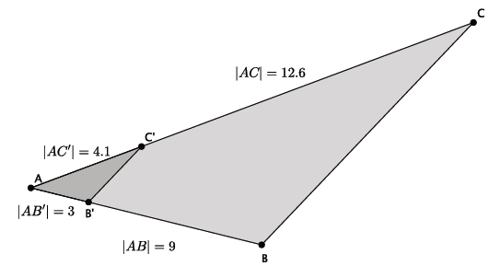

Based on the information given, is $△ABC\sim △AB^{'}C^{'}$? Explain.
No, $△ABC$ is not similar to $△AB^{'}C^{'}$. Since there is only information about one pair of corresponding angles, then we must check to see that the corresponding sides have equal ratios. That is, the following must be true:
$$\frac{9}{3}=\frac{12.6}{4.1}.$$
When we compare products of each numerator with the denominator of the other fraction, we see that
$36.9≠37.8$. Since the corresponding sides do not have equal ratios, the fractions are not equivalent, and the triangles are not similar.

- In the diagram below, you have $△ABC$ and $△A{'B}^{'}C^{'}$. Use this information to answer parts (a)–(b).
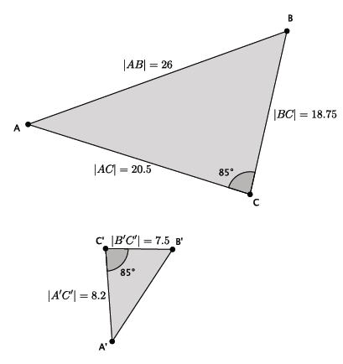
  - Based on the information given, is $△ABC\sim △A{'B}^{'}C^{'}$? Explain.
Yes, $△ABC\sim △A'B^{'}C^{'}$. Since there is only information about one pair of corresponding angles being equal, then the corresponding sides must be checked to see if their ratios are equal.
$$\frac{8.2}{20.5}=\frac{7.5}{18.75}$$
When we compare products of each numerator with the denominator of the other fraction, we see that $153.75=153.75$. Since the products are equal, the fractions are equivalent, and the triangles are similar.

  - Given that $△ABC\sim △A{'B}^{'}C^{'}$, determine the length of side $A^{'}B^{'}$.
Let $x$ represent the length of $A^{'}B^{'}$.
$$\frac{x}{26}=\frac{7.5}{18.75}$$
We are looking for the value of $x$ that makes the fractions equivalent. Therefore, $18.75x=195$, and
$x=10.4$. The length of side $A^{'}B^{'}$ is $10.4$.

