Lesson 10: Informal Proof of AA Criterion for Similarity

Classwork
Exercises
- Use a protractor to draw a pair of triangles with two pairs of equal angles. Then measure the lengths of sides, and verify that the lengths of their corresponding sides are equal in ratio.

- Draw a new pair of triangles with two pairs of equal angles. Then measure the lengths of sides, and verify that the lengths of their corresponding sides are equal in ratio.

- Are the triangles shown below similar? Present an informal argument as to why they are or are not similar.
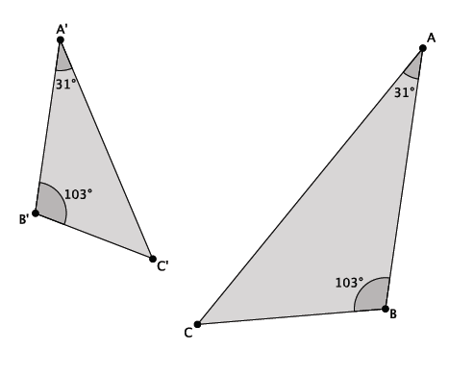

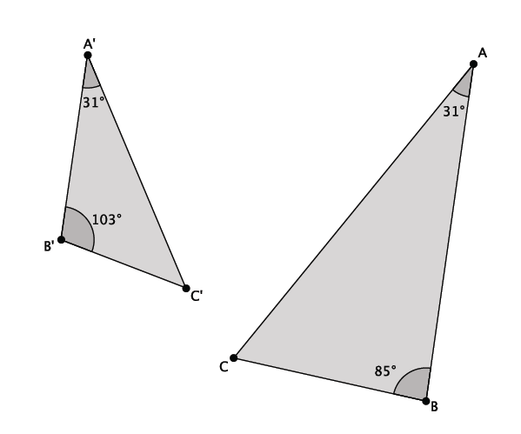
- Are the triangles shown below similar? Present an informal argument as to why they are or are not similar.

- Are the triangles shown below similar? Present an informal argument as to why they are or are not similar.
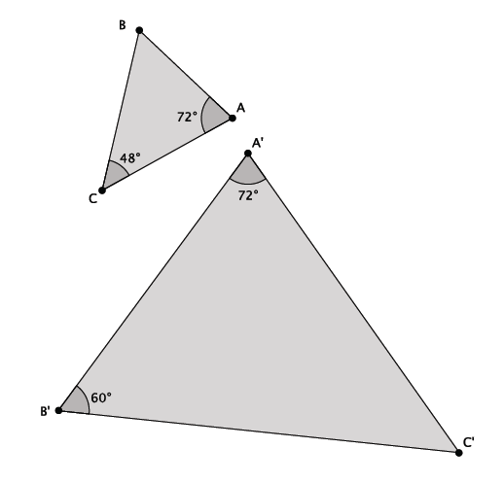

Problem Set

- Are the triangles shown below similar? Present an informal argument as to why they are or are not similar.
Lesson Summary
Two triangles are said to be similar if they have two pairs of corresponding angles that are equal in measure.
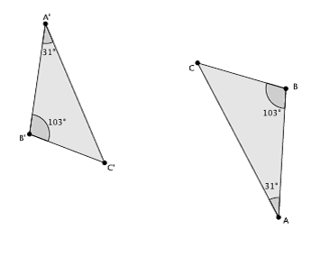

- Are the triangles shown below similar? Present an informal argument as to why they are or are not similar.
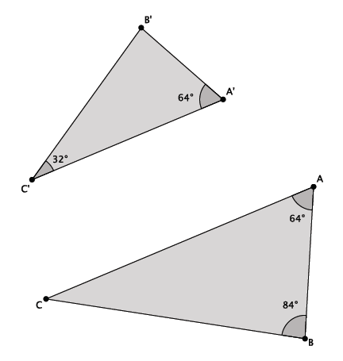
- Are the triangles shown below similar? Present an informal argument as to why they are or are not similar.
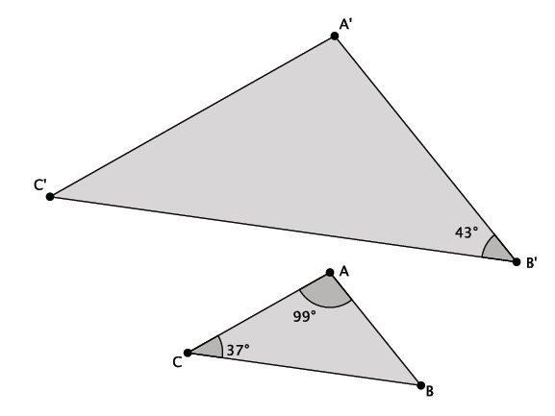

- Are the triangles shown below similar? Present an informal argument as to why they are or are not similar.
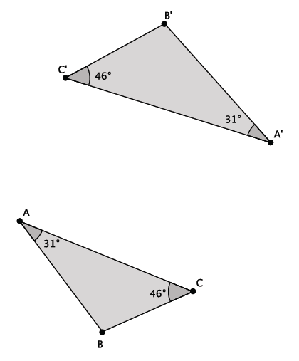

- Are the triangles shown below similar? Present an informal argument as to why they are or are not similar.
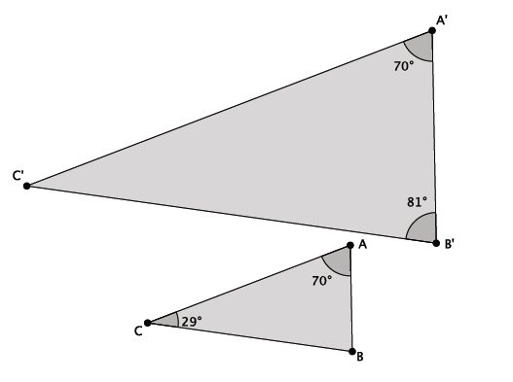

- Are the triangles shown below similar? Present an informal argument as to why they are or are not similar.
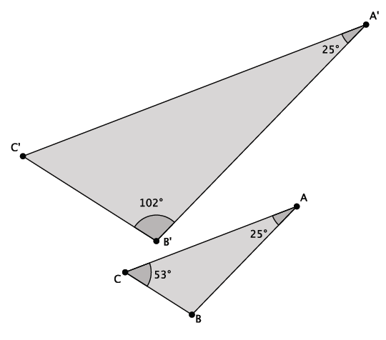
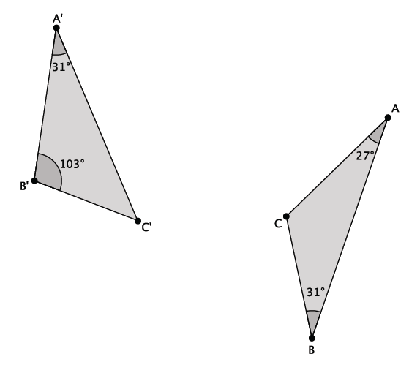

- Are the triangles shown below similar? Present an informal argument as to why they are or are not similar.

