Lesson 10: Informal Proof of AA Criterion for Similarity

Student Outcomes
- Students know an informal proof of the angle-angle (AA) criterion for similar triangles.
- Students present informal arguments as to whether or not triangles are similar based on AA criterion.

Classwork
Concept Development (5 minutes)
- Recall the exercise we did using lined paper to verify experimentally the properties of the Fundamental Theorem of Similarity (FTS). In that example, it was easy for us to see that that the triangles were similar because one was a dilation of the other by some scale factor. It was also easy for us to compare the size of corresponding angles because we could use what we knew about parallel lines cut by a transversal.
Scaffolding:
Consider having students review their work of the activity by talking to a partner about what they did and what they proved with respect to FTS.

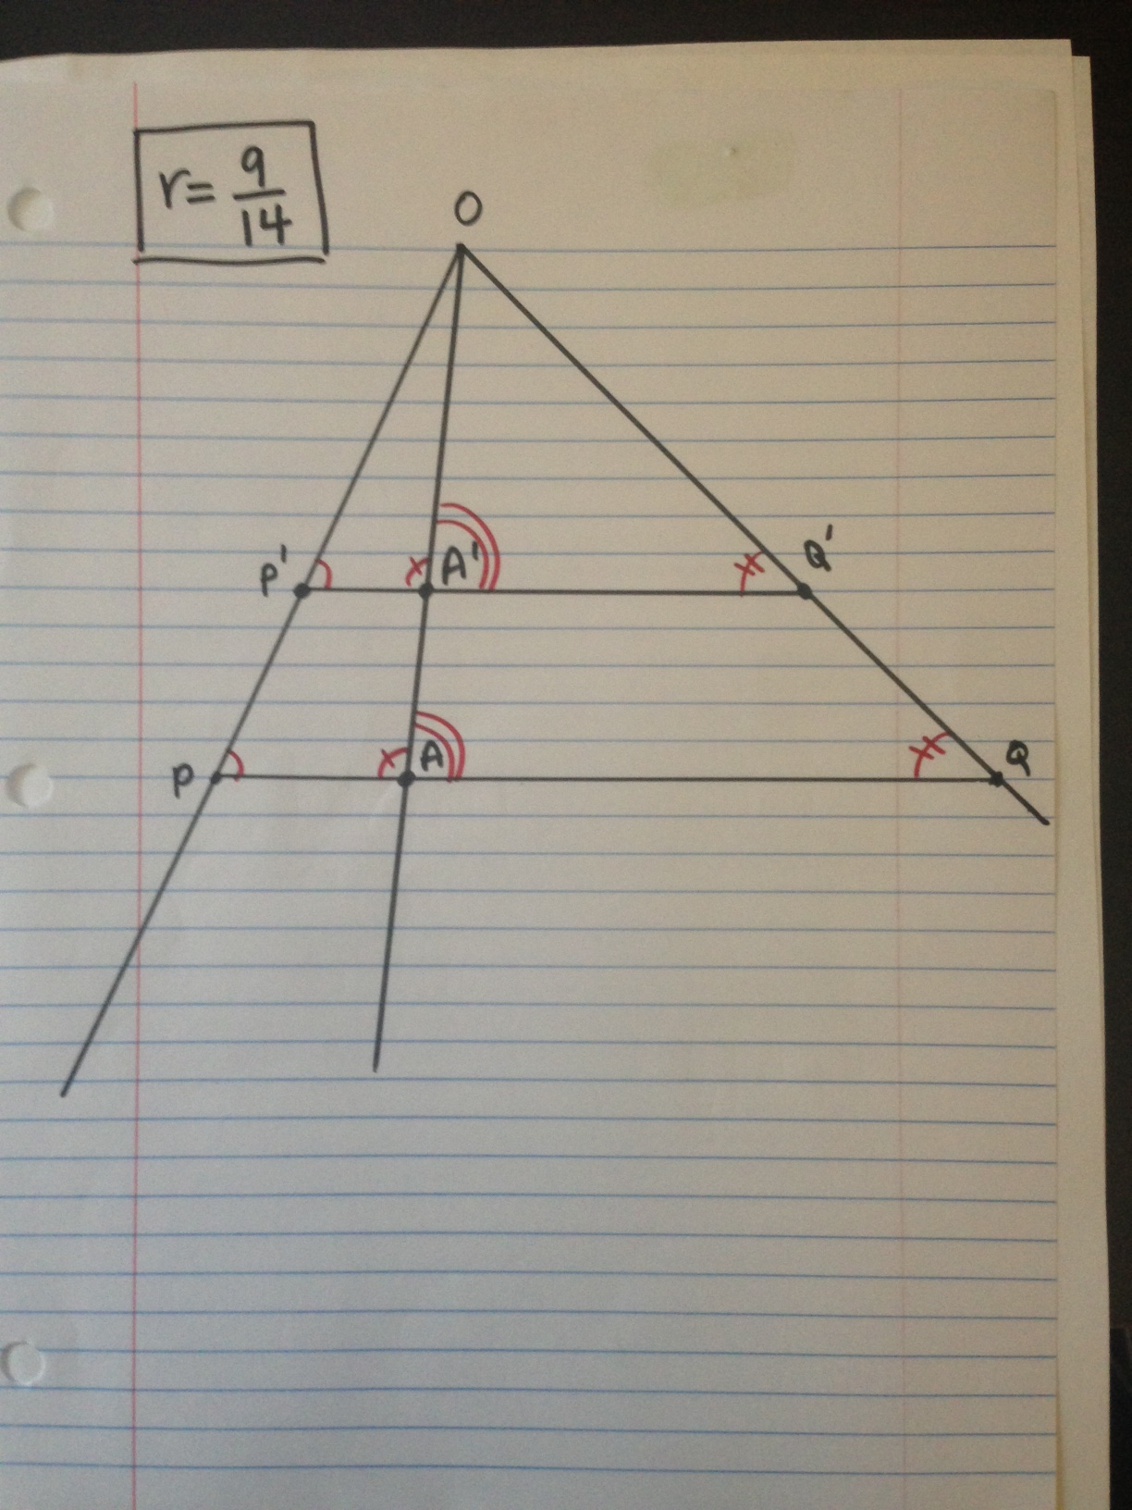

- Our goal today is to show that we can say any two triangles with equal angles will be similar. It is what we call the AA criterion for similarity. The theorem states: Two triangles with two pairs of equal angles are similar.
- Notice that we only use AA instead of AAA; that is, we only need to show that two of the three angles are equal in measure. Why do you think that is so?
  - We only have to show two angles are equal because the third angle has no choice but to be equal as well. The reason for that is the triangle sum theorem. If you know that two pairs of corresponding angles are equal, say they are $30°$ and $90°$, then the third pair of corresponding angles has no choice but to be $60°$ because the sum of all three angles must be $180°$.
- What other property do similar triangles have besides equal angles?
  - The lengths of their corresponding sides are equal in ratio (or proportional).
- Do you believe that it is enough to say that two triangles are similar just by comparing two pairs of corresponding angles?
  - Some students may say yes, and others may say no. Encourage students to justify their claims. Either way, they can verify the validity of the theorem by completing Exercises 1 and 2.

Exercises 1–2 (8 minutes)
Students complete Exercises 1 and 2 independently.
Exercises
- Use a protractor to draw a pair of triangles with two pairs of equal angles. Then measure the lengths of sides, and verify that the lengths of their corresponding sides are equal in ratio.
Sample student work shown below.

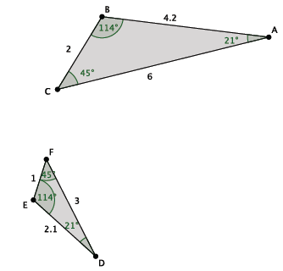
$$\frac{1}{2}=\frac{2.1}{4.2}=\frac{3}{6}$$
Scaffolding:
If students hesitate to begin, suggest specific side lengths for them to use.

- Draw a new pair of triangles with two pairs of equal angles. Then measure the lengths of sides, and verify that the lengths of their corresponding sides are equal in ratio.
Sample student work shown below.
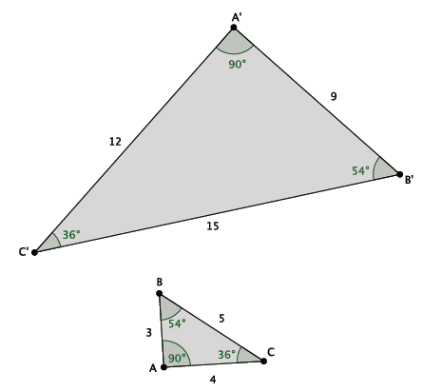
$$\frac{9}{3}=\frac{12}{4}=\frac{15}{5}$$

Discussion (10 minutes)
- Did everyone notice that they had similar triangles in Exercises 1 and 2?
  - Yes.
If students respond no, ask them how close the ratios were with respect to being equal. In some cases, human error either in measuring the angles or side lengths can cause the discrepancy. Another way around this is by selecting ahead of time one student to share his or her work on a document camera for all to see.
To develop conceptual understanding, students may continue to generate triangles with two pairs of equal angles and then generalize to develop the AA criterion for similarity. A more formal proof follows, which may also be used.
- What we need to do now is informally prove why this is happening, even though we all drew different triangles with different angle measures and different side lengths.
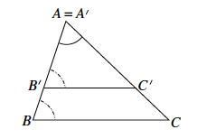
- We begin with a special case. Suppose $A=A'$, and $B'$ and $C'$lie on the rays $\vec{AB}$ and $\vec{AC}$, respectively.

- In this case, we are given that $\left|∠A'B'C'\right|=\left|∠ABC\right|$ and $\left|∠B'A'C'\right|=\left|∠BAC\right|$ (notice that the latter is simply saying that an angle is equal to itself). The fact that $\left|∠A'B'C'\right|=\left|∠ABC\right|$implies that $B^{'}C^{'}∥BC$ because if corresponding angles of two lines cut by a transversal are equal, then the two lines are parallel (from Module 2). Now, if we let $r=\frac{\left|AB^{'}\right|}{\left|AB\right|}$, then the dilation from center $A$ with scale factor $r$ means that $\left|AB'\right|=r\left|AB\right|.$ We know from our work in Lessons 4 and 5 that the location of $C'$ is fixed because $\left|AC'\right|=r\left|AC\right|.$ Therefore, the dilation of $△ABC$ is exactly $△A^{'}B^{'}C^{'}.$
Ask students to paraphrase the proof, or offer them this version: We are given that the corresponding angles $\left|∠A'B'C'\right|$and$\left|∠ABC\right|$ are equal. The only way that corresponding angles can be equal is if we have parallel lines. That means that $B^{'}C^{'}∥BC.$ If we say that the length of $|AB^{'}|$ is equal to the length of $|AB|$ multiplied by some scale factor, then we are looking at a dilation from center $A.$ Based on our work in previous lessons with dilated points in the coordinate plane, we know that $C'$ has no choice as to its location and that the length of $|AC^{'}|$ must be equal to the length of $|AC|$ multiplied by the same scale factor $r.$ For those reasons, when we dilate $△ABC$ by scale factor $r$, we get $△A^{'}B^{'}C^{'}.$
- This shows that given two pairs of equal corresponding angles that $△ABC\sim △A^{'}B^{'}C^{'}.$
- In general, if $△A^{'}B^{'}C^{'}$ did not share a common point (i.e., $A$) with $△ABC$, we would simply perform a sequence of rigid motions (a congruence), so that we would be in the situation just described.

The following are instructions to prepare manipulatives to serve as a physical demonstration of the AA criterion for similarity when the triangles do not share a common angle. Prepare ahead of time cardboard or cardstock versions of triangles $A^{'}B^{'}C^{'}$ and $ABC$ (including a triangle $△AB_{0}C_{0}$ drawn within $△ABC).$ Demonstrate the congruence
$△A^{'}B^{'}C^{'}≅ △AB_{0}C_{0}$ by moving the cardboard between these two triangles.
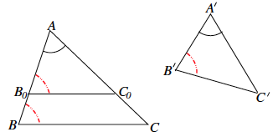

Example 1 (2 minutes)
- Are the triangles shown below similar? Present an informal argument as to why they are or why they are not.
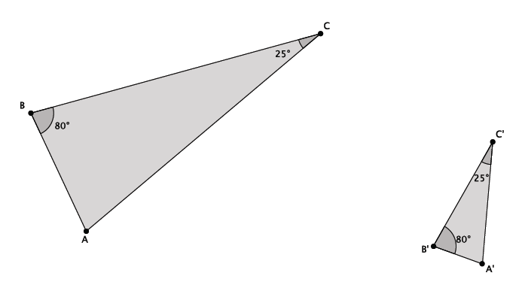
  - Yes, $△ABC \sim △A^{'}B^{'}C^{'}.$ They are similar because they have two pairs of corresponding angles that are equal. Namely, $\left|∠B\right|=\left|∠B^{'}\right|=80°$, and $\left|∠C\right|=\left|∠C'\right|=25°.$

Example 2 (2 minutes)
- Are the triangles shown below similar? Present an informal argument as to why they are or why they are not.
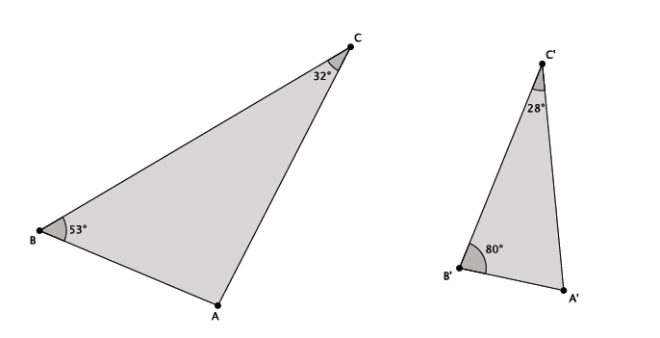
  - No, $△ABC$ is not similar to $△A^{'}B^{'}C^{'}.$ They are not similar because they do not have two pairs of corresponding angles that are equal. Namely, $\left|∠B\right|≠\left|∠B'\right|$, and $\left|∠C\right|≠\left|∠C^{'}\right|.$

Example 3 (2 minutes)
- Are the triangles shown below similar? Present an informal argument as to why they are or why they are not.
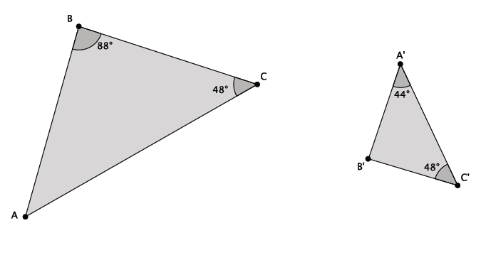
  - Yes, $△ABC\sim △A^{'}B^{'}C^{'}.$ They are similar because they have two pairs of corresponding angles that are equal. You have to use the triangle sum theorem to find out that $\left|∠A\right|=44°$ or $\left|∠B'\right|=88°$. Then you can see that$\left|∠A\right|=\left|∠A'\right|=44°$, $\left|∠B\right|=\left|∠B'\right|=88°$, and $\left|∠C\right|=\left|∠C'\right|=48°$.

Exercises 3–5 (8 minutes)

- Are the triangles shown below similar? Present an informal argument as to why they are or are not similar.
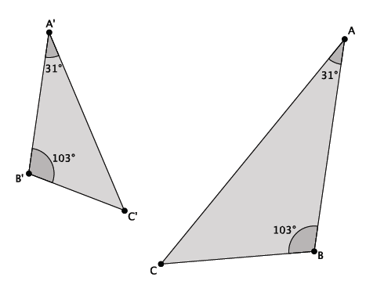
Yes, $△ABC\sim △A^{'}B^{'}C^{'}$. They are similar because they have two pairs of corresponding angles that are equal. Namely, $\left|∠B\right|=\left|∠B'\right|=103°$, and $\left|∠A\right|=\left|∠A'\right|=31°$.

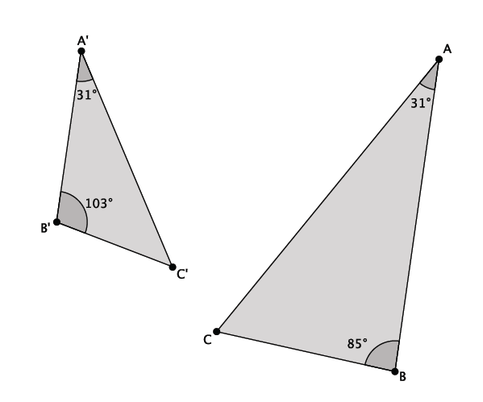
- Are the triangles shown below similar? Present an informal argument as to why they are or are not similar.

No, $△ABC$ is not similar to $△A^{'}B^{'}C^{'}$. They are not similar because they do not have two pairs of corresponding angles that are equal, just one. Namely,$\left|∠A\right|=\left|∠A'\right|$, but $\left|∠B\right|≠\left|∠B^{'}\right|$.

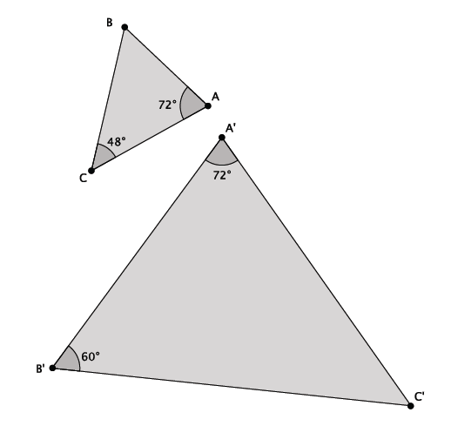
- Are the triangles shown below similar? Present an informal argument as to why they are or are not similar.

Yes, $△ABC\sim △A^{'}B^{'}C^{'}$. They are similar because they have two pairs of corresponding angles that are equal. You have to use the triangle sum theorem to find out that $\left|∠B\right|=60°$ or $\left|∠C'\right|=48°$. Then you can see that$\left|∠A\right|=\left|∠A'\right|=72°$, $\left|∠B\right|=\left|∠B'\right|=60°$, and $\left|∠C\right|=\left|∠C'\right|=48°$.

Closing (3 minutes)
Summarize, or ask students to summarize, the main points from the lesson.
- We understand a proof of why the AA criterion is enough to state that two triangles are similar. The proof depends on our understanding of dilation, angle relationships of parallel lines, and congruence.
- We practiced using the AA criterion to present informal arguments as to whether or not two triangles were similar.
Lesson Summary
Two triangles are said to be similar if they have two pairs of corresponding angles that are equal in measure.

Exit Ticket (5 minutes)
Name ___________________________________________________ Date____________________
Lesson 10: Informal Proof of AA Criterion for Similarity

Exit Ticket

- Are the triangles shown below similar? Present an informal argument as to why they are or are not similar.

- Are the triangles shown below similar? Present an informal argument as to why they are or are not similar.

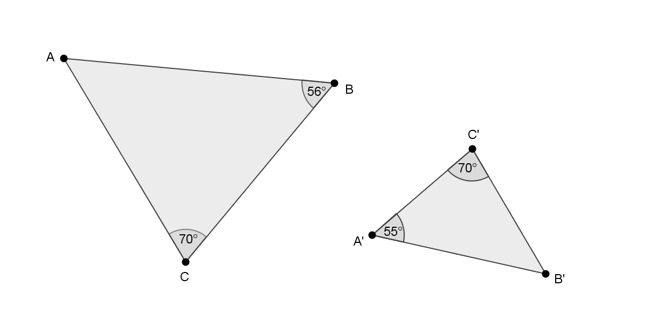
Exit Ticket Sample Solutions

- Are the triangles shown below similar? Present an informal argument as to why they are or are not similar.
Yes,$△ABC\sim △A^{'}B^{'}C^{'}$. They are similar because they have two pairs of corresponding angles that are equal. You have to use the triangle sum theorem to find out that $\left|∠B'\right|=45˚$or $\left|∠A\right|=45˚$. Then you can see that $\left|∠A\right|=\left|∠A'\right|=45˚$, $\left|∠B\right|=\left|∠B'\right|=45˚$, and $\left|∠C\right|=\left|∠C'\right|=90˚$.

- Are the triangles shown below similar? Present an informal argument as to why they are or are not similar.
No, $△ABC$ is not similar to $△A^{'}B^{'}C^{'}.$ They are not similar because they do not have two pairs of corresponding angles that are equal. Namely, $\left|∠A\right|≠\left|∠A^{'}\right|,$ and $\left|∠B\right|≠\left|∠B'\right|$.

Problem Set Sample Solutions
Students practice presenting informal arguments to prove whether or not two triangles are similar.

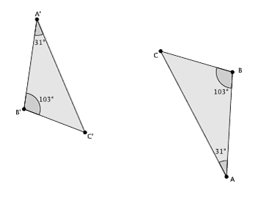
- Are the triangles shown below similar? Present an informal argument as to why they are or are not similar.

Yes, $△ABC\sim △A^{'}B^{'}C^{'}$. They are similar because they have two pairs of corresponding angles that are equal. Namely, $\left|∠B\right|=\left|∠B'\right|=103°$, and $\left|∠A\right|=\left|∠A'\right|=31°$.

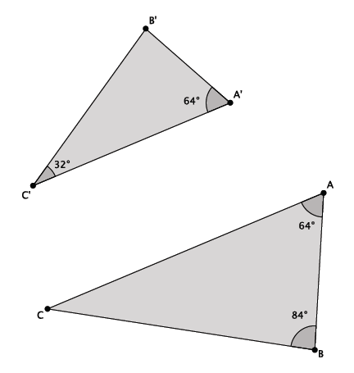
- Are the triangles shown below similar? Present an informal argument as to why they are or are not similar.

Yes, $△ABC \sim △A^{'}B^{'}C^{'}$. They are similar because they have two pairs of corresponding angles that are equal. You have to use the triangle sum theorem to find out that $\left|∠B'\right|=84°$ or $\left|∠C\right|=32°$. Then you can see that$\left|∠A\right|=\left|∠A'\right|=64°$, $\left|∠B\right|=\left|∠B'\right|=84°$, and $\left|∠C\right|=\left|∠C'\right|=32°$.

- Are the triangles shown below similar? Present an informal argument as to why they are or are not similar.
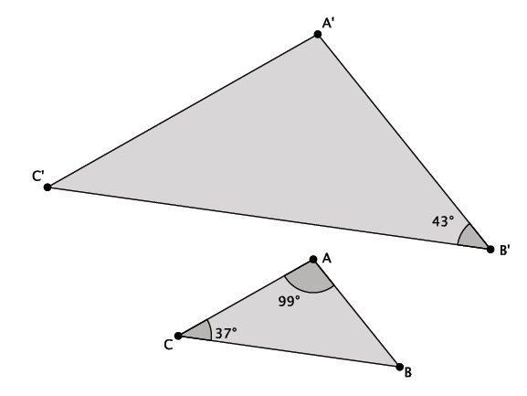
We do not know if $△ABC$ is similar to $△A^{'}B^{'}C^{'}$. We can use the triangle sum theorem to find out that $\left|∠B\right|=44°$, but we do not have any information about $\left|∠A'\right|$ or $\left|∠C'\right|$. To be considered similar, the two triangles must have two pairs of corresponding angles that are equal. In this problem, we only know of one pair of corresponding angles and that pair does not have equal measure.

- Are the triangles shown below similar? Present an informal argument as to why they are or are not similar.
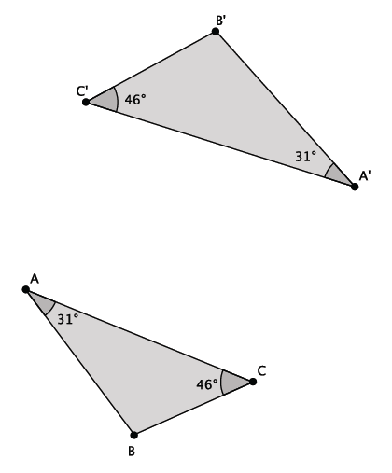

Yes, $△ABC \sim △A^{'}B^{'}C^{'}$. They are similar because they have two pairs of corresponding angles that are equal. Namely, $\left|∠C\right|=\left|∠C'\right|=46°$, and $\left|∠A\right|=\left|∠A'\right|=31°$.

- Are the triangles shown below similar? Present an informal argument as to why they are or are not similar.
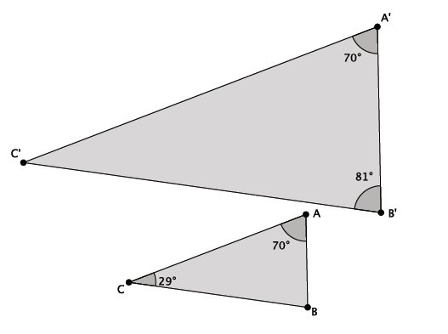
Yes, $△ABC \sim △A^{'}B^{'}C^{'}$. They are similar because they have two pairs of corresponding angles that are equal. You have to use the triangle sum theorem to find out that $\left|∠B\right|=81°$ or $\left|∠C'\right|=29°$. Then you can see that$\left|∠A\right|=\left|∠A'\right|=70°$, $\left|∠B\right|=\left|∠B'\right|=81°$, and $\left|∠C\right|=\left|∠C'\right|=29°$.

- Are the triangles shown below similar? Present an informal argument as to why they are or are not similar.
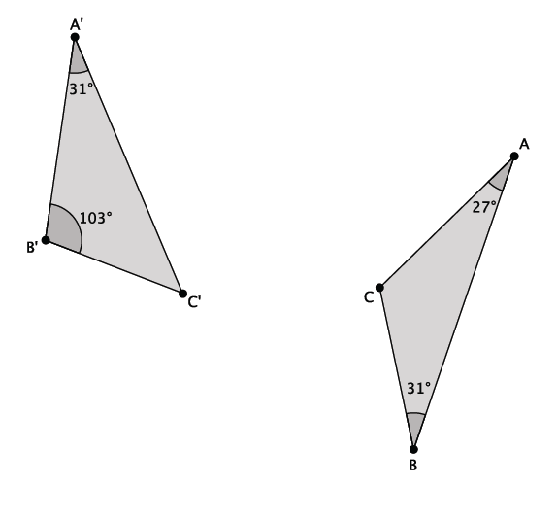

No, $△ABC$ is not similar to $△A^{'}B^{'}C^{'}$. By the given information, $\left|∠B\right|≠\left|∠B'\right|$, and $\left|∠A\right|≠\left|∠A'\right|.$

- Are the triangles shown below similar? Present an informal argument as to why they are or why they are not.
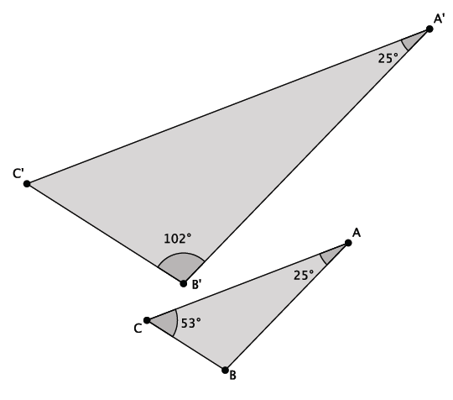

Yes, $△ABC \sim △A^{'}B^{'}C^{'}$. They are similar because they have two pairs of corresponding angles that are equal. You have to use the triangle sum theorem to find out that $\left|∠B\right|=102°$ or $\left|∠C'\right|=53°$. Then you can see that$\left|∠A\right|=\left|∠A'\right|=25°$, $\left|∠B\right|=\left|∠B'\right|=102°$, and $\left|∠C\right|=\left|∠C'\right|=53°$.

