Lesson 9: Basic Properties of Similarity

Classwork

Exploratory Challenge 1

The goal is to show that if is similar to , then is similar to . Symbolically, if , then .

Macintosh HD:Users:shassan:Dropbox:Module 3:Images:Basic Properties of Similarity:explchal1sss.pdf

* 1. First determine whether or not is in fact similar to (If it isn’t, then no further work needs to be done.) Use a protractor to verify that the corresponding angles are congruent and that the ratios of the corresponding sides are equal to some scale factor.
  2. Describe the sequence of dilation followed by a congruence that proves
  3. Describe the sequence of dilation followed by a congruence that proves
  4. Is it true that and ? Why do you think this is so?

Exploratory Challenge 2

Macintosh HD:Users:stefaniehassan:Desktop:explchal2s.pdfThe goal is to show that if is similar to , and is similar to , then is similar to   
 Symbolically, if and , then

* 1. Describe the similarity that proves

* 1. Describe the similarity that proves
  2. Verify that, in fact, by checking corresponding angles and corresponding side lengths. Then describe the sequence that would prove the similarity .
  3. Is it true that if and , then ? Why do you think this is so?

Lesson Summary

Similarity is a symmetric relation. That means that if one figure is similar to another, , then we can be sure that .

Similarity is a transitive relation. That means that if we are given two similar figures, , and another statement about , then we also know that .

Problem Set

1. Would a dilation alone be enough to show that similarity is symmetric? That is, would a dilation alone prove that if , then ? Consider the two examples below.
   1. Given . Is a dilation enough to show that ? Explain.

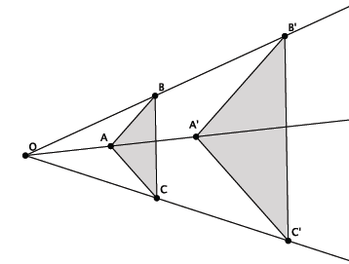

* 1. Given Is a dilation enough to show that ? Explain.

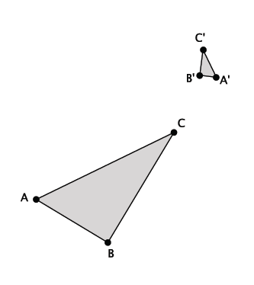

* 1. In general, is dilation enough to prove that similarity is a symmetric relation? Explain.

1. Would a dilation alone be enough to show that similarity is transitive? That is, would a dilation alone prove that if   
   , and , then ? Consider the two examples below.
   1. Given and . Is a dilation enough to show that ? Explain.

Macintosh HD:Users:shassan:Dropbox:Module 3:Images:Basic Properties of Similarity:ps2a.pdf

* 1. Given and . Is a dilation enough to show that ? Explain.

Macintosh HD:Users:shassan:Dropbox:Module 3:Images:Basic Properties of Similarity:ps2b.pdf

* 1. In general, is dilation enough to prove that similarity is a transitive relation? Explain.

1. In the diagram below, and . Is ? If so, describe the dilation followed by the congruence that demonstrates the similarity.

Macintosh HD:Users:shassan:Desktop:ps3.pdf