|  |
| --- |
|  |

Lesson 9: Basic Properties of Similarity

Student Outcomes

* Students know that similarity is both a symmetric and a transitive relation.

Classwork

**Concept Development (4 minutes)**

* If we say that one figure, , is similar to another figure , i.e., , can we also say that ? That is, is similarity symmetric? Keep in mind that there is a very specific sequence of a dilation followed by a congruence that would map to .
  + *Expect students to say yes, they would expect similarity to be symmetric.*
* If we say that figure is similar to another figure , i.e., , and figure is similar to yet another figure , i.e., , is it true that ? That is, is similarity transitive?
  + *Expect students to say yes, they would expect similarity to be transitive.*

The Exploratory Challenges to follow are for students to get an intuitive sense that, in fact, these two statements are true.

Exploratory Challenge 1 (10 minutes)

Students work in pairs to complete Exploratory Challenge 1.

Exploratory Challenge 1

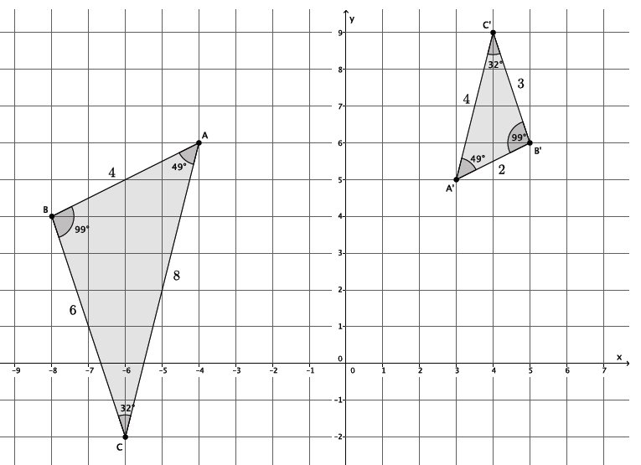The goal is to show that if is similar to , then is similar to . Symbolically, if , then .

* 1. 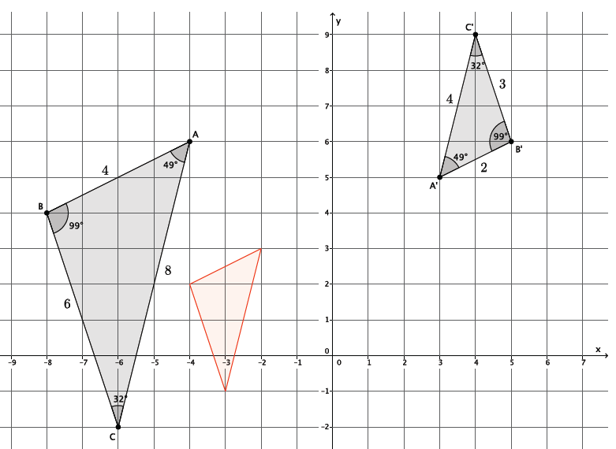First determine whether or not is in fact similar to . (If it isn’t, then no further work needs to be done.) Use a protractor to verify that the corresponding angles are congruent and that the ratios of the corresponding sides are equal to some scale factor.

***The corresponding angles are congruent: ,,and .***

***The ratios of the corresponding sides are equal: .***

* 1. Describe the sequence of dilation followed by a congruence that proves .

***To map***  onto , dilate from center by scale factor noted in the diagram above by the red triangle. Then translate the red triangle up two units and five units to the right. Next, rotate the red triangle degrees around point until coincides with .

* 1. Describe the sequence of dilation followed by a congruence that proves .

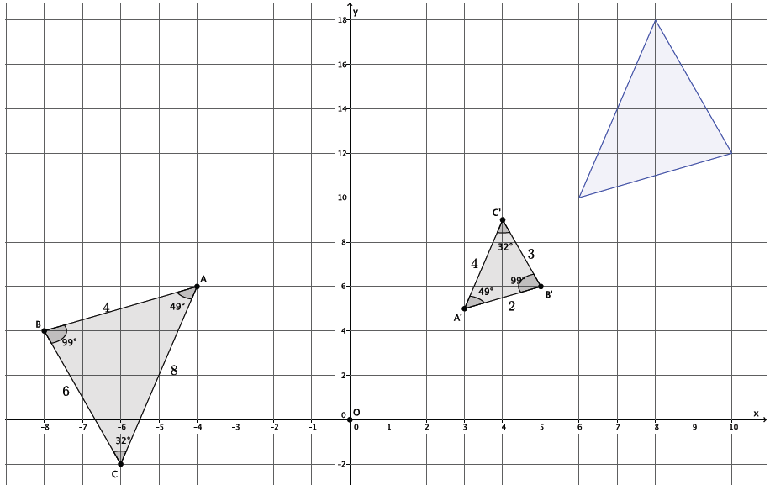Note that in the diagram below the -axis has been compressed.

***To map***  onto , dilate from center by scale factor , noted by the blue triangle in the diagram. Then, translate the blue triangle ten units to the left and two units down. Next, rotate the blue triangle degrees around point until side coincides with side .

* 1. Is it true that and ? Why do you think this is so?

Yes, it is true that and . I think it is true because when we say figures are similar, it means that they are the same figure, just a different size because one has been dilated by a scale factor. For that reason, if one figure, like , is similar to another, like , it must mean that . However, the sequence you would use to map one of the figures onto the other will be different.

**Concept Development (3 minutes)**

Ask students to share what they wrote for part (d) of Exploratory Challenge 1.

Expect students to respond in a similar manner to the response for part (d). If they do not, ask questions about what similarity means, what a dilation does, and how we map figures onto one another.

* For any two figures and , if then . This is what the statement that **similarity is a symmetric relation** means.

Exploratory Challenge 2 (15 minutes)

Students work in pairs to complete Exploratory Challenge 2.

Exploratory Challenge 2

The goal is to show that if is similar to , and is similar to , then is similar to   
. Symbolically, if and , then .

Macintosh HD:Users:stefaniehassan:Desktop:explchal2.pdf

* 1. Describe the similarity that proves .

Macintosh HD:Users:stefaniehassan:Desktop:explchal2a.pdf

***To map***  onto , we need to first determine the scale factor that will make the same size as . Then ***.*** Dilate from center by scale factor , shown in red in the diagram. Then, translate the red triangle units up.

* 1. Macintosh HD:Users:stefaniehassan:Desktop:explchal2b.pdfDescribe the similarity that proves .

***To map***  onto , we need to first determine the scale factor that will make the same size as . Then Dilate from center by scale factor , shown in blue in the diagram. Then, translate the blue triangle units down and units to the right Next, rotate the blue triangle degrees clockwise around point until the blue triangle coincides with   
.

* 1. Macintosh HD:Users:stefaniehassan:Desktop:explchal2c.pdfVerify that, in fact, by checking corresponding angles and corresponding side lengths. Then describe the sequence that would prove the similarity .

***The corresponding angles are congruent: , , and . The ratio of the corresponding sides are equal: . Dilate***  from center by scale factor   
, shown as the pink triangle in the diagram. Then translate the pink triangle units to the right. Finally, rotate the pink triangle degrees clockwise around point until the pink triangle coincides with   
.

* 1. Is it true that if and , then ? Why do you think this is so?

Yes, it is true that if and , then . Again, because these figures are similar it means that they have equal angles and are made different sizes based on a specific scale factor. Since dilations map angles to angles of the same degree, it makes sense that all three figures would have the “same shape.” Also, using the idea that similarity is a symmetric relation, the statement that implies that . Since we know that , it is reasonable to conclude that .

**Concept Development (3 minutes)**

Ask students to share what they wrote for part (d) of Exploratory Challenge 2.

Expect students to respond in a similar manner to the response for part (d). If they do not, ask questions about what similarity means, what a dilation does, and how they might use what they just learned about similarity being a symmetric relation.

* For any three figures *, , and ,* if and , then . This is what the statement that **similarity is a transitive relation** means.

Closing (5 minutes)

Summarize, or ask students to summarize, the main points from the lesson.

* We know that similarity is a symmetric relation. That means that if one figure is similar to another, , then we can be sure that . The sequence that maps one onto the other will be different, but we know that it is true.
* We know that similarity is a transitive relation. That means that if we are given two similar figures, , and another statement about , then we also know that . Again, the sequence and scale factor will be different to prove the similarity, but we know it is true.

Lesson Summary

**Similarity is a symmetric relation. That means that if one figure is similar to another, , then we can be sure that .**

**Similarity is a transitive relation. That means that if we are given two similar figures, , and another statement about , then we also know that .**

Exit Ticket (5 minutes)

Name ___________________________________________________ Date____________________

Lesson 9: Basic Properties of Similarity

Exit Ticket

Use the diagram below to answer Questions 1 and 2.

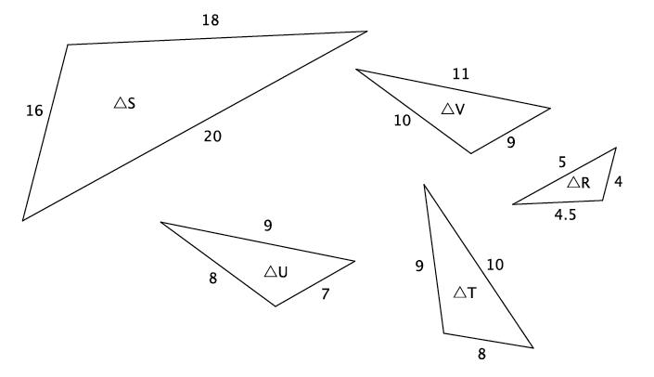

1. Which two triangles, if any, have similarity that is symmetric?
2. Which three triangles, if any, have similarity that is transitive?

Exit Ticket Sample Solutions

Use the diagram below to answer Questions 1 and 2.

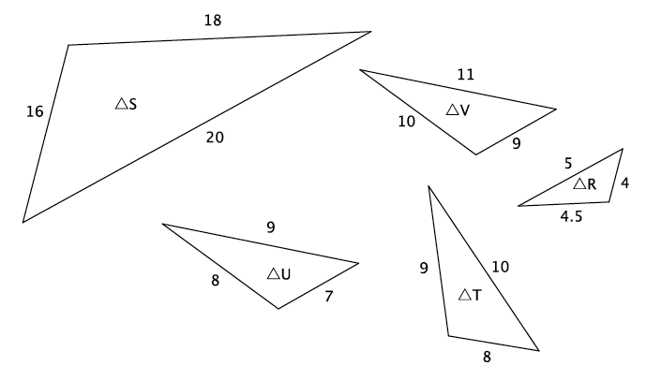

1. Which two triangles, if any, have similarity that is symmetric?

and .

and .

and .

Which three triangles, if any, have similarity that is transitive?

**One possible solution: Since** and, then .

**Note that** and are not similar to each other or any other triangles. Therefore, they should not be in any solution.

Problem Set Sample Solutions

1. Would a dilation alone be enough to show that similarity is symmetric? That is, would a dilation alone prove that if , then ? Consider the two examples below.
   1. 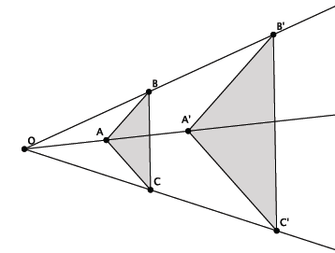Given . Is a dilation enough to show that ? Explain.

For these two triangles, a dilation alone is enough to show that if, then . The reason that dilation alone is enough is because both of the triangles have been dilated from the same center. Therefore, to map one onto the other, all that would be required is a dilation.

* 1. 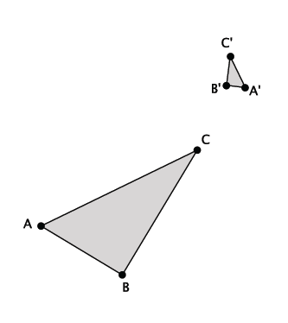Given . Is a dilation enough to show that ? Explain.

For these two triangles, a dilation alone is not enough to show that if , then . The reason is that a dilation would just make them the same size. It would not show that you could map one of the triangles onto the other. To do that, you would need a sequence of basic rigid motions to demonstrate the congruence.

* 1. In general, is dilation enough to prove that similarity is a symmetric relation? Explain.

No, in general a dilation alone does not prove that similarity is a symmetric relation. In some cases, like part (a), it would be enough, but because we are talking about general cases, we must consider figures that require a sequence of basic rigid motions to map one onto the other. Therefore, in general, to show that there is a symmetric relationship, we must use what we know about similar figures, a dilation followed by a congruence, as opposed to dilation alone.

1. Would a dilation alone be enough to show that similarity is transitive? That is, would a dilation alone prove that if   
   , and , then ? Consider the two examples below.
   1. Given and . Is a dilation enough to show that ? Explain.

Macintosh HD:Users:shassan:Dropbox:Module 3:Images:Basic Properties of Similarity:ps2a.pdf

Yes, in this case, we could dilate by different scale factors to show that all three triangles are similar to each other.

* 1. Given and . Is a dilation enough to show that ? Explain.

Macintosh HD:Users:shassan:Dropbox:Module 3:Images:Basic Properties of Similarity:ps2b.pdf

In this case, it would take more than just a dilation to show that all three triangles were similar to one another. Specifically, it would take a dilation followed by a congruence to prove the similarity among the three.

* 1. In general, is dilation enough to prove that similarity is a transitive relation? Explain.

No, in some cases it might be enough, but the general case requires the use of dilation and a congruence. Therefore, to prove that similarity is a transitive relation you must use both a dilation and a congruence.

1. In the diagram below, and . Is ? If so, describe the dilation followed by the congruence that demonstrates the similarity.

Macintosh HD:Users:shassan:Desktop:ps3.pdf

Yes, because similarity is transitive. Since , then , which means . Then a dilation from the origin by scale factor will make the same size as . Translate the dilated image of units to the left, and then reflect across line . The sequence of the dilation and the congruence will map onto demonstrating the similarity.