Lesson 8: Similarity

Classwork

**Example 1**

Macintosh HD:Users:shassan:Dropbox:Module 3:Images:Similarity:example1student.pdfIn the picture below, we have a triangle that has been dilated from center by a scale factor of . It is noted by . We also have triangle which is congruent to triangle (i.e., ).

Describe the sequence that would map triangle onto triangle

Exercises 1–4

1. Triangle was dilated from center by scale factor . The dilated triangle is noted by *.* Another triangle is congruent to triangle (i.e., ). Describe a dilation followed by the basic rigid motion that would map triangle onto triangle.

Macintosh HD:Users:shassan:Dropbox:Module 3:Images:Similarity:exer1s.pdf

1. 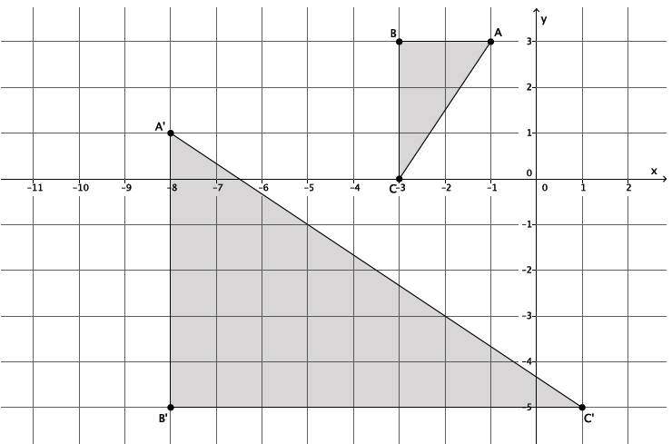Describe a sequence that would show
2. 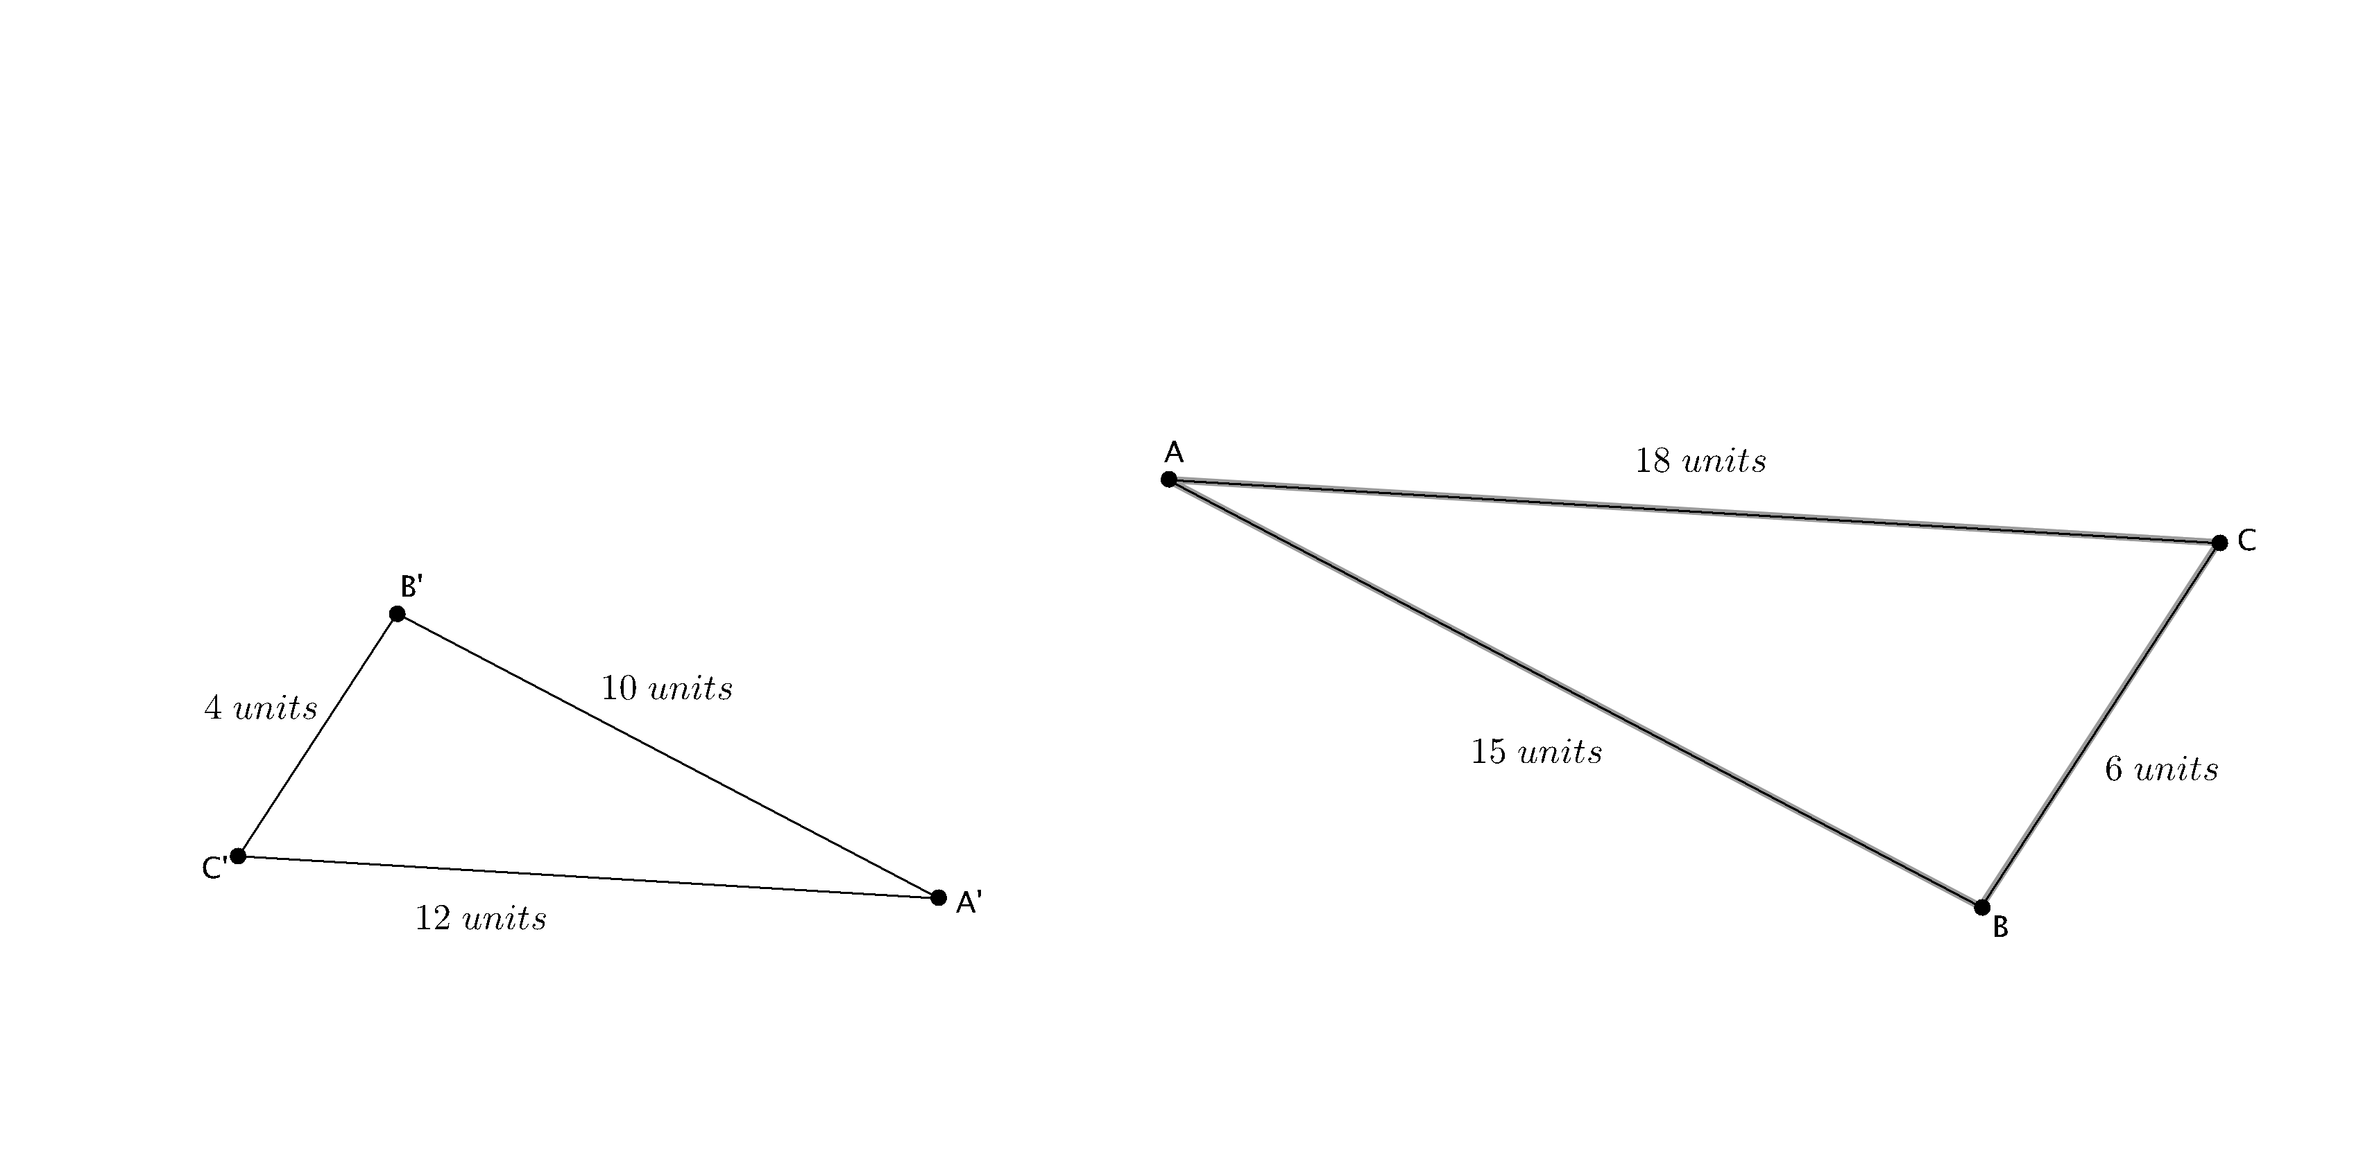Are the two triangles shown below similar? If so, describe a sequence that would prove . If not, state how you know they are not similar.
3. Are the two triangles shown below similar? If so, describe a sequence that would prove . If not, state how you know they are not similar.

Macintosh HD:Users:shassan:Desktop:ex3.pdf

Lesson Summary

Similarity is defined as mapping one figure onto another as a sequence of a dilation followed by a congruence (a sequence of rigid motions).

The notation means that is similar to

Problem Set

1. Macintosh HD:Users:shassan:Dropbox:Module 3:Images:Similarity:ps1s.pdfIn the picture below, we have a triangle that has been dilated from center by scale factor . It is noted by *.* We also have a triangle , which is congruent to triangle (i.e., ). Describe the sequence of a dilation, followed by a congruence (of one or more rigid motions ) that would map triangle onto triangle .
2. Macintosh HD:Users:shassan:Dropbox:Module 3:Images:Similarity:new ps2s.pdfTriangle was dilated from center by scale factor . The dilated triangle is noted by *.* Another triangle is congruent to triangle  *(*i.e., . Describe the dilation followed by the basic rigid motions that would map triangle onto triangle.
3. Macintosh HD:Users:Stefanie:Desktop:ps3.pdfAre the two figures shown below similar? If so, describe a sequence that would prove the similarity. If not, state how you know they are not similar.
4. Macintosh HD:Users:Stefanie:Desktop:ps4.pdfTriangle is similar to triangle (i.e., ). Prove the similarity by describing a sequence that would map triangle onto triangle *.*
5. Macintosh HD:Users:Stefanie:Desktop:ps4 copy.pdfAre the two figures shown below similar? If so, describe a sequence that would prove . If not, state how you know they are not similar.
6. Describe a sequence that would show

