|  |
| --- |
|  |

Lesson 7: Informal Proofs of Properties of Dilations

Student Outcomes

* Students know an informal proof of why dilations are angle-preserving transformations.
* Students know an informal proof of why dilations map segments to segments, lines to lines, and rays to rays.

Lesson Notes

These properties were first introduced in Lesson 2. In this lesson, students think about the mathematics behind why those statements are true in terms of an informal proof developed through a discussion. This lesson is optional.

Classwork

**Discussion (15 minutes)**

Begin by asking students to brainstorm what we already know about dilations. Accept any reasonable responses. Responses should include the basic properties of dilations; for example, lines map to lines, segments to segments, rays to rays, etc. Students should also mention that dilations are angle-preserving. Let students know that in this lesson they will informally prove why the properties are true.

* In previous lessons, we learned that dilations are angle-preserving transformations. Now we want to develop an informal proof as to why the theorem is true:

*Theorem: Dilations preserve the measures of angles.*

* We know that dilations map angles to angles. Let there be a dilation from center and scale factor . Given , we want to show that if , , and , then . In other words, when we dilate an angle, the measure of the angle remains unchanged. Take a moment to draw a picture of the situation. (Give students a couple of minutes to prepare their drawings. Instruct them to draw an angle on the coordinate plane and to use the multiplicative property of coordinates learned in the previous lesson.)

*Scaffolding:*

Provide more explicit directions, such as: “Draw an angle and dilate it from a center to create an image, angle .”

* + *(Have students share their drawings). Sample drawing below.*
* Macintosh HD:Users:shassan:Desktop:discus1.pdfCould line be parallel to line ?
  + *Yes. Based on what we know about the Fundamental Theorem of Similarity, since and* , *then we know that line is parallel to line .*
* Could line intersect line *?*
  + *Yes, if we extend the ray , it will intersect line .*
* Could line be parallel to line *?*
  + *No*. *Based on what we know about the Fundamental Theorem of Similarity, line and line are supposed to be parallel. In the last module, we learned that there is only one line that is parallel to a given line going through a specific point. Since line and line have a common point, , only one of those lines can be parallel to line .*
* Now that we are sure that line intersects line , mark that point of intersection on your drawing (extend rays if necessary). Let’s call that point of intersection point .
  + *Sample student drawing below:*

Macintosh HD:Users:shassan:Desktop:discus1a.pdf

* At this point, we have all the information that we need to show that . (Give students several minutes in small groups to discuss possible proofs for why .)

*Scaffolding:*

Remind students what we know about angles that have a relationship to parallel lines. They may need to review their work from Topic C of Module 2. Also, students may use protractors to measure the angles as an alternative way of verifying the result.

* + *We know that when parallel lines are cut by a transversal, then their alternate interior angles are equal in measure. Looking first at parallel lines and , we have transversal, . Then, alternate interior angles are equal (i.e., ). Now, looking at parallel lines and , we have transversal, . Then, alternate interior angles are equal (i.e., ). We have the two equalities, and , where within each equality is the angle . Therefore,*

Macintosh HD:Users:shassan:Desktop:discus1b.pdf*Sample drawing below:*

* Using FTS and our knowledge of angles formed by parallel lines cut by a transversal, we have proven that dilations are angle-preserving transformations.

Exercise (5 minutes)

Following this demonstration, give students the option of either (a) summarizing what they learned from the demonstration or (b) writing a proof as shown in the Exercise.

Exercise

Use the diagram below to prove the theorem: *Dilations preserve the measures of angles.*

Let there be a dilation from center with scale factor . Given , show that since ,   
, and , then . That is, show that the image of the angle after a dilation has the same measure, in degrees, as the original.

Macintosh HD:Users:shassan:Desktop:exer1.pdf

***Using FTS, we know that line is parallel to , and that line is parallel to . We also know that there exists just one line through a given point, parallel to a given line. Therefore, we know that must intersect at a point. We know this because there is already a line that goes through point that is parallel to , and that line is . Since cannot be parallel to , it must intersect it. We will let the intersection of and be named point . Alternate interior angles of parallel lines cut by a transversal are equal in measure. Parallel lines and are cut by transversal . Therefore, the alternate interior angles and are equal. Parallel lines and are cut by transversal . Therefore, the alternate interior angles and are equal. Since and are equal to , then .***

Example 1 (5 minutes)

In this example, students verify that dilations map lines to lines.

* On the coordinate plane, mark two points: and . Connect the points to make a line; make sure you go beyond the actual points to show that it is a line and not just a segment. Now, use what you know about the multiplicative property of dilation on coordinates to dilate the points from center by some scale factor. Label the images of the points. What do you have when you connect to ?

Have several students share their work with the class. Make sure each student explains that the dilation of line is the line Sample student work shown below.

Macintosh HD:Users:shassan:Desktop:example1.pdf

* Each of us selected different points and different scale factors. Therefore, we have informally shown that dilations map lines to lines.

Example 2 (5 minutes)

In this example, students verify that dilations map segments to segments.

* On the coordinate plane, mark two points: and . Connect the points to make a segment. This time, make sure you do not go beyond the marked points. Now, use what you know about the multiplicative property of dilation on coordinates to dilate the points from center by some scale factor. Label the images of the points. What do you have when you connect to

Macintosh HD:Users:shassan:Desktop:example2.pdfHave several students share their work with the class. Make sure each student explains that the dilation of segment is the segment Sample student work shown below.

* Each of us selected different points and different scale factors. Therefore, we have informally shown that dilations map segments to segments.

Example 3 (5 minutes)

In this example, students verify that dilations map rays to rays.

* On the coordinate plane, mark two points: and . Connect the points to make a ray; make sure you go beyond point to show that it is a ray. Now, use what you know about the multiplicative property of dilation on coordinates to dilate the points from center by some scale factor. Label the images of the points. What do you have when you connect to

Macintosh HD:Users:shassan:Desktop:example3.pdfHave several students share their work with the class. Make sure each student explains that the dilation of ray is the ray Sample student work shown below.

* Each of us selected different points and different scale factors. Therefore, we have informally shown that dilations map rays to rays.

Closing (5 minutes)

Summarize, or ask students to summarize, the main points from the lesson.

* We know an informal proof for dilations being angle-preserving transformations that uses the definition of dilation, the Fundamental Theorem of Similarity, and the fact that there can only be one line through a point that is parallel to a given line.
* We informally verified that dilations of segments map to segments, dilations of lines map to lines, and dilations of rays map to rays.

Exit Ticket (5 minutes)

Name ___________________________________________________ Date____________________

Lesson 7: Informal Proofs of Properties of Dilations

Exit Ticket

Macintosh HD:Users:shassan:Desktop:et1s.pdfDilate with center and scale factor . Label the dilated angle, .

1. If , then what is the measure of ?
2. If segment is cm. What is the measure of segment ?
3. Which segments, if any, are parallel?

Exit Ticket Sample Solutions

Dilate with center and scale factor . Label the dilated angle, .

Macintosh HD:Users:shassan:Desktop:et1.pdf

1. If , then what is the measure of ?

Since dilations preserve angles, then .

1. If segment is cm. What is the measure of segment ?

The length of segment is cm.

1. Which segments, if any, are parallel?

Since dilations map segments to parallel segments, then , and .

Problem Set Sample Solutions

1. **A dilation from center by scale factor of a line maps to what? Verify your claim on the coordinate plane.**

**The dilation of a line maps to a line.**

**Sample student work shown below.**

Macintosh HD:Users:shassan:Desktop:ps1.pdf

1. **A dilation from center by scale factor of a segment maps to what? Verify your claim on the coordinate plane.**

**The dilation of a segment maps to a segment.**

**Sample student work shown below.**

Macintosh HD:Users:shassan:Desktop:ps2.pdf

1. **A dilation from center by scale factor of a ray maps to what? Verify your claim on the coordinate plane.**

**The dilation of a ray maps to a ray.**

Macintosh HD:Users:shassan:Desktop:ps3.pdf**Sample student work shown below.**

1. **Challenge Problem:**

**Prove the theorem: *A dilation maps lines to lines*.**

**Let** there be a dilation from center with scale factor so that and . Show that line maps to line (i.e., that dilations map lines to lines). Draw a diagram, and then write your informal proof of the theorem. (Hint: This proof is a lot like the proof for segments. This time, let be a point on line , that is not between points and .)

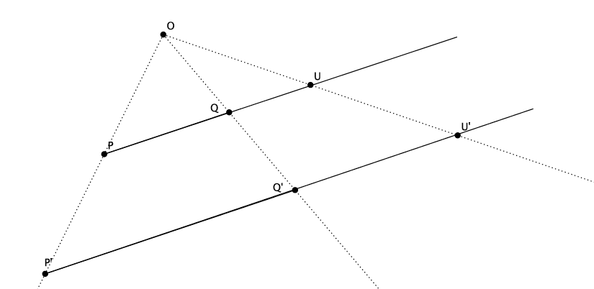Sample student drawing and response below:

Let be a point on line . By definition of dilation, we also know that . We need to show that is a point on line . If we can, then we have proven that a dilation maps lines to lines.

By definition of dilation and FTS, we know that and that line is parallel to . Similarly, we know that and that line is parallel to line . Since is a point on line , then we also know that line is parallel to line . But we already know that is parallel to . Since there can only be one line that passes through that is parallel to line , then line and line must coincide. That places the dilation of point , , on the line , which proves that dilations map lines to lines.