|  |
| --- |
|  |

Lesson 6: Dilations on the Coordinate Plane

Student Outcomes

* Students describe the effect of dilations on two-dimensional figures using coordinates.

Classwork

Example 1 (7 minutes)

Students learn the multiplicative effect of scale factor on a point. Note that this effect holds when the center of dilation is the origin. In this lesson, the center of any dilation used will always be assumed to be

Show the diagram below and ask students to look at and write/share a claim about the effect that dilation has on the coordinates of dilated points.

* Macintosh HD:Users:shassan:Desktop:ex2.pdfThe graph below represents a dilation from center by scale factor

MP.3

Show them the second diagram below so students can check if their claim was correct. Give students time to verify the claim that they made about the above graph, with the one below. Then have them share their claims with the class. Use the discussion that follows to crystallize what students observed.

* 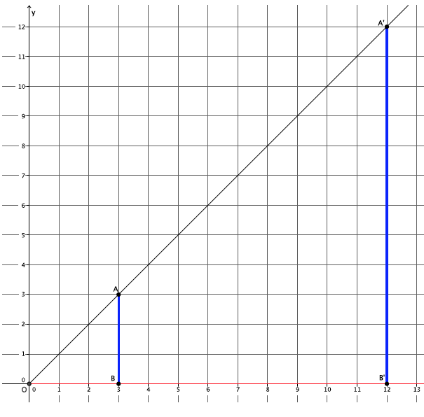The graph below represents a dilation from center by scale factor

MP.3

* Macintosh HD:Users:shassan:Desktop:ex1.pdfIn Lesson 5, we found the location of a dilated point by using the knowledge of dilation and scale factor, as well as the lines of the coordinate plane to ensure equal angles, to find the coordinates of the dilated point. For example, we were given the point and told the scale factor of dilation was Remember that the center of this dilation is . We created the following picture and determined the location of to be .
* We can use this information and the observations we made at the beginning of class to develop a shortcut for finding the coordinates of dilated points when the center of dilation is the origin.
* Notice that the horizontal distance from the -axis to point was multiplied by a scale factor of . That is, the -coordinate of point was multiplied by a scale factor of . Similarly, the vertical distance from the -axis to point was multiplied by a scale factor of .
* Here are the coordinates of point and the dilated point Since the scale factor was , we can more easily see what happened to the coordinates of after the dilation if we write the coordinates of as . That is, the scale factor of multiplied by each of the coordinates of point to get

MP.8

* The reasoning goes back to our understanding of dilation. The length , by the definition of dilation, and the length ; therefore,

where the length of the segment is the -coordinate of the dilated point (i.e., ) and the length of the segment is the -coordinate of the dilated point (i.e., ).

In other words, based on what we know about the lengths of dilated segments, when the center of dilation is the origin, we can determine the coordinates of a dilated point by multiplying each of the coordinates in the original point by the scale factor.

Example 2 (3 minutes)

Students learn the multiplicative effect of scale factor on a point.

* Let’s look at another example from Lesson 5. We were given the point and asked to find the location of the dilated point when Our work on this problem led us to coordinates of approximately for point Verify that we would get the same result if we multiply each of the coordinates of point by the scale factor.

*and*

*Therefore, multiplying each coordinate by the scale factor produced the desired result.*

Example 3 (5 minutes)

* The coordinates in other quadrants of the graph are affected in the same manner as we have just seen. Based on what we have learned so far, given point predict the location of when is dilated from a center at the origin, by scale factor .

Provide students time to predict, justify, and possibly verify, in pairs, that Verify the fact on the coordinate plane, or have students share their verification with the class.

* As before, mark a point on the -axis. Then, Where is located?
  + Macintosh HD:Users:shassan:Desktop:example3.pdf*Since the length of , then . But we are looking at a distance to the left of zero; therefore, the location of is .*
* Now that we know where is, we can easily find the location of . It will be on the ray but at what location?
  + Macintosh HD:Users:shassan:Desktop:example3a.pdf*The location of as desired.*

Exercises 1–5 (5 minutes)

Students complete Exercises 1–5 independently.

Exercises 1–5

1. Point is dilated from the origin by scale factor . What are the coordinates of point ?
2. Point is dilated from the origin by scale factor . What are the coordinates of point ?
3. Point is dilated from the origin by scale factor . What are the coordinates of point ?
4. Point is dilated from the origin by scale factor . What are the coordinates of point ?
5. Point is dilated from the origin by scale factor . What are the coordinates of point ?

Example 4 (4 minutes)

Students learn the multiplicative effect of scale factor on a two-dimensional figure.

* Now that we know the multiplicative relationship between a point and its dilated location (i.e., if point is dilated from the origin by scale factor , then ), we can quickly find the coordinates of any point, including those that comprise a two-dimensional figure, under a dilation of any scale factor.
* For example, triangle has coordinates ,, and The triangle is being dilated from the origin with scale factor What are the coordinates of triangle ?
* First, find the coordinates of
* Next, locate the coordinates of
* Finally, locate the coordinates of .
* Therefore, the vertices of triangle will have coordinates of , , and , respectively.

Example 5 (4 minutes)

Students learn the multiplicative effect of scale factor on a two-dimensional figure.

* Parallelogram has coordinates of , ,, and , respectively. Find the coordinates of parallelogram after a dilation from the origin with a scale factor
* Therefore, the vertices of parallelogram will have coordinates of ,,, and , respectively.

Exercises 6–8 (9 minutes)

Students complete Exercises 6–8 independently.

Exercises 6–8

1. Macintosh HD:Users:shassan:Desktop:exer6.pdfThe coordinates of triangle are shown on the coordinate plane below. The triangle is dilated from the origin by scale factor . Identify the coordinates of the dilated triangle .

Point , so .

Point , so .

Point , so .

The coordinates of the vertices of triangle are , , and , respectively.

1. Macintosh HD:Users:shassan:Dropbox:Module 3:Images:Dil on Coord plane New L6 Images:exer7.pdfFigure is shown on the coordinate plane below. The figure is dilated from the origin by scale factor . Identify the coordinates of the dilated figure , and then draw and label figure on the coordinate plane.

Point , so .

Point , so .

Point , so .

Point , so .

The coordinates of the vertices of figure are , , , and , respectively.

1. Macintosh HD:Users:shassan:Dropbox:Module 3:Images:Dil on Coord plane New L6 Images:exer 8.pdfThe triangle has coordinates and . Draw and label triangle on the coordinate plane. The triangle is dilated from the origin by scale factor Identify the coordinates of the dilated triangle , and then draw and label triangle on the coordinate plane.

Point , then

Point , so .

Point , so .

The coordinates of triangle are , , and , respectively.

Closing (4 minutes)

Summarize, or ask students to summarize, the main points from the lesson.

* We know that we can calculate the coordinates of a dilated point given the coordinates of the original point and the scale factor.
* To find the coordinates of a dilated point we must multiply both the -coordinate and the -coordinate by the scale factor of dilation.
* If we know how to find the coordinates of a dilated point, we can find the location of a dilated triangle or other two-dimensional figure.

Lesson Summary

**Dilation has a multiplicative effect on the coordinates of a point in the plane. Given a point in the plane, a dilation from the origin with scale factor moves the point to .**

**For example, if a point in the plane is dilated from the origin by a scale factor of , then the coordinates of the dilated point are .**

Exit Ticket (4 minutes)

Name Date

Lesson 6: Dilations on the Coordinate Plane

Exit Ticket

1. The point is dilated from the origin by a scale factor What are the coordinates of ?
2. The triangle shown on the coordinate plane below, is dilated from the origin by scale factor What is the location of triangle ? Draw and label it on the coordinate plane.

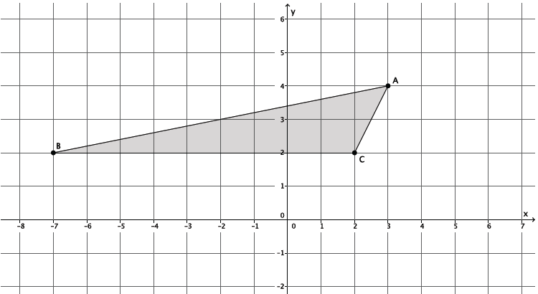

Exit Ticket Sample Solutions

1. The point is dilated from the origin by a scale factor What are the coordinates of ?

Since point , then .

1. The triangle shown on the coordinate plane below, is dilated from the origin by scale factor . What is the location of triangle ? Draw and label it on the coordinate plane.

Macintosh HD:Users:shassan:Dropbox:Module 3:Images:Dil on Coord plane New L6 Images:et2.pdf

Point , so .

Point , so .

Point , so .

The coordinates of the vertices of triangle are , , and , respectively.

Problem Set Sample Solutions

Students practice finding the coordinates of dilated points of two-dimensional figures.

1. Triangle is shown on the coordinate plane below. The triangle is dilated from the origin by scale factor . Identify the coordinates of the dilated triangle .

Macintosh HD:Users:shassan:Desktop:ps1.pdf

Point , so .

Point , so .

Point , so .

The coordinates of the vertices of triangle are , , and , respectively.

1. Triangle is shown on the coordinate plane below. The triangle is dilated from the origin by scale factor . Identify the coordinates of the dilated triangle .

Macintosh HD:Users:shassan:Dropbox:Module 3:Images:Dil on Coord plane New L6 Images:ps2.pdf

Point , so .

Point , so .

Point , so .

The coordinates of the vertices of triangle are , , and , respectively.

1. The triangle has coordinates ,, and . The triangle is dilated from the origin by a scale factor . Identify the coordinates of the dilated triangle .

Point , so .

Point , so .

Point , so .

The coordinates of the vertices of triangle are , , and , respectively.

1. Figure is shown on the coordinate plane below. The figure is dilated from the origin by scale factor . Identify the coordinates of the dilated figure , and then draw and label figure on the coordinate plane.

Macintosh HD:Users:shassan:Dropbox:Module 3:Images:Dil on Coord plane New L6 Images:exer6.pdf

Point , so .

Point , so .

Point , so .

Point , so .

The coordinates of the vertices of figure are , ,, and , respectively.

1. Figure has coordinates , , , and . The figure is dilated from the origin by scale factor . Identify the coordinates of the dilated figure .

Point , so .

Point , so .

Point , so .

Point , so .

The coordinates of the vertices of figure are , ,, and , respectively.