Lesson 5: First Consequences of FTS

Classwork

Exercise 1

In the diagram below, points and have been dilated from center by scale factor . , cm, and cm.

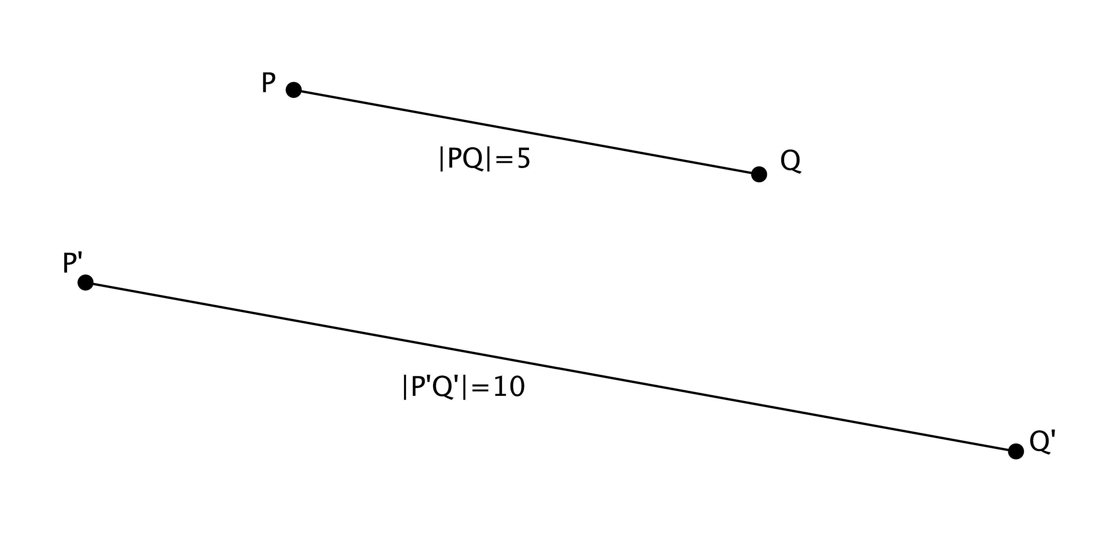

* 1. Determine the scale factor .
  2. Locate the center of dilation. Measure the segments to verify that and *.* Show your work below.

**Exercise 2**

Macintosh HD:Users:shassan:Dropbox:Module 3:Images:First Conseq of FTS:exer1s.pdfIn the diagram below, you are given center and ray . Point is dilated by a scale factor . Use what you know about FTS to find the location of point .

Exercise 3

Macintosh HD:Users:shassan:Dropbox:Module 3:Images:First Conseq of FTS:exer3s.pdfIn the diagram below, you are given center and ray . Point is dilated by a scale factor . Use what you know about FTS to find the location of point .

Lesson Summary

Converse of the Fundamental Theorem of Similarity:

*If lines and are parallel, and then from a center , , , and .*

To find the coordinates of a dilated point, we must use what we know about FTS, dilation, and scale factor.

Problem Set

1. Macintosh HD:Users:shassan:Dropbox:Module 3:Images:First Conseq of FTS:ps 1s.pdfDilate point located at from center by a scale factor .

What is the precise location of point ?

1. Macintosh HD:Users:shassan:Dropbox:Module 3:Images:First Conseq of FTS:ps2s.pdfDilate point located at from center by a scale factor . Then dilate point located at from center , by a scale factor of . What are the coordinates of and ? Explain.
2. Explain how you used the Fundamental Theorem of Similarity in Problems 1 and 2.