|  |
| --- |
|  |

Lesson 5: First Consequences of FTS

Student Outcomes

* Students verify the converse of the Fundamental Theorem of Similarity experimentally.
* Students apply the Fundamental Theorem of Similarity to find the location of dilated points on the plane.

Classwork

**Concept Development (5 minutes)**

Begin by having students restate (in their own words) the Fundamental Theorem of Similarity (FTS) that they learned in the last lesson.

* The Fundamental Theorem of Similarity states:

*Given a dilation with center and scale factor , then for any two points and in the plane so that , , and are not collinear, the lines and are parallel, where and , and furthermore, .*

The paraphrased version from the last lesson was: FTS states that given a dilation from center , and points and (points , , and are not on the same line), the segments formed when you connect to and to are parallel. More surprising is the fact that the segment , even though it was not dilated as points and were, dilates to segment , and the length of segment is the length of segment multiplied by the scale factor.

* The converse of this theorem is also true. That is, *if lines and are parallel, and , then from a center , , , and and .*

The converse of a theorem begins with the conclusion and produces the hypothesis. FTS concludes that lines are parallel and the length of segment is the length of segment multiplied by the scale factor. The converse of FTS begins with the statement that the lines are parallel and the length of segment is the length of segment multiplied by the scale factor. It ends with us knowing that the points and are dilations of points and by scale factor , and their respective segments, and , have lengths that are the scale factor multiplied by the original lengths of segment and segment Consider providing students with some simple examples of converses, and discuss whether or not the converses are true. For example, “If it is raining, then I have an umbrella,” and its converse, “If I have an umbrella, then it is raining.” In this case, the converse is not necessarily true. An example where the converse is true is “If we turn the faucet on, then water comes out,” and the converse is “If water comes out, then the faucet is on.”

* The converse of the theorem is basically the work we did in the last lesson but backwards. In the last lesson, we knew about dilated points and found out that the segments between the points, , , and their dilations ,, were dilated according the same scale factor, i.e., . We also discovered that the lines containing those segments were parallel, i.e., . The converse states that we are given parallel lines, and , where a segment, , in one line is dilated by scale factor to a segment, , in the other line. With that knowledge, we can say something about the center of dilation and the relationship between segments and , as well as segments and *.*

In Exercise 1 below, students are given the information in the converse of FTS, i.e., and Students then verify the conclusion of the converse of FTS by measuring lengths of segments and their dilated images to make sure that they have the properties stated, i.e., and *.*

Consider showing the diagram below and asking students to make conjectures about the relationship between segment and segment , as well as segment and segment You can record the conjectures and possibly have the class vote on which they believe to be true.

Macintosh HD:Users:shassan:Desktop:FTS 2.pdfIn the diagram below, the lines containing segments and are parallel, and the length of segment is equal to the length of segment multiplied by the scale factor dilated from center

Exercise 1 (5 minutes)

Have students verify experimentally the validity of the converse of the theorem. They can work independently or in pairs. Note that the image in the Student Materials packet is to scale and should be printed at 100% scale to preserve the intended size of the figure for accurate measurements. Adjust your copier or printer settings to actual size and set page scaling to none. The image below is not to scale.

Exercise 1

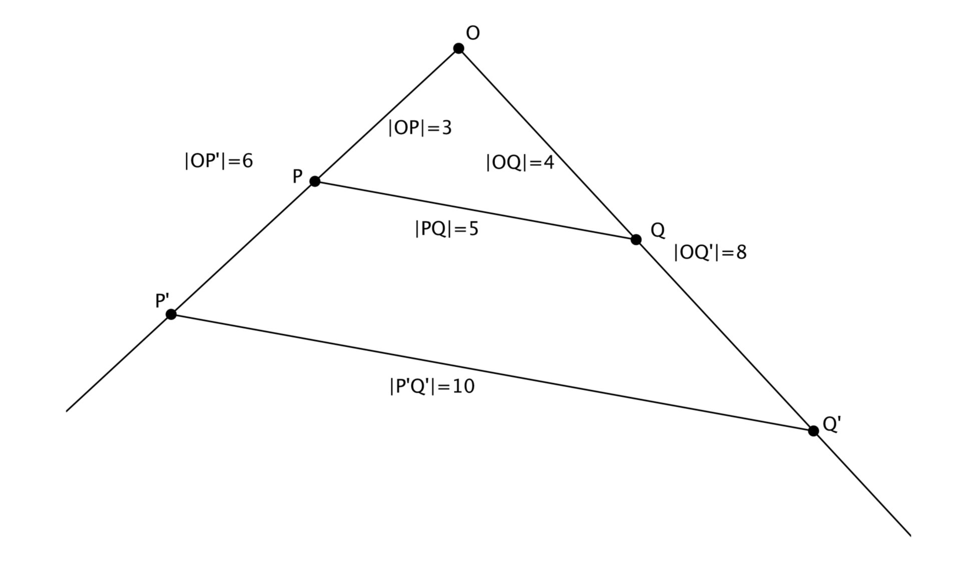In the diagram below, points and have been dilated from center by scale factor . , cm, and cm.

*Scaffolding:*

If students need help getting started, have them review the activity from Lesson 4. Ask what they should do to find the center . Students should say draw lines through and , the point of intersection is the center .

* 1. Determine the scale factor .

***According to FTS, . Therefore, , so .***

* 1. Locate the center of dilation. Measure the segments to verify that *and .* Show your work below.

***Center and measurements shown above.***

Example 1 (5 minutes)

* Now that we know FTS and the converse of FTS in terms of dilations, we will practice using them to find the coordinates of points and dilated points on a plane. We will begin simply.
* 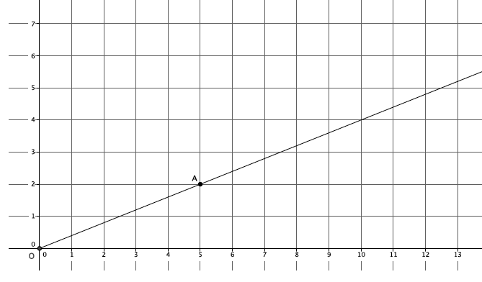In the diagram, we have center and ray . We want to find the coordinates of point . We are given that the scale factor of dilation is .
* To find we could use a ruler or compass to measure , but now that we know about FTS, we can do this another way. First, we should look for parallel lines that will help us locate point . How can we use the coordinate plane to ensure parallel lines?
  + *We could use the vertical or horizontal lines of the coordinate plane to ensure lines are parallel. The coordinate plane is set up so that the lines never intersect. You could also think of those lines as translations of the -axis and -axis. Therefore, we are guaranteed to have parallel lines.*
* 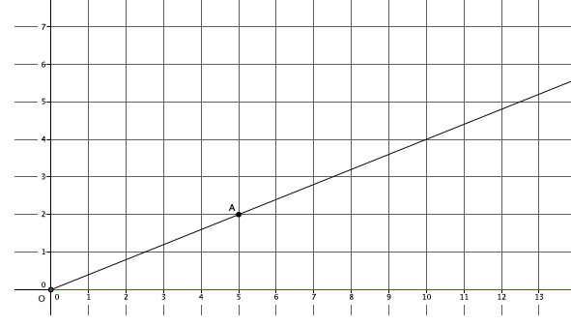Let’s use the -axis as one of our rays. (Show picture below). Where should we place a point , on the ray along the -axis?
  + *Since we are using the lines on the coordinate plane to verify parallelism, we should place point directly below point , on the -axis. Point should be at .*
* 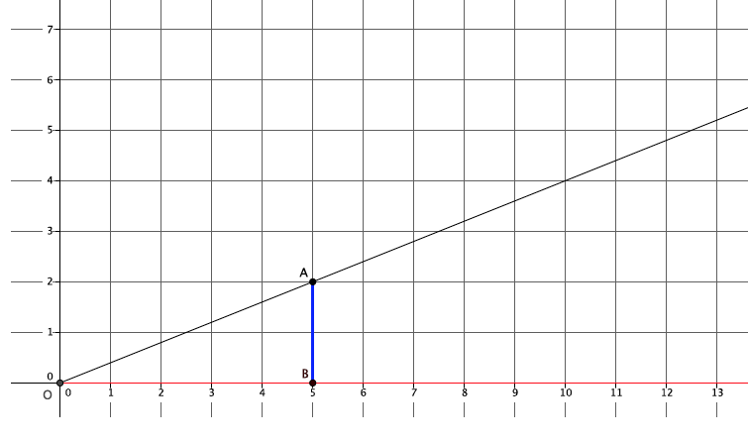(Show picture below.) This is beginning to look like the activity we did in Lesson 4. We know that that scale factor . Where should we put point ?
  + *It is clear that the length of ; therefore, , so the point should be placed at .*
* 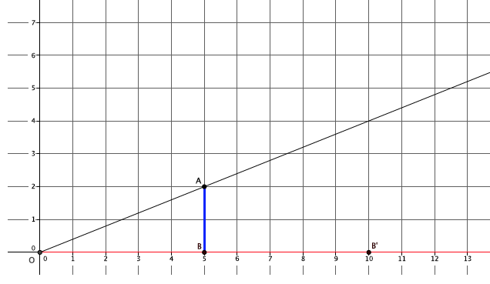(Show picture below.) Now that we know the location of *,* using FTS, what do we expect to be true about the lines containing segments and ?
  + *We expect the lines containing segments and to be parallel.*
* 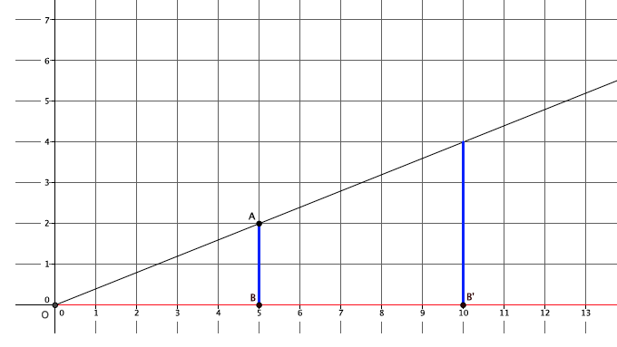(Show picture below.) Then what is the location of point ?
  + *Point will be located at .*
* 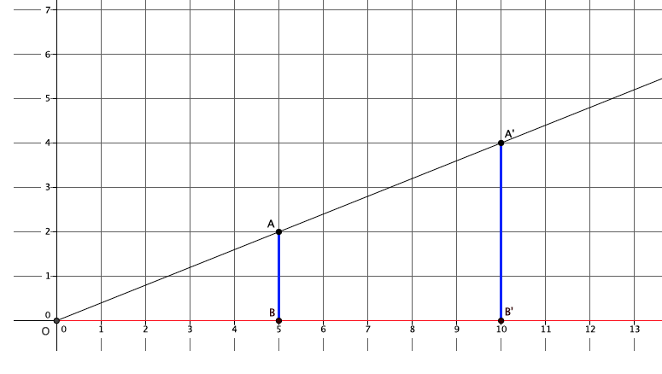(Show picture below.) Could point be located anywhere else? Specifically, could have a different -coordinate? Why or why not?
  + *No*. *Point must be at . If it had another -coordinate, then lines and would have not been dilated by the scale factor .*
* Could point be located at another location that has as its -coordinate? For example, could be at ? Why or why not?
  + *No. Point must be at . By definition of dilation, if point is dilated from center , then the dilated point must be on the ray , making points , , and collinear. If were at or at any coordinate other than , then the points , , and would not be collinear.*

Exercise 2 (3 minutes)

Students work independently to find the location of point on the coordinate plane.

Exercise 2

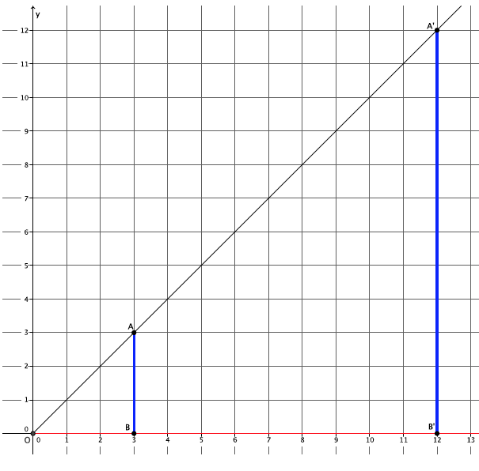In the diagram below, you are given center and ray . Point is dilated by a scale factor . Use what you know about FTS to find the location of point .

***Point must be located at .***

Example 2 (6 minutes)

* 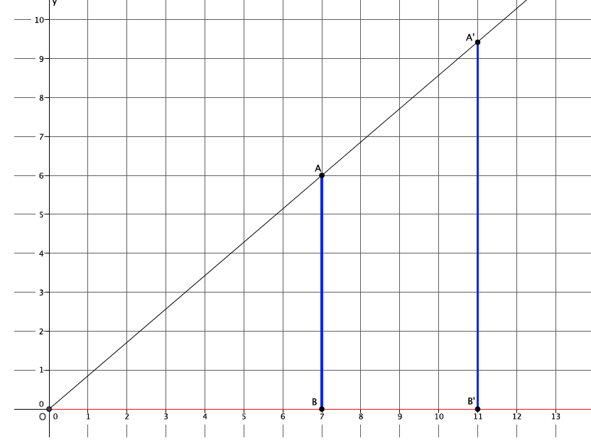In the diagram we have center and ray . We are given that the scale factor of dilation is . We want to find the precise coordinates of point . Based on our previous work, we know exactly how to begin. Draw a ray along the -axis and mark a point , directly below point , on the ray . (Show picture below.) The question now is how do we locate ? Think about our work from Lesson 4.
* In Lesson 4, we counted lines to determine the scale factor. Given the scale factor, we know that the point B should be exactly lines from the center , and that the dilated point, , should be exactly lines from the center. Therefore, is located at .
* Now that we know the location of , where will we find ?
  + *Point will be at the intersection of the ray* , *and the line , which must be parallel to line .*
* (Show picture below.) Now that we know where is we need to find the precise coordinates of it. The -coordinate is easy, but how can we find the *-*coordinate? (Give students time to talk in pairs or small groups.)
  + 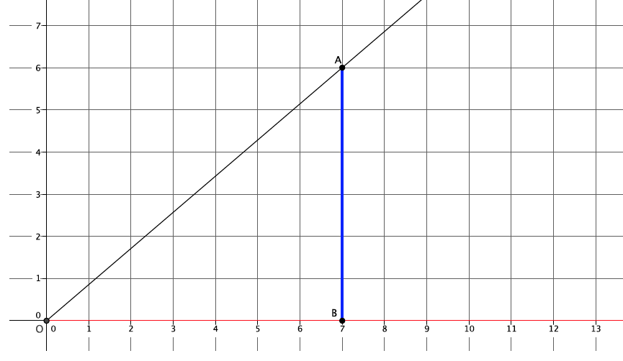*The -coordinate will be the exact length of the segment . To find that length, we can use what we know about the length of segment and the scale factor since .*
* The length of segment will give us the -coordinate. Then . That means that the location of is .

Exercise 3 (4 minutes)

Students work independently or in pairs to find the location of point on the coordinate plane.

Exercise 3

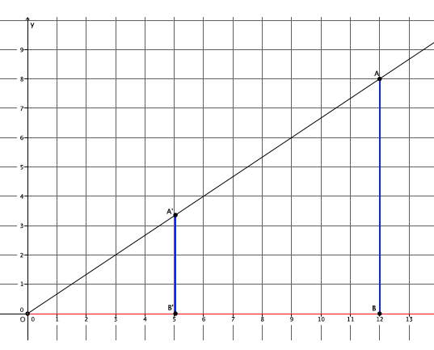In the diagram below, you are given center and ray . Point is dilated by a scale factor . Use what you know about FTS to find the location of point .

***The -coordinate of is . The -coordinate will be equal to the length of segment . Since , then . The location of is .***

Example 3 (8 minutes)

* In the diagram below we have center and rays and . We are given that the scale factor is . We want to find the precise coordinates of points and .
* 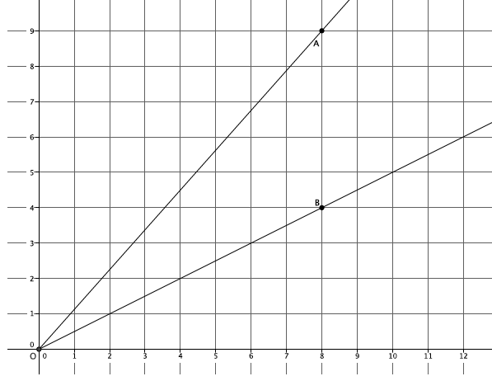Based on our previous work, we know exactly how to begin. Describe what we should do.
  + *Draw a ray along the -axis, and mark a point , directly below point , on the ray .*
* 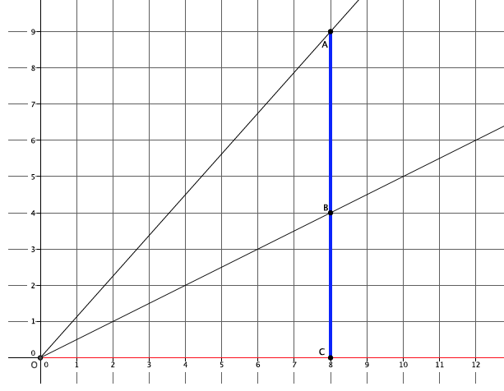(Show picture below.) Based on our work in Lesson and our knowledge of FTS, we know that points and along ray enjoy the same properties we have been using in the last few problems. Let’s begin by finding the coordinates of . What should we do first?
  + *First, we need to place the points*, , and  *on their respective rays by using the scale factor. Since the scale factor and will have an -coordinate of . (Also, they are lines from the center.)*
* 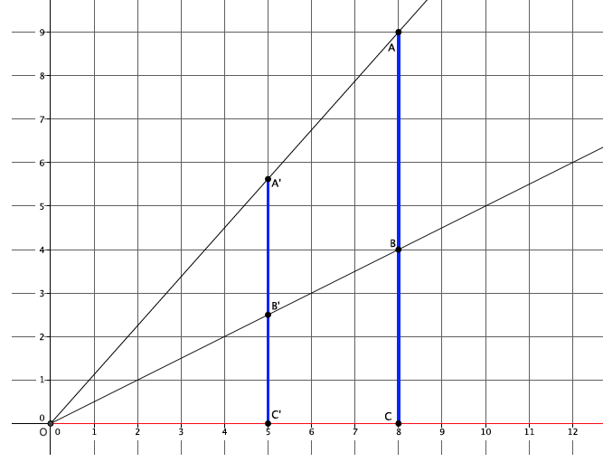(Show picture below.) Let’s first find the coordinates of . What do we need to do to find the *-*coordinate of ?
  + *The -coordinate of will be the length of the segment . We can calculate that length by using what we know about segment and the scale factor.*
* The -coordinate of is. Then the location of is .
* Work with a partner to find the -coordinate of .
  + *The -coordinate of is the length of segment . Then .* The location of is .

Closing (4 minutes)

Summarize, or ask students to summarize, the main points from the lesson.

* We experimentally verified the converse of FTS. That is, if we are given parallel lines and and know , then we know from a center , , , , and . In other words, if we are given parallel lines and , and we know that the length of segment is equal to the length of segment multiplied by the scale factor, then we also know that the length of segment is equal to the length of segment multiplied by the scale factor and that the length of segment is equal to the length of segment multiplied by the scale factor.
* We know how to use FTS to find the coordinates of dilated points, even if the dilated point is not on an intersection of graph lines.

Lesson Summary

**Converse of the Fundamental Theorem of Similarity:**

***If lines and are parallel, and , then from a center , , , , and .***

**To find the coordinates of a dilated point, we must use what we know about FTS, dilation, and scale factor.**

Exit Ticket (5 minutes)

Name ___________________________________________________ Date____________________

Lesson 5: First Consequences of FTS

Exit Ticket

Macintosh HD:Users:shassan:Desktop:ET5.pdfIn the diagram below, you are given center and ray . Point is dilated by a scale factor . Use what you know about FTS to find the location of point .

Exit Ticket Sample Solutions

Macintosh HD:Users:shassan:Desktop:ETM3L5problem.pdfIn the diagram below, you are given center and ray . Point is dilated by a scale factor . Use what you know about FTS to find the location of point .

The -coordinate of is . The -coordinate will be equal to the length of segment . Since , then . The location of is .

Problem Set Sample Solutions

Students practice using the first consequences of FTS in terms of dilated points and their locations on the coordinate plane.

1. 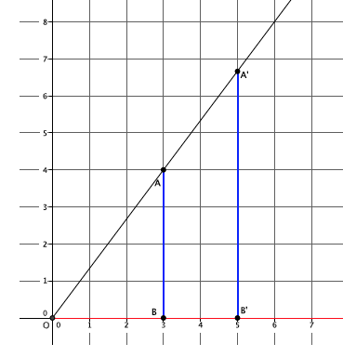Dilate point , located at from center , by a scale factor .

What is the precise location of point ?

The -coordinate of point will be the length of segment . Since , then . The location of point is , or approximately .

1. 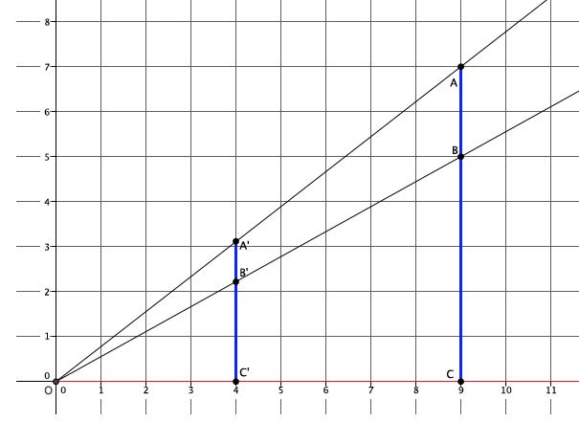Dilate point , located at from center , by a scale factor . Then dilate point , located at from center , by a scale factor of . What are the coordinates of and ? Explain.

The -coordinate of point will be the length of . Since , then . The location of point is , or approximately. The -coordinate of point will be the length of . Since , then . The location of point is , or approximately .

1. Explain how you used the Fundamental Theorem of Similarity in Problems 1 and 2.

Using what I knew about scale factor, I was able to determine the placement of points and , but I did not know the actual coordinates. So, one of the ways that FTS was used was actually in terms of the converse of FTS. I had to make sure I had parallel lines. Since the lines of the coordinate plane guarantee parallel lines, I knew that . Then, since I knew the length of segment and the scale factor, I could find the precise location of . The precise location of was found in a similar way but using .