Lesson 3: Examples of Dilations

Classwork

**Example 1**

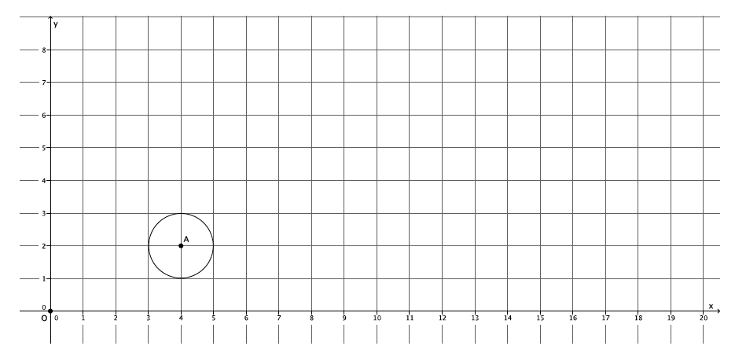Dilate circle , from center at the origin by scale factor

Exercises 1–2

1. Dilate ellipse , from center at the origin of the graph, with scale factor . Use as many points as necessary to develop the dilated image of ellipse .

Macintosh HD:Users:shassan:Dropbox:Module 3:Images:Examples of dilations:ex1s.pdf

1. What shape was the dilated image?

Exercise 3

1. Triangle has been dilated from center by a scale factor of denoted by triangle . Using a ruler, verify that it would take a scale factor of from center to map triangle onto triangle .

Macintosh HD:Users:shassan:Dropbox:Module 3:Images:Examples of dilations:ex3l3s.pdf

Lesson Summary

Dilations map circles to circles and ellipses to ellipses.

If a figure is dilated by scale factor , we must dilate it by a scale factor of to bring the dilated figure back to the original size. For example, if a scale factor is , then to bring a dilated figure back to the original size, we must dilate it by a scale factor .

Problem Set

1. Dilate the figure from center by a scale factor . Make sure to use enough points to make a good image of the original figure.

Macintosh HD:Users:shassan:Dropbox:Module 3:Images:Examples of dilations:ps1s.pdf

1. Describe the process for selecting points when dilating a curved figure.
2. A triangle was dilated from center by a scale factor of . What scale factor would shrink the dilated figure back to the original size?
3. A figure has been dilated from center by a scale factor of . What scale factor would shrink the dilated figure back to the original size?
4. A figure has been dilated from center by a scale factor of . What scale factor would magnify the dilated figure back to the original size?