Lesson 3: Examples of Dilations

Student Outcomes
- Students know that dilations map circles to circles and ellipses to ellipses.
- Students know that to shrink or magnify a dilated figure back to its original size from center $O$ with scale factor $r$ you must dilate the figure by a scale factor of $\frac{1}{r}$.

Classwork
Example 1 (8 minutes)
Ask students to (a) describe how they would plan to dilate a circle and (b) conjecture about what the result will be when they dilate a circle. Consider asking them to collaborate with a partner and to share their plans and conjectures with the class. Then, you may have students attempt to dilate the circle on their own, based on their plans. As necessary, show students how to dilate a curved figure, namely, circle $A$(i.e., circle with center $A$).
- We want to find out how many points we will need to dilate in order to develop an image of circle $A$ from center of dilation $O$ at the origin of the graph, with scale factor $r=3$.

Example 1
Dilate circle $A$ from center $O$ at the origin by scale factor $r=3$.
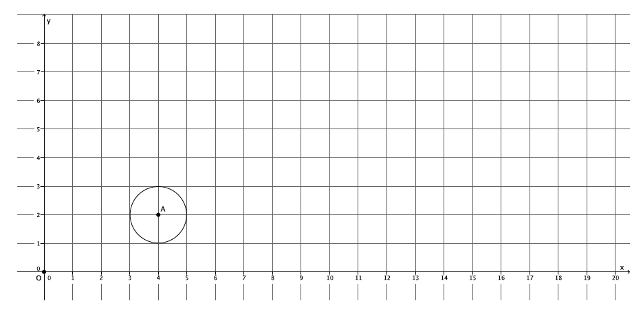

- Will three points be enough? Let’s try.
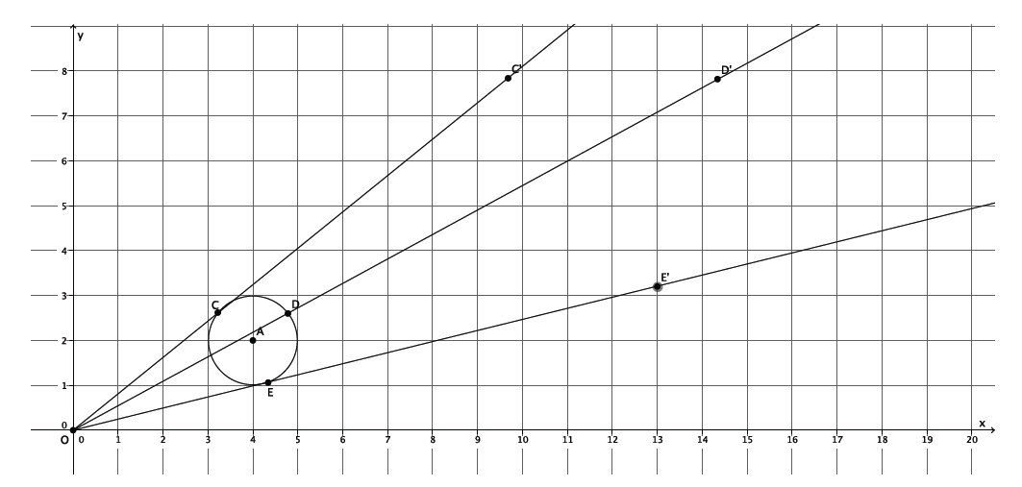
- (Show a picture of three dilated points). If we connect these three dilated points, what image will we get?
  - With just three points, the image will look like a triangle.

- What if we dilate a fourth point? Will that be enough? Let’s try.
- (Show picture of four dilated points). If we connect these four dilated points, what image will we get?
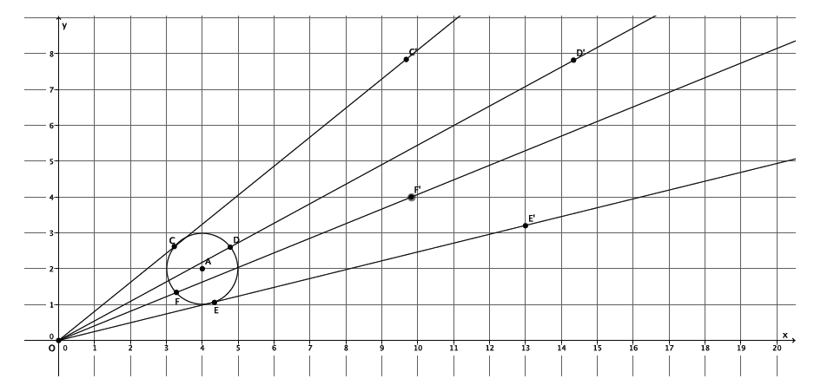
  - With four points, the image will look like a quadrilateral.

- What if we dilate five, six, or ten points? What do you think?
  - The more points that are dilated, the more the image will look like a circle.
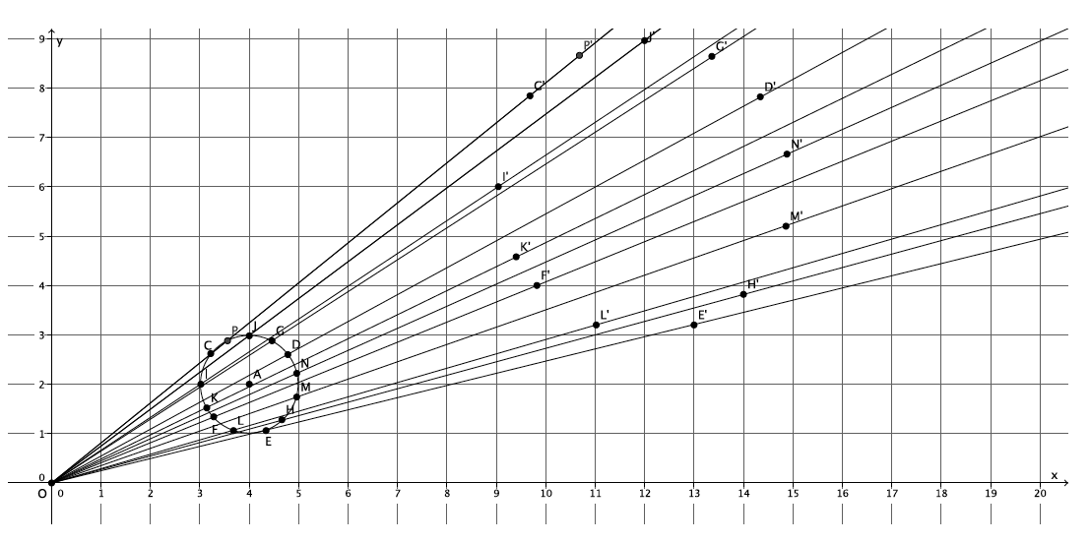
- (Show the picture with many dilated points).

- Notice that the shape of the dilated image is now unmistakably a circle. Dilations map circles to circles, so it is important that when we dilate a circle we choose our points carefully.
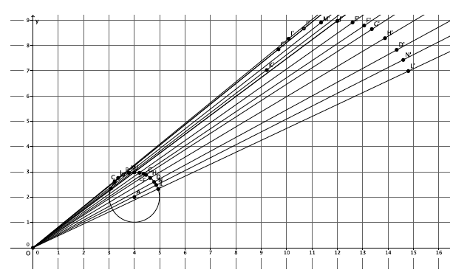
- Would we have an image that looked like a circle if all of the points we considered were located on just one part of the circle? For example, what if all of our points were located on just the top half of the circle? Would the dilated points produce an image of the circle?
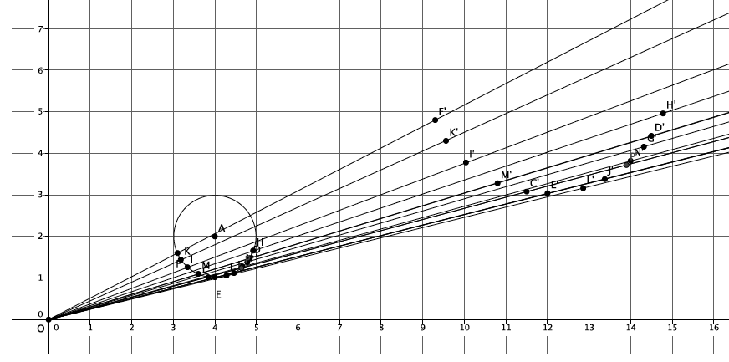
- Or, consider the image when we select points just on the lower half of the circle:

- Consider the image when the points are focused on just the sides of the circle:
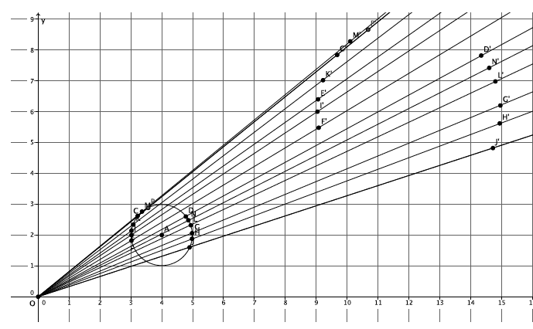

- The images are not good enough to truly show that the original figure was a circle.
- How should we select points to dilate when we have a curved figure?
  - We should select points on all parts of the curve, not just those points focused in one area.
- The number of points to dilate that is enough is as many as are needed to produce a dilated image that looks like the original. For curved figures, like this circle, the more points you dilate the better. The location of the points you choose to dilate is also important. The points selected to dilate should be spread out evenly on the curve.
Exercises 1–2 (10 minutes)
Prior to this exercise, ask students to make a conjecture about what figure will result when we dilate an ellipse. Similarly, ask them to develop a plan for how they will perform the dilation. Then have students dilate an ellipse on the coordinate plane.
Exercises 1–2
- Dilate ellipse $E$, from center $O$ at the origin of the graph, with scale factor $r=2$. Use as many points as necessary to develop the dilated image of ellipse $E$.
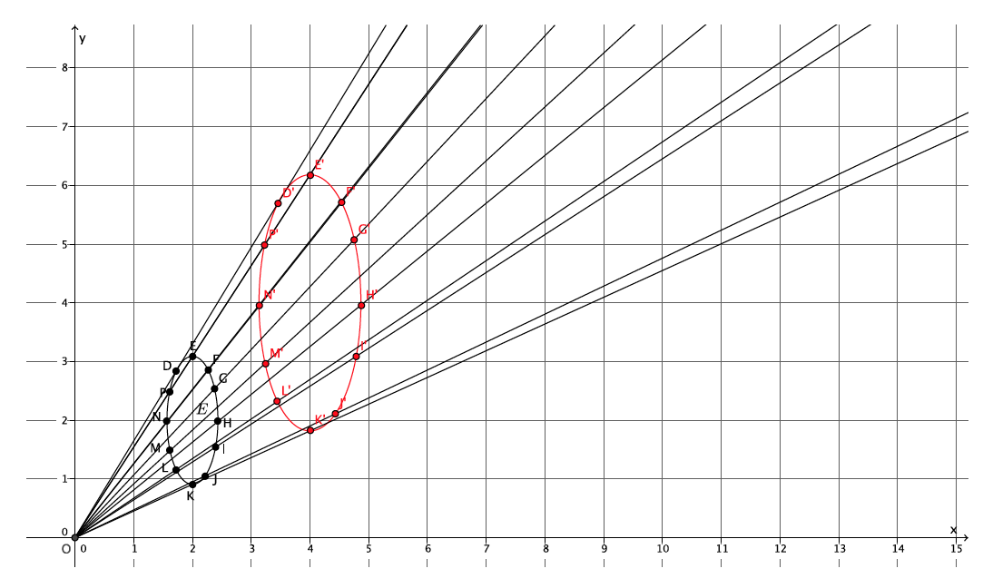
Dilated image of $E$ is shown in red below. Verify that students have dilated enough points evenly placed to get an image that resembles an ellipse.

- What shape was the dilated image?
The dilated image was an ellipse. Dilations map ellipses to ellipses.

Example 2 (4 minutes)
- In the picture below, we have a triangle $ABC$, that has been dilated from center $O$, by a scale factor of $r=\frac{1}{3}$. It is noted by $A'B'C'$.
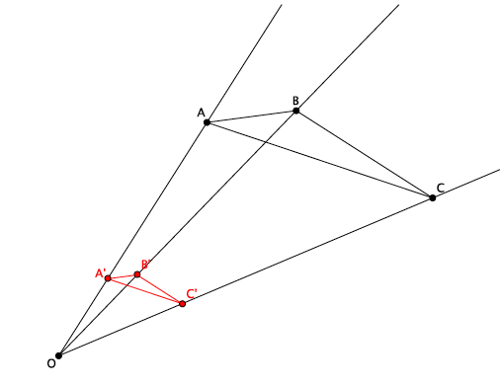
Ask students what we can do to map this new triangle, triangle $A'B'C'$, back to the original. Tell them to be as specific as possible. Students should write their conjectures or share with a partner.
- Let’s use the definition of dilation and some side lengths to help us figure out how to map triangle $A'B'C'$ back onto triangle $ABC$. How are the lengths $\left|{OA}^{'}\right|$ and $\left|OA\right|$ related?
  - We know by the definition of dilation that $\left|{OA}^{'}\right|=r\left|OA\right|$.
- We know that $r=\frac{1}{3}$. Let’s say that the length of segment $OA$ is $6$ units (we can pick any number, but $6$ will make it easy for us to compute). What is the length of segment $OA'$?
MP.6
  - Since $\left|OA'\right|=\frac{1}{3}\left|OA\right|$, and we are saying that the length of segment $OA$ is $6$, then $\left|OA'\right|=\frac{1}{3}×6=2$, and $\left|OA'\right|=2$ units.
- Now since we want to dilate triangle $A'B'C'$ to the size of triangle $ABC$, we need to know what scale factor $r$ is required so that $\left|OA\right|=r\left|OA'\right|$. What scale factor should we use and why?
  - We need a scale factor $r=3$ because we want $\left|OA\right|=r\left|OA'\right|$. Using the lengths from before, we have $6=r×2$. Therefore, $r=3$.
- Now that we know the scale factor, what precise dilation would map triangle $A'B'C'$ onto triangle $ABC$?
  - A dilation from center $O$ with scale factor $r=3$.

Example 3 (4 minutes)
- In the picture below we have triangle $DEF$ that has been dilated from center $O$ by a scale factor of $r=4$. It is noted by $D'E'F'$.

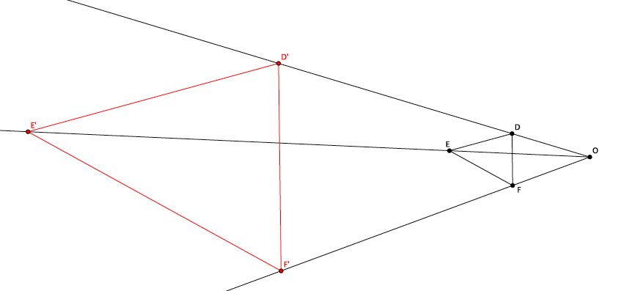
- Based on the example we just did, make a conjecture about how we could map this new triangle $D'E'F'$ back onto the original triangle.
Let students attempt to prove their conjectures on their own or with a partner. If necessary, use the scaffolding questions that follow.
- What is the difference between this problem and the last?
  - This time the scale factor is greater than one, so we will need to shrink triangle $D'E'F'$ to the size of triangle $DEF$.
- We know that $r=4$. Let’s say that the length of segment $OF$ is $3$ units. What is the length of segment $OF'$?
  - Since $\left|OF'\right|=r\left|OF\right|$ and we are saying that the length of segment $OF$ is $3$, then $\left|OF'\right|=4×3=12$, and $\left|OF'\right|=12$ units.
- Now, since we want to dilate triangle $D'E'F'$ to the size of triangle $DEF$, we need to know what scale factor $r$ is required so that $\left|OF\right|=r\left|OF'\right|$. What scale factor should we use, and why?
  - We need a scale factor $r=\frac{1}{4}$ because we want $\left|OF\right|=r\left|OF'\right|$. Using the lengths from before, we have $3=r×12$. Therefore, $r=\frac{1}{4}$.
- What precise dilation would make triangle $D'E'F'$ the same size as triangle $DEF$?
  - A dilation from center $O$ with scale factor $r=\frac{1}{4}$ would make triangle $D'E'F'$ the same size as triangle $DEF$.

Discussion (4 minutes)
- In the last two problems, we needed to figure out the scale factor $r$ that would bring a dilated figure back to the size of the original. In one case, the figure was dilated by a scale factor $r=\frac{1}{3}$, and to map the dilated figure back to the original size we needed to magnify it by a scale factor $r=3$. In the other case, the figure was dilated by a scale factor $r=4$, and to map the dilated figure back to the original size we needed to shrink it by a scale factor $r=\frac{1}{4}$. Is there any relationship between the scale factors in each case?
  - The scale factors of $3$ and $\frac{1}{3}$ are reciprocals of one another and so are $4$ and $\frac{1}{4}$.
- If a figure is dilated from a center $O$ by a scale factor $r=5$, what scale factor would shrink it back to its original size?
  - A scale factor of $\frac{1}{5}$
MP.8
- If a figure is dilated from a center $O$ by a scale factor $=\frac{2}{3}$ , what scale factor would shrink it back to its original size?
  - A scale factor of $\frac{3}{2}$
- Based on these examples and the two triangles we examined, determine a general rule or way of determining how to find the scale factor that will map a dilated figure back to its original size.
Give students time to write and talk with their partners. Lead a discussion that results in the crystallization of the rule below.
- To shrink or magnify a dilated figure from center $O$ with scale factor $r$ back to its original size, you must dilate the figure by a scale factor of$\frac{1}{r}$.

Exercise 3 (5 minutes)
Allow students to work in pairs to describe sequences that map one figure onto another.
Exercise 3
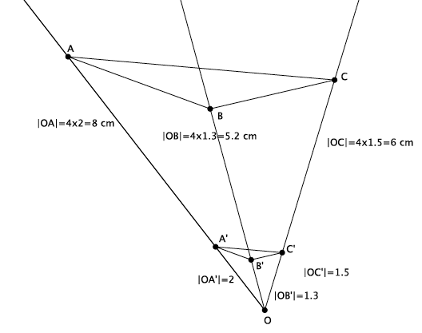
- Triangle $ABC$ has been dilated from center $O$ by a scale factor of $r=\frac{1}{4}$ denoted by triangle $A'B'C'$. Using a ruler, verify that it would take a scale factor of $r=4$ from center $O$ to map triangle $A'B'C'$ onto triangle $ABC$.
Verify that students have measured the lengths of segments from center $O$ to each of the dilated points. Then verify that students have multiplied each of the lengths by $4$ to see that it really is the length of the segments from center $O$ to the original points.

Closing (5 minutes)
Summarize, or ask students to summarize, the main points from the lesson.
- To dilate curved figures, we need to use a lot of points spread evenly throughout the figure; therefore, we focused on the curves to produce a good image of the original figure.
- If a figure is dilated by scale factor $r$, we must dilate it by a scale factor of $\frac{1}{r}$ to bring the dilated figure back to the original size. For example, if a scale factor is $r=4$, then to bring a dilated figure back to the original size, we must dilate it by a scale factor $r=\frac{1}{4}$.
Lesson Summary
Dilations map circles to circles and ellipses to ellipses.
If a figure is dilated by scale factor $r$, we must dilate it by a scale factor of $\frac{1}{r}$ to bring the dilated figure back to the original size. For example, if a scale factor is $r=4$, then to bring a dilated figure back to the original size, we must dilate it by a scale factor $r=\frac{1}{4}$.

Exit Ticket (5 minutes)

Name ___________________________________________________ Date____________________
Lesson 3: Examples of Dilations

Exit Ticket

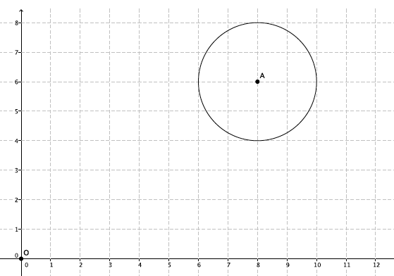
- Dilate circle $A$ from center $O$ by a scale factor $=\frac{1}{2}$. Make sure to use enough points to make a good image of the original figure.

- What scale factor would magnify the dilated circle back to the original size of circle $A$? How do you know?
Exit Ticket Sample Solutions

- Dilate circle $A$ from center $O$ by a scale factor $=\frac{1}{2}$. Make sure to use enough points to make a good image of the original figure.
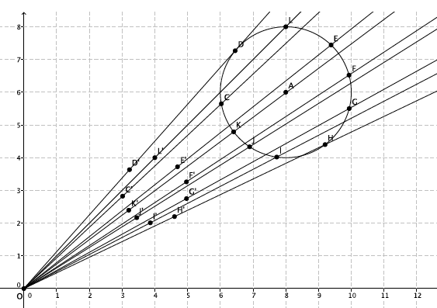
Student work shown below. Verify that students used enough points to produce an image similar to the original.

- What scale factor would magnify the dilated circle back to the original size of circle $A$?
A scale factor of $r=2$ would bring the dilated circle back to the size of circle $A$. Since the circle was dilated by a scale factor of $r=\frac{1}{2}$, then to bring it back to its original size, you must dilate by a scale factor that is the reciprocal of $\frac{1}{2}$, which is $2$.

Problem Set Sample Solutions
Students practice dilating a curved figure and stating the scale factor that would bring a dilated figure back to its original size.

- Dilate the figure from center $O$ by a scale factor $r=2$. Make sure to use enough points to make a good image of the original figure.
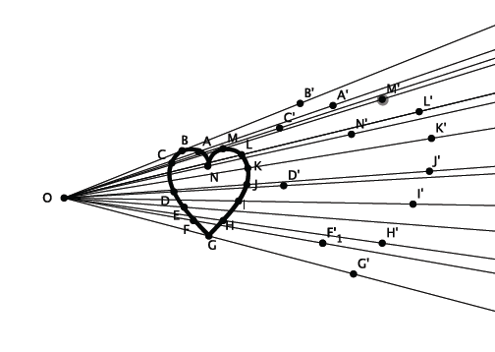
Sample student work shown below. Verify that students used enough points to produce an image similar to the original.
E’

- Describe the process for selecting points when dilating a curved figure.
When dilating a curved figure, you have to make sure to use a lot of points to produce a decent image of the original figure. You also have to make sure that the points you choose are not all concentrated in just one part of the figure.

- A triangle $ABC$ was dilated from center $O$ by a scale factor of $r=5$. What scale factor would shrink the dilated figure back to the original size?
A scale factor of $r=\frac{1}{5}$ would bring the dilated figure back to its original size.

- A figure has been dilated from center $O$ by a scale factor of $r=\frac{7}{6}$. What scale factor would shrink the dilated figure back to the original size?
A scale factor of $r=\frac{6}{7}$would bring the dilated figure back to its original size.

- A figure has been dilated from center $O$ by a scale factor of $r=\frac{3}{10}$. What scale factor would magnify the dilated figure back to the original size?
A scale factor of $r=\frac{10}{3}$ would bring the dilated figure back to its original size.

