Lesson 2: Properties of Dilations

Classwork

**Examples 1–2: Dilations Map Lines to Lines**

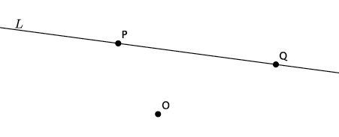

**Example 3: Dilations Map Lines to Lines**

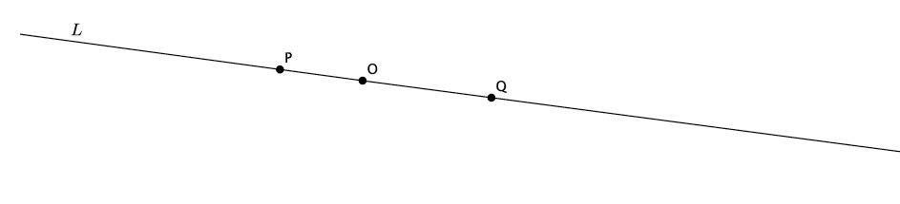

Exercise

Given center and triangle , dilate the triangle from center with a scale factor .

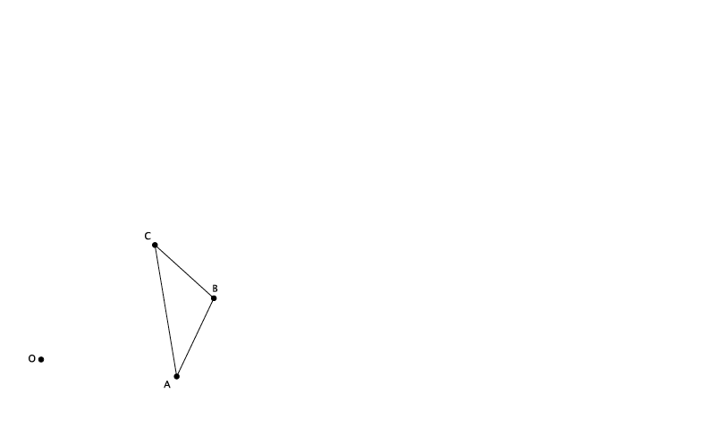

* 1. Note that the triangle is made up of segments , , and . Were the dilated images of these segments still segments?
  2. Measure the length of the segments and . What do you notice? (Think about the definition of dilation.)
  3. Verify the claim you made in part (b) by measuring and comparing the lengths of segments and and segments and . What does this mean in terms of the segments formed between dilated points?
  4. Measure and . What do you notice?
  5. Verify the claim you made in part (d) by measuring and comparing and and and . What does that mean in terms of dilations with respect to angles and their degrees?

Lesson Summary

Dilations map lines to lines, rays to rays, and segments to segments. Dilations map angles to angles of the same degree.

Problem Set

1. Use a ruler to dilate the following figure from center , with scale factor .

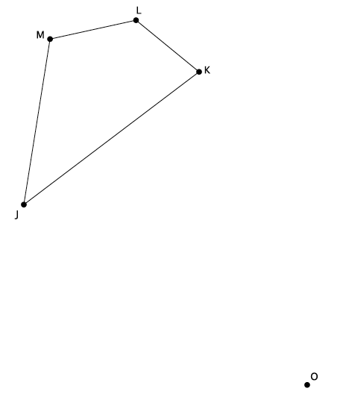

1. Use a compass to dilate the figure from center , with scale factor .

Macintosh HD:Users:shassan:Dropbox:Module 3:Images:Properties of dilations:ps2s.pdf

* 1. Dilate the same figure, , from a new center, , with scale factor . Use double primes () to distinguish this image from the original.
  2. What rigid motion, or sequence of rigid motions, would map *to* ?

1. Given center and triangle , dilate the figure from center by a scale factor of . Label the dilated triangle *.*

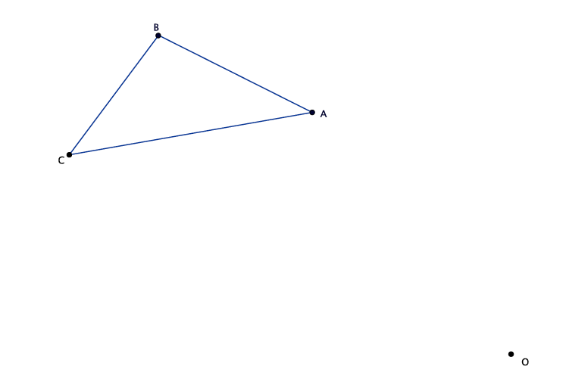

1. A line segment undergoes a dilation. Based on today’s lesson, what will the image of the segment be?
2. Angle measures . After a dilation, what will the measure of be? How do you know?