Lesson 1: What Lies Behind “Same Shape”?

Classwork
Exploratory Challenge
Two geometric figures are said to be similar if they have the same shape but not necessarily the same size. Using that informal definition, are the following pairs of figures similar to one another? Explain.
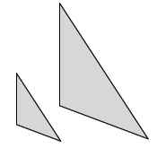
Pair A:

Pair B:

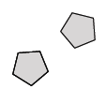
Pair C:

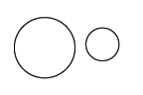
Pair D:

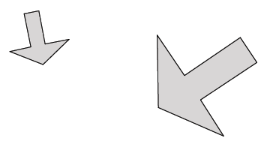
Pair E:

Pair F:

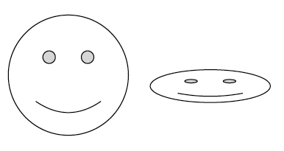
Pair G:

Pair H:

Exercises 1–6
- Given $\left|OP\right|=5$ in.
  - If segment $OP$ is dilated by a scale factor $r=4$, what is the length of segment ${OP}^{'}$?

  - If segment $OP$ is dilated by a scale factor $=\frac{1}{2}$ , what is the length of segment ${OP}^{'}$?

Use the diagram below to answer Exercises 2–6. Let there be a dilation from center $O$. Then $Dilation(P)=P^{'}$ and $Dilaton(Q)=Q^{'}$. In the diagram below, $\left|OP\right|=3$ cm and $\left|OQ\right|=4$ cm, as shown.
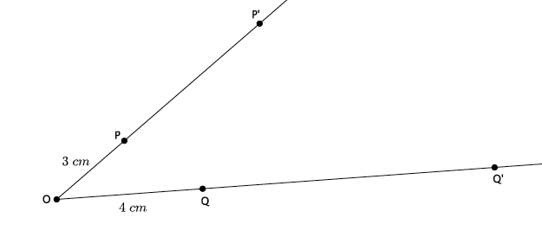
- If the scale factor is $r=3$, what is the length of segment ${OP}^{'}$?

- Use the definition of dilation to show that your answer to Exercise 2 is correct.

- If the scale factor is $r=3$, what is the length of segment ${OQ}^{'}$?

- Use the definition of dilation to show that your answer to Exercise 4 is correct.

- If you know that $\left|OP\right|=3, \left|{OP}^{'}\right|=9$, how could you use that information to determine the scale factor?

Lesson Summary
Definition: A dilation, a transformation of the plane with center $O$, with scale factor $r$ ($r>0$) is a rule that assigns to each point $P$ of the plane a point $Dilation(P)$ so that
- $Dilation(O)=O$, (i.e., a dilation does not move the center of dilation.)
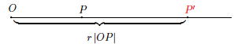
- If $P≠O$, then the point $Dilation(P)$, (to be denoted more simply by $P^{'}$) is the point on the ray $\vec{OP}$ so that $\left|{OP}^{'}\right|=r\left|OP\right|$.
In other words, a dilation is a rule that moves points in the plane a specific distance, determined by the scale factor $r$, from a center $O$. When the scale factor $r>1$, the dilation magnifies a figure. When the scale factor $0<r<1,$ the dilation shrinks a figure. When the scale factor $r=1$, there is no change in the size of the figure; that is, the figure and its image are congruent.

Problem Set

- Let there be a dilation from center $O$. Then $Dilation(P)=P^{'}$ and $Dilation(Q)=Q^{'}$. Examine the drawing below. What can you determine about the scale factor of the dilation?
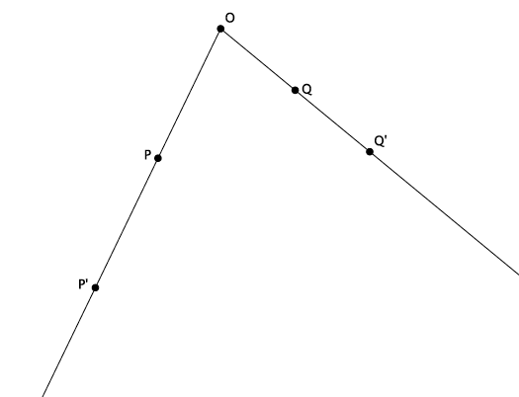

- Let there be a dilation from center $O$. Then $Dilation(P)=P^{'}$, and $Dilation(Q)=Q^{'}$. Examine the drawing below. What can you determine about the scale factor of the dilation?
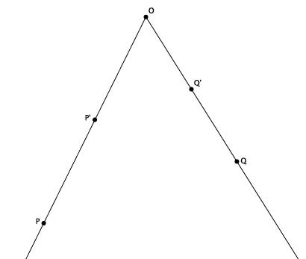

- Let there be a dilation from center $O$ with a scale factor $r=4$. Then $Dilation(P)=P^{'}$ and $Dilation(Q)=Q^{'}$. $\left|OP\right|=3.2$ cm, and $\left|OQ\right|=2.7$ cm, as shown. Use the drawing below to answer parts (a) and (b). Drawing not to scale.
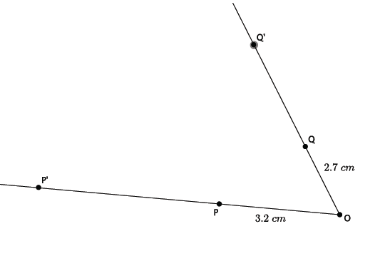
  - Use the definition of dilation to determine the length of ${OP}^{'}$.
  - Use the definition of dilation to determine the length of $OQ’.$
- Let there be a dilation from center $O$ with a scale factor $r$. Then $Dilation(A)=A^{'}$, $Dilation\left(B\right)=B^{'},$ and $Dilation(C)=C'$. $\left|OA\right|=3$, $\left|OB\right|=15$, $\left|OC\right|=6$, and $\left|{OB}^{'}\right|=5$, as shown. Use the drawing below to answer parts (a)–(c).
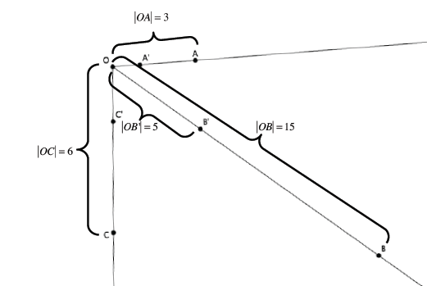

  - Using the definition of dilation with lengths $OB$ and ${OB}^{'}$, determine the scale factor of the dilation.
  - Use the definition of dilation to determine the length of ${OA}^{'}$.
  - Use the definition of dilation to determine the length of ${OC}^{'}$.

