Lesson 1: What Lies Behind “Same Shape”?

Student Outcomes
- Students learn the definition of dilation and why “same shape” is not good enough to say two figures are similar.
- Students know that dilations magnify and shrink figures.

Lesson Notes
The goal of this module is to arrive at a precise understanding of the concept of similarity: What does it mean for two geometric figures to have “the same shape but not necessarily the same size?” Note that we introduced the concept of congruence in the last module and are introducing the concept of dilation presently. Then a similarity (or a similarity transformation) is, by definition, the sequence of a dilation followed by a congruence.
The basic references for this module are Teaching Geometry According to the Common Core Standards and Pre-Algebra, both by Hung-Hsi Wu. The latter is identical to the document cited on page 92 of the Common Core State Standards for Mathematics: Wu, H., “Lecture Notes for the 2009 Pre-Algebra Institute,” September 15, 2009.

Classwork
Exploratory Challenge (10 minutes)
Have students examine the following pairs of figures and record their thoughts.
Exploratory Challenge
Two geometric figures are said to be similar if they have the same shape but not necessarily the same size. Using that informal definition, are the following pairs of figures similar to one another? Explain.
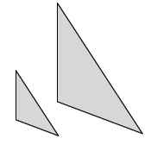
Pair A:

Yes, these figures appear to be similar. They are the same shape, but one is larger than the other, or one is smaller than the other.

Pair B:

No, these figures do not appear to be similar. One looks like a square and the other like a rectangle.
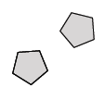
Pair C:

These figures appear to be exactly the same, which means they are congruent.
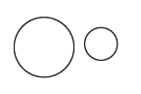
Pair D:

Yes, these figures appear to be similar. They are both circles, but they are different sizes.
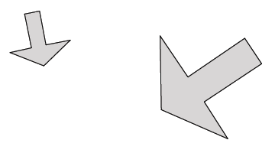
Pair E:

Yes, these figures appear to be similar. They are the same shape, but they are different in size.
Pair F:

Yes, these figures appear to be similar. The faces look the same, but they are just different in size.

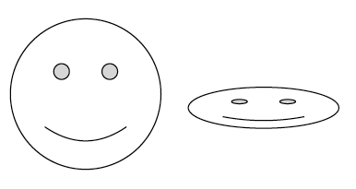
Pair G:

They do not look to be similar, but I’m not sure. They are both happy faces, but one is squished compared to the other.

Pair H:

No, these two figures do not look to be similar. Each is curved but shaped differently.

Discussion (20 minutes)
- In mathematics, we want to be absolutely sure about what we are saying. Therefore, we need precise definitions for similar figures. For example, you may have thought that the figures in Pair G were similar because they are both happy faces. However, a precise definition of similarity tells you that they are in fact NOT similar because the parts of the face are not in proportion. Think about trying to adjust the size of a digital picture. When you grab from the corner of the photo, everything looks relatively the same (i.e., it looks to be in proportion), but when you grab from the sides, top, or bottom of the photo, the picture does not look quite right (i.e., things are not in proportion).
Note to Teacher:
The embedded .mov file demonstrates what happens to a picture when the corners are grabbed (as opposed to the sides or top). You may choose to demonstrate this in the classroom using a picture of your choice.
- You probably said that the curved figures in Pair H were not similar. However, a precise definition of similarity tells you that in fact they ARE similar. They are shapes called parabolas that you will learn about in Algebra. For now, just know that one of the curved figures has been dilated according to a specific factor.
- Now we must discuss what is meant by a transformation of the plane known as dilation. In the next few lessons, we will use dilation to develop a precise definition for similar figures.
Scaffolding:
Explain to students that the notation $\left|OP\right|$ means the length of the segment $OP$.
- Definition: A dilation, a transformation of the plane with center $O$, with scale factor $r$ ($r>0$) is a rule that assigns to each point $P$ of the plane a point $Dilation(P)$ so that
- $Dilation(O)=O$, (i.e., a dilation does not move the center of dilation.)
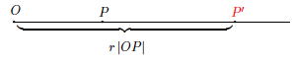
- If $P≠O$, then the point $Dilation(P)$, (to be denoted more simply by $P^{'}$) is the point on the ray $\vec{OP}$ so that $\left|{OP}^{'}\right|=r\left|OP\right|$.

- In other words, a dilation is a rule that moves points in the plane a specific distance, determined by the scale factor $r$, from a center $O$.
- In previous grades, you did scale drawings of real-world objects. When a figure shrinks in size, the scale factor $r$ will be less than one but greater than zero (i.e., $0<r<1$). In this case, a dilation where $0<r<1$, every point in the plane is pulled toward the center $O$ proportionally the same amount.
- You may have also done scale drawings of real-world objects where a very small object was drawn larger than it is in real life. When a figure is magnified (i.e., made larger in size), the scale factor $r$ will be greater than $1$ (i.e., $r>1$). In this case, a dilation where $r>1$, every point in the plane is pushed away from the center $O$ proportionally the same amount.
- If figures shrink in size when the scale factor is $0<r<1$ and magnify when the scale factor is $r>1$, what happens when the scale factor is exactly one (i.e., $r=1$)?
  - When the scale factor is $r=1$, the figure does not change in size. It does not shrink or magnify. It remains congruent to the original figure.
- What does proportionally the same amount mean with respect to the change in size that a dilation causes? Think about this example: If you have a segment, $OP$, of length $3$ cm that is dilated from a center $O$ by a scale factor $r=4$, how long is the dilated segment ${OP}^{'}$?
  - The dilated segment ${OP}^{'}$ should be $4$ times longer than the original (i.e., $4×3$ or $12$ cm).
- For dilation, we think about the measures of the segments accordingly:
$\left|{OP}^{'}\right|=r\left|OP\right|$ The length of the dilated segment ${OP}^{'}$is equal to the length of the original segment, $OP$, multiplied by the scale factor $r$.
- Now think about this example: If you have a segment, $OQ$, of length $21$ cm, and it is dilated from a center $O$ by a scale factor $r=\frac{1}{3}$, how long is the dilated segment ${OQ}^{'}$?
  - According to the definition of dilation, the length of the dilated segment is $\frac{1}{3}×21$ (i.e., $\frac{1}{3}$ the original length). Therefore, the dilated segment is $7$ cm. This makes sense because the scale factor is less than one, so we expect the length of the side to be shrunk.
- To determine if one object is a dilated version of another, you can measure their individual lengths and check to see that the length of the original figure, multiplied by the scale factor, is equal to the dilated length.

Exercises 1–6 (8 minutes)
Have students check to see if figures are, in fact, dilations and find measures using scale factor.
Exercises 1–6
- Given $\left|OP\right|=5$ in.
  - If segment $OP$ is dilated by a scale factor $r=4$, what is the length of segment ${OP}^{'}$?
$\left|{OP}^{'}\right|=20$ in. because the scale factor multiplied by the length of the original segment is $20$, i.e., $4×5=20$.

  - If segment $OP$ is dilated by a scale factor $r=\frac{1}{2}$, what is the length of segment ${OP}^{'}$?
$\left|{OP}^{'}\right|=2.5$ in. because the scale factor multiplied by the length of the original segment is $2.5$, i.e., $\left(\frac{1}{2}\right)×5=2.5$.

Use the diagram below to answer Exercises 2–6. Let there be a dilation from center $O$. Then, $Dilation(P)=P^{'}$ and $Dilation(Q)=Q^{'}$. In the diagram below, $\left|OP\right|=3$ cm and $\left|OQ\right|=4$ cm, as shown.
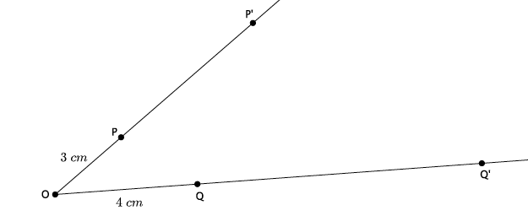
- If the scale factor is $r=3$, what is the length of segment ${OP}^{'}$?
The length of the segment ${OP}^{'}$ is $9$ cm.
- Use the definition of dilation to show that your answer to Exercise 2 is correct.
$\left|{OP}^{'}\right|=r \left|OP\right|$; therefore, $\left|{OP}^{'}\right|=3×3=9$ and $\left|{OP}^{'}\right|=9$.

- If the scale factor is $r=3$, what is the length of segment ${OQ}^{'}$?
The length of the segment ${OQ}^{'}$ is $12$ cm.

- Use the definition of dilation to show that your answer to Exercise 4 is correct.
$\left|{OQ}^{'}\right|=r\left|OQ\right|$; therefore, $\left|{OQ}^{'}\right|=3×4=12$ and $\left|{OQ}^{'}\right|=12$.

- If you know that $\left|OP\right|=3$,$\left|{OP}^{'}\right|=9$, how could you use that information to determine the scale factor?
Since we know $\left|{OP}^{'}\right|=r\left|OP\right|$, we can solve for $r$: $\frac{\left|{OP}^{'}\right|}{\left|OP\right|}=r$, which is $\frac{9}{3}=r$ or $3=r$.

Closing (3 minutes)
Summarize, or ask students to summarize, the main points from the lesson.
- We need a precise definition for similar that includes the use of dilation.
- A dilation will magnify a figure when the scale factor is greater than one and that a dilation will shrink a figure when the scale factor is greater than zero but less than one.
- If we multiply a segment by the scale factor, we will get the length of the dilated segment (i.e., $\left|{OP}^{'}\right|=r\left|OP\right|$).
Lesson Summary
Definition: A dilation, a transformation of the plane with center $O$, with scale factor $r$ ($r>0$) is a rule that assigns to each point $P$ of the plane a point $Dilation(P)$ so that
- $Dilation(O)=O$, (i.e., a dilation does not move the center of dilation.)
- If $P≠O$, then the point $Dilation(P)$, (to be denoted more simply by $P^{'}$) is the point on the ray $\vec{OP}$ so that $\left|{OP}^{'}\right|=r\left|OP\right|$.
In other words, a dilation is a rule that moves points in the plane a specific distance, determined by the scale factor $r$, from a center $O$. When the scale factor $r>1$, the dilation magnifies a figure. When the scale factor $0<r<1$, the dilation shrinks a figure. When the scale factor $r=1$, there is no change in the size of the figure; that is, the figure and its image are congruent.

Exit Ticket (4 minutes)

Name ___________________________________________________ Date____________________
Lesson 1: What Lies Behind “Same Shape”?

Exit Ticket

- Why do we need a better definition for similarity than “same shape, not the same size”?

- Use the diagram below. Let there be a dilation from center $O$ with scale factor $r=3$. Then $Dilation(P)=P^{'}$. In the diagram below, $\left|OP\right|=5$ cm. What is $\left|{OP}^{'}\right|$? Show your work.
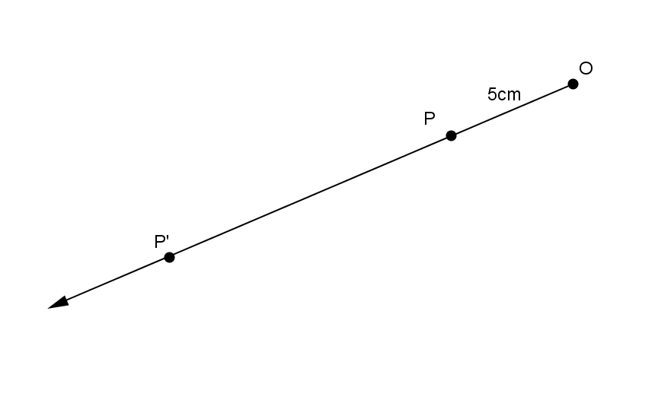

- Use the diagram below. Let there be a dilation from center $O$. Then $Dilation(P)=P^{'}$. In the diagram below, $\left|OP\right|=18$ cm and $\left|{OP}^{'}\right|=9$ cm. What is the scale factor $r$? Show your work.
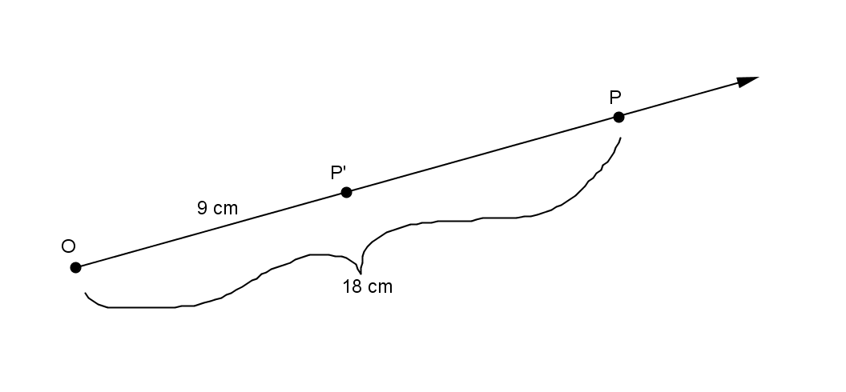
Exit Ticket Sample Solutions

- Why do we need a better definition for similarity than “same shape, but not the same size”?
We need a better definition that includes dilation and a scale factor because some figures may look to be similar (e.g., the smiley faces), but we cannot know for sure unless we can check the proportionality. Other figures (e.g., the parabolas) may not look similar but are. We need a definition so that we are not just guessing if they are similar by looking at them.

- Use the diagram below. Let there be a dilation from center $O$ with scale factor $3$. Then $Dilation(P)=P^{'}$. In the diagram below, $\left|OP\right|=5$ cm. What is $\left|{OP}^{'}\right|$? Show your work.
Since $\left|{OP}^{'}\right|=r\left|OP\right|$, then
$\left|{OP}^{'}\right|=3×5$ cm,
$\left|{OP}^{'}\right|=15$cm.

- Use the diagram below. Let there be a dilation from center $O$. Then $Dilation(P)=P^{'}$. In the diagram below, $\left|OP\right|=18$ cm and $\left|{OP}^{'}\right|=9$ cm. What is the scale factor $r$? Show your work.
Since $\left|{OP}^{'}\right|=r\left|OP\right|$, then
$9$cm$=r×18$ cm,
$\frac{1}{2}=r$.

Problem Set Sample Solutions
Have students practice using the definition of dilation and finding lengths according to a scale factor.

- Let there be a dilation from center $O$. Then $Dilation(P)=P^{'}$ and $Dilation(Q)=Q^{'}$. Examine the drawing below. What can you determine about the scale factor of the dilation?
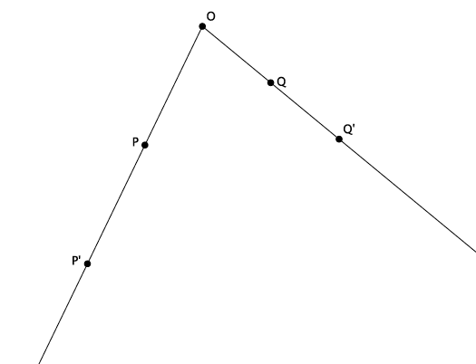
The scale factor must be greater than one, $r>1$, because the dilated points are farther from the center than the original points.

- Let there be a dilation from center $O$. Then $Dilation(P)=P^{'}$, and $Dilation(Q)=Q^{'}$. Examine the drawing below. What can you determine about the scale factor of the dilation?
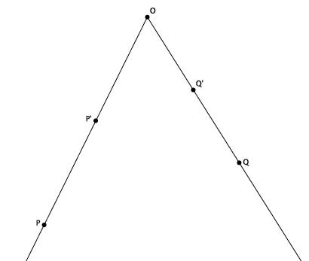
The scale factor must be greater than zero but less than one, $0<r<1$, because the dilated points are closer to the center than the original points.

- Let there be a dilation from center $O$ with a scale factor $r=4$. Then $Dilation(P)=P^{'}$ and $Dilation(Q)=Q^{'}$. $\left|OP\right|=3.2$ cm, and $\left|OQ\right|=2.7$ cm, as shown. Use the drawing below to answer parts (a) and (b). Drawing not to scale.
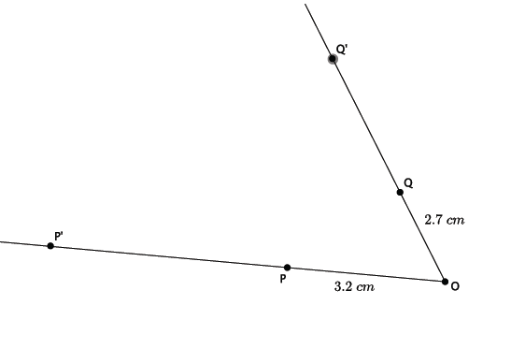
  - Use the definition of dilation to determine the length of ${OP}^{'}$.
$\left|{OP}^{'}\right|=r\left|OP\right|$; therefore, $\left|{OP}^{'}\right|=4×\left(3.2\right)=12.8$ and $\left|{OP}^{'}\right|=12.8$ cm.

  - Use the definition of dilation to determine the length of $OQ'.$
$\left|{OQ}^{'}\right|=r\left|OQ\right|$; therefore, $\left|{OQ}^{'}\right|=4×\left(2.7\right)=10.8$ and $\left|{OQ}^{'}\right|=10.8$ cm.

- Let there be a dilation from center $O$ with a scale factor $r$. Then $Dilation(A)=A^{'}$, $Dilation\left(B\right)=B^{'}$, and $Dilation(C)=C'$. $\left|OA\right|=3$, $\left|OB\right|=15$, $\left|OC\right|=6$, and $\left|{OB}^{'}\right|=5$, as shown. Use the drawing below to answer parts (a)–(c).
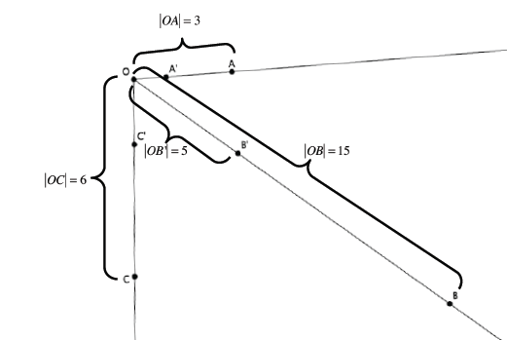

  - Using the definition of dilation with lengths $OB$ and ${OB}^{'}$, determine the scale factor of the dilation.
$\left|{OB}^{'}\right|=r\left|OB\right|$, which means $5=r×15$; therefore, $r=\frac{1}{3}$.

  - Use the definition of dilation to determine the length of ${OA}^{'}$.
$\left|{OA}^{'}\right|=\frac{1}{3}\left|OA\right|$; therefore, $\left|{OA}^{'}\right|=\frac{1}{3}×3=1$, and $\left|{OA}^{'}\right|=1$.

  - Use the definition of dilation to determine the length of ${OC}^{'}$.
$\left|{OC}^{'}\right|=\frac{1}{3}\left|OC\right|$; therefore, $\left|{OC}^{'}\right|=\frac{1}{3}×6=2$, and $\left|{OC}^{'}\right|=2$.

