Lesson 16: Applications of the Pythagorean Theorem

Classwork
Example 1
Given a right triangle with a hypotenuse with length $13$ units and a leg with length $5$ units, as shown, determine the length of the other leg.
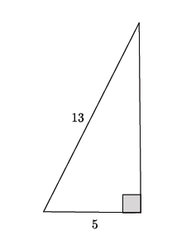
$$5^{2}+b^{2}={13}^{2} \\ 5^{2}-5^{2}+b^{2}={13}^{2}-5^{2} \\ b^{2}={13}^{2}-5^{2} \\ b^{2}=169-25 \\ b^{2}=144 \\ b=12$$

The length of the leg is $12$ units.

Exercises 1–2
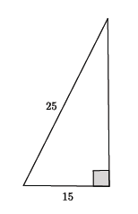
- Use the Pythagorean theorem to find the missing length of the leg in the right triangle.

- You have a $15$-foot ladder and need to reach exactly $9$ feet up the wall. How far away from the wall should you place the ladder so that you can reach your desired location?
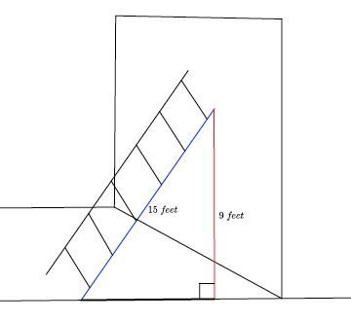

Exercises 3–6
- Find the length of the segment $AB$, if possible.
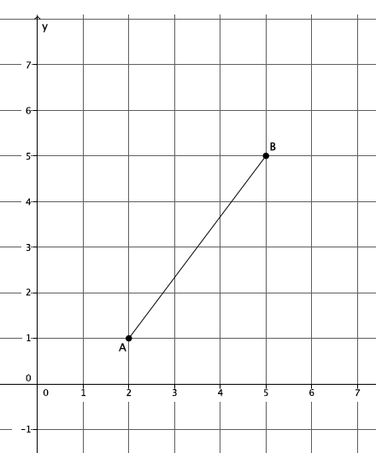

- Given a rectangle with dimensions $5$ cm and $10$cm, as shown, find the length of the diagonal, if possible.
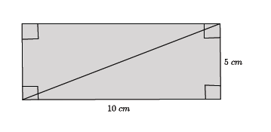

- A right triangle has a hypotenuse of length $13$ in. and a leg with length $4$ in. What is the length of the other leg?

- Find the length of $b$in the right triangle below, if possible.
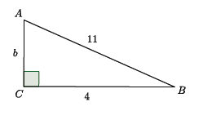

Lesson Summary
The Pythagorean theorem can be used to find the unknown length of a leg of a right triangle.
An application of the Pythagorean theorem allows you to calculate the length of a diagonal of a rectangle, the distance between two points on the coordinate plane, and the height that a ladder can reach as it leans against a wall.
Problem Set

- Find the length of the segment $AB$shown below, if possible.
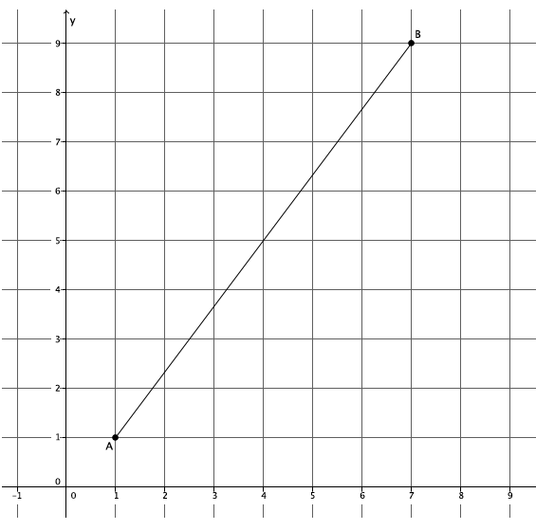

- A $20$-foot ladder is placed $12$ feet from the wall, as shown. How high up the wall will the ladder reach?
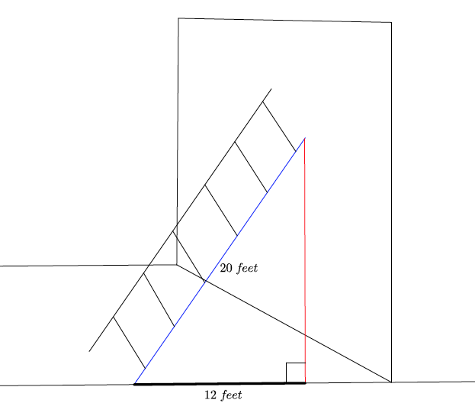

- A rectangle has dimensions $6$ in. by $12$ in. What is the length of the diagonal of the rectangle?

Use the Pythagorean theorem to find the missing side lengths for the triangles shown in Problems 4–8.
- Determine the length of the missing side, if possible.
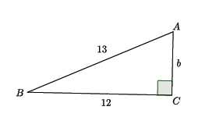

- Determine the length of the missing side, if possible.
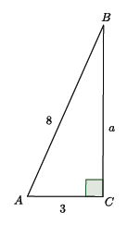

- Determine the length of the missing side, if possible.
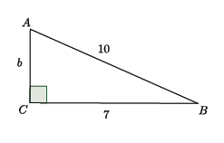

- Determine the length of the missing side, if possible.

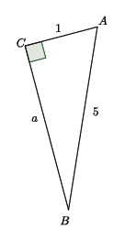

- Determine the length of the missing side, if possible.
