Lesson 16: Applications of the Pythagorean Theorem

Student Outcomes
- Students use the Pythagorean theorem to determine missing side lengths of right triangles.

Lesson Notes
Since 8.G.B.6 and 8.G.B.7 are post-test standards, this lesson is designated as an extension lesson for this module. However, the content within this lesson is prerequisite knowledge for Module 7. If this lesson is not used with students as part of the work within Module 2, it must be used with students prior to beginning work on Module 7. Please realize that many mathematicians agree that the Pythagorean theorem is the most important theorem in geometry and has immense implications in much of high school mathematics in general (e.g., especially when studying quadratics and trigonometry). It is crucial that students see the teacher explain several proofs of the Pythagorean Theorem and practice using it before being expected to produce a proof on their own.

Classwork
Example 1 (4 minutes)
Pythagorean theorem as it applies to missing side lengths of triangles:
Example 1
Given a right triangle with a hypotenuse with length $13$ units and a leg with length $5$ units, as shown, determine the length of the other leg.
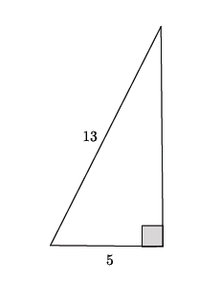
$$5^{2}+b^{2}={13}^{2} \\ 5^{2}-5^{2}+b^{2}={13}^{2}-5^{2} \\ b^{2}={13}^{2}-5^{2} \\ b^{2}=169-25 \\ b^{2}=144 \\ b=12$$

The length of the leg is $12$units.

- Let $b$ represent the missing leg of the right triangle; then, by the Pythagorean theorem:
$$5^{2}+b^{2}={13}^{2}.$$
- If we let $a$represent the missing leg of the right triangle, then by the Pythagorean theorem:
$$a^{2}+5^{2}={13}^{2}.$$

- Which of these two equations is correct: $5^{2}+b^{2}={13}^{2}$ or $a^{2}+5^{2}={13}^{2}$?
- It does not matter which equation we use as long as we are showing the sum of the squares of the legs as equal to the square of the hypotenuse.
Scaffolding:
If students do not believe that we could use either equation, solve each of them and show that the answer is the same.
- Using the first of our two equations, $5^{2}+b^{2}={13}^{2}$, what can we do to solve for $b$ in the equation?
  - We need to subtract $5^{2}$ from both sides of the equation.
$$\begin{aligned}&5^{2}+&b^{2}&={13}^{2} \\ 5^{2}-&5^{2}+&b^{2}&={13}^{2}-5^{2} \\ &&b^{2}&={13}^{2}-5^{2}\end{aligned}$$
- Point out to students that we are looking at the Pythagorean theorem in a form that allows us to find the length of one of the legs of the right triangle. That is, $b^{2}=c^{2}-a^{2}$.
$$\begin{aligned}b^{2}&={13}^{2}&-5^{2}& \\ b^{2}&=169&-25& \\ b^{2}&=144& \\ b&=12\end{aligned}$$
  - The length of the leg of the right triangle is $12$ units.

Example 2 (4 minutes)
Pythagorean theorem as it applies to missing side lengths of triangles in a real-world problem:
- Suppose you have a ladder of length $13$ feet. Suppose that to make it sturdy enough to climb, you must place the ladder exactly $5$ feet from the wall of a building. You need to post a banner on the building $10$ feet above the ground. Is the ladder long enough for you to reach the location you need to post the banner?
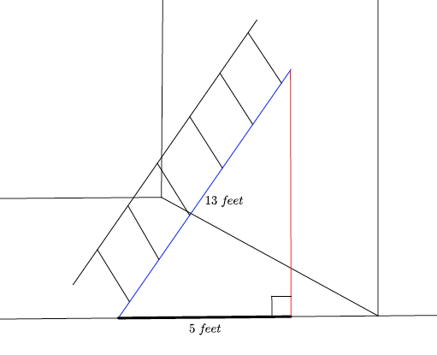
The ladder against the wall forms a right angle. For that reason, we can use the Pythagorean theorem to find out how far up the wall the ladder will reach. If we let $h$represent the height the ladder can reach, what equation will represent this problem?
  - $5^{2}+h^{2}={13}^{2}$ or $h^{2}={13}^{2}-5^{2}$
- Using either equation, we see that this is just like Example 1. We know that the missing side of the triangle is $12$ feet. Is the ladder long enough for you to reach the $10$-foot banner location?
  - Yes, the ladder allows us to reach $12$ feet up the wall.

Example 3 (3 minutes)
Pythagorean theorem as it applies to missing side lengths of a right triangle:
- Given a right triangle with a hypotenuse of length $15$ units and a leg of length $9$, what is the length of the other leg?
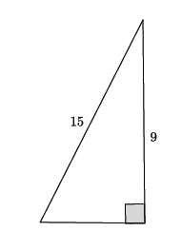
- If we let the length of the missing leg be represented by $a$, what equation will allow us to determine its value?
- $a^{2}+9^{2}={15}^{2}$ or $a^{2}={15}^{2}-9^{2}$.
- Finish the computation:
$$\begin{aligned}a^{2}&=225-81 \\ a^{2}&=144 \\ a&=12\end{aligned}$$
  - The length of the missing leg of this triangle is $12$ units.

Exercises 1–2 (5 minutes)
Students work on Exercises 1 and 2 independently.

Exercises 1–2
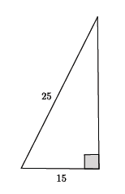
- Use the Pythagorean theorem to find the missing length of the leg in the right triangle.
Let $b$ represent the missing leg length; then,
$$15^{2}+b^{2}=25^{2} \\ 15^{2}-15^{2}+b^{2}=25^{2}-15^{2} \\ b^{2}=625-225 \\ b^{2}=400 \\ b=20.$$
The length of the leg is $20$ units.

- You have a $15$-foot ladder and need to reach exactly $9$ feet up the wall. How far away from the wall should you place the ladder so that you can reach your desired location?
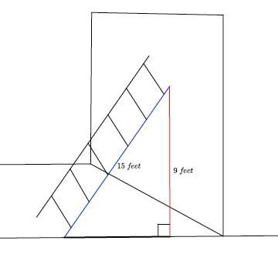
Let $a$ represent the distance the ladder must be placed from the wall; then,
$$a^{2}+9^{2}=15^{2} \\ a^{2}+9^{2}-9^{2}=15^{2}-9^{2} \\ a^{2}=225-81 \\ a^{2}=144 \\ a=12.$$
The ladder must be placed exactly $12$ feet from the wall.

Example 4 (5 minutes)
Pythagorean theorem as it applies to distances on a coordinate plane:
- We want to find the length of the segment $AB$ on the coordinate plane, as shown.
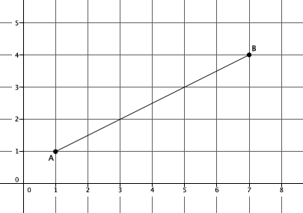
- If we had a right triangle, then we could use the Pythagorean theorem to determine the length of the segment. Let’s draw a line parallel to the $y$-axis through point $B$. We will also draw a line parallel to the$x$-axis through point $A$.
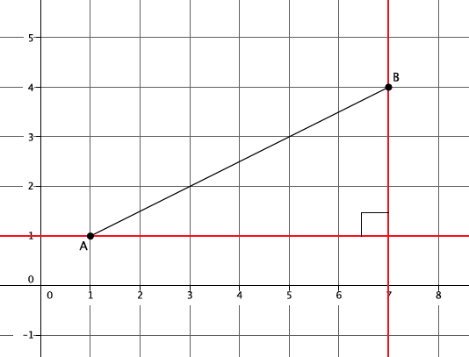
- How can we be sure we have a right triangle?
  - The coordinate plane is set up so that the intersection of the $x$-axis and $y$-axis are perpendicular. The line parallel to the $y$-axis through $B$ is just a translation of the $y$-axis. Similarly, the line parallel to the $x$-axis through $A$ is a translation of the $x$-axis. Since translations preserve angle measure, the intersection of the two red lines are also perpendicular, meaning we have a $90°$ angle and a right triangle.
- Now that we are sure we can use the Pythagorean theorem, we need to know the lengths of the legs. Count the units from point $A$ to the right angle and point $B$ to the right angle. What are those lengths?
  - The base of the triangle is $6$ units, and the height of the triangle is $3$ units.
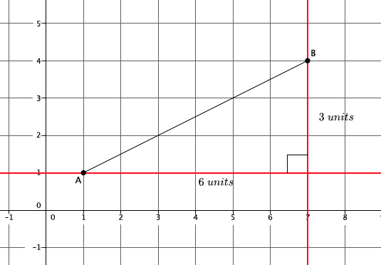
- What equation can we use to find the length of the segment $AB$? Let’s represent that length by $c$.
  - $3^{2}+6^{2}=c^{2}$
  - The length of $c$ is
$$\begin{aligned}3^{2}+6^{2}&=c^{2} \\ 9+36&=c^{2} \\ 45&=c^{2}.\end{aligned}$$
- We cannot get a precise answer, so we will leave the length of $c$ as $c^{2}=45$.

Example 5 (3 minutes)
Pythagorean Theorem as it applies to the length of a diagonal in a rectangle:
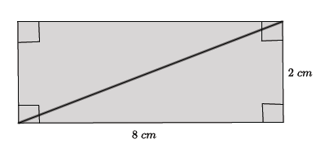
- Given a rectangle with side lengths of $8$ cm and $2$ cm, as shown, what is the length of the diagonal?

- If we let the length of the diagonal be represented by $c$, what equation can we use to find its length?
  - $2^{2}+8^{2}=c^{2}$
  - The length of $c$ is
$$\begin{aligned}2^{2}+8^{2}&=c^{2} \\ 4+64&=c^{2} \\ 68&=c^{2}.\end{aligned}$$
- We cannot get a precise answer, so we will leave the length of $c$ as $c^{2}=68$.

Exercises 3–6 (11 minutes)
Students work independently on Exercises 3–6.
Exercises 3–6
- Find the length of the segment $AB$, if possible.
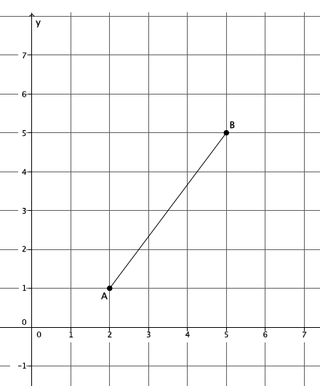

If we let the length of $AB$ be represented by $c$, then
$$3^{2}+4^{2}=c^{2} \\ 9+16=c^{2} \\ 25=c^{2} \\ 5=c$$
The length of segment $AB$ is $5$ units.

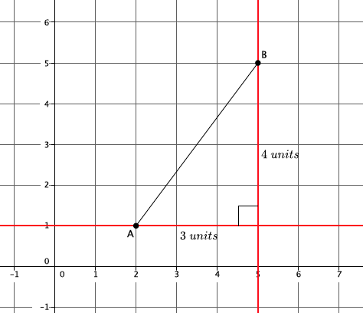

- Given a rectangle with dimensions $5$ cm and $10$cm, as shown, find the length of the diagonal, if possible.
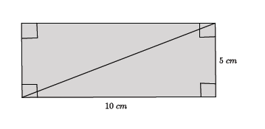
Let $c$ represent the length of the diagonal; then,
$$c^{2}=5^{2}+10^{2} \\ c^{2}=25+100 \\ c^{2}=125.$$
We cannot find a precise answer for $c$, so the length is ${(c}^{2}=125)$cm.

- A right triangle has a hypotenuse of length $13$ in. and a leg with length $4$ in. What is the length of the other leg?
If we let $a$ represent the length of the other leg, then
$$\begin{aligned}a^{2}+4^{2}&={13}^{2} \\ a^{2}+4^{2}-4^{2}&={13}^{2}-4^{2} \\ a^{2}&=13^{2}-4^{2} \\ a^{2}=169-16 \\ a^{2}=153.\end{aligned}$$
We cannot find a precise length for $a$, so the leg is ${(a}^{2}=153)$in.

- Find the length of $b$ in the right triangle below, if possible.
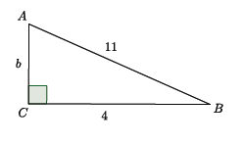
By the Pythagorean theorem,
$$\begin{aligned}4^{2}+b^{2}&=11^{2} \\ 4^{2}-4^{2}+b^{2}&=11^{2}-4^{2} \\ b^{2}=121-16 \\ b^{2}=105.\end{aligned}$$
A precise length for side $b$ cannot be found, so $b^{2}=105$.

Closing (5 minutes)
Summarize, or have students summarize, the lesson.
- We know how to use the Pythagorean theorem to find the length of a missing side of a right triangle whether it be one of the legs or the hypotenuse.
- We know how to apply the Pythagorean theorem to a real life problem like how high a ladder will reach along a wall.
- We know how to find the length of a diagonal of a rectangle.
- We know how to determine the length of a segment that is on the coordinate plane.
Lesson Summary
The Pythagorean theorem can be used to find the unknown length of a leg of a right triangle.
An application of the Pythagorean theorem allows you to calculate the length of a diagonal of a rectangle, the distance between two points on the coordinate plane, and the height that a ladder can reach as it leans against a wall.

Exit Ticket (5 minutes)

Name Date
Lesson 16: Applications of the Pythagorean Theorem

Exit Ticket

- Find the length of the missing side of the rectangle shown below, if possible.
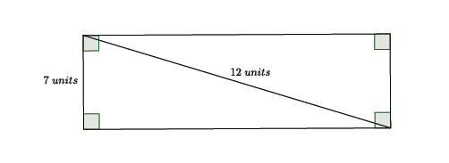

- Find the length of all three sides of the right triangle shown below, if possible.

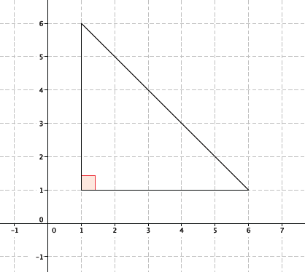

Exit Ticket Sample Solutions

- Find the length of the missing side of the rectangle shown below, if possible.
Let $a$ represent the length of the unknown leg. Then,
$$\begin{aligned}a^{2}+7^{2}&=12^{2} \\ a^{2}+7^{2}-7^{2}&=12^{2}-7^{2} \\ a^{2}&=12^{2}-7^{2} \\ a^{2}&=144-49 \\ a^{2}&=95.\end{aligned}$$
The precise length of the side cannot be found, but $a^{2}=95$units$.$

- Find the length of all three sides of the right triangle shown below, if possible.
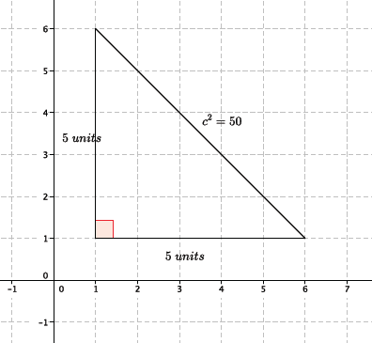
The two legs are each $5$ units in length. The hypotenuse is
$$\begin{aligned}5^{2}+5^{2}&=c^{2} \\ 25+25&=c^{2} \\ 50&=c^{2}.\end{aligned}$$
The precise length of the hypotenuse cannot be found, but $c^{2}=50$units.

Problem Set Sample Solutions
Students practice using the Pythagorean theorem to find missing lengths in right triangles.

- Find the length of the segment $AB$shown below, if possible.
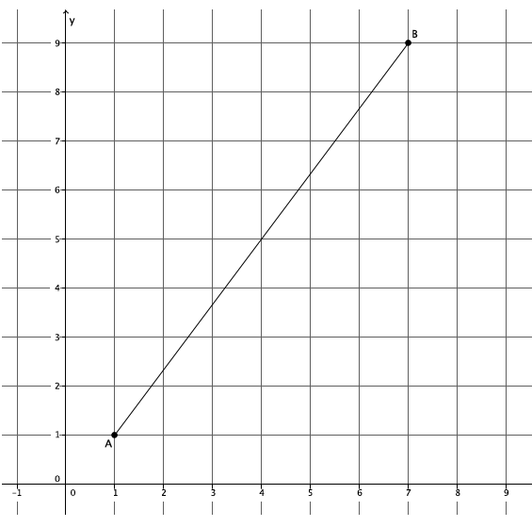
If we let the length of $AB$ be represented by $c$, then by the Pythagorean theorem
$$\begin{aligned}6^{2}+8^{2}&=c^{2} \\ 36+64&=100 \\ 100&=c^{2} \\ 10&=c.\end{aligned}$$
The length of the segment $AB$ is $10$ units.
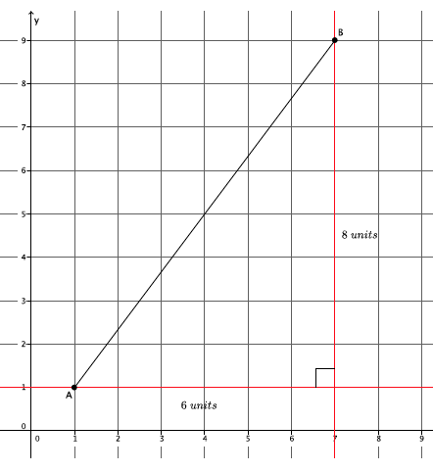

- A $20$-foot ladder is placed $12$ feet from the wall, as shown. How high up the wall will the ladder reach?

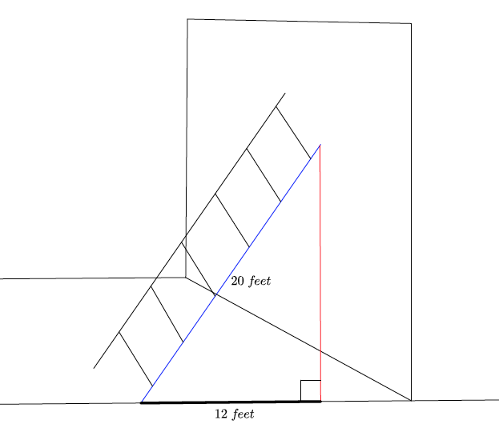
Let $a$ represent the height up the wall that the ladder will reach. Then,
$$\begin{aligned}a^{2}+12^{2}&=20^{2} \\ a^{2}+12^{2}-12^{2}&=20^{2}-12^{2} \\ a^{2}&=20^{2}-12^{2} \\ a^{2}&=400-144 \\ a^{2}&=256 \\ a&=16.\end{aligned}$$
The ladder will reach $16$ feet up the wall.

- A rectangle has dimensions $6$ in. by $12$ in. What is the length of the diagonal of the rectangle?
If we let $c$ represent the length of the diagonal, then
$$\begin{aligned}6^{2}+12^{2}&=c^{2} \\ 36+144&=c^{2} \\ 180&=c^{2}.\end{aligned}$$
A precise answer cannot be determined for the length of the diagonal, so we say that ($c^{2}=180)$in.

Use the Pythagorean theorem to find the missing side lengths for the triangles shown in Problems 4–8.
- Determine the length of the missing side, if possible.
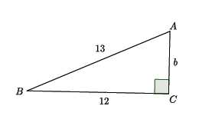
$$\begin{aligned}{12}^{2}+b^{2}&={13}^{2} \\ {12}^{2}-{12}^{2}+b^{2}&={13}^{2}-{12}^{2} \\ b^{2}&={13}^{2}-{12}^{2} \\ b^{2}&=169-144 \\ b^{2}&=25 \\ b&=5\end{aligned}$$
The length of the missing side is $5$ units.

- Determine the length of the missing side, if possible.
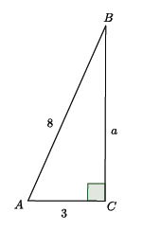
$$\begin{aligned}a^{2}+3^{2}&=8^{2} \\ a^{2}+3^{2}-3^{2}&=8^{2}-3^{2} \\ a^{2}&=8^{2}-3^{2} \\ a^{2}&=64-9 \\ a^{2}&=55\end{aligned}$$
We cannot get a precise answer, but$a^{2}=55$.

- Determine the length of the missing side, if possible.
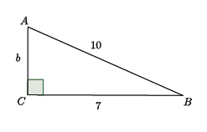
$\begin{aligned}7^{2}+b^{2}&={10}^{2} \\ 7^{2}-7^{2}+b^{2}&={10}^{2}-7^{2} \\ b^{2}&={10}^{2}-7^{2} \\ b^{2}&=100-49 \\ b^{2}&=51\end{aligned}$
We cannot get a precise answer, but $b^{2}=51.$
- Determine the length of the missing side, if possible.

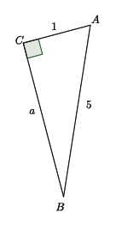
$\begin{aligned}a^{2}+1^{2}&=5^{2} \\ a^{2}+1^{2}-1^{2}&=5^{2}-1^{2} \\ a^{2}&=5^{2}-1^{2} \\ a^{2}&=25-1 \\ a^{2}&=24\end{aligned}$
We cannot get a precise answer, but $a^{2}=24$.
- Determine the length of the missing side, if possible.
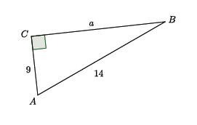
$\begin{aligned}a^{2}+9^{2}&={14}^{2} \\ a^{2}+9^{2}-9^{2}&={14}^{2}-9^{2} \\ a^{2}&={14}^{2}-9^{2} \\ a^{2}&=196-81 \\ a^{2}&=115\end{aligned}$
We cannot get a precise answer, but $a^{2}=115$.

