Lesson 15: Informal Proof of the Pythagorean Theorem

Classwork

**Example 1**

Now that we know what the Pythagorean theorem is, let’s practice using it to find the length of a hypotenuse of a right triangle.

Determine the length of the hypotenuse of the right triangle.

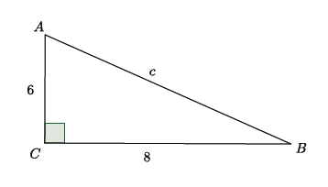

The Pythagorean theorem states that for right triangles , where and are the legs and is the hypotenuse. Then,

Since we know that , we can say that the hypotenuse .

**Example 2**

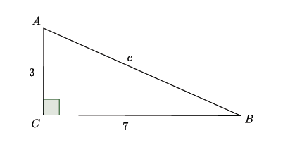Determine the length of the hypotenuse of the right triangle.

Exercises 1–5

For each of the exercises, determine the length of the hypotenuse of the right triangle shown. Note: Figures not drawn to scale.

1. 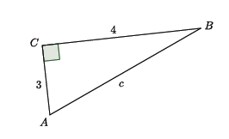

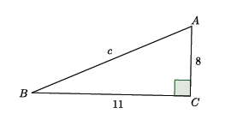

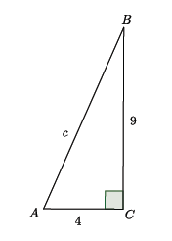

1. 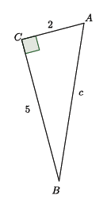
2. 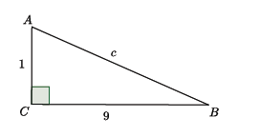

Lesson Summary

Given a right triangle with being the vertex of the right angle, then the sides and are called the *legs* of and is called the *hypotenuse* of .

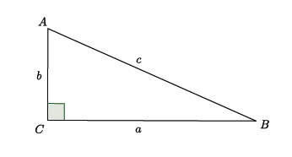

Take note of the fact that side is opposite the angle , side is opposite the angle , and side is opposite the angle .

The Pythagorean theorem states that for any right triangle,

Problem Set

For each of the problems below, determine the length of the hypotenuse of the right triangle shown. Note: Figures not drawn to scale.

1. 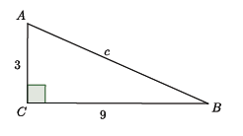
2. 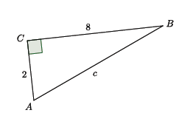
3. 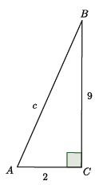
4. 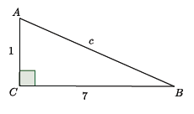

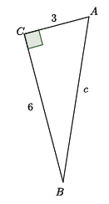

1. 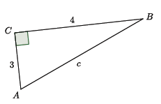
2. 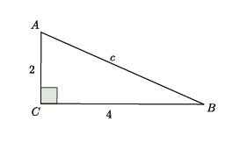
3. 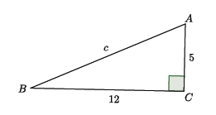

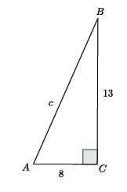

1. 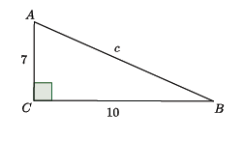
2. 