Lesson 15: Informal Proof of the Pythagorean Theorem

Student Outcomes
- Students are introduced to the Pythagorean theorem and will be shown an informal proof of the theorem.
- Students will use the Pythagorean theorem to find the length of the hypotenuse of a right triangle.

Lesson Notes
Since 8.G.B.6 and 8.G.B.7 are post-test standards, this lesson is designated as an extension lesson for this module. However, the content within this lesson is prerequisite knowledge for Module 7. If this lesson is not used with students as part of the work within Module 2, it must be used with students prior to beginning work on Module 7. Please realize that many mathematicians agree that the Pythagorean theorem is the most important theorem in geometry and has immense implications in much of high school mathematics in general (e.g., especially when studying quadratics and trigonometry). It is crucial that students see the teacher explain several proofs of the Pythagorean theorem and practice using it before being expected to produce a proof on their own.

Classwork
Concept Development (5 minutes)
The Pythagorean theorem is a famous theorem that will be used throughout much of high school mathematics. For that reason, you will see several proofs of the theorem throughout the year and have plenty of practice using it. The first thing you need to know about the Pythagorean theorem is what it states.
Pythagorean Theorem: If the lengths of the legs of a right triangle are $a$ and $b$, and the length of the hypotenuse is $c$, then $a^{2}+b^{2}=c^{2}$.
Given a right triangle $ABC$ with $C$ being the vertex of the right angle, then the sides $AC$ and $BC$ are called the legs of $∆ABC$, and $AB$ is called the hypotenuse of $∆ABC$.
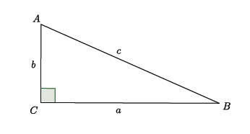
Scaffolding:
Draw arrows, one at a time, to show that each side is the opposite of the given angle.
Take note of the fact that side $a$ is opposite the angle $A$, side $b$ is opposite the angle $B$, and side $c$ is opposite the angle $C$.
Discussion (15 minutes)
The first proof of the Pythagorean theorem that you will see requires you to know some basic facts about geometry.
- Congruent triangles have equal areas.
- All corresponding parts of congruent triangles are congruent.
- The triangle sum theorem. ($∠$ sum of $△$)
  - For right triangles, the two angles that are not the right angle have a sum of $90°$. ($∠$ sum of rt. $△$)
What we will look at next is what is called a square within a square. The outside square has side lengths $\left(a+b\right)$, and the inside square has side lengths $c$. Our goal is to show that $a^{2}+b^{2}=c^{2}$. To accomplish this goal, we will compare the total area of the outside square with the parts it is comprised of, i.e., the four triangles and the smaller inside square.
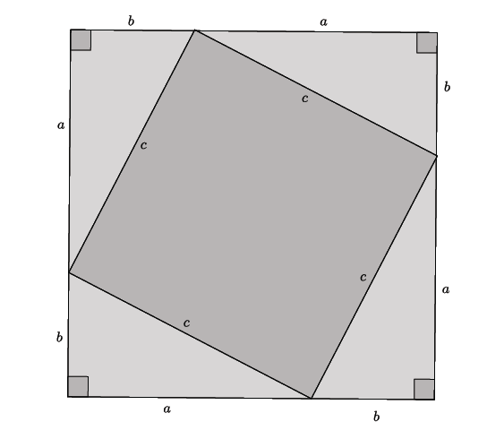
Note to Teacher:
Remind students to use the distributive law to determine the area of the outside square. Also remind them to use what they know about exponential notation to simplify the expression.
Ask students the following questions during the discussion:
- Looking at the outside square only, the square with side lengths $\left(a+b\right)$; what is its area?
  - The area of the outside square is ${\left(a+b\right)}^{2}=a^{2}+2ab+b^{2}$.
- Are the four triangles with sides lengths $a$ and $b$ congruent? If so, how do you know?
  - Yes, the triangles are congruent. From the diagram, we can see that each triangle has a right angle, and each triangle has side lengths of $a$ and $b$. Our rigid motions will preserve those measures, and we can trace one triangle and use rigid motions to prove that they are congruent.
- What is the area of just one triangle?
  - $\frac{1}{2}ab$
- Does each triangle have the same area? If so, what is the sum of all four of those areas?
  - Yes, each triangle has the same area because they are congruent. The sum of all four triangles is $4\left(\frac{1}{2}ab\right)=2ab$.
- We called this entire figure a square within a square, but we want to make sure that the figure in the center is indeed a square. To do so, we need to look at the angles of the triangles. First of all, what do we know about corresponding angles of congruent triangles?
  - Corresponding angles of congruent triangles are also congruent and equal in measure.
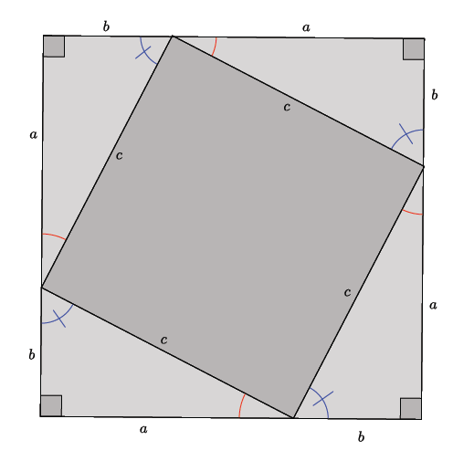
- So we know that the angles marked by the red arcs are equal in measure, and the angles marked with the blue arcs and line are equal in measure. What do we know about the sum of the interior angles of a triangle ($∠$ sum of $△$)?
  - The sum of the interior angles of a triangle is $180°$.
- What is the sum of the two interior angles of a right triangle, not including the right angle ($∠$ sum of rt. $△$)? How do you know?
  - For right triangles, we know that one angle has a measure of $90°$. Since the sum of all three angles must be $180°$, then we know that the other two angles must have a sum of $90°$.
- Now look at just one side of the figure. We have an angle with a red arc and an angle with a blue arc. In between them is another angle that we do not know the measure of. All three angles added together make up the straight side of the outside figure. What must be the measure of the unknown angle (the measure of the angle between the red and blue arcs)? How do you know?
  - Since the angle with the red arc and the angle with the blue arc must have a sum of $90°$, and all three angles together must make a straight angle measuring $180°$ ($∠s$on a line), then the unknown angle must equal $90°$.
- That means that the figure with side lengths $c$ must be a square. It is a figure with four equal sides and four right angles. What is the area of this square?
  - The area of the square must be $c^{2}$.
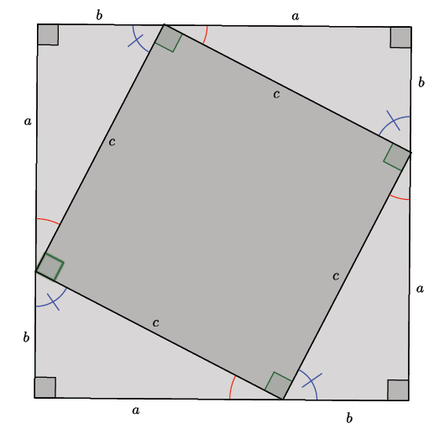
- Recall our goal: To show that $a^{2}+b^{2}=c^{2}$. To accomplish this goal, we will compare the total area of the outside square with the parts it is comprised of, i.e., the four triangles and the smaller, inside square. Do we have everything we need to accomplish our goal?
  - Yes, we know the area of the outside square, ${\left(a+b\right)}^{2}=a^{2}+2ab+b^{2}$, the sum of the areas of the four triangles, $4\left(\frac{1}{2}ab\right)=2ab,$ and the area of the inside square, $c^{2}$.
Show students the end of the square within a square proof:
Total area of the outside square $=$area of four triangles $+$ area of inside square
$$\begin{aligned}a^{2}+2ab+b^{2}=2ab+c^{2} \\ a^{2}+2ab-2ab+b^{2}=2ab-2ab+c^{2} \\ a^{2}+b^{2}=c^{2}.\end{aligned}$$
Thus, we have shown the Pythagorean theorem to be true using a square within a square.

Example 1 (2 minutes)
Example 1
Now that we know what the Pythagorean theorem is, let’s practice using it to find the length of a hypotenuse of a right triangle.
Determine the length of the hypotenuse of the right triangle.
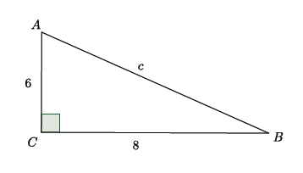
The Pythagorean theorem states that for right triangles $a^{2}+b^{2}=c^{2}$, where $a$ and $b$ are the legs and $c$ is the hypotenuse. Then,
$$\begin{aligned}a^{2}+b^{2}=c^{2} \\ 6^{2}+8^{2}=c^{2} \\ 36+64=c^{2} \\ 100=c^{2}.\end{aligned}$$
Since we know that $100=10^{2}$, we can say that the hypotenuse $c=10$.

Example 2 (3 minutes)
Example 2
Determine the length of the hypotenuse of the right triangle.
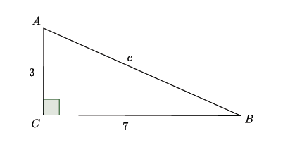

- Based on our work in the last example, what should we do to find the length of the hypotenuse?
  - Use the Pythagorean theorem and replace $a$ and $b$with $3$and $7$. Then,
$$\begin{aligned}a^{2}&+&b^{2}&=c^{2} \\ 3^{2}&+&7^{2}&=c^{2} \\ 9&+&49&=c^{2} \\ &&58&=c^{2}.\end{aligned}$$
- Since we do not know what number times itself produces $58$, for now we can leave our answer as $58=c^{2}$. Later this year, we will learn how to determine the actual value for $c$ for problems like this one.

Exercises 1–5 (10 minutes)
Exercises 1–5
For each of the exercises, determine the length of the hypotenuse of the right triangle shown. Note: Figures not drawn to scale.
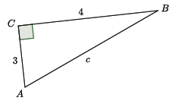
$$a^{2}+b^{2}=c^{2}$$
$$3^{2}+4^{2}=c^{2}$$
$$9+16=c^{2}$$
$$25=c^{2}$$
$$5=c$$

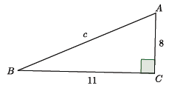
$$a^{2}+b^{2}=c^{2}$$
$$8^{2}+{11}^{2}=c^{2}$$
$$64+121=c^{2}$$
$$185=c^{2}$$

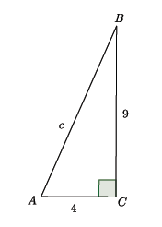

$$a^{2}+b^{2}=c^{2}$$
$$4^{2}+9^{2}=c^{2}$$
$$16+81=c^{2}$$
$$97=c^{2}$$

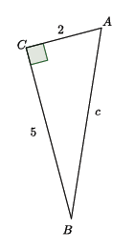

$$a^{2}+b^{2}=c^{2}$$
$$2^{2}+5^{2}=c^{2}$$
$$4+25=c^{2}$$
$$29=c^{2}$$

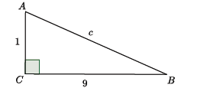
$$a^{2}+b^{2}=c^{2}$$
$$1^{2}+9^{2}=c^{2}$$
$$1+81=c^{2}$$
$$82=c^{2}$$

Closing (5 minutes)
Summarize, or have students summarize, the lesson.
- We were shown a proof for the Pythagorean theorem that required us to find the area of four congruent triangles and two squares.
- We learned that right triangles have sides $a$ and $b$ known as legs and a side $c$ known as the hypotenuse.
- We know that for right triangles, $a^{2}+b^{2}=c^{2}$.
- We learned how to use the Pythagorean theorem in order to find the length of the hypotenuse of a right triangle.
Lesson Summary
Given a right triangle $ABC$ with $C$ being the vertex of the right angle, then the sides $AC$ and $BC$ are called the legs of $∆ABC$, and $AB$ is called the hypotenuse of $∆ABC$.
Take note of the fact that side $a$ is opposite the angle $A$, side $b$ is opposite the angle $B$, and side $c$ is opposite the angle $C$.
The Pythagorean theorem states that for any right triangle, $a^{2}+b^{2}=c^{2}$.

Exit Ticket (5 minutes)
Name Date
Lesson 15: Informal Proof of the Pythagorean Theorem

Exit Ticket

- Label the sides of the right triangle with leg, leg, and hypotenuse.

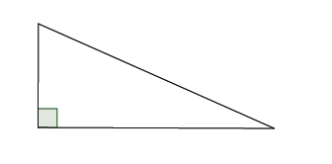

- Determine the length of $c$in the triangle shown.

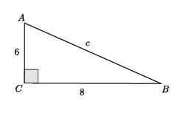
- Determine the length of $c$ in the triangle shown.

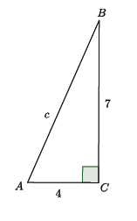

Exit Ticket Sample Solutions

- Label the sides of the right triangle with leg, leg, and hypotenuse.
leg

leg

hypotenuse

- Determine the length of $c$ in the triangle shown.
$$a^{2}+b^{2}=c^{2} \\ 6^{2}+8^{2}=c^{2} \\ 36+64=c^{2} \\ 100=c^{2} \\ 10=c$$

- Determine the length of $c$ in the triangle shown.
$$a^{2}+b^{2}=c^{2}$$
$$4^{2}+7^{2}=c^{2}$$
$$16+49=c^{2}$$
$$65=c^{2}$$

Problem Set Sample Solutions
Students practice using the Pythagorean theorem to find the length of the hypotenuse of a right triangle.
For each of the problems below, determine the length of the hypotenuse of the right triangle shown. Note: Figures not drawn to scale.
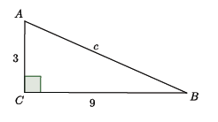
$$a^{2}+b^{2}=c^{2}$$
$$3^{2}+9^{2}=c^{2}$$
$$9+81=c^{2}$$
$$90=c^{2}$$

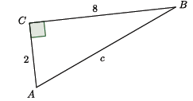
$$a^{2}+b^{2}=c^{2}$$
$$8^{2}+2^{2}=c^{2}$$
$$64+4=c^{2}$$
$$68=c^{2}$$

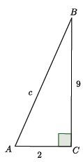

$$a^{2}+b^{2}=c^{2}$$
$$9^{2}+2^{2}=c^{2}$$
$$81+4=c^{2}$$
$$85=c^{2}$$

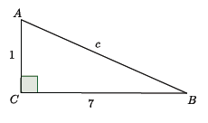

$$a^{2}+b^{2}=c^{2}$$
$$7^{2}+1^{2}=c^{2}$$
$$49+1=c^{2}$$
$$50=c^{2}$$

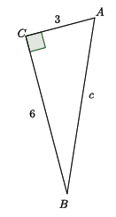
$$a^{2}+b^{2}=c^{2}$$
$$6^{2}+3^{2}=c^{2}$$
$$36+9=c^{2}$$
$$45=c^{2}$$

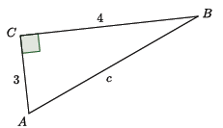

$$a^{2}+b^{2}=c^{2} \\ 4^{2}+3^{2}=c^{2} \\ 16+9=c^{2} \\ 25=c^{2} \\ 5=c$$

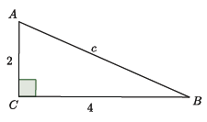

$$a^{2}+b^{2}=c^{2}$$
$$4^{2}+2^{2}=c^{2}$$
$$16+4=c^{2}$$
$$20=c^{2}$$

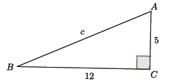
$$a^{2}+b^{2}=c^{2} \\ {12}^{2}+5^{2}=c^{2} \\ 144+25=c^{2} \\ 169=c^{2} \\ 13=c$$

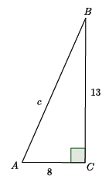
$$a^{2}+b^{2}=c^{2}$$
$${13}^{2}+8^{2}=c^{2}$$
$$169+64=c^{2}$$
$$233=c^{2}$$

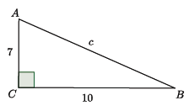
$$a^{2}+b^{2}=c^{2}$$
$${10}^{2}+7^{2}=c^{2}$$
$$100+49=c^{2}$$
$$149=c^{2}$$

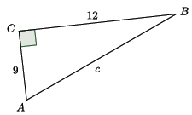
$$a^{2}+b^{2}=c^{2} \\ {12}^{2}+9^{2}=c^{2} \\ 144+81=c^{2} \\ 225=c^{2} \\ 15=c$$

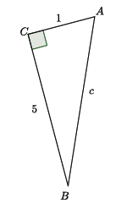
12.
$$a^{2}+b^{2}=c^{2} \\ 5^{2}+1^{2}=c^{2} \\ 25+1=c^{2} \\ 26=c^{2}$$

